**Romania** 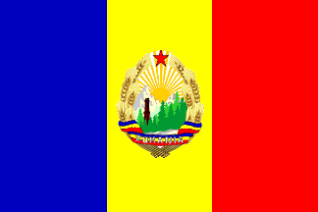

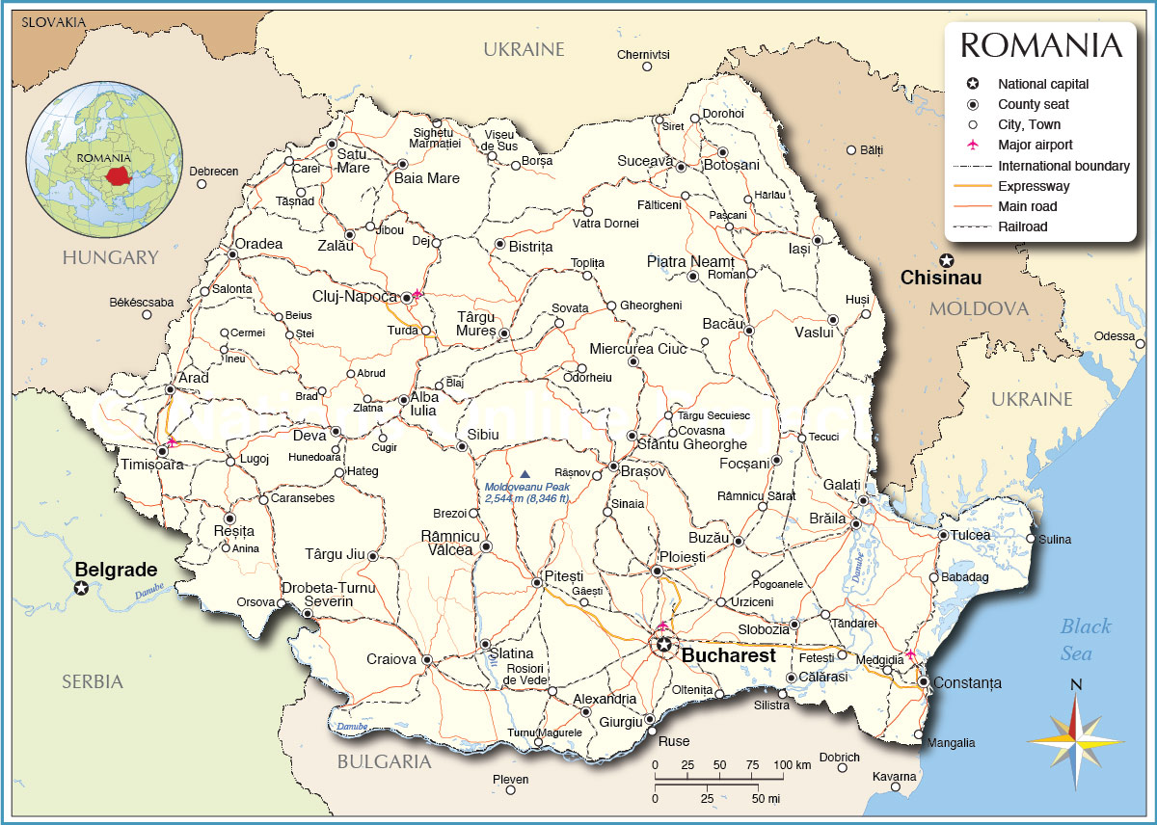

**Romania** is one of the five remaining Warsaw Pact countries and is the clear winner in the re-shuffling of power within the alliance. Ceausescu the longtime dictator has clearly ingratiated himself with the new regime in Moscow and much of the military and financial assistance that was going to East Germany and Poland is now heading to Bucharest, where the ruthless dictator has used it to prop up his faltering regime.

Romania has shifted from being a weak and faltering partner to being the staunchest ally to the Soviet Union within the Pact.