**Romanian Navy**

The Romanian navy, is a small coastal defence force which also supports a domestic ship building capability. The main role of the navy is to support the Soviet Black Sea Fleet in times of crisis, but a critical secondary role was the riverine elements along the Danube River. The Danube is a critical element in the resupply of Army units that deploy westward into Balkans, Hungary, Czechoslovakia and even Germany. This page will be limited to the Black Sea flotilla, and will leave the river flotilla for later development.

The fleet is based in two Black Sea locations; Constanta, and Mangalia with the Frigate and submarine based at the former and the corvettes at the later.

**Frigate**

The flagship of the Romanian navy is the locally designed and built [Mărășești](https://en.wikipedia.org/wiki/Romanian_frigate_M%C4%83r%C4%83%C8%99e%C8%99ti). Initially commissioned in 1986 the ship has spent half its life in refit to address design problems and is now christened with its third name, and third classification. As a Frigate it is a marginally capable ship with outdated Surface to Surface missiles (SSM) and Surface to Air Missiles (SAM). The ship is slow by most standards and very large for its type.

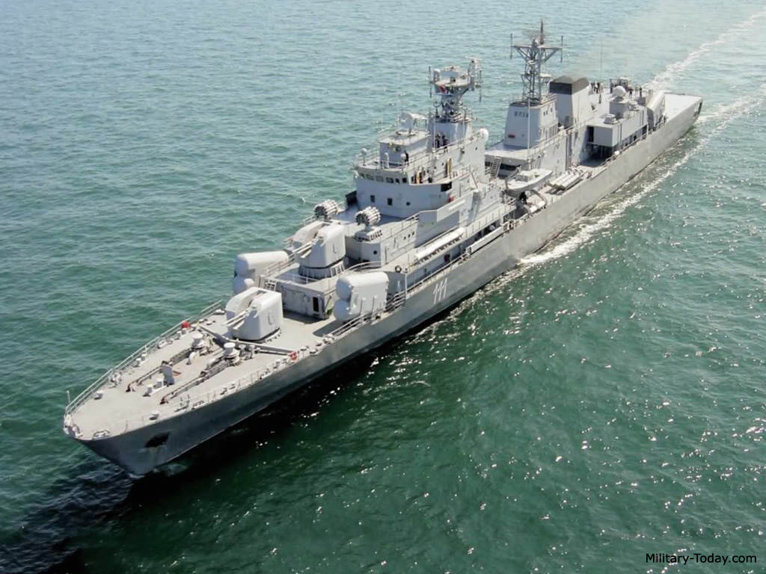

**Corvettes**

**Tetal Class**. Another home grown design, these ships have no missiles and focus on ASW operations. The Tetal-II sub class has one gun turret removed and replaced by a helicopter landing deck.

|  |  |  |
| --- | --- | --- |
| Class | Pennant | Name |
| Tetal-I | F-260 | Amiral Petre Barbuneanu |
|  | F-261 | Vice-Amiral Vasile Scodrea |
|  | F-262 | Vice-Amiral Vasile Urseanu |
|  | F-263 | Vice-Amiral Eugeniu Rosca |
| Tetal-II | F-264 | Contraamiral Eustațiu Sebastian |
|  | F-265 | Contraamiral Horia Macellariu |

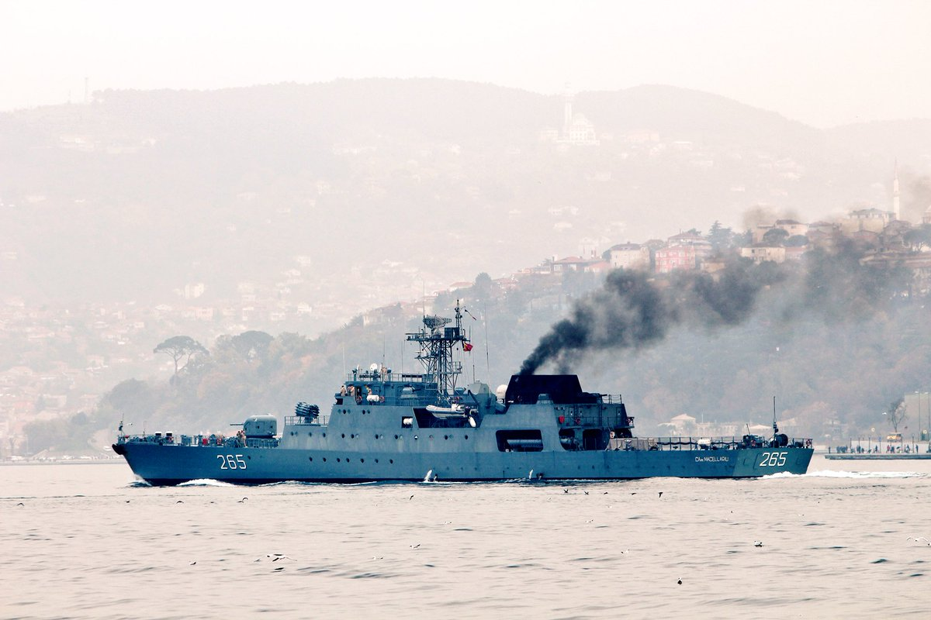

**Missile Boats**

[**Tarantul Class**](http://russianships.info/eng/warfareboats/project_12411.htm)The Romanian Navy received three of this class in the early 1990’s from the Soviet Back Sea Fleet. With 4x P-15M (S-N-2C) Styx, Surface to Surface Missiles (SSM) and high speed (42 Knts), this is a potent little ship, weighing in at 495 tons.

|  |  |  |  |  |
| --- | --- | --- | --- | --- |
| Class | Pennant | Name | Status | Remarks |
| Tarantul I | F-188 | Zborul | Active |  |
|  | F-189 | Pescăruşul | Active |  |
|  | F-190 | Lăstunul | Active |  |

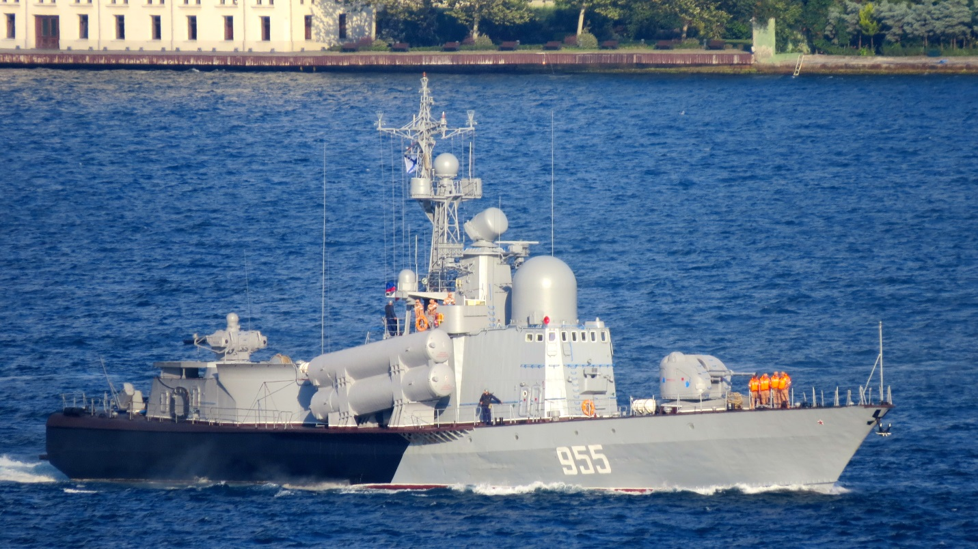

[**Osa Class**](http://russianships.info/eng/warfareboats/project_205.htm)The Romanian Navy took delivery of three Osa I and three Osa II boats. The main improvement between the two sub classes was an enhanced version of the P-15 (S-N-2C) Styx SSM. All are based at Atia. The Osa I boats are in reserve and will take several days to activate.

|  |  |  |  |  |
| --- | --- | --- | --- | --- |
| Class | Pennant | Name | Status | Remarks |
| Osa I | F-195 | Vulturul | Reserve |  |
|  | F-198 | Eretele | Reserve |  |
|  | F-199 | Albatrosul | Reserve |  |
| Osa II | F-202 | Smeul | Active |  |
|  | F-204 | Vijelia | Active |  |
|  | F-209 | Vulcanul | Active |  |

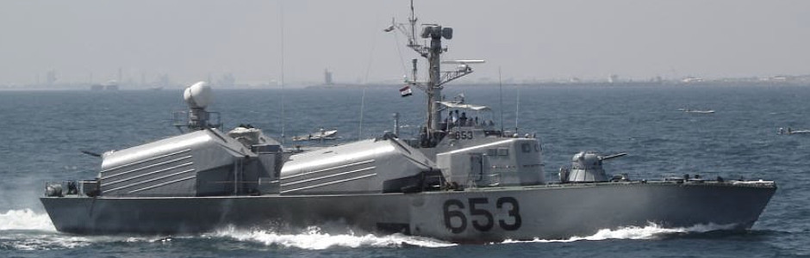

**ASW Corvettes**

[**Poti Class**](http://russianships.info/eng/warships/project_204.htm)These rugged little ships have a good ASW suite in a small package. The Romanian Navy operate three, one of which is constantly on patrol.

|  |  |  |  |  |
| --- | --- | --- | --- | --- |
| Class | Pennant | Name | Status | Remarks |
|  | MPK-31 |  | Active |  |
|  | MPK-32 |  | Active |  |
|  | MPK-33 |  | Active |  |

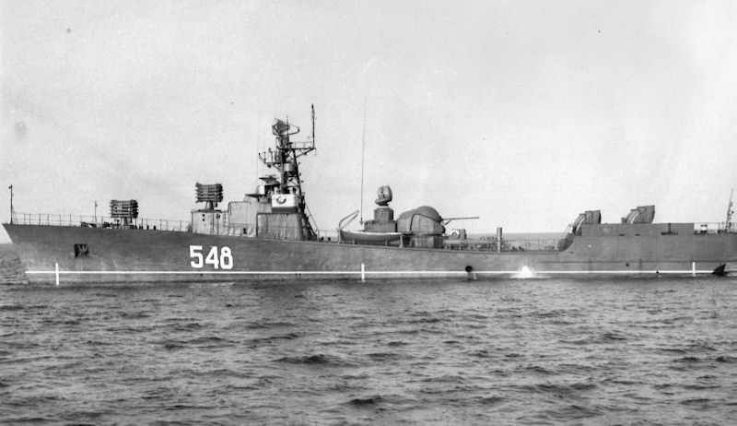

**Submarines**

[**Delfinul (Kilo) Class**](https://en.wikipedia.org/wiki/Romanian_submarine_Delfinul)Romania has one submarine of the very capable and dangerous Kilo class. In the shallow waters of the Black sea and the confined space of the shipping lanes, this is a very potent threat, particularly to Turkish naval units.

