**Ground forces of Serbia and Montenegro (VSCG)**

The splintering of the ‘Former Republic of Yugoslavia’ (FRY) during the ‘Yugoslav Wars’ which are ongoing in Bosnia and Croatia also tore the Yugoslav National Army (formerly JNA) to pieces. The bulk of the organized force remains under Serbian control and has been structured into the VSCG. This [link](https://www.cia.gov/library/readingroom/docs/1993-07-01b.pdf) provides a moderately redacted summary of the military situation as it stood in July 93.

The key divergence from the historical occurring in the Northern Fury world is that the influence and pressure from Moscow is even stronger than it was. Belgrade was actively courted to re-join the Warsaw Pact, which it did in the latter half of ‘93. NATO, very aware and concerned over this possibility was somewhat more circumspect in its support of the independent Slovenian and Croatian governments and is now cautiously avoiding confrontation. UN, NATO and EU monitoring and peacekeeping forces remain in place in both Bosnia and Croatia, but the Soviet veto in the UN Security council has blunted the teeth of their mandates, hence there is a much less aggressive NATO stance and reduced forces.

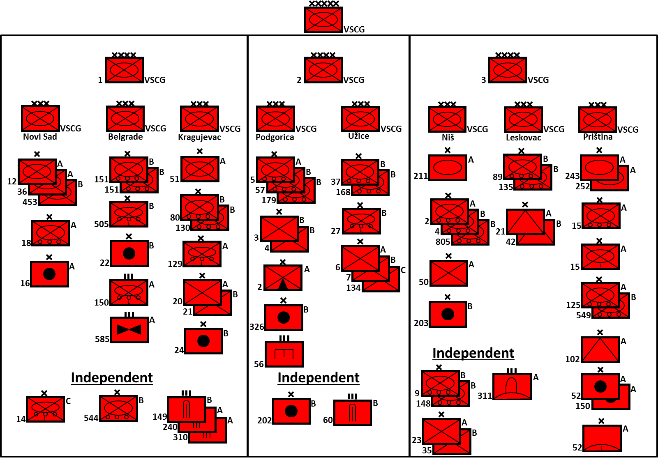

The armies of the VSCG are arrayed as depicted in the map obtained at the CIA link above:

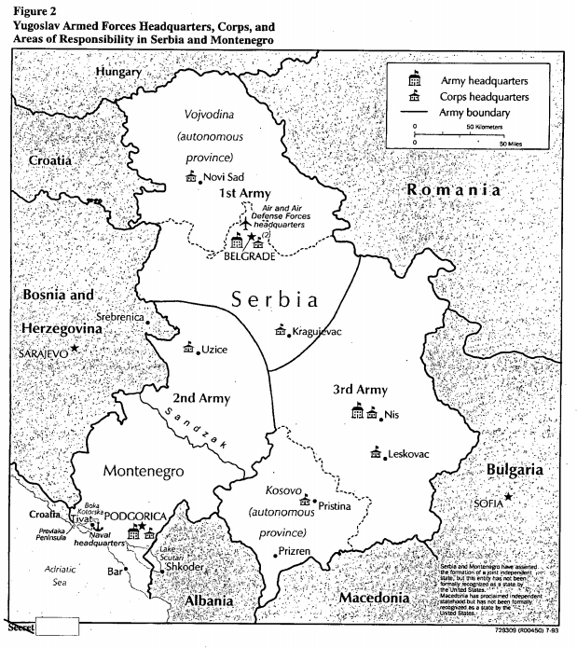

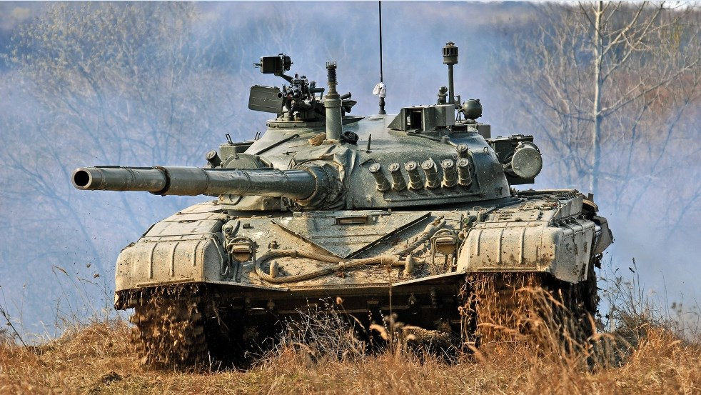

|  |  |  |  |  |
| --- | --- | --- | --- | --- |
| MBT | T-72 | M-84 | 27 |  |
|  |  | M-84A | 212 |  |
|  | T-72M1 | T-72M | 60 |  |
|  | T-55 | T-55AM | 1200 |  |
|  |  | T-55H | 282 |  |
|  |  | T-34 | Many | In reserve |
| IFV | BMP-1 | M80A | 995 |  |
| APC |  | MTLB | 200 |  |
|  |  | OT M-60 | 551 |  |
|  |  | BTR-50 | 120 |  |
|  |  | BTR-60 | 80 |  |
|  |  | TAB-72 | 40 |  |
| Recon |  | BRDM-2 | 50 |  |
|  |  | BOV | 317 |  |
| Arty | 105mm | M-1 | some | Note that between 1200 and 2000 guns and MLR systems are in service in Serbia |
|  |  | M-56 | many |
|  | 122mm | D-30 | 78 |  |
|  |  | M-1938 | 72 |  |
|  |  | A-19 | some |  |
|  |  | 2S1 | 72 |  |
|  | 130mm | M-46 | 112 |  |
|  | 152mm | D-20 | 20 |  |
|  |  | M-84 | 52 |  |
|  |  | ML-20 | 18? |  |
|  |  | M-1943 | 36? | In reserve |
|  | 155mm | M-2 | Some | In reserve |
| MRL | 122mm | BM-21 | 348 |  |
|  | 128mm | M-63 Plamen | 38 |  |
|  |  | M-63 Towed | 300 |  |
|  |  | M-77 Oganj | 130 |  |
|  | 262mm | M-87 Orkan II | 16 | Production continued beyond original 9 |
|  |  | M-87 Orkan | 50 |  |
| AT | 100mm | T-12 | 300? | Approximately |
|  |  | SU-100 | 20 |  |
| AAA | 30mm | BOV-3/30 SPAAG | 100 |  |
|  |  | M53/59 Praga | 789 |  |
|  | 57mm | ZSU-57-2 | 100 |  |
| SAM | SA-2 | S-75 | some |  |
|  | SA-3 | S-125 | 60 | 14 Batteries |
|  | SA-6 | 2K12 |  | 12 Batteries |
|  | SA-8 | 9K33 | Some |  |
|  | SA-9 | CA-95 | 48 |  |
|  | SA-13 | 9M37M | 18 | Locally produced & upgraded |
| MANPAD | SA-7 | CA-94 | Many | Locally produced |
|  | SA-14 |  |  |  |
|  | SA-16 | 9K38 | 226 |  |
| SSMs | FROG-7 |  | 16 |  |

