**Navy of Serbia and Montenegro**

The Navy of Serbia and Montenegro was largely made up of ships that escaped the naval base at Split Croatia during the Croatian civil war in 1991. These ships joined a few ships which were already based at Kotor Montenegro to reform the fleet. Several ships were damaged and captured by Croatia in the fighting while two submarines were evacuated on the surface because they were undergoing repairs and refit, because Kotor lacks the proper facilities, these two submarines are destined to be scrapped.

NATO operations under the auspices of ***OPERATION MARITIME GUARD*** followed by ***OPERATION SHARP GUARD*** have severely curtailed operations but local coastal patrols continue.

**Frigates**

[**Koni Class**](https://en.wikipedia.org/wiki/Koni-class_frigate)two key ships toescape Croatia were the Koni class Frigates ***VPBR-31 Beograd*** and ***VPBR-32 Podgorica*** formerly ***RF-31 Split*** and ***RF-32 Koper***. Neither very large nor very modern, this ship still causes NATO and Italy in particular grave concern as they are the most potent threat ships permanently based in the Mediterranean. The 4K33 "Osa-M" Surface to Air Missile (SAM) launcher ( SA-N-4 Gecko), has 20 reloads giving the ship a moderate missile umbrella out to about 13Km. The ASW suite is decent and she carries 2x 76mm guns as well as 2x 30mm cannons acting as a last ditch Close in Weapons System (CIWS).

|  |  |  |  |  |
| --- | --- | --- | --- | --- |
| **Class** | **Pennant** | **Name** | **Status** | **Remarks** |
| Koni | VPBR-31 | Beograd | Active |  |
|  | VPBR-32 | Podgorica | Active |  |

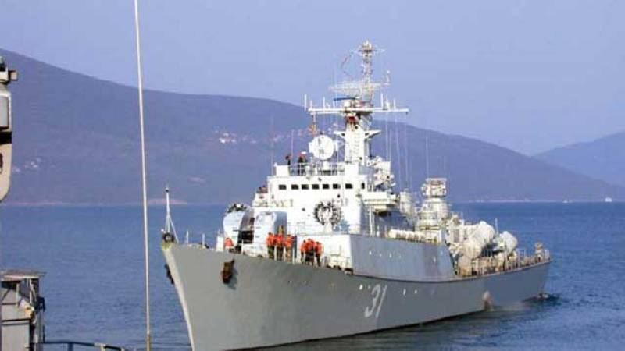

[**Kotor Class**](http://www.balkanwarhistory.com/2016/05/kotor-class-frigate.html)These two ships were designed and built in Yugoslavia and were based on the Koni class with some improvements and repositioning of the Anti-Ship missiles. They displace about 25% less than the Koni class and are 9 meters shorter.

|  |  |  |  |  |
| --- | --- | --- | --- | --- |
| **Class** | **Pennant** | **Name** | **Status** | **Remarks** |
| Kotor | VPBR-33 | Kotor | Active |  |
|  | VPBR-34 | Novi Sad | Active |  |

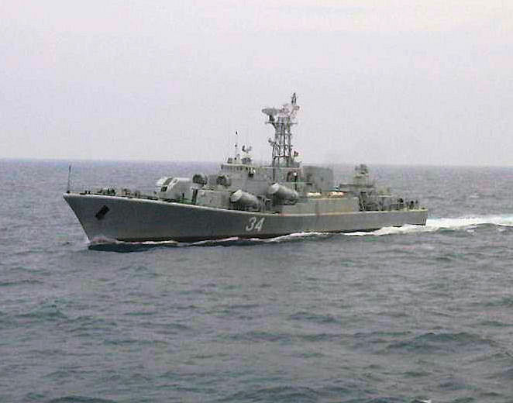

**Missile Boats**

[**Končar Class**](http://www.balkanwarhistory.com/2017/04/koncar-class-missile-boat.html)These ships were completely designed and built in Yugoslavia as an eventual replacement for the Osa class. Firing an improved missile, the P-15 (S-N-2C) Styx SSM, the main improvement was to make these roughly equivalent to the Soviet Osa II boats and more capable than the Osa I purchased in the 1960s. They are also ten years newer than the Osa’s and helped to establish a modern shipbuilding industry in Yugoslavia. One ship was captured by the Croatians (RTOP-402, Vlado Ćetković) and put to use as the ***Šibenik.***

|  |  |  |  |  |
| --- | --- | --- | --- | --- |
| **Class** | **Pennant** | **Name** | **Status** | **Remarks** |
| Končar | RTOP-401 | Rade Končar | Active |  |
|  | RTOP-402 | Vlado Ćetković | Captured | Croatian Šibenik |
|  | RTOP-403 | Ramiz Sadiku | Active |  |
|  | RTOP-404 | Hasan Zahirović-Laca | Active |  |
|  | RTOP-405 | Jordan Nikolov Orce | Active |  |
|  | RTOP-406 | Ante Banina | Active |  |

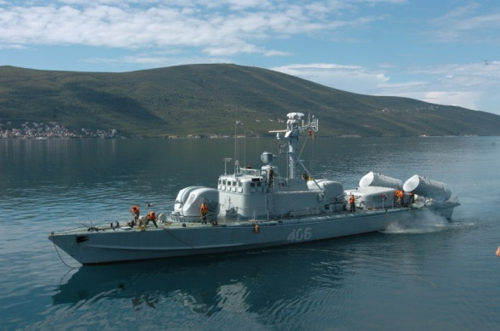

[**Osa Class**](http://russianships.info/eng/warfareboats/project_205.htm)The Yugoslavian Navy took delivery of ten Osa I boats, all of which were supposed to retire in the mid 1990s. Two of these boats were captured by the Croatians, one was put into commission while the other was sunk as a target ship.

|  |  |  |  |  |
| --- | --- | --- | --- | --- |
| Class | Pennant | Name | Status | Remarks |
| Osa I | RC-301 | Mitar Acev | Captured | Croatian Dubrovnik |
|  | RC-302 | Vlado Bagat | Active |  |
|  | RC-303 | Petar Drapšin | Active |  |
|  | RC-304 | Stjepan Filipović-Stevo | Active |  |
|  | RC-305 | Žikica Jovanović-Španac | Active |  |
|  | RC-306 | Nikola Martinović | Active |  |
|  | RC-307 | Josip Mažar | Active |  |
|  | RC-308 | Karlo Rojc | Active |  |
|  | RC-309 | Franc Rozman-Stane | Active |  |
|  | RC-310 | Velimir Škorpik | Sunk | Captured and sunk as target |

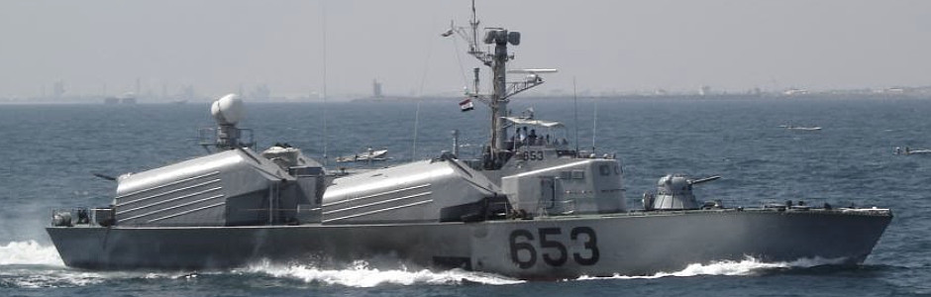

**Torpedo Boats**

[**Shershen Class**](http://russianships.info/eng/warfareboats/project_206.htm): Four of these boats were purchased from the Soviet Union while the other 10 were built under licence in Yugoslavia. All wereobsolete by 1994 and historically were in various levels of readiness. Croatia captured two, but one was so damaged that it was not put into service and sunk as a target instead.

|  |  |  |  |  |
| --- | --- | --- | --- | --- |
| **Class** | **Pennant** | **Name** | **Status** | **Remarks** |
| Shershen | TČ-211 | Pionir | Active |  |
|  | TČ-212 | Partizan | Active |  |
|  | TČ-213 | Proleter | Active |  |
|  | TČ-214 | Topčider | Active |  |
|  | TČ-215 | Ivan | Active |  |
|  | TČ-216 | Jadran | Active |  |
|  | TČ-217 | Kornat | Active |  |
|  | TČ-218 | Biokovac | Active |  |
|  | TČ-219 | Streljko | Sunk | Captured and sunk as target |
|  | TČ-220 | Crvena zvezda | Active |  |
|  | TČ-221 | Partizan III | Captured | Croatian OBM-51 Vukovar |
|  | TČ-222 | Partizan II | Active |  |
|  | TČ-223 | Napredak | Active |  |
|  | TČ-224 | Pionir II | Active |  |

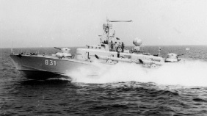

**Patrol Boats**

[**Mirna Class**](https://en.wikipedia.org/wiki/Mirna-class_patrol_boat)This is a small (140 Ton) class of patrol boat designed and built in Yugoslavia. Armed with a 40mm and quad 20mm cannon, these boats are fast and maneuverable. Croatia captured and is using three of the 11 boats built.

|  |  |  |  |  |
| --- | --- | --- | --- | --- |
| Class | Pennant | Name | Status | Remarks |
| Mirna | PČ-171 | Biokovo | Captured | Croatian OB-01 Novigrad |
|  | PČ-172 | Pohorje | Active |  |
|  | PČ-173 | Koprivnik | Active |  |
|  | PČ-174 | Učka | Active |  |
|  | PČ-175 | Grmeč | Active |  |
|  | PČ-176 | Mukos | Captured | Croatian OB-02 Šolta |
|  | PČ-177 | Fruška Gora | Active |  |
|  | PČ-178 | Kosmaj | Active |  |
|  | PČ-179 | Zelengora | Active |  |
|  | PČ-180 | Cer | Captured | Croatian OB-03 Cavtat |
|  | PČ-181 | Durmitor | Captured | Croatian OB-04 Hrvatska Kostajnica |

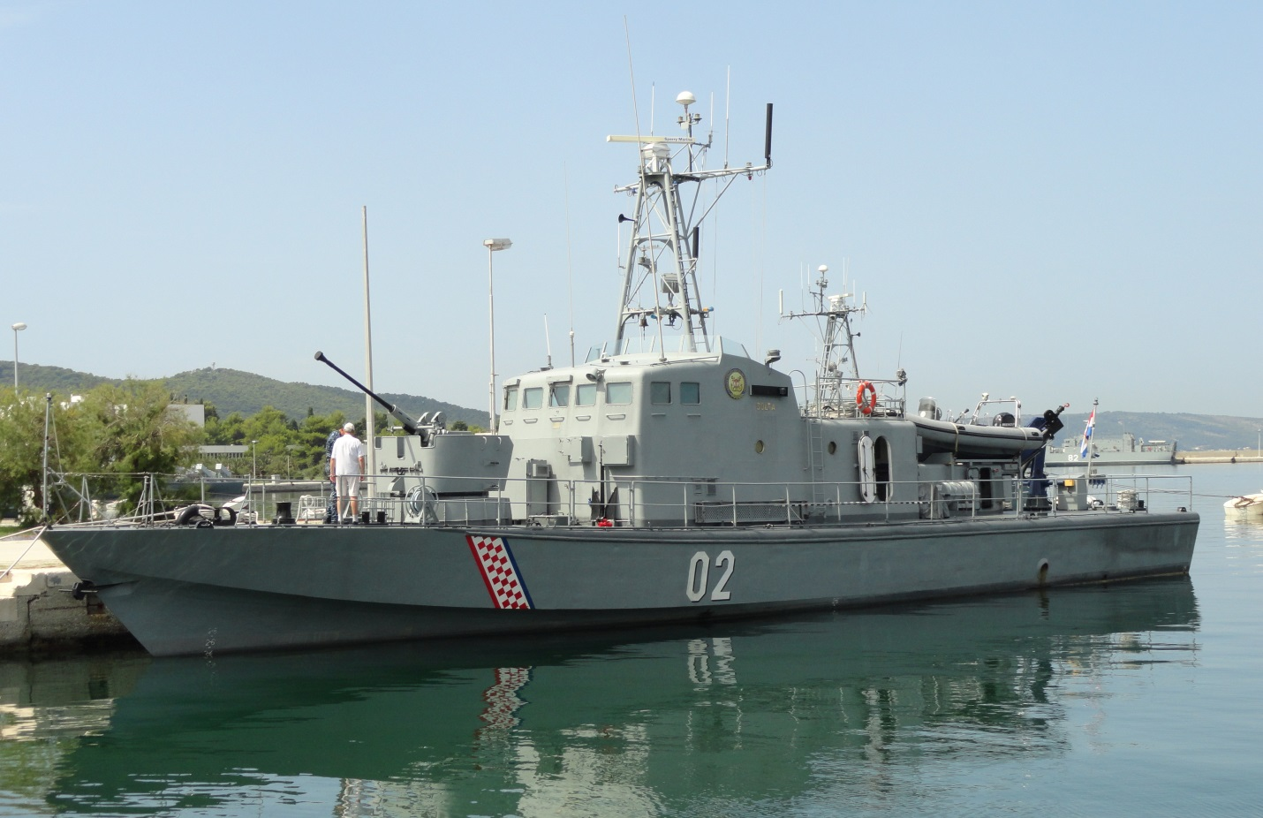

**Submarines**

[**Heroj Class**](http://www.balkanwarhistory.com/2017/10/heroj-class-submarine.html)These three boats were designed and built in Yugoslavia in the 1960s, all relocated to Montenegro but ***P-821 Heroj*** was undergoing refit at the time and remains unserviceable.

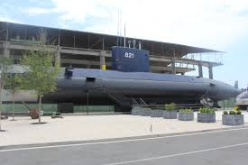

|  |  |  |  |  |
| --- | --- | --- | --- | --- |
| **Class** | **Pennant** | **Name** | **Status** | **Remarks** |
|  | P-821 | Heroj | Refit |  |
|  | P-822 | Janak | Active |  |
|  | P-823 | Uskok | Active |  |

[**Sava Class**](https://en.wikipedia.org/wiki/Sava-class_submarine)These two boats were developed after the Heroj class and represent an improvement on the design with more armaments, two additional torpedo tubes and better minelaying equipment. Both escaped to Montenegro at the outbreak of the Croatian civil war but ***P-832 Drava*** was undergoing a major refit which was never completed.

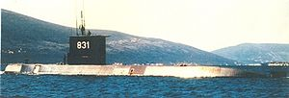

|  |  |  |  |  |
| --- | --- | --- | --- | --- |
| Class | Pennant | Name | Status | Remarks |
|  | P-831 | Sava | Active |  |
|  | P-832 | Drava | Refit |  |