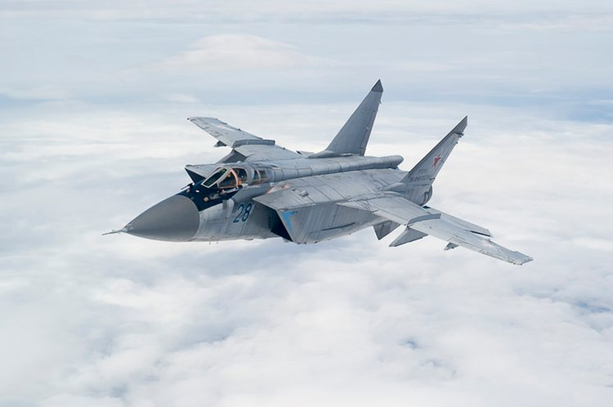

**[MiG-31 ‘Foxhound’](https://www.fighter-planes.com/info/mig31_foxhound.htm)**

Based on the design of and resembling to the MiG-25 is where the similarities between these two interceptors end, the MiG-31 is a significant improvement on a very good design. The Foxhound is longer, has a pilot *and* a weapons systems operator (WSO), significantly advanced radar (phased array vice mechanical scan), able to track multiple targets, better engines, more and longer range weapons, secure data-links and many other improvements.

Beginning production in 1975, the success of this aircraft spelled the end of improvements for the MiG-25, with older versions being upgraded to the ‘PDS’ model vice production of a follow on modernized airframe.

The MiG-31 was not exported. The role, similar to that of the MiG-25 was engaging American bombers in the high arctic where its speed, long range and powerful radar made an ideal fit. Anti-Satellite engagement was another task, with a service ceiling of 82,000 feet and an ability to launch very long range missiles, although this was still experimental in 1994.

Historically production and evolution of the MiG-31 was severely affected by the breakup of the Soviet Union; the MiG-31M, a major upgrade was flown in 1985 but was not put into production until 2008, and by then a less capable follow on version, the ‘B’ had been built. In Northern Fury production of the ‘M’ would continue and the original aircraft would be upgraded to that standard and be given the designation ‘SM’.

**MiG-31 Foxhound-A**: The basic version of the interceptor. 349 produced, about 200 upgraded to ‘SM’ (Hypothetical), and 125 others remaining in this configuration until upgraded;

**MiG-31M/SM Foxbat-B**: A much improved aircraft with upgraded radar and IRST (Infra-Red Sense and Track), ability to carry six R-33 (AA-9 ‘Amos’), and/or R-77 (AA-12 ‘Adder’) missiles. There are 200 ‘M’ and 200 converted ‘SM’ available to the PVO. Of note, the R-77 air to air missile is becoming available to the PVO in limited numbers by the start of Northern Fury.

**Note**: Historically there were about 150 MiG-31B built starting in 1990 with production virtually stopped in late 1991. In the Northern Fury world the ‘B’ is never produced in favor of the ‘M’, and I’ve made the assumption that 200 of the more advanced airframes could be built over three years vice the 150 actually constructed in 18 months.

