**Naval Aviation**

Similar to the US Navy (USN), the Soviets has a separate air force dedicated to supporting the fleet. Much different to the USN however are the roles, types and tasks of naval aviation, for the Soviets, embarked aircraft on ships was a much smaller task because of the lesser emphasis on aircraft carriers, the focus of Soviet Naval Aviation was finding and sinking USN aircraft Carriers and generally supporting the fleet with bombers, Anti-Submarine Warfare (ASW) and long range reconnaissance. Each fleet has its own supporting aviation formation which is tailored for the expected tasks of that fleet, using the Air Division as a common basis, but the groupings within Regiments of that Division would often contain a mix of airframes.

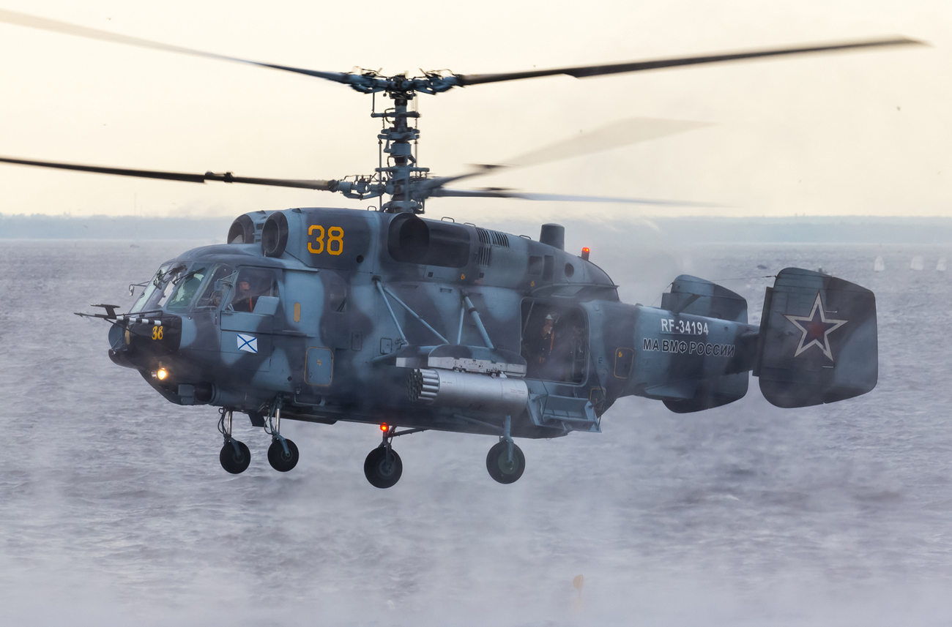

[**Red Banner Northern Fleet**](https://www.ww2.dk/new/navy/SF.htm):

The air arm of the Red Banner Northern Fleet operates over 675 aircraft spanning a wide array of capabilities from long range reconnaissance to shipborne ASW helicopters. Although all of the aircraft flying off the two Kuznetzov class carriers report to Northern Fleet, the Yak-38 and Yak-141 operating from the four Kiev class carriers report to the 311th Independent Shipborne Assault Aviation Regiment Shipborne Aviation Squadron located in the Far East. Northern Fleet works closely with the air element of the Baltic Fleet as well as the 6th Red Banner Air Defence Army PVO and the Leningrad Military District air command.

|  |  |  |  |  |  |
| --- | --- | --- | --- | --- | --- |
| Division | Regiment | Location | Number | Aircraft type | Remarks |
| 5th Red Banner | 574th MRAP | Lakhta | 32 | Tu-22M3 |  |
|  |  |  | 5 | Tu-22M3R |  |
|  |  |  | 4 | Tu-22MP |  |
|  | 924th RB MRAP | Olenegorsk | 34 | Tu-22M3 |  |
|  |  |  | 8 | Tu-16P Buket |  |
|  | 987th MRAP | Severomorsk-3 | 32 | Tu-16K-10-26 |  |
|  |  |  | 6 | Tu-16K-10-26P |  |
| 35th PARLD | 76th OPLAP DD | Fedotovo | 36 | Tu-142 |  |
|  | 135th OPLAP DD | Fedotovo | 32 | Tu-142 |  |
| 57th OShAD | 100th OShAP | Severomorsk-3 | 24 | Su-33 | Kuznetzov |
|  |  |  | 24 | Mig-29K | Backup |
|  |  |  | 18 | Su-25 (Var) | Training |
|  | 279th OShAP | Severomorsk-3 | 24 | Su-33 | Varyag |
|  |  |  | 24 | Mig-29K | Backup |
|  |  |  | 18 | Su-25 (Var) | Training |
|  | 38th ShPLAP | Severomorsk-2 | 80 | Ka-27/Ka-29 |  |
|  | 830th ShPLAP | Severomorsk-2 | 80 | Ka-27/Ka-29 |  |
| Northern Fleet | 342nd OEVP | Ostrov | 16 | Tu-16SPS | EW Regt |
|  | 976th ODRAP | Severomorsk-1 | 6 | Su-24MR |  |
|  |  |  | 4 | Su-24MP |  |
|  |  |  | 32 | Su-24M |  |
|  | 24th OPLAP DD | Severomorsk-1 | 24 | Il-38 |  |
|  | 912th OTAP | Luostari | 18 | An-24 |  |
|  |  |  | 8 | An-26 |  |
|  |  |  | 24 | An-12 |  |
|  | 392nd ODRAP | Conakry | 12 | Tu-95RTS |  |
|  |  |  | 12 | Tu-16RM2 |  |
|  | 403rd RB OPLAP | Severomorsk-1 | 18 | Be-12 |  |
|  |  |  | 24 | Mi-14 |  |

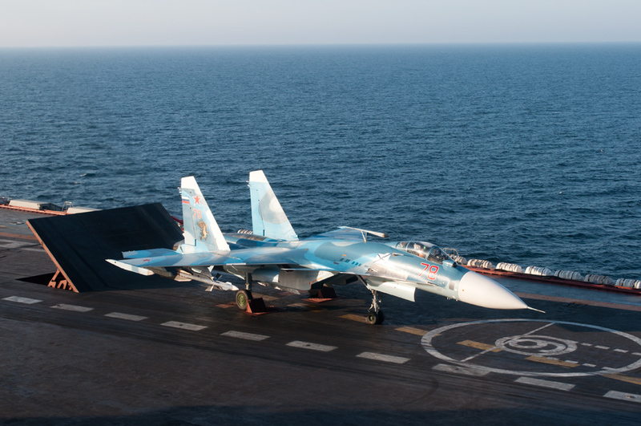

[**Red Banner Pacific Fleet**](https://www.ww2.dk/new/navy/TOF.htm):

The Department of Aviation for Pacific Fleet is that largest air element in the Navy, comprising of more than 725 aircraft of all types. Working closely with the PVO 11th Air Defence Army and the VVS 1st Air Army these air forces protect the lengthy eastern coastline of the Soviet Union. Pacific Fleet keeps several long range aircraft at Cam Ranh Bay naval base in southern Viet Nam.

|  |  |  |  |  |  |
| --- | --- | --- | --- | --- | --- |
| Division | Regiment | Location | Number | Aircraft type | Remarks |
| 25th Rananskaya | 141st Gds MRAP | Khorol | 24 | Tu-16K-10-26 |  |
|  |  |  | 6 | Tu-16K-10-26P |  |
|  |  |  | 8 | Tu-16P Buket |  |
|  | 183rd MRAP | Knevichi | 25 | Tu-22M3 |  |
|  |  |  | 4 | Tu-22M3R |  |
|  |  |  | 8 | Tu-16RM-1 |  |
| 143rd MRAD | 568th MRAP | Mongokhto | 24 | Tu-22M3 |  |
|  |  |  | 4 | Tu-22MP |  |
|  |  |  | 8 | Tu-16RM-1 |  |
|  | 570th MRAP | Mongokhto | 24 | Tu-22M3 |  |
|  |  |  | 8 | Tu-16 P Buket |  |
|  |  |  | 16 | Tu-16SPS |  |
| Pacific Fleet | 271st ODRAP | Pristan | 8 | Tu-16R |  |
|  |  |  | 6 | TU-16RM-2 |  |
|  | 77th OPARLP | Nikolaevka | 18 | Il-38 |  |
|  | 289th OShPLAP | Nikolaevka | 40 | Ka-27/Ka-29 |  |
|  | 710th OShPLAP | Novonezhino | 40 | Ka-27/Ka-29 |  |
|  | 173rd OBAP | Knevichi | 32 | Su-24M |  |
|  |  |  | 6 | Su-24MR |  |
|  |  |  | 4 | Su-24MP |  |
|  | 311th OShAP | Pristan | 48 | Yak-38 | 4x Kiev Class |
|  |  |  | 36 | Yak-141 |  |
|  | 304th ODRAP |  | 6 | Tu-16RM-2 |  |
|  |  |  | 8 | Tu-16R |  |
|  |  |  | 12 | Tu-95RTS |  |
|  | 310th OPLAP DD |  | 32 | Tu-142 |  |
|  | 317th OSAP | Elizovo | 18 | Be-12 |  |
|  |  |  | 24 | An-12 |  |
|  | 593rd OSAP | Knevichi | 24 | An-12 |  |
|  |  |  | 24 | An-12PP |  |
|  |  |  | 20 | An-24/26 |  |
|  |  |  | 4 | Tu-134 |  |
|  | 55th OPLAS | Korsakov | 10 | Mi-8 |  |
|  |  |  | 30 | Mi-14 |  |
|  | 51st OPLAS | Novonezhino | 10 | Mi-8 |  |
|  |  |  | 30 | Mi-14 |  |
| VVS 33rd Ftr-Bmbr | 300th Ftr-Bmbr | Pereyaslavka-2 | 41 | Su-17M2 |  |
|  | 229th Ftr-Bmbr | Birofeld | 42 | Su-17M3 |  |

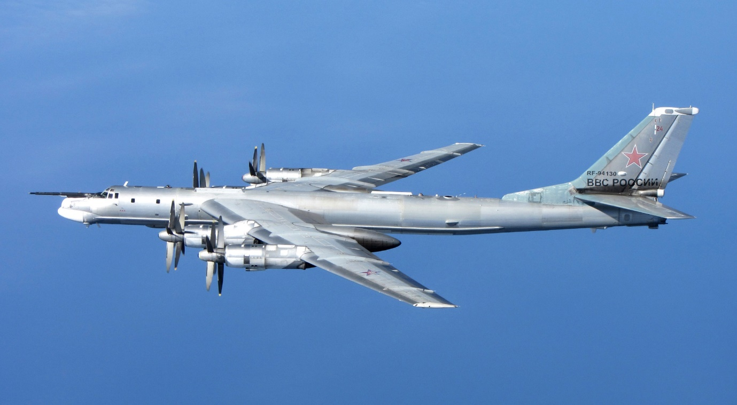

[**Twice Red Banner Baltic Fleet**](https://www.ww2.dk/new/navy/BF.htm): This is the smallest air command in the Navy and it is much less reliant on Long Range Aviation that the other fleets. In the confined area of the Baltic, naval aviation is very much the junior partner and needs to integrate its operations with the 15th, 26th and 76th Air Armies of the VVS as well as the PVO forces of Leningrad Military District, 2nd and 6th Air Defence Armies; this is a very complex air-space. Most of the coordination is done at the **High Command of the Western Direction** although the Baltic Fleets activities are mostly supporting the Army, they have a focus on ASW within the Baltic and supporting amphibious operations to allow surface forces to break out into the Atlantic.

|  |  |  |  |  |  |
| --- | --- | --- | --- | --- | --- |
| Division | Regiment | Location | Number | Aircraft type | Remarks |
| Baltic Fleet | 15th OMDRAP | Chkalovsk | 6 | Su-24MR |  |
|  |  |  | 4 | Su-24MP |  |
|  | 846th RB OMRAP | Chkalovsk | 32 | Su-24M |  |
|  | 745th OShPLAP | Donskoye | 40 | Ka-27/Ka-29 |  |
|  | 49th OPLAS | Khrabrovo | 8 | Be-12 |  |
|  |  |  | 24 | Mi-14 |  |
|  | 145th OPLAS DD | Riga-Skulte | 8 | Il-38 |  |
|  | 170th OMRAP | Bykhov | 18 | Tu-22M3 |  |
|  | OTAP | Khrabrovo | 24 | An-24 |  |
|  |  |  | 8 | An-26 |  |
|  |  |  | 24 | An-12 |  |
|  |  |  | 2 | Tu-134 |  |
|  | 9th Gds ODRAP |  | 12 | Tu-95RTS |  |
| VVS 132nd Bmbr | 4th Gds Mar Aslt | Chernyakhovsk | 29 | Su-24M |  |
|  | 321st Mar Aslt | Suurkyul | 29 | Su-24M |  |
|  | 668th Mar Aslt | Tukums | 30 | Su-24M |  |

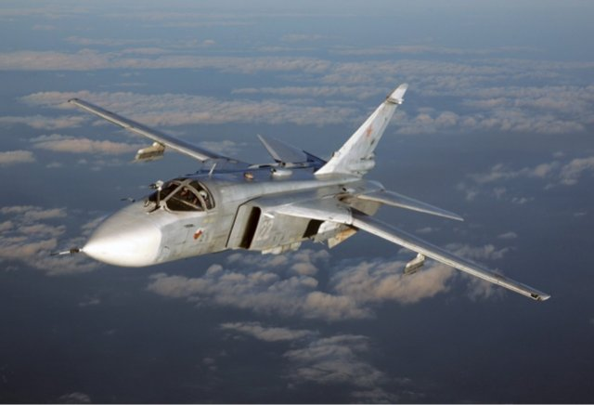

[**Red Banner Black Sea Fleet**](https://www.ww2.dk/new/navy/CHF.htm): The naval aviation in the Black Sea Fleet have the difficult problem of Turkey to deal with in its operations. Supporting amphibious operations to break out of the Black Sea is the primary focus but providing reconnaissance and long range aviation to units in the Mediterranean is also a major task. In both cases close coordination is required with the PVO 19th Air Defence Army and the 34th Air Army of the VVS.

|  |  |  |  |  |  |
| --- | --- | --- | --- | --- | --- |
| Division | Regiment | Location | Number | Aircraft type | Remarks |
| 2nd Guards | 5th Guards | Veseloye | 24 | Tu-22M3 |  |
|  |  |  | 16 | Tu-16SPS |  |
|  | 124th MRAP | Gvardeskoye | 24 | Tu-16K-10-26 |  |
|  |  |  | 6 | Tu-16K-10-26P |  |
|  | 943rd MRAP | Oktyabrskoye | 24 | Tu-22M3 |  |
|  |  |  | 5 | Tu-22M3R |  |
|  |  |  | 8 | Tu-16P Buket |  |
| Black Sea Fleet | 318th OTAP | Kacha | 8 | Be-12 |  |
|  |  |  | 24 | Mi-14 |  |
|  | 30th RB OMRAP |  | 24 | Tu-22M3 |  |
|  |  |  | 4 | Tu-22MP |  |
|  |  |  | 4 | Tu-22MR |  |
|  | 78th OShPLAP | Donuzlav | 40 | Ka-27/Ka-29 |  |
|  | 872nd OShPLAP | Kacha | 16 | Mi-8 |  |
|  | 917 OSAP | Kacha | 24 | An-24 |  |
|  |  |  | 8 | An-26 |  |
| VVS 29th Ftr-Bmbr | 43rd Ftr-Bmbr | Gvardeyskoye | 43 | Su-17M3 |  |

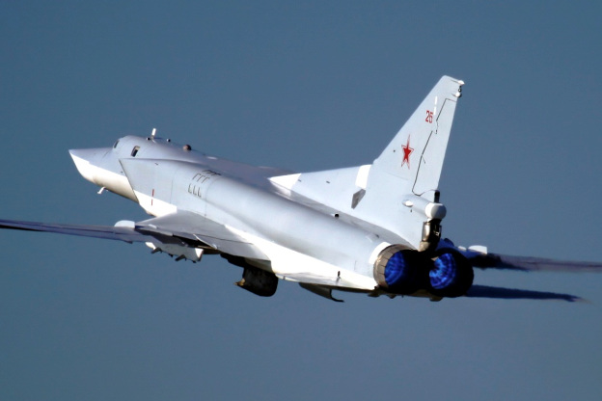

[**High Command of the Navy**](https://www.ww2.dk/new/navy/VMF.htm): Although Navy pilots and some technicians attend VVS schools, the primary responsibility for training, particularly for ASW and shipborne operations falls to the High Command of the Navy which operates many schools, academies and training centers. The establishments with aircraft are listed here.

|  |  |  |  |  |  |
| --- | --- | --- | --- | --- | --- |
| Division | Regiment | Location | Number | Aircraft type | Remarks |
| 1063rd Trg Ctr | 299th IIShSAP | Saki | 36 | Su-25 |  |
|  |  | Severomorsk-3 | 18 | Su-33 | Replacement |
|  |  |  | 36 | Yak-38U |  |
| 33rd Trg Ctr | 555th IISAP | Ochakov |  | Various | Instructor trg ASW |
|  | 540th IISAP | Nikolayev | 24 | Tu-22M3 | Instructor trg Bmr |
|  |  |  | 12 | Tu-16K-10-26 |  |
|  |  |  | 16 | Tu-16 |  |
|  | 316th OPLAP | Nikolayev | 8 | Be-12 |  |
| 44th Trg Ctr | 240th IISAP | Ostrov | 4 | T-22M3R |  |
|  |  |  | 4 | Su-24M |  |
|  |  |  | 2 | Tu-16K-10-26P |  |
|  | 327th OTAP | Ostafyevo | 22 | An-24 | Moscow |
|  |  |  | 8 | An-26 |  |
|  |  |  | 24 | An-12 |  |
|  |  |  | 4 | Il-76 |  |

