**Soviet Air Defence Force (PVO)**

The PVO or *voyska protivovozdushnoy oborony*, otherwise known as the ***voyska PVO***, or simply the ***V-PVO*** was responsible for the defence of Soviet airspace and in particular defence against NATO and specifically American bombers. [In the 1980s the responsibilities were broadened](https://fas.org/nuke/guide/russia/agency/pvo.htm) to include providing air superiority over concentrations of ground forces – especially along the Army’s main axis of advance and second echelon forces. The PVO is comprised of a significant Command & Control (C2) structure nine Air Defence (AD) Armies and two special zones: Leningrad Military District and the Moscow Air Defence District. Each of these formations has an extensive C2 network, early warning radars, electronic warfare (EW) systems, and a mix of Surface to Air Missile (SAM) units and fighter interceptor regiments. Below is a graphical depiction of the areas of responsibility for the AD formations in Northern Fury. In total the PVO operated over 3,800 aircraft with 2,600 of them being interceptors and the remainder being support, training and transport aircraft; additionally, almost 12,000 SAM systems are in use as well as hundreds of radar and EW sites.

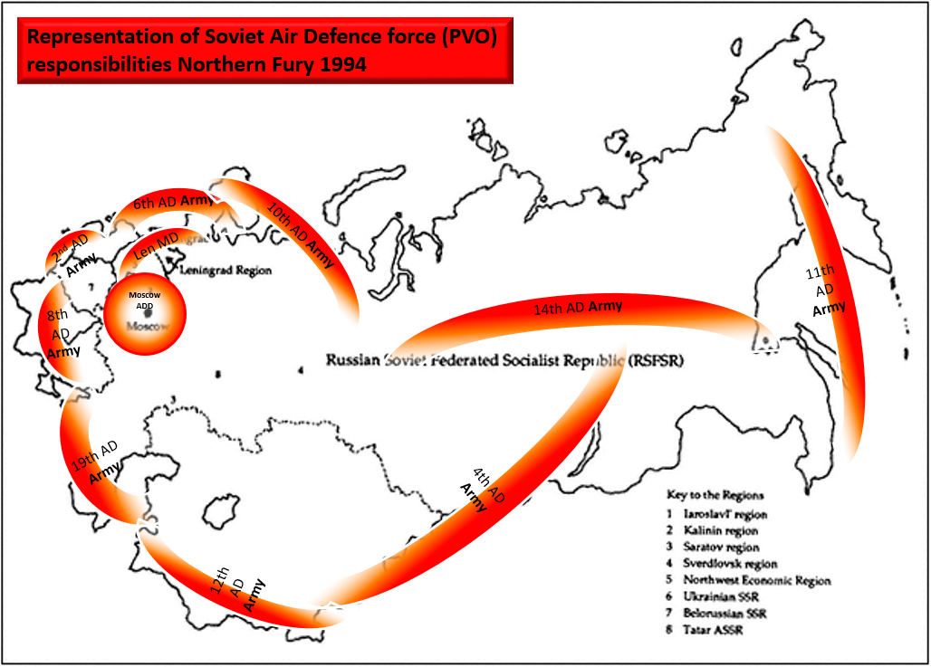

Organizationally each AD Army and the two districts are tailored to its specific task and the threats situation it faced.

[**2nd Independent Red Banner AD Army**](https://www.ww2.dk/new/pvo/2oapvo.htm)**:** With an HQ in Minsk this was re-activated in 1986, probably in response to the reorganization of forces and broadening of responsibilities, it is ideally positioned to provide air superiority forces to any conflict with NATO. Most of the SAMs in the Missile Brigades are of the very modern S-300 type, while it is unlikely that US Strategic bombers would be a major threat so there are no pure interceptors but much more agile fighter types able to engage with F-111, Tornados or Mirage IV, eventually all of the MiG-23s would be replaced by Su-27 but that will not happen for several years.

|  |  |  |  |  |  |
| --- | --- | --- | --- | --- | --- |
| Corps | Regiment | Location | Number | Aircraft type | Remarks |
| 11th AD Corps | 61st | Baranovichi | 38 | Su-27 |  |
|  | 201st | Machulishchi | 38 | MiG-23MLD |  |
|  |  |  |  |  | 6x AA Missile Bdes |
|  |  |  |  |  | 2x Tech Bds |
| 28th AD Corps | 179th | Stryy | 43 | MiG-23MLD |  |
|  | 894th | Ozernoye | 38 | MiG-23MLD |  |
|  |  |  |  |  | 6x AA Missile Bdes |
|  |  |  |  |  | 1x Tech Bde |
|  |  |  |  |  | 1x EW Bde |
| Army Units | 25th Ind Tpt Sqn | Machulischi |  | Mixed Tpt |  |

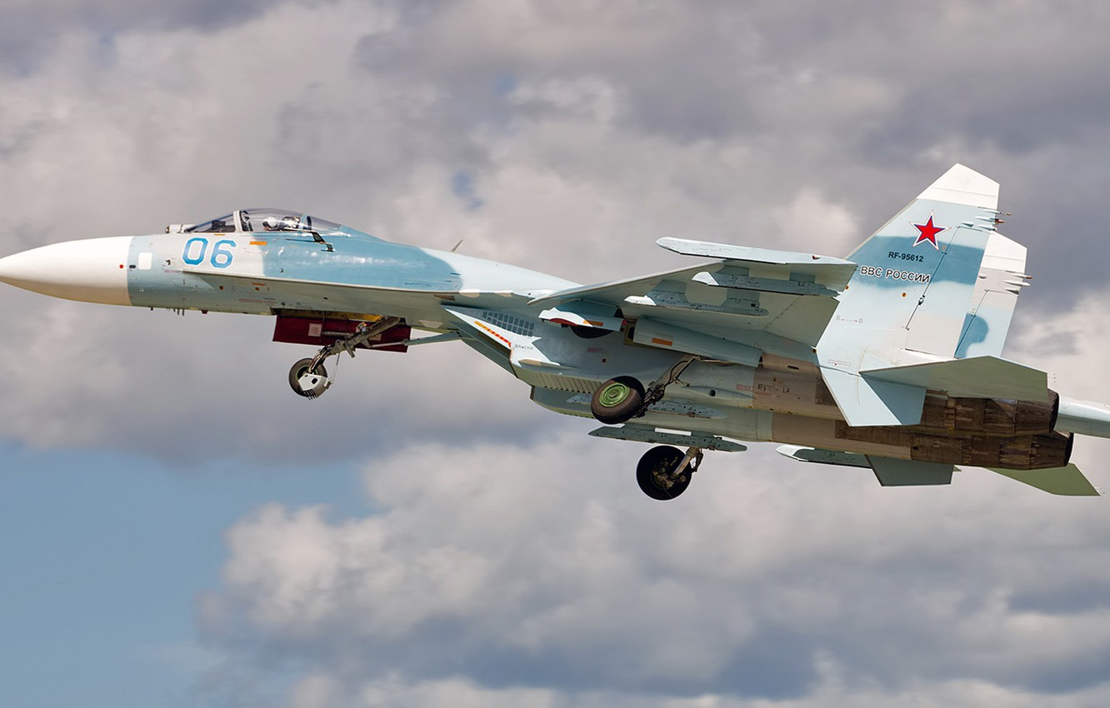

[**4th Independent Red Banner AD Army**](https://www.ww2.dk/new/pvo/4oapvo.htm)**:** Mostly responsible for threats emanating from China, and covering a very wide area so this force has more of an intercept role relying on MiG-25 and MiG-31 as well as older SAM systems (SA-2, SA-5). Some older MiG-23s have been replaced with hand-me-down MiG-25s (412th & 765th Regt). This Army is quite dispersed so relies on Division structures rather than more centralized Corps.

|  |  |  |  |  |  |
| --- | --- | --- | --- | --- | --- |
| Division | Regiment | Location | Number | Aircraft type | Remarks |
| 28th AD Div | 681st | Danilovo | 38 | MiG-23MLD |  |
|  | 683rd | Bobrovka | 38 | MiG-23MLD |  |
|  |  |  |  |  | 1x AA Missile Bdes |
|  |  |  |  |  | 5x AA Missile Regt |
|  |  |  |  |  | 1x Tech Bde |
| 90th AD Div | 412th | Dombarovskiy | 38 | MiG-25PD/PDS |  |
|  |  |  |  |  | 1x AA Missile Bdes |
|  |  |  |  |  | 5x AA Missile Regt |
|  |  |  |  |  | 2x Tech Bde |
| 91st AD Div | 763rd | Yugorsk-2 | 30 | MiG-31 |  |
|  |  |  | 6 | MiG-25U |  |
|  | 764th | Bolshoye | 32 | MiG-31 |  |
|  | 765th | Salka | 38 | MiG-25PD/PDS |  |
|  |  |  |  |  | 2x AA Missile Bdes |
|  |  |  |  |  | 6x AA Missile Regt |
|  |  |  |  |  | 1x Tech Bde |
|  |  |  |  |  | 2x Tech Regts |

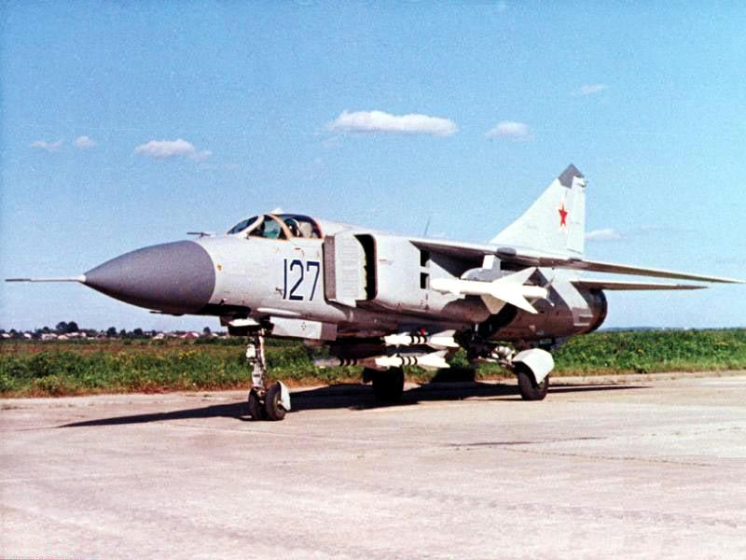

[**6th Independent Red Banner AD Army**](https://www.ww2.dk/new/pvo/6oapvo.htm): Probably the most complex area of any AD Army, the 6th covers Karelia facing Finland, the Baltics and the northern approach to Moscow. Most of the SAM systems are the most modern available and the aircraft are a mix between fighters and interceptors. The 892nd Regt was reactivated in 1993 and is destined to receive Su-27s but is currently outfitted with the antiquated Su-15s.

|  |  |  |  |  |  |  |
| --- | --- | --- | --- | --- | --- | --- |
| Corps | Division | Regiment | Location | Number | Aircraft type | Remarks |
| 27th AD Corps |  | 54th Gds | Savostleyka | 38 | MiG-25PD/PDS |  |
|  |  | 698th Gds | Nivenskoye | 36 | Su-27 |  |
|  |  | 892nd | Nivenskoye | 40 | Su-15TM |  |
|  |  |  |  |  |  | 8x AA Missile Bdes |
|  |  |  |  |  |  | 2x Tech Bds |
| 54th AD Corps |  | 57th Gds RB | Norilsk | 31 | MiG-31M/SM |  |
|  |  |  |  |  |  | 5x AA Missile Regt |
|  |  |  |  |  |  | 2x Tech Bds |
| Independent | 14th AD | 425th | Haapsalu | 38 | MiG-23MLD |  |
|  |  | 655th | Pyarnu | 42 | MiG-23MLD |  |
|  |  | 656th | Tapa | 38 | MiG-23MLD |  |
|  |  |  |  |  |  | 5x AA Missile Bdes |
|  |  |  |  |  |  | 4x AA Missile Regt |
|  |  |  |  |  |  | 2x Tech Bds |

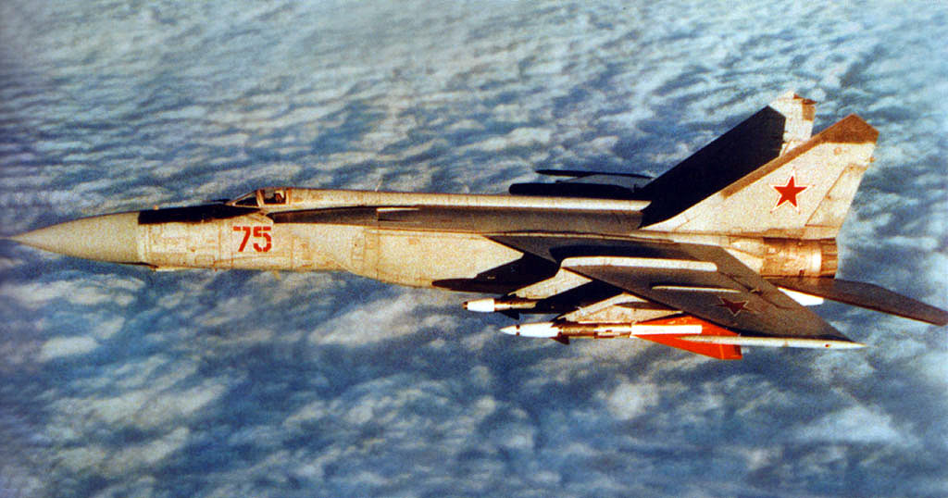

[**8th Independent AD Army**](https://www.ww2.dk/new/pvo/8oapvo.htm): Covering the south western approaches over the Black Sea and threats from the Mediterranean region, this army is unlikely to provide air superiority tasks and has significant tactical air forces in the area able to handle any fighter threat. Therefore the key vulnerability from this approach is cruise missiles and potentially long range bombers coming in over Turkey. Most of the SAM systems are the modern S-300 type but there are some older models as well. The weakness in this formation are two regiments of Su-15s which will offer very limited capability against a modern threat.

|  |  |  |  |  |  |
| --- | --- | --- | --- | --- | --- |
| Corps | Regiment | Location | Number | Aircraft type | Remarks |
| 49th AD Corps | 636th Gd | Kramatorsk | 39 | Su-15TM |  |
|  | 933rd | Dnepropetrovsk | 38 | MiG-25PD/PDS |  |
|  | 146th | Vasilkov | 38 | MiG-25PD/PDS |  |
|  |  |  |  |  | 8x AA Missile Bdes |
|  |  |  |  |  | 2x Tech Bds |
| 60th AD Corps | 62nd | Balbek | 39 | Su-15TM |  |
|  | 738th | Zaporoshye | 38 | MiG-25PD/PDS |  |
|  |  |  |  |  | 6x AA Missile Bdes |
|  |  |  |  |  | 2x AA Missile Regt |
|  |  |  |  |  | 2x Tech Bds |
| Army Units | 498th Trg Msl Bde | Opotchka |  |  |  |
|  |  |  |  |  |  |

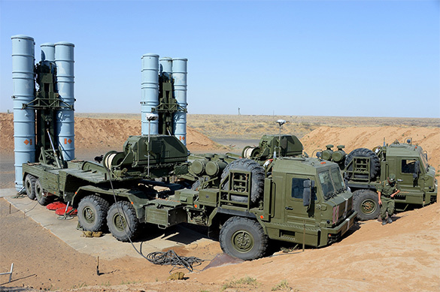

[**10th Independent AD Army**](http://www.ww2.dk/new/pvo/10oapvo.htm): The AD Army with the largest threat of defending against American bombers was the 10th maintained watch from the Kola Peninsula to the Kara Sea, about 1,000 Km of coastline in the high Arctic on a direct route from North America to Moscow. Relying mostly on its four regiments of modernized MiG-31 and another four of older MiG-25. The regiment of Su-27 will likely be involved in air superiority missions in northern Norway and the aging Su-15s will form a backstop of questionable value until replaced by MiG-31s in the coming year. The SAM units are all of the most modern types and concentrated on the Kola Peninsula.

|  |  |  |  |  |  |  |
| --- | --- | --- | --- | --- | --- | --- |
| Corps/Army | Division | Regiment | Location | Number | Aircraft type | Remarks |
|  | 4th AD Div | 72nd | Savatiya-Kotlas | 30 | MiG-31M/SM |  |
|  |  | 641st | Afrikanda | 38 | MiG-25PD/PDS |  |
|  |  |  |  |  |  | 1x AA Missile Bdes |
|  |  |  |  |  |  | 1x Tech Bds |
| 21st AD Corps |  | 174th Gds | Monchegorsk | 32 | MiG-31M/SM |  |
|  |  | 431st RB | Afrikanda | 38 | MiG-25PD/PDS |  |
|  |  | 941st | Kilp-Yavr | 38 | Su-27 |  |
|  |  |  |  |  |  | 4x AA Missile Bdes |
|  |  |  |  |  |  | 1x AA Missile Regt |
|  |  |  |  |  |  | 1x Tech Bde |
|  |  |  |  |  |  | 1x EW Bde |
|  | 5th AD Div | 57th Gds RB | Norilsk-Alykel | 30 | MiG-31M/SM |  |
|  |  | 265th | Poduzhemye | 39 | Su-15TM |  |
|  |  |  |  |  |  | 1x AA Missile Regt |
|  |  |  |  |  |  | 2x Tech Regts |
| 23rd RB AD Corps |  | 518th | Talagi | 30 | MiG-31M/SM |  |
|  |  | 524th | Letneozersk | 38 | MiG-25PD/PDS |  |
|  |  | 445th | Savatiya-Kotlas | 38 | MiG-25PD/PDS |  |
|  |  |  |  |  |  | 2x AA Missile Bdes |
|  |  |  |  |  |  | 1x AA Missile Regt |
|  |  |  |  |  |  | 1x Tech Bde |
|  |  |  |  |  |  | 1x Tech Regt |

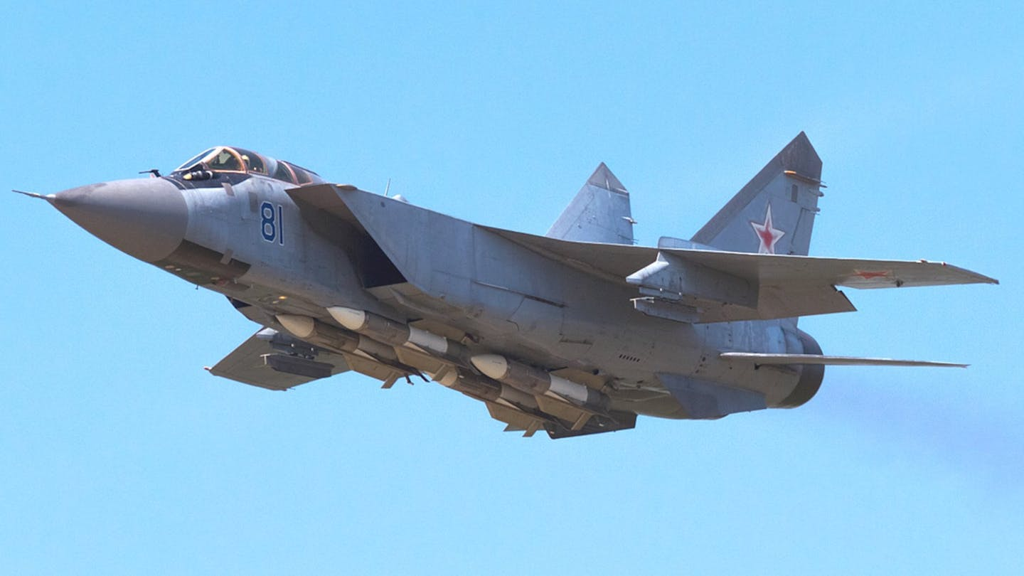

[**11th Independent Red Banner AD Army**](http://www.ww2.dk/new/pvo/11oapvo.htm): The largest AD Army, the 11th protects the Soviet Far East from attack covering from Vladivostok to the Bering Strait, a distance of 4,500 km, with a total of 12 regiments of aircraft and 24 brigades or regiments of SAMs. The threat from this axis is low however and correspondingly, over half this force is quite dated and bordering on obsolete, the older MiG-23s are little better as fighters than the Su-15s are as interceptors.

|  |  |  |  |  |  |  |
| --- | --- | --- | --- | --- | --- | --- |
| Corps/Army | Division | Regiment | Location | Number | Aircraft type | Remarks |
| 8th RB AD Corps |  | 60th | Dzemgi | 38 | Su-27 |  |
|  |  | 301st | Kalinka | 38 | MiG-23P |  |
|  |  | 308th | Postovaya | 38 | MiG-23P |  |
|  |  |  |  |  |  | 3x AA Missile Bdes |
|  |  |  |  |  |  | 1x AA Missile Regt |
|  |  |  |  |  |  | 1x Tech Bde |
|  |  |  |  |  |  | 3x Tech Regt |
| 23rd AD Corps |  | 22nd Gds | Tsentralnaya | 38 | Su-27 |  |
|  |  | 47th | Zolotaya Dolina | 38 | MiG-25PD/PDS |  |
|  |  | 530th | Chuguevka | 30 | MiG-31M/SM |  |
|  |  | 821st | Spassk-Dalniy | 38 | MiG-23P |  |
|  |  |  |  |  |  | 4x AA Missile Bdes |
|  |  |  |  |  |  | 2x AA Missile Regt |
|  |  |  |  |  |  | 1x Tech Bde |
|  |  |  |  |  |  | 1x Tech Regt |
| 72nd AD Corps |  | 41st | Burevestnik | 38 | MiG-23ML |  |
|  |  | 528th | Smirnykh | 38 | MiG-23ML |  |
|  |  | 777th | Sokol-Dolinsk | 30 | MiG-31M/SM |  |
|  |  | 865th | Yelizovo | 30 | MiG-31 |  |
|  |  |  |  |  |  | 1x AA Missile Bdes |
|  |  |  |  |  |  | 3x AA Missile Regt |
|  |  |  |  |  |  | 5x Tech Regt |
| Army Troops | 25th AD Div | 171st | Ugolny Kopi | 39 | Su-15TM |  |
|  |  |  |  |  |  | 2x AA Missile Regt |
|  |  |  |  |  |  | 1x Tech Bde |
|  | 29th AD Div |  |  |  |  | 1x AA Missile Bdes |
|  |  |  |  |  |  | 3x AA Missile Regt |
|  |  |  |  |  |  | 1x Tech Regt |
|  |  | 167th Mixed Avn | Khabarovsk |  |  |  |

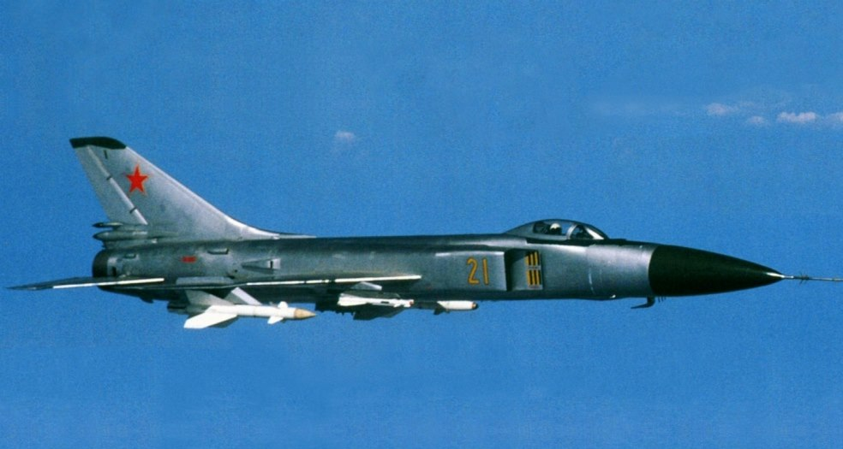

[**12th Independent AD Army**](http://www.ww2.dk/new/pvo/12oapvo.htm): Concentrated in the southern ‘Stans’ (Turkmenistan, Uzbekistan, Tajikistan and Kyrgyzstan) facing Iran and Afghanistan, the primary threat facing this force is from Pakistan as both Iran and India are allies and Afghanistan is still in turmoil after the ten-year occupation by the Soviet Army. The two regiments of MiG-25s however will be useful on the off chance that American bombers attempted to infiltrate through the Hindukush mountains. The SAM forces in this army are mostly older types.

|  |  |  |  |  |  |  |
| --- | --- | --- | --- | --- | --- | --- |
| Corps/Army | Division | Regiment | Location | Number | Aircraft type | Remarks |
| 37th AD Corps |  | 737th | Chervonoglinskoye | 36 | MiG-23P |  |
|  |  |  |  |  |  | 3x AA Missile Bdes |
|  |  |  |  |  |  | 1x Tech Bds |
|  | 15th AD Div | 9th Gds | Andizhan | 38 | Su-27 |  |
|  |  |  |  |  |  | 2x AA Missile Bdes |
|  |  |  |  |  |  | 3x AA Missile Regt |
|  |  |  |  |  |  | 1x Tech Bde |
|  |  |  |  |  |  | 1x Tech Regt |
|  | 17th AD Div | 152nd | Ak-Tepe | 38 | MiG-25PD/PDS |  |
|  |  | 179th Gds | Nebit-Dag | 40 | MiG-23M |  |
|  |  | 364th | Nebit-Dag | 38 | MiG-25PD/PDS |  |
|  |  |  |  |  |  | 4x AA Missile Regt |
|  |  |  |  |  |  | 2x Tech Bde |

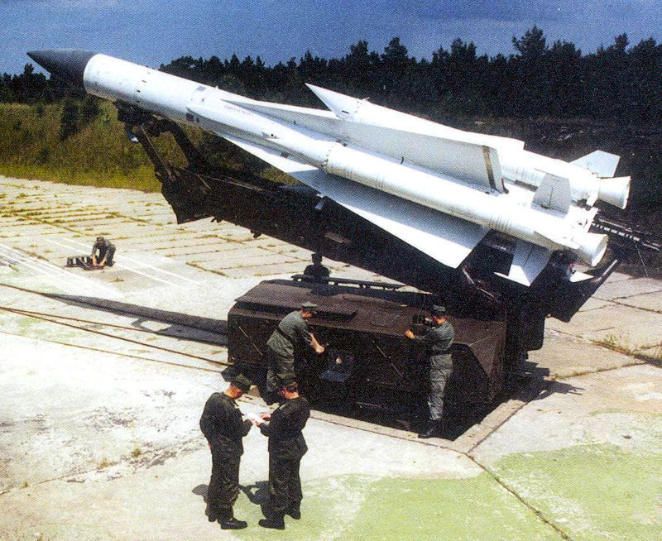

[**14th Independent AD Army**](http://www.ww2.dk/new/pvo/14oapvo.htm): Patrolling the Siberian region this army is the second most likely to encounter American Strategic bombers and is therefore equipped with very modern systems. Three of the four MiG-31 regiments are modernized SM variants and many of the SAM systems are S-300s. Most of this force however is deployed far to the south, along the Trans-Siberian railway protecting the link to the Far East from attack from both the north and China to the south. In times of higher threat, the aircraft would deploy to a number of dispersal bases to the north.

|  |  |  |  |  |  |  |
| --- | --- | --- | --- | --- | --- | --- |
| Corps/Army | Division | Regiment | Location | Number | Aircraft type | Remarks |
| 38th AD Corps |  | 849th | Kupino | 38 | MiG-23P |  |
|  |  |  |  |  |  | 2x AA Missile Bdes |
|  |  |  |  |  |  | 7x AA Missile Regt |
|  |  |  |  |  |  | 1x Tech Bde |
|  |  |  |  |  |  | 1x Tech Regt |
| 50th Gds AD Corps |  | 22nd | Bezrechnaya | 38 | MiG-25PD/PDS |  |
|  |  | 350th | Bratsk | 30 | MiG-31M/SM |  |
|  |  |  |  |  |  | 1x AA Missile Bdes |
|  |  |  |  |  |  | 2x AA Missile Regt |
|  |  |  |  |  |  | 1x Tech Bde |
|  |  |  |  |  |  | 2x Tech Regt |
| 56th AD Corps |  | 64th | Omsk-Severnyy | 31 | MiG-31M/SM |  |
|  |  | 336th | Karaganda | 30 | MiG-31 |  |
|  |  |  |  |  |  | 4x AA Missile Regt |
|  |  |  |  |  |  | 2x Tech Regt |
| Army Tps | 22nd AD Div |  |  |  |  | 2x AA Missile Regt |
|  |  |  |  |  |  | 2x Tech Regt |
|  | 94th AD Div | 712th | Kansk | 36 | MiG-31M/SM |  |
|  |  |  |  |  |  | 3x AA Missile Regt |
|  |  |  |  |  |  | 2x Tech Regt |
|  |  | 197th Ind Tpt | Novosibirsk |  |  |  |

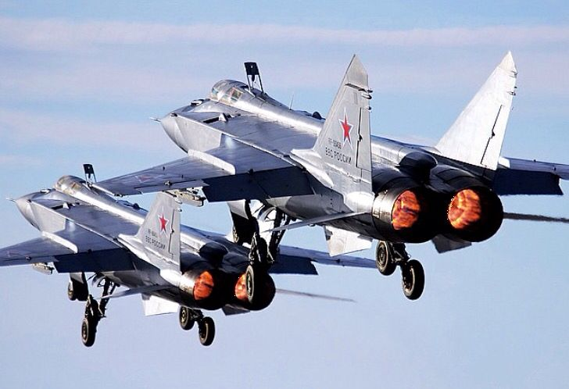

[**19th Independent Red Banner AD Army**](http://www.ww2.dk/new/pvo/19oapvo.htm)**:** Concentrated in the Caucuses facing Turkey and Iran, this army’s role is to guard the southern approach to Moscow by intercepting bomber and cruise missile attacks emanating from the Mediterranean or Red Seas and perhaps from the Indian Ocean. With seven regiments of interceptors, mostly MiG-25, and 21 SAM brigades/regiments in a relatively small area this should not be a problem.

|  |  |  |  |  |  |  |
| --- | --- | --- | --- | --- | --- | --- |
| Corps/Army | Division | Regiment | Location | Number | Aircraft type | Remarks |
| 12th AD Corps |  | 83rd | Rostov-na-Don | 38 | MiG-25PD/PDS |  |
|  |  | 562nd | Krymsk | 38 | MiG-25PD/PDS |  |
|  |  | 393rd Gds | Krymsk | 38 | MiG-25PD/PDS | Upgr from MiG-23 |
|  |  |  |  |  |  | 3x AA Missile Bdes |
|  |  |  |  |  |  | 5x AA Missile Regt |
|  |  |  |  |  |  | 1x Tech Bde |
|  |  |  |  |  |  | 2x Tech Regt |
| Army Tps | 10th RB AD Div | 767th | Marinovka | 39 | Su-15TM |  |
|  |  |  |  |  |  | 1x AA Missile Bde |
|  |  |  |  |  |  | 4x AA Missile Regt |
|  |  |  |  |  |  | 2x Tech Regt |
|  | 96th AD Div | 166th Gds | Marneuli | 38 | MiG-25PD/PDS |  |
|  |  | 529th | Gudauta | 38 | MiG-25PD/PDS |  |
|  |  |  |  |  |  | 3x AA Missile Bdes |
|  |  |  |  |  |  | 2x AA Missile Regt |
|  |  |  |  |  |  | 2x Tech Bde |
|  | 97th AD Div | 82nd | Nasosnaya | 30 | MiG-31M/SM |  |
|  |  |  |  |  |  | 2x AA Missile Bdes |
|  |  |  |  |  |  | 1x AA Missile Regt |
|  |  |  |  |  |  | 1x Tech Bde |

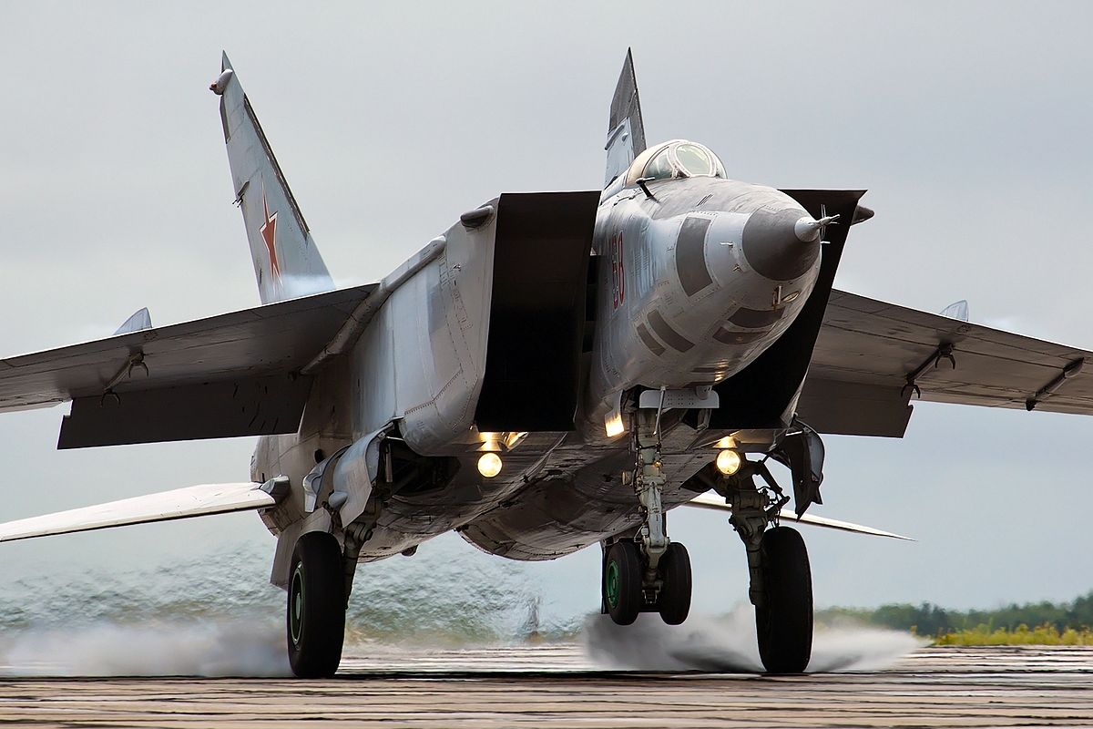

[**Leningrad Military District**](http://www.ww2.dk/new/pvo/18kpvo.htm): The Leningrad Military District is not part of the PVO, however, the 18th Red Banner Air Defence Corps does belong to the PVO. In fact, there were several organizational changes in the 1970s and 80’s but when the PVO re-established the 6th AD Army, the 18th AD Corps (In Northern Fury) remained in Location to defend Leningrad and was therefore independent of any AD Army.

|  |  |  |  |  |  |
| --- | --- | --- | --- | --- | --- |
| Corps/Army | Regiment | Location | Number | Aircraft type | Remarks |
| 18th RB AD Corps | 177th | Lodeynoye | 38 | MiG-23MLD |  |
|  | 180th Gds | Gromovo | 31 | MiG-31M/SM |  |
|  |  |  |  |  | 5x AA Missile Bde |
|  |  |  |  |  | 5x AA Missile Regt |
|  |  |  |  |  | 1x Tech Bde |

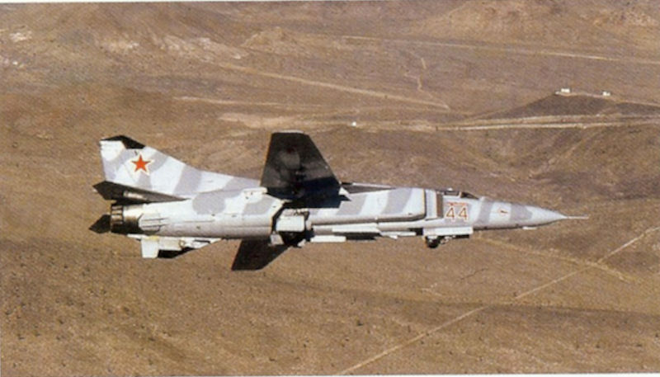

[**Moscow Order of Lenin Air Defence District**](http://www.ww2.dk/new/pvo/mopvo.htm): It is probably not an exaggeration to say that Moscow is the most heavily defended city in the world. As a separate AD command this district is larger than most of the AD Armies with four interceptor and six fighter regiments plus 41 SAM brigades/regiments.

|  |  |  |  |  |  |  |
| --- | --- | --- | --- | --- | --- | --- |
| Corps/Army | Division | Regiment | Location | Number | Aircraft type | Remarks |
| 1st AD Army | 86th AD Div |  | Vidnoye |  |  | 5x AA Missile Regt |
|  |  |  |  |  |  | 1x Tech Regt |
|  | 87th AD Div |  | Balashikha |  |  | 4x AA Missile Regt |
|  |  |  |  |  |  | 1x Tech Regt |
|  | 88th AD Div |  | Dolgoprudnyy |  |  | 5x AA Missile Regt |
|  |  |  |  |  |  | 1x Tech Regt |
|  | 89th AD Div |  | Odintsovo |  |  | 5x AA Missile Regt |
|  |  |  |  |  |  | 1x Tech Regt |
| 2nd AD Corps |  | 28th | Krichev | 38 | MiG-25PD/PDS |  |
|  |  | 28th Gds | Andreapol | 38 | MiG-23M/P |  |
|  |  | 401st | Stryy | 38 | MiG-23M/P |  |
|  |  | 790th | Khotilovo | 38 | MiG-25PD/PDS |  |
|  |  |  |  |  |  | 4x AA Missile Regt |
|  |  |  |  |  |  | 1x Tech Bde |
| 3rd AD Corps |  | 475th | Tunoshna | 38 | MiG-23P |  |
|  |  | 611th | Bezhetsk | 38 | MiG-25PD/PDS |  |
|  |  |  |  |  |  | 1x AA Missile Bde |
|  |  |  |  |  |  | 8x AA Missile Regt |
|  |  |  |  |  |  | 1x Tech Bde |
|  |  |  |  |  |  | 1x Tech Regt |
| 7th AD Corps |  | 191st | Efremov | 38 | MiG-23P |  |
|  |  | 472nd | Kursk | 38 | MiG-23P |  |
|  |  |  |  |  |  | 4x AA Missile Regt |
|  |  |  |  |  |  | 1x Tech Bde |
|  |  |  |  |  |  | 1x Tech Regt |
| 16th AD Corps |  | 153rd | Morshansk | 30 | MiG-31M/SM |  |
|  |  | 786th | Pravdinsk | 31 | MiG-31M/SM |  |
|  |  |  |  |  |  | 1x AA Missile Bde |
|  |  |  |  |  |  | 4x AA Missile Regt |
|  |  |  |  |  |  | 1x Tech Bde |
|  |  |  |  |  |  | 1x Tech Regt |
|  |  | 436th Ind Tpt Avn | Stupino |  |  |  |

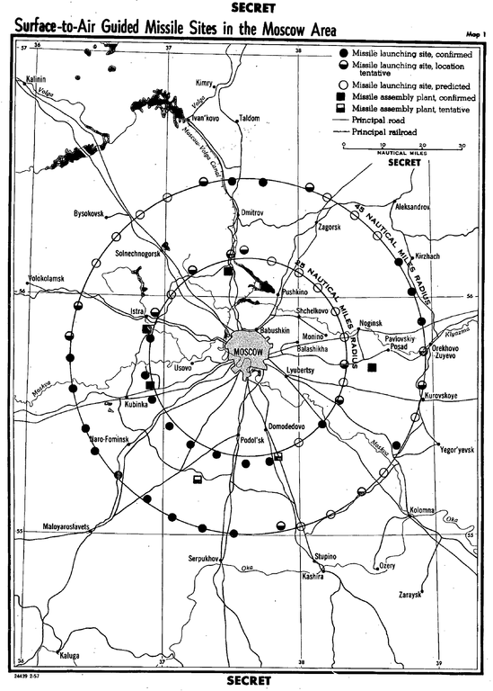

[**PVO Forces**](http://www.ww2.dk/new/pvo/pvostrany.htm): One of the main functions of forces directly under PVO control was training. The PVO operated many schools for technical training, an Officer academy and three flight training centers flying over 1,200 aircraft.

|  |  |  |  |  |  |
| --- | --- | --- | --- | --- | --- |
| Corps/Army | Regiment | Location | Number | Aircraft type | Remarks |
| Armavir Avn School | 627th Gds | Tikhoretsk | 84 | Aero L-39 |  |
|  | 709th | Maykop | 120 | MiG-21UM |  |
|  | 713th | Armavir | 151 | L-39 |  |
|  | 761st | Maykop | 84 | L-39 |  |
|  |  |  | 109 | L-29 |  |
| Stavropol Avn School | 218th | Salsk | 76 | MiG-23M/P |  |
|  | 382nd | Khankala | 90 | L-39 |  |
|  |  |  | 79 | L-29 |  |
|  | 700th | Tikhoretsk | 81 | Su-15 |  |
|  | 762nd | Kholodnogorsk | 100 | L-39 |  |
|  | 978th Ind Tpt | Klin/Moscow | 16 | Il-76 |  |
|  |  |  | 12 | An-12 |  |
|  |  |  | 2 | An-24 |  |
|  |  |  | 2 | An-26 |  |
|  |  |  | 2 | Tu-134 |  |
| 148th Ctr for retraining | 594th Trg | Savostleyka | 100 | MiG-21bis |  |
|  | 615th Trg | Savostleyka | 100 | MiG-21bis |  |
|  | 142nd Ind Tpt | Savostleyka |  | Various |  |

