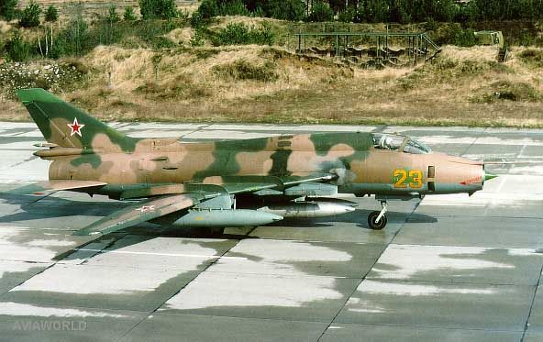

**[Su-17 ‘Fitter’](http://www.airvectors.net/avsu17_2.html" \l "m3)**

An evolutionary design based on the Su-7 ‘Fitter’ but with the addition of variable geometry wings, additional range and improved avionics. The Fitter-C was fielded in 1969, starting a long carrier as the mainstay Fighter-Bomber for the Soviet Air Force (VVS). In total 2,867 were produced including 1,165 Su-20 export versions used by 15 other nations.

**Su-17 ‘Fitter-B’:** All of the 224 baseline Su-17s are either in reserve or training roles.

**Su-17M ‘Fitter-C’:** Improved engines and increased range as well and ability to use newer weapons. 253 of these were built and all are currently in second line formations.

**Su-17M2 ‘Fitter-D’**: A longer version of the original with an early laser rangefinder and an automated navigation and attack computer. Range was increased and the ability to use early precision guided munitions (PGM) made this version much more useful. 220 of these are used in Naval Aviation Regiments including about 50 **Su-17M2R**, reconnaissance variants which are almost identical but have fittings for a reconnaissance pod.

**Su-17UM ‘Fitter-G’**: A dual cockpit trainer version with about 75 built.

**Su-17M3 ‘Fitter-H’**: Based on the two-seat ‘UM’ airframe with the second seat replaced by extra fuel and more avionics, this version had an internal Doppler radar and a laser rangefinder. New to the type as well was the ability to launch newer short rage air to air missiles. Over half of the production run was exported but the VVS retained 480 of this version for operations including some **Su-17M3R** reconnaissance variants;

**Su-17UM3 ‘Fitter-G’**: Another dual cockpit training variant, but this one was combat-capable. 165 were built but NATO still referred to it as the ‘Fitter-G’;

**Su-17M4 ‘Fitter-K’**: The last production version of this aircraft with improved avionics and electronics, a more powerful laser rangefinder, ability to use TV guided and anti-radiation munitions. When production terminated in 1990 the VVS was operating about 230 of this type including some **Su-17M4R** reconnaissance variants and a small number of **Su-17M4P** for SEAD (Suppression of Enemy Air Defence) missions.

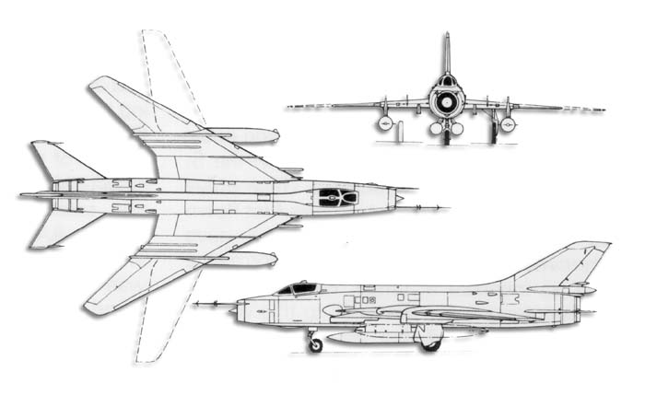

|  |  |  |  |  |
| --- | --- | --- | --- | --- |
| Version | VVS | Naval Avn | Training | Reserve |
| **Su-17 ‘Fitter-B’** |  |  |  | 224 (Mothballed) |
| **Su-17 ‘Fitter-C’** |  |  |  | 253 (2nd line) |
| **Su-17 ‘Fitter-D’** |  | 220 |  |  |
| **Su-17 ‘Fitter-G’** |  |  | 75+165 |  |
| **Su-17 ‘Fitter-H** | 480 |  |  |  |
| **Su-17 ‘Fitter-K’** | 230 |  |  |  |
| Totals | 710 | 220 | 240 | 477 |