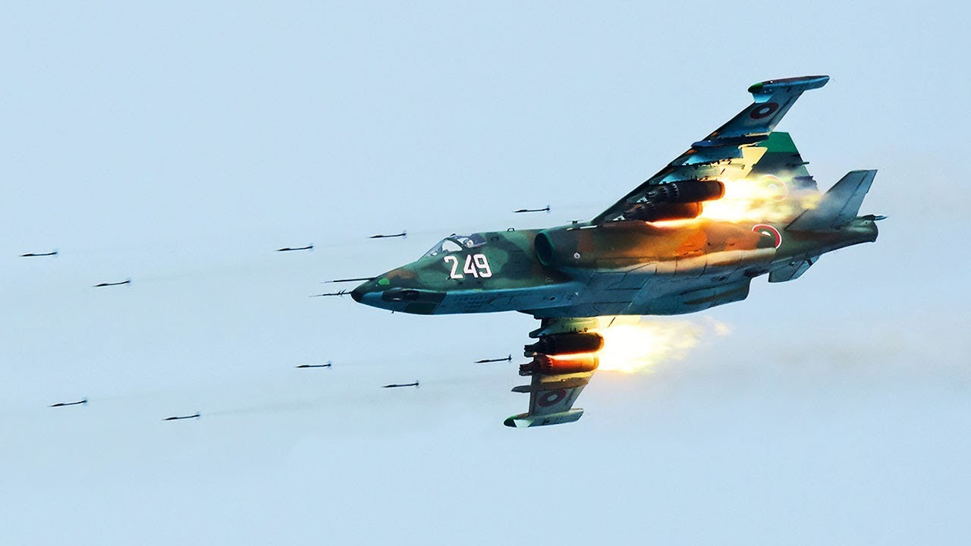

**[Su-25 ‘Frogfoot’](http://www.airvectors.net/avsu25.html)**

The Soviet answer to the American A-10 ‘Warthog’, drew on their long history of dedicated Close Air Support (CAS) aircraft primarily developed in World War Two. The Su-25 *Grach*, meaning Rook in Russian, is a rugged, dependable aircraft with a heavy bomb load and a wide variety of munitions. It is faster and more agile than the A-10 but don’t use Precision Guided Munitions (PGM) to the same degree. Like the A-10 the Frogfoot is able to withstand a considerable amount of damage and still fly.

**Su-25 ‘Frogfoot-A’:** A total of about 400 Su-25s were in use by the Soviet Air force (VVS), all in front line formations.

**Su-25BM ‘Frogfoot’:** The only difference between this aircraft and the baseline version were improved engines and the ability to tow a target. About 50 were produced.

**Su-25UB/UBM ‘Frogfoot-B’:** There were actually several training versions with this being the main one. About 50 single Seat and 130 dual seat ‘UBM’ fully combat capable trainer versions were built. Other training versions; the ‘UTG’ designed for aircraft carrier training (10) and several others were not combat capable.

**Su-25T ‘Frogfoot-C’:** Historically this aircraft was not produced, however in Northern Fury it was. This version was based on the ‘UB’ with the second cockpit removed to allow more fuel and avionics. With all weather and night attack capability and the ability to use TV and semi active laser guided munitions, the usefulness in the CAS role was significantly increased. In Northern Fury 150 of these are available and NATO has given them the Frogfoot-C designation even though that did not come until a much later version of this aircraft.

