**Soviet Support Aircraft**

**[An-30 Clank](https://en.wikipedia.org/wiki/Antonov_An-30)**

Developed from the An-24, the Clank is primarily used for mapping, geographic survey and reconnaissance – but has a secondary transport role. Of the 115 built, 23 have been sold to Bulgaria, China, Cuba, Czechoslovakia, Mongolia and Vietnam leaving 92 operating in the Soviet Air Force, mostly in reserve.

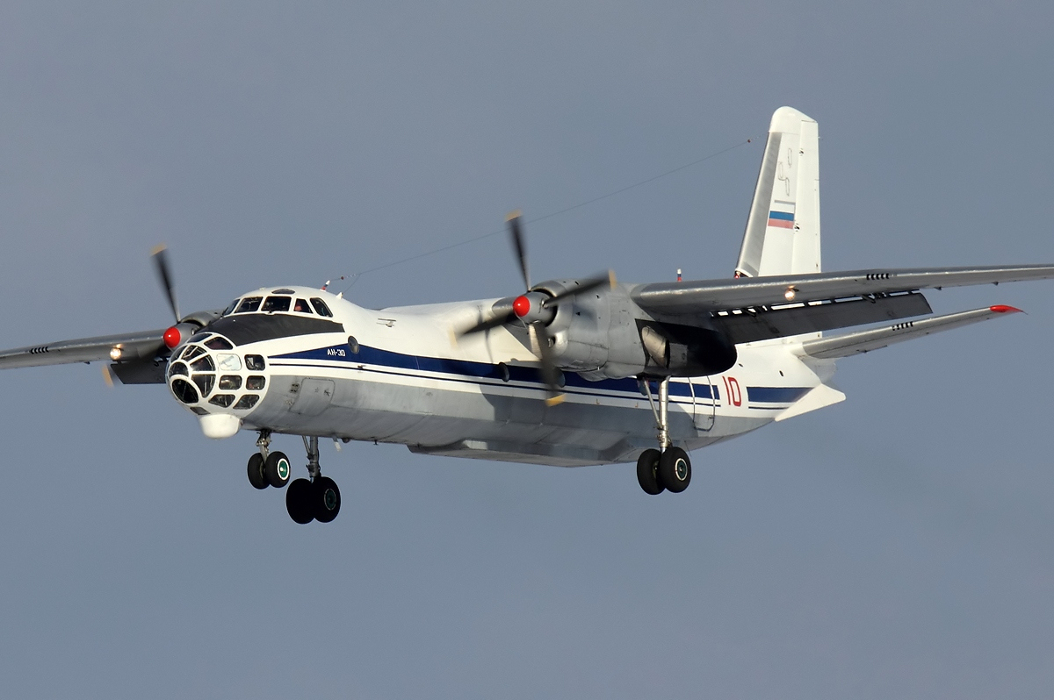

[**M-4 Bison Tanker**](https://www.airlinereporter.com/2015/05/nothing-stops-a-charging-bison/)

The M-4 Bison has been retired as a bomber but lives on in a support role as a tanker, extending the range of the bomber force as well as supporting some of the more modern fighters. About 70 M-4 3MS-2 Bison-B tankers are in service to support the fleet, not nearly enough by NATO standards but the Soviets seem content with that number.

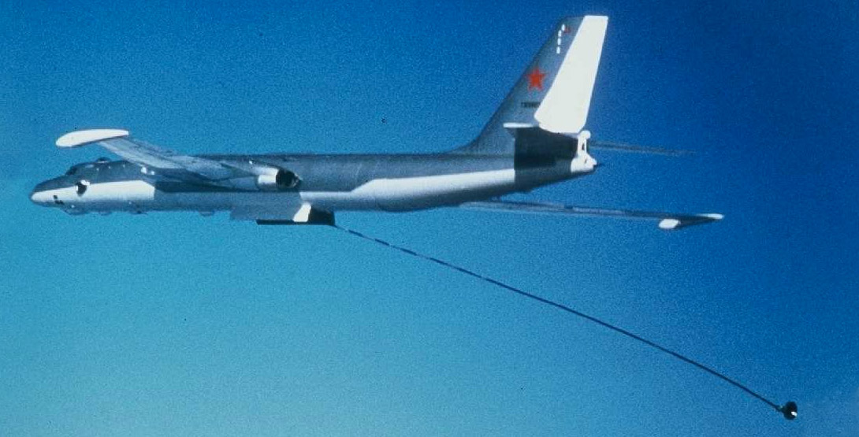

[**A-50M Mainstay**](https://en.wikipedia.org/wiki/Beriev_A-50)

Based on the successful transport design for the Il-76, about 40 airframes were transferred to the Beriev plant for conversion to an Airborne Early Warning & Airborne Contol aircraft (AWACs) similar in concept the E-3 Sentry in the west – but less capable. In Northern Fury there are 42 A-50s in service with more being produced at a rate of 2 per year. All have been upgraded to the ‘M’ standard meaning that they have a refueling probe.

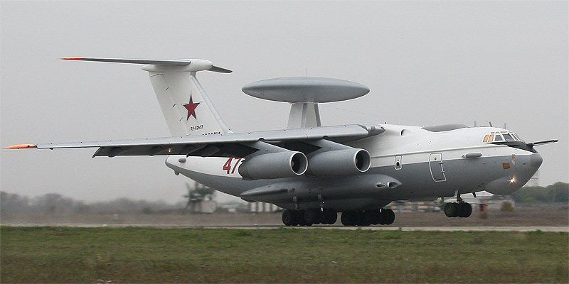

[**An-71 Madcap**](https://en.wikipedia.org/wiki/Antonov_An-71)

An AWACs aircraft used by the VVS and based on the An-72 Coaler transport. The project was canceled due to the fall of the Soviet Union and only 3 were built, but in Northern Fury there are 24 of these aircraft available.

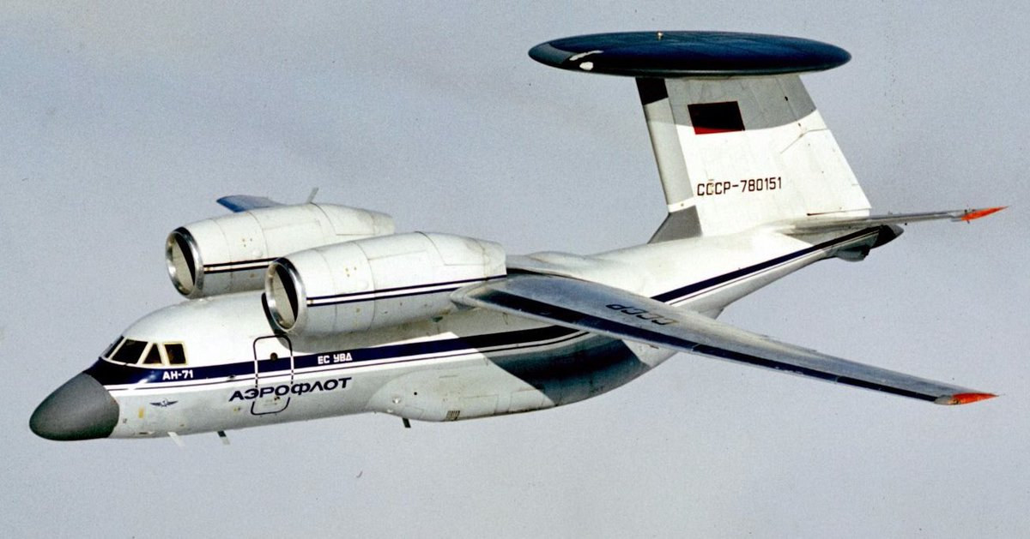

***the Air Force was divided into three aircraft based groups of units. They were the VVS-DA (Voenno-Vozdushnye Sily Dal'naya Aviatsiya) or Long Range Aviation (Bombers), the VVS-FA (Voenno-Vozdushnye Sily Frontovaya Aviatsiya) or Frontal Aviation (Fighters, Fighter Bombers and Attack aircraft), and the VVS-VTA (Voenno-Vozdushnye Sily Voenno-Transportnaya Aviatsiya) or Military Transport Aviation. The PVO (Voyska protivovozdushnoy oborony or Voyska PVO) which was the primary fighter / interceptor and surface-based defensive force was not part of the VVS; as a result, the A-50 Mainstay AWACS aircraft and its predecessor the Tu-126 Moss served exclusively with the Voyska PVO and did not assist in the direction of tactical aircraft. The An-71 was designed to be used overland to support the VVS-FA in tactical operations. This doctrine of each force having its own AWACS planes is contrary to most Western air forces' use of land based AWACS aircraft;***

[**Be-12 Mail**](https://en.wikipedia.org/wiki/Beriev_Be-12): A Turbo-prop flying boat designed for maritime reconnaissance, ASW, SAR and limited transport duties. For Northern Fury there are 60 Be-12s available, mostly supporting the Northern and Pacific fleets but it can also be found in the Baltic and Black Sea fleets.

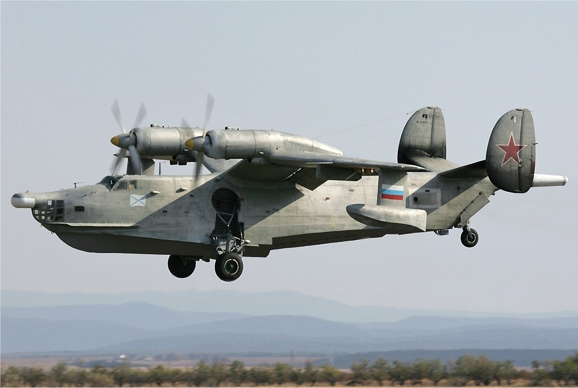

[**Il-80 Maxdome**](https://en.wikipedia.org/wiki/Ilyushin_Il-80): Based on the Il-86 airliner, these four aircraft have been heavily converted to act as airborne command and control centers in the event of nuclear war. They are specially fitted to survive radioactive and EMP (Electro Magnetic Pulse) effects and have extensive communications suites. In times of high tension one of these aircraft is always airborne and if nuclear war is imminent the President and other high level officials will be on board one of these aircraft.

