**Long Range Aviation**

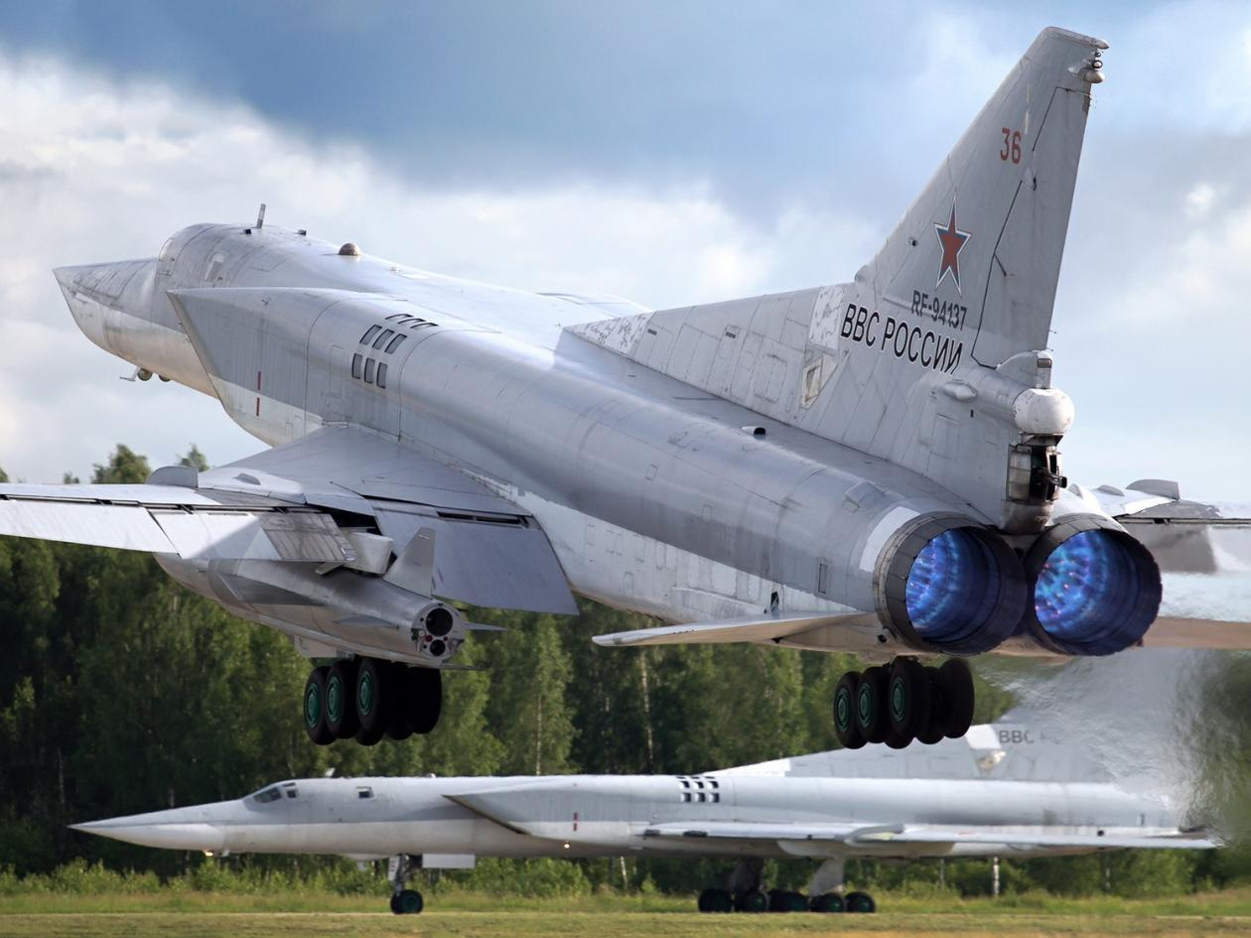

The long range bomber force is almost an air force of its own right, they exist as the part of the Armed Forces (VA) of the Supreme High Command (VGK) and because of the nuclear capability have a Strategic Purpose (SN). Thus the VA VKG (SN), similar to the US Strategic Air Command (SAC), operated with a degree of independence from the lager Air Force, prior to 1980 this was a separate air force (Long Range Aviation of the Armed Forces – DA VS) but now operates as a separate command administered by the Air Force (VVS) and controlled by the VKG. In total the force operates about 1,500 aircraft which includes about 1,000 bombers supported by reconnaissance, electronic warfare, and training versions of the bombers as well as transport assets for both cargo and personnel. Organized into three main Air Armies and the 6th Independent Corps the force in the Northern Fury world under the Medvedev regime has been refreshing its skills – always present – in using conventional rather than nuclear weapons, while maintaining its deterrence posture.

**30th Air Army**: The smallest and most remotely located air army, the 30th is in the Far East and is focused on strikes in China or Japan and the Pacific. Capacity to conduct maritime strike is a high priority as is working in conjunction with the Air Department of the Pacific Fleet.

|  |  |  |  |  |  |
| --- | --- | --- | --- | --- | --- |
| Division | Regiment | Location | Number | Aircraft type | Remarks |
| 31st | 1225th | Belaya | 12 | Tu-22M3 |  |
|  |  |  | 24 | Tu-22M2 |  |
|  |  |  | 8 | Tu-16 Elka |  |
|  | 1229th | Belaya | 36 | Tu-22M2 |  |
|  |  |  | 8 | Tu-16 Elka |  |
|  |  |  | 12 | Tu-16R |  |
| 55th | 303rd | Zavitinsk | 24 | Tu-16K-10 |  |
|  |  |  | 12 | Tu-16RM-1 |  |
|  | 444th | Vozdvizhenka | 24 | Tu-22M2 |  |
|  |  |  | 12 | Tu-16RM-1 |  |
|  | 219th LR Recon | Spassk-Dalniy | 8 | Tu-16P Buket |  |
|  |  |  | 16 | Tu-16R |  |
|  |  |  | 12 | Tu-22PD |  |
|  |  |  | 8 | Tu-16 Elka |  |

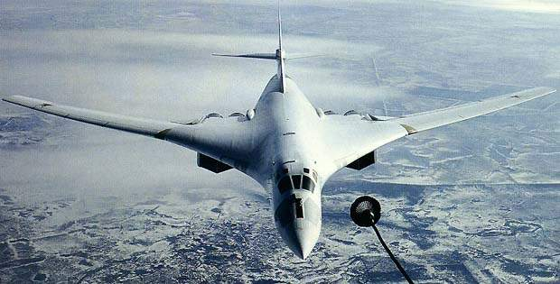

**37th Air Army:** Centrally located in proximity to Moscow this force is postured to strike either north over the Arctic or into the Atlantic or South through the Middle east and Balkans on targets in the Mediterranean or Indian Ocean area.

|  |  |  |  |  |  |
| --- | --- | --- | --- | --- | --- |
| Division | Regiment | Location | Number | Aircraft type | Remarks |
| 37th | 40th | Ukrainka | 24 | Tu-22M3 |  |
|  |  |  | 10 | Tu-16K-10-26B |  |
|  |  | Ukrainka | 36 | Tu-22RDM |  |
|  |  |  | 12 | Tu-22PD |  |
|  | 73rd |  | 42 | Tu-95MS |  |
| 79th | 1023rd | Dolon | 15 | Tu-95MS6 |  |
|  |  |  | 12 | Tu-16K-26 |  |
|  |  |  | 12 | Tu-16R |  |
|  |  |  | 5 | Tu-16RR |  |
|  | 1226th | Dolon | 15 | Tu-95MS6 |  |
|  |  |  | 12 | Tu-16K-26 |  |
|  |  |  | 11 | Tu-22PD |  |
| 106th | 409th | Uzin | 32 | Tu-95MS |  |
|  | 1006th | Uzin | 32 | Tu-95MS |  |
|  |  |  | 6 | Tu-16P Buket |  |
| Army Units | 230th Tanker | Engels | 36 | M-4 Bison |  |
|  | 43rd Tpt | Ostafevo | 25 | An-24 |  |

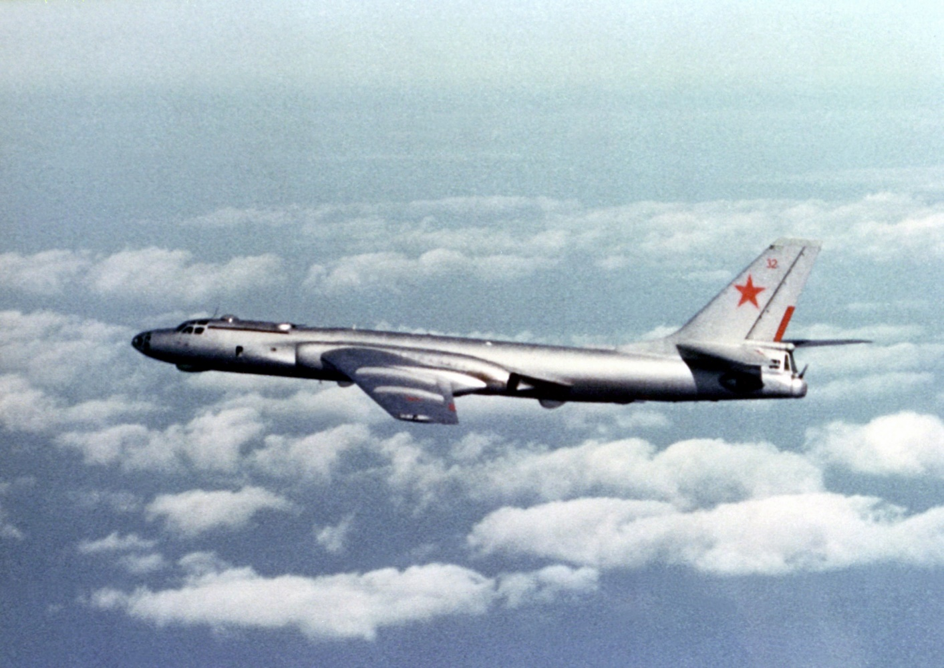

**46th Red Banner Air Army:** Located in the Smolensk area west of Moscow has the most modern Soviet bomber – the Tu-160 Blackjack – as well as some of the oldest – Tu-22KPD Blinder – and is ideally situated to support either the conventional forces in Europe or a strategic nuclear attack on North America. Consisting of four divisions and 14 regiments, this is the largest of the Long Range Aviation Air Armies.

|  |  |  |  |  |  |
| --- | --- | --- | --- | --- | --- |
| Division | Regiment | Location | Number | Aircraft type | Remarks |
| 13th Gds | 184th | Priluki | 24 | Tu-160 |  |
|  |  |  | 2 | Tu-134UBL |  |
|  | 185th Gds | Poltava | 18 | Tu-22M3 |  |
|  |  |  | 6 | Tu-16P Buket |  |
|  | 52nd Gds | Shaikovka | 19 | Tu-22M3 |  |
|  |  |  | 6 | Tu-16P Buket |  |
| 15th Gds | 121st Gds | Engels | 24 | Tu-160 |  |
|  |  |  | 2 | Tu-134UBL |  |
|  | 203rd Gds | Dyagilevo | 36 | Tu-22KPD |  |
|  |  |  | 8 | Tu-16 Elka |  |
|  | 341st | Ozernoye | 36 | Tu-22KPD |  |
| 22nd Gds | 200th Gds | Belaya | 20 | Tu-22M3 |  |
|  |  |  | 18 | Tu-16K-10 |  |
|  | 260th | Stryy | 18 | Tu-22M3 |  |
|  |  |  | 23 | Tu-16K-10 |  |
| 326th | 79th | Ukrainka | 36 | Tu-95K-22 |  |
|  |  |  | 8 | Tu-16 Elka |  |
|  | 182nd Gds | Ukrainka | 22 | Tu-95MS16 |  |
|  |  |  | 8 | Tu-16 Elka |  |
|  | 132nd | Vozdvizhevka | 18 | Tu-22M3 |  |
|  |  |  | 17 | Tu-16K-10 |  |
| Army units | 290th LR Recon | Zyabrovka | 36 | Tu-22RDM |  |
|  |  |  | 13 | Tu-16R |  |
|  |  |  | 6 | Tu-16RR |  |
|  | 199th Gds LR R | Nezhin | 36 | Tu-22RDM |  |
|  |  |  | 12 | Tu-22PD |  |
|  | 103rd Tpt R | Smolensk | 25 | An-12 |  |

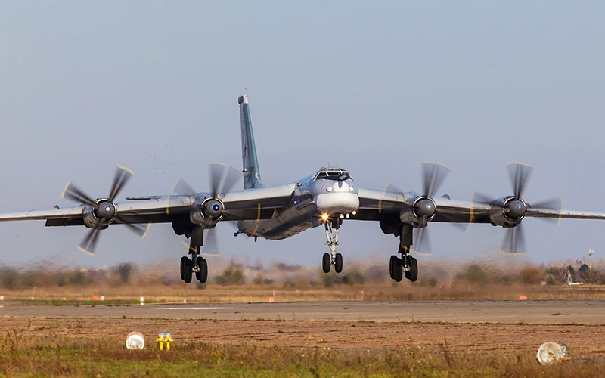

**6th Independent Heavy Bomber Aviation Corps:**  Formed the 46th Air Army in 1980 and moved into reserve status. Early activation of this force commenced in early 1993 with staff training and maintenance on aircraft in reserve. Units were reformed in Nov 1993 under the cover of the Soviet massive buildup and exercise to exert pressure on Poland, there was a considerable degree of misinformation presented and although indicators were received and noted in the west, there was little or no reaction.

|  |  |  |  |  |  |
| --- | --- | --- | --- | --- | --- |
| Division | Regiment | Location | Number | Aircraft type | Remarks |
| 160th | 291st | Balbasovo | 24 | Tu-95K-22 |  |
|  |  |  | 12 | Tu-16P Buket |  |
|  | 402nd | Balbasovo | 36 | Tu-22M2 |  |
|  |  |  | 8 | Tu-16P Buket |  |
|  | 157th | Smolensk | 36 | Tu-22M2 |  |
|  |  |  | 8 | Tu-16P Buket |  |
| 11th Gds | 171st | Baranovichi | 32 | Tu-16K-26 |  |
|  |  |  | 8 | Tu-16Ye |  |
|  | 173rd | Migalovo | 32 | Tu-16K-26 |  |
|  |  |  | 8 | Tu-16Ye |  |
|  | 210th Gds | Zyabrovka | 32 | Tu-16K-26 |  |
|  |  |  | 8 | Tu-16Ye |  |
| 45th | 198th | Kirovograd | 32 | Tu-16K-26 |  |
|  |  |  | 8 | Tu-16 Elka |  |
|  | 362nd | Seshcha | 32 | Tu-16K-26 |  |
|  |  |  | 8 | Tu-16 Elka |  |
| 53rd | 840th | Soltsy | 30 | Tu-22M2 |  |
|  |  |  | 8 | Tu-22RDM |  |
|  | 37th | Shatolovo | 36 | Tu-22M2 |  |
|  |  |  | 8 | Tu-22RDM |  |
|  | 49th Instr | Dyagilevo | 12 | Tu-95U |  |
| 139th Gds | 111th | Bobruisk | 32 | Tu-16K-26 |  |
|  |  |  | 12 | Tu-16R |  |
|  | 226th Gds | Poltava | 2 | Tu-16E |  |
|  |  |  | 12 | Tu-16P Buket |  |
|  | 251st | Belaya | 16 | Tu-16K-10 |  |
|  |  |  | 16 | Tu-16K-26 |  |
|  |  |  | 8 | Tu-16 Elka |  |
|  |  |  | 12 | Tu-16R |  |

