**Soviet Transport Aviation** – (VTA) – Komandovaniye voyenno-transportnoy aviatsii.

HQ VTA reports directly to HQ of the Air Force (VVS) and is responsible for all routine transport, both Strategic around the globe and tactical in support of the Army or Navy. Although in peacetime this organization controls somewhere between 1,500 and 2,000 aircraft – wartime mobilization would see this number double or even treble almost immediately as aircraft from the state controlled airline Aeroflot were rolled into service.

In addition to the formations listed below, each Air Army and some Air Corps and Divisions have ‘Independent Mixed Squadrons or Regiments’, each of these comprise of several types of transport aircraft, usually a mix of ***An-12 Cub*** and ***Mi-8 Hip*** but often have strategic transport and VIP aircraft as well. The Navy also operates several transport units as does the Air Defence forces.

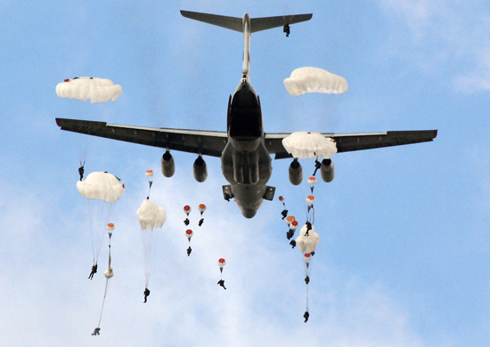

Although VTA formations are not assigned to subordinate areas, they are affiliated and based on location, meant to support. 3rd Gds Transport Division is located conveniently to transport the 76th Gds Airborne Division for instance, while 6th Red Banner Transport Division is situated to work with the 7th Gds Airborne Division, and 12th Transport Division is equipped to support global strategic cargo lift. The large number of independent regiments reflects the diverse nature of the fleet and the expansive area that needs to be covered.

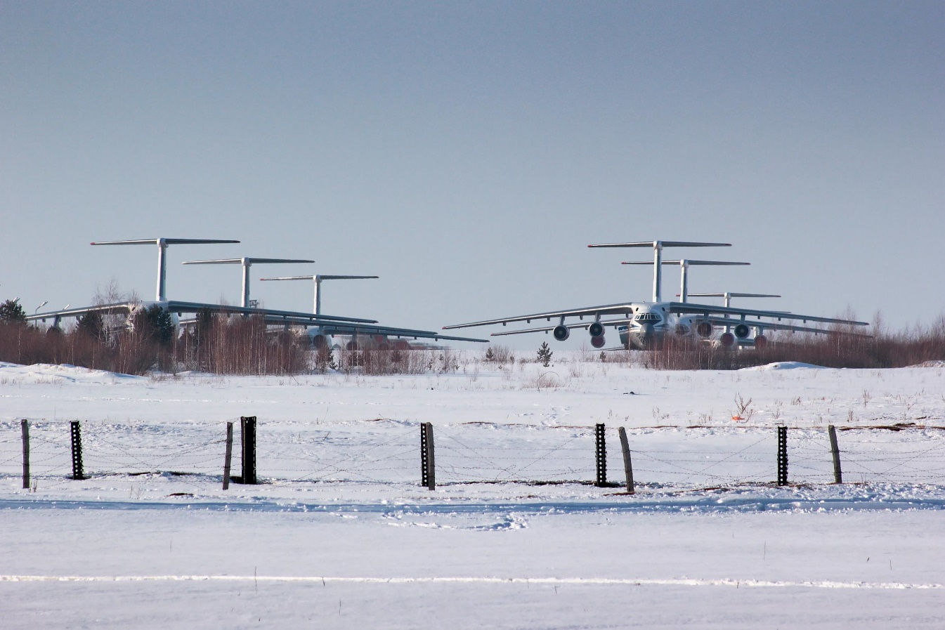

Although detailed load tables are required, a rule of thumb for para-dropping Soviet Desantniki or Airborne Forces is one regiment of Il-76 transport aircraft for one airborne regiment. However, it takes the better part of five regiments with some additional support to drop an entire airborne division in one lift. Realistically three or possibly four of the six airborne divisions could be para-dropped simultaneously and each would likely take two lifts to complete the drop and provide adequate resupply, depending on the distances involved and any reinforcing troops, a divisional drop would consume a full division of air transports for up to three days, and probably requires a regiment of transports to provide sufficient supplies until a ground or sea link-up is made. Therefore, para-dropping all six airborne divisions would take the better part of a week to accomplish if they were all to be deployed as close to simultaneously as possible. There is also an independent unit – 345th Gds Airborne Regiment located in Georgia SSR and a large independent Il-76 regiment (192nd) located in the Far East, these two organizations are available to reinforce any mass para-drops.

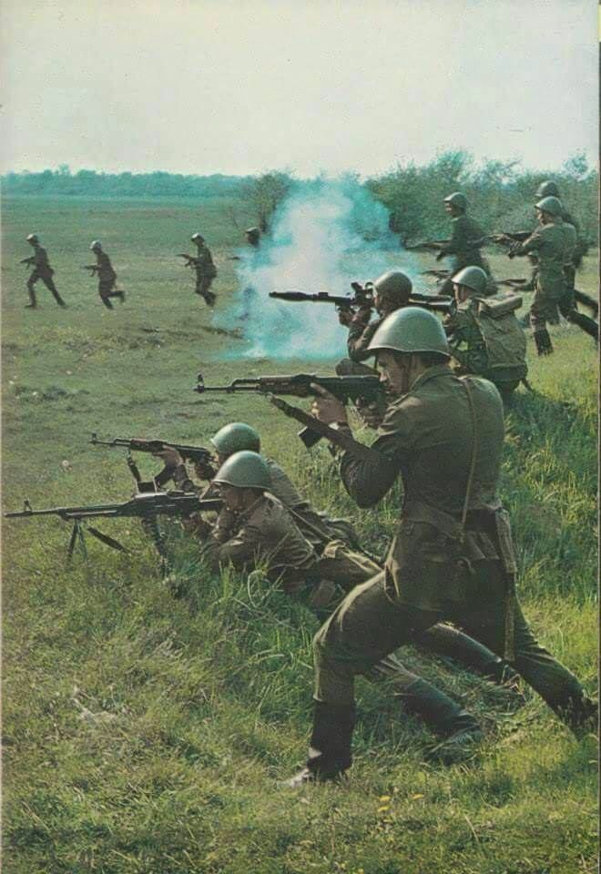

An interesting aspect of Soviet para-drops, they parachute armored vehicles with the troops inside; this [quick video](https://www.youtube.com/watch?v=lpzkQeoJn7k) is dated but shows the technique.

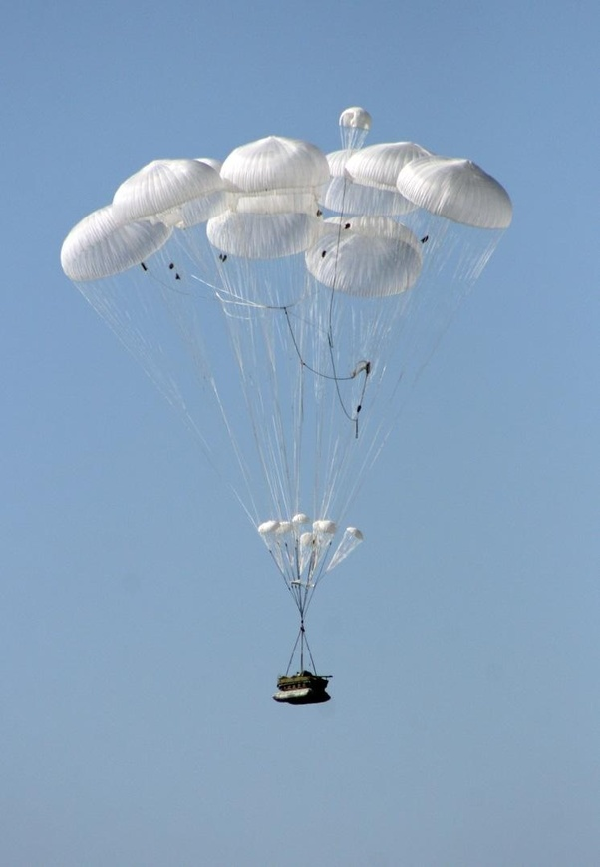

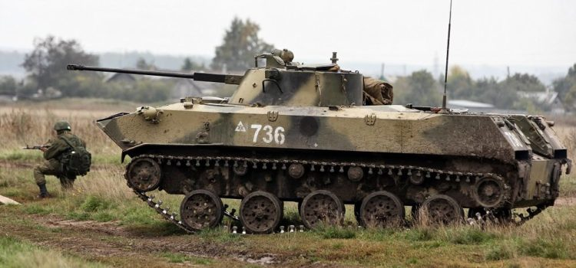

|  |  |  |  |  |  |  |
| --- | --- | --- | --- | --- | --- | --- |
| Corps/Army | Division | Regiment | Location | Number | Aircraft type | Remarks |
| HQ VTA | 3rd Gds | 103rd Gds | Smolensk | 25 | Il-76 |  |
|  |  | 110th | Novgorod | 29 | Il-76 |  |
|  |  | 334th RB | Pskov | 29 | Il-76 |  |
|  |  | 708th | Taganrog | 32 | Il-76MD |  |
|  | 6th RB | 37th Gds | Artsyz | 30 | Il-76 |  |
|  |  | 338th | Zaporozhye | 28 | Il-76 |  |
|  |  | 339th | Vitebsk | 30 | Il-76 |  |
|  |  | 363rd | Krivoi Rog | 30 | Il-76 |  |
|  | 7th | 25th Gds | Melitopol | 31 | Il-76 |  |
|  |  | 175th | Melitopol | 30 | Il-76 |  |
|  |  | 369th RB | Dhanskoy | 31 | Il-76 |  |
|  | 8th RB Sp Purpose | 353rd | Moscow |  | Various |  |
|  |  | 354th | Moscow |  | Various |  |
|  | 12th RB | 8th | Migalovo | 22 | An-22 | + 10 in Reserve |
|  |  | 81st | Ivanovo | 22 | An-22 | + 10 in Reserve |
|  |  | 235th | Seshcha | 27 | An-124 |  |
|  |  | 566th | Seshcha | 27 | An-124 |  |
|  | 18th Gds RB | 128th | Panevezhis | 31 | Il-76 |  |
|  |  | 196th Gds | Tartu | 28 | Il-76 |  |
|  |  | 600th | Kedainiai | 30 | Il-76 |  |
|  |  | 117th EW Regt | Siauliai | 29 | An-12PPS |  |
|  |  |  |  | 5 | An-12BKI |  |
|  |  |  |  | 6 | An-12BKS |  |
|  |  |  |  | 5 | An-12BPS |  |
|  | 23rd | 150th | Ulan-Ude |  | Various |  |
|  |  | 930th | Zavitinsk | 42 | An-12 |  |
|  | Independent | 192nd | Ukkurey | 46 | Il-76 |  |
|  |  | 194th Gds | Fergana | 48 | An-12 |  |
|  |  | 195th | Yuzhno | 16 | An-12 | SAR |
|  |  |  |  | 14 | An-24 | SAR |
|  |  | 197th Mixed | Novosibirsk |  | Various |  |
|  |  | 239th RB Heli | Efremov | 26 | Mi-6 |  |
|  |  |  |  | 34 | Mi-8 |  |
|  |  |  |  | 12 | Mi-26 |  |
|  |  | 244th | Novgorod | 52 | An-12 |  |
|  |  | 280th Heli | Leonidovo | 30 | Mi-6 |  |
|  |  |  |  | 35 | Mi-8 |  |
|  |  |  |  | 12 | Mi-26 |  |
|  |  | 355th Sp Purpose | Moscow | 32 | Tu-134 |  |
|  |  |  |  | 40 | Tu-154 |  |
|  |  | 359th Heli | Vaskovo | 22 | Mi-6 |  |
|  |  |  |  | 24 | Mi-8 |  |
|  |  |  |  | 12 | Mi-26 |  |
|  |  | 436th Heli | Stupino | 26 | Mi-6 |  |
|  |  |  |  | 32 | Mi-8 |  |
|  |  |  |  | 10 | Mi-26 |  |
|  |  | 456th Mixed | Vinnitsa |  | Various |  |
|  |  | 517th Instructor | Ivanovo | 22 | Il-76 |  |
|  |  | 688th Heli | Zheludok | 27 | Mi-6 |  |
|  |  |  |  | 31 | Mi-8 |  |
|  |  |  |  | 11 | Mi-26 |  |
|  |  | 696th Heli Test | Torzhok | 16 | Mi-6 |  |
|  |  |  |  | 8 | Mi-8 |  |
|  |  |  |  | 22 | Mi-24 |  |
|  |  |  |  | 4 | Mi-26 |  |
|  |  | 978th | Klin | 2 | An-225 |  |