**Frontal Aviation: VVS (*Voenno-Vozdushmiy Sily****)*

VVS literally means Military Air Force, but in the west the VVS is commonly referred to a s Frontal Aviation because its primary purpose is to provide air support to the Soviet Army and the various air forces are subordinated to Soviet Army *Fronts* in wartime. Comprising more than 11,500 aircraft, not including Long Range Aviation which is accounted separately, the VVS is organized into 14 Air Armies in addition to major components in three Military Districts (MD) which are largely training and demonstration forces. Amongst this force are more than 2,250 front line combat fighters, 3,200 fighter-bombers, over 1,000 second line and aging fighters/fighter-bombers, 500 support and reconnaissance airframes, 800 transports and over 3,500 training aircraft. Each of the Air Armies reports to either a MD or the General Staff in peacetime and would be assigned to various pre-arranged *Fronts* in wartime.

**1st Red Banner Air Army**: Reports directly to the High Command of the Far East HQ in Vladivostok, and is primarily responsible for supporting the Pacific Fleet and should there be difficulties with China or Korea, support the army forces involved. A squadron of MiG-29 is usually located at Cam Ranh Bay Naval Base in southern Viet Nam.

|  |  |  |  |  |  |  |
| --- | --- | --- | --- | --- | --- | --- |
| Corps/Army | Division | Regiment | Location | Number | Aircraft type | Remarks |
|  | 28th Ftr | 216th Ftr | Komsomolsk | 41 | Su-27S |  |
|  |  | 302nd Ftr | Khabarovsk | 41 | MiG-29A |  |
|  |  | 404th Ftr | Orlovka | 41 | MiG-29M |  |
|  | 83rd Bmbr | 56th Bmbr | Vozzaevka | 32 | Su-24 |  |
|  |  | 277th Bmbr | Komsomolsk | 30 | Su-24 |  |
|  |  | 302nd Bmbr | Pereyaslavka-2 | 24 | Su-24M |  |
|  | 303rd RB Ftr-Bmbr | 18th Ftr-Bmbr | Galenki | 36 | Su-25A | Upgrade from MiG-27 |
|  |  |  |  | 6 | Su-25UBM |  |
|  |  | 224th Ftr-Bmbr | Ozernaya Pad | 41 | MiG-27D |  |
|  |  | 523rd Ftr-Bmbr | Vozdvizhenka | 39 | Su-17M4 |  |
| Army Units |  | 187th Ind Asslt | Chernigovka | 41 | Su-25A |  |
|  |  | 293rd Ind Recon | Vozzhaevka | 6 | Su-24MR |  |
|  |  |  |  | 8 | MiG-25RB |  |
|  |  |  |  | 12 | MiG-25BM |  |
|  |  |  |  | 4 | MiG-25R |  |
|  |  |  |  | 12 | Su-17M3R |  |
|  |  | 799th Ind Recon | Varfolomeevka | 6 | Su-24MR |  |
|  |  | 257th Ind Mixed | Khabarovsk |  | Various |  |

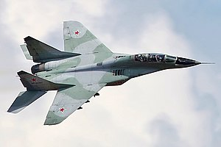

**4th Air Army**: Displaced from Poland in 1989 and largely dispersed this force resides in the Ukraine and will reinforce westward.

|  |  |  |  |  |  |  |
| --- | --- | --- | --- | --- | --- | --- |
| Corps/Army | Division | Regiment | Location | Number | Aircraft type | Remarks |
|  | 131st RB Ftr | 114th RB Ftr | Ivano-Frankovsk | 41 | Su-27S |  |
|  |  | 192nd Ftr | Ivano-Frankovsk | 45 | MiG-23MLA |  |
|  | 30th Ftr-Bmbr | 58th Ftr-Bmbr | Step | 41 | Su-17M2 |  |
|  |  | 6th Bmbr | Step | 41 | Su-17M2 |  |
|  |  | 26th Gds Bmbr | Uchastok | 41 | Su-17M3 |  |
| Army Units |  | 153rd Mix Sqn | Kishinev |  | Various |  |

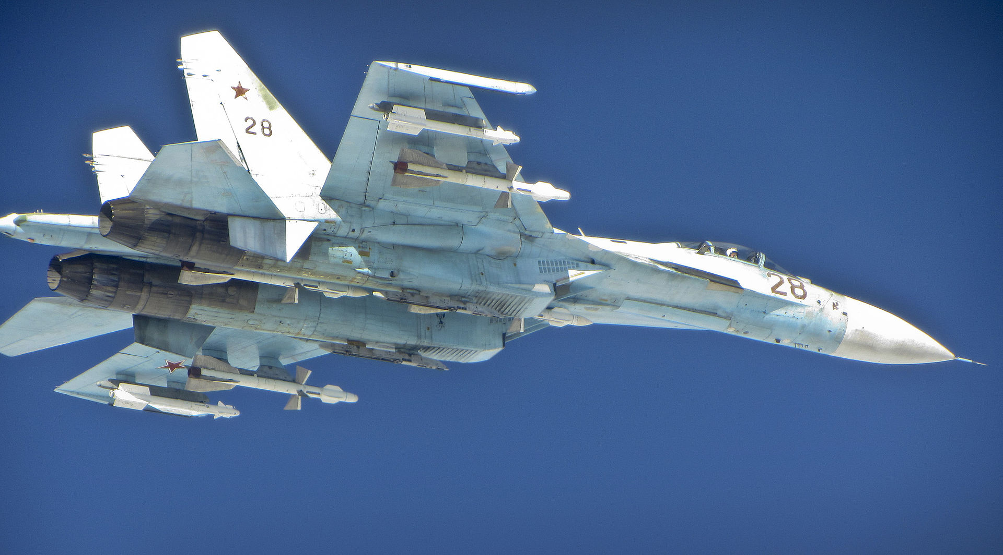

**5th Air Army**: Reporting to Odessa MD this Air Army will likely be committed to the Western Military Direction as a second echelon air force, or it could easily support the Southwestern Military Direction in either the Balkans or Turkey, it comprises a large number of independent regiments which could indicate that it will not be committed as a whole and could farm out its units individually and form a mobilization HQ for activating reserve elements.

|  |  |  |  |  |  |  |
| --- | --- | --- | --- | --- | --- | --- |
| Corps/Army | Division | Regiment | Location | Number | Aircraft type | Remarks |
|  | 119th RB Ftr | 86th Gds Ftr | Markuleshty | 41 | MiG-29SM |  |
|  |  | 161st Ftr | Limanskoye | 41 | MiG-29SM |  |
|  |  | 841st Gds RB Ftr | Meria | 52 | MiG-23M |  |
|  | 29th Ftr-Bmbr | 34th RB Bombr | Rostov | 35 | Su-17M3 |  |
|  |  | 314th Bmbr | Cherlyany | 40 | Su-17M3 |  |
|  |  | 733rd Bmbr | Volgograd | 40 | Su-17M3 |  |
| Army Units |  | 642nd Gds Ftr-Bmr | Voznesensk | 53 | MiG-29A |  |
|  |  | 90th Ind Asslt | Artsyz | 40 | Su-25A |  |
|  |  | 827 Ind Recon | Limanskoye | 40 | Su-17M4 |  |
|  |  |  |  | 15 | MiG-21R |  |
|  |  | 29th Bmbr Trg | Berdyansk | 32 | Su-24 |  |
|  |  | 117th Ind EW | Orenburg | 29 | An-12PPS |  |
|  |  |  |  | 5 | An-12BKI | Other spec AC |
|  |  | 112th Mix Sqn | Odessa |  | Various |  |
|  |  | 208th Ind EW Sqn | Buyalyk | 14 | Mi-8PPA |  |

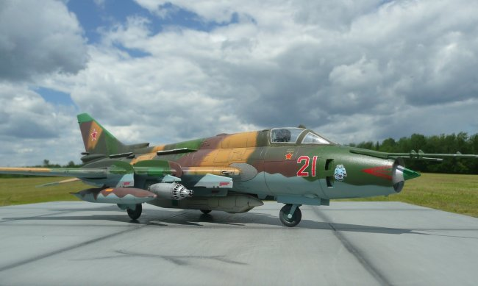

**14th Air Army:** The primary responsibility of this force is to reinforce the South Western Military Direction and very likely the 1st Bulgarian Front attacking into Greece and Turkey. A secondary option would be to reinforce 36th Air Army further west fighting NATO forces over the Balkans.

|  |  |  |  |  |  |  |
| --- | --- | --- | --- | --- | --- | --- |
| Corps/Army | Division | Regiment | Location | Number | Aircraft type | Remarks |
|  | 4th Ftr | 92nd Ftr | Mukachevo | 39 | MiG-29A |  |
|  |  | 145th Ftr | Ivano-Frankovsk | 41 | MiG-29A |  |
|  |  | 916th RB Ftr |  | 41 | Su-27S |  |
|  | 289th Bmbr | 69th Bmbr | Cherlyany | 24 | Su-24M |  |
|  |  | 806th Bmbr | Lutsk | 24 | Su-24M |  |
| Army Units |  | 48th Ind Recon | Kolomiya | 8 | MiG-25RB |  |
|  |  |  |  | 8 | MiG-25BM |  |
|  |  |  |  | 8 | Su-24MR |  |
|  |  |  |  | 4 | Su-24MP |  |
|  |  |  |  | 15 | MiG-21R |  |
|  |  | 452nd Ind Asslt | Chortkov | 34 | Su-25A |  |
|  |  | 234th Ind Mix | Lvov |  | Various |  |
|  |  | 209th Ind EW Sqn |  | 11 | Mi-8PPA |  |

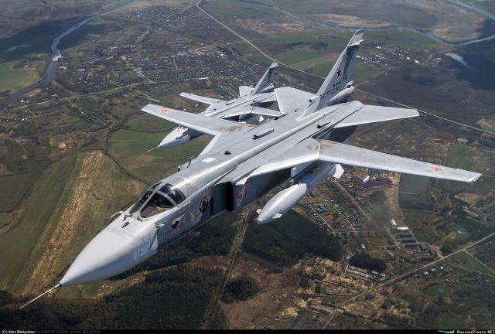

**15th Air Army**: Based in the Baltics this army will work closely with Baltic Fleet and 26th Air Army units along the Baltic coast. Not a large army and dependent on others to provide air superiority, although the newly added regiment of Su-30s should go a long way to fixing that issue.

|  |  |  |  |  |  |  |
| --- | --- | --- | --- | --- | --- | --- |
| Corps/Army | Division | Regiment | Location | Number | Aircraft type | Remarks |
|  | 39th Ftr-Bmbr | 53rd Gds Ftr-Bmbr | Siauliai | 36 | MiG-27D |  |
|  |  |  |  | 11 | MiG-23UM |  |
|  |  | 372nd Ftr-Bmbr | Borisoglebsk | 36 | MiG-27D |  |
|  |  |  |  | 12 | MiG-23UM |  |
|  |  | 899th Ftr-Bmbr | Buturlinovka | 47 | MiG-27D |  |
|  |  |  |  | 11 | MiG-23UM |  |
| Army Units |  | 866th RB Recon | Jekabpils | 12 | Su-24MR |  |
|  |  |  |  | 4 | Su-24MP |  |
|  |  |  |  | 14 | Su-17M3R |  |
|  |  | 236th Ftr-Bmbr | Lielvarde | 41 | Su-30 |  |
|  |  | 249th Mix Sqn | Riga-Spilve |  | Var Heli +An-14 |  |
|  |  |  | Riga-Skulte |  | Var Tpt |  |
|  |  | 285th Ind EW Sqn |  | 19 | Mi-8PPA |  |

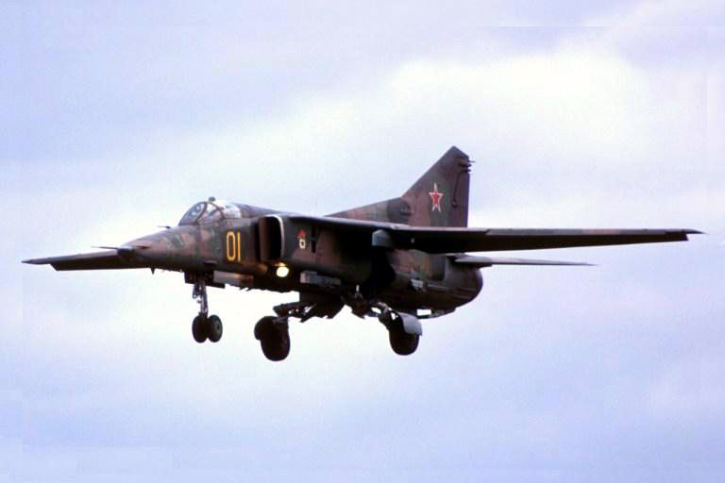

**16th Air Army**: Formerly based in East Germany, this Air Army re-deployed to Czechoslovakia with the exception of a few units which deployed back to the Soviet Union, mostly to Moscow Military District. Of all Soviet VVS forces this Army is held at the highest state of readiness and its presence has improved Czechoslovakian training as well.

|  |  |  |  |  |  |  |
| --- | --- | --- | --- | --- | --- | --- |
| Corps/Army | Division | Regiment | Location | Number | Aircraft type | Remarks |
|  | 16th Gds RB Ftr | 33rd Ftr | Milovice | 32 | MiG-29SMT | 2 MiG-23UM |
|  |  | 773rd Ftr | Kbely | 31 | MiG-29M | 3 MiG-23UM |
|  |  | 787th Ftr | Ruzyně | 31 | MiG-29M | 2 MiG-23UM |
|  | 125th Ftr-Bmbr | 19th Gds Ftr-Bmbr | Trenčín | 32 | MiG-27D | 7 MiG-23UM |
|  |  | 20th Gds RB Ftr-Bm | Sliač | 36 | Su-17M4 |  |
|  |  | 730th Ftr-Bmbr | Poprad-Tatry | 38 | Su-17M4 |  |
|  | 6th Gds RB Ftr | 31st Gds Ftr | Brataslava | 32 | MiG-29M |  |
|  |  | 85th Gds Ftr | Kuchyňa | 41 | MiG-29SM |  |
|  |  | 968th Ftr | Piešťany | 46 | MiG-29S | 4 MiG-29UB |
|  | 105th Ftr-Bmbr | 296th Ftr-Bmbr | Hořovice | 32 | MiG-27D | 10 MiG-23UM |
|  |  | 559th Ftr-Bmbr | Pribram | 32 | MiG-27D | 9 MiG-23UM |
|  |  | 911th Ftr-Bmbr | Tábor | 32 | MiG-27D | 10 MiG-23UM |
|  | 126th Ftr | 35th Ftr | Čáslav | 41 | MiG-29S | 6 MiG-23UM |
|  |  | 833rd Ftr | Hradčany | 36 | MiG-23MLD |  |
|  |  | 116th Gds Ftr | Letňany | 41 | Su-27S |  |
| Army Units |  | 357th Ind Asslt | Mnichovo | 45 | Su-25T | 6 L-39C |
|  |  | 368th Ind Asslt | Karlovy Vary | 45 | Su-25T | 4 L-39C |
|  |  | 11th Ind Recon | Ostrava | 20 | Su-24MR |  |
|  |  |  |  | 12 | Su-24MP |  |
|  |  | 294th Ind Recon | Vyskov | 16 | Su-17M3R | 5 Su-17UM |
|  |  | 931st Gd Ind Recon | Brataslava | 9 | Mig-25R |  |
|  |  |  |  | 3 | MiG-25RB | 2 MiG-25U |
|  |  |  |  | 8 | MiG-25BM |  |
|  |  | 226th Ind Mix | Brataslava |  | Various |  |
|  |  | 292nd Ind EW Sqn | Kbely | 11 | Mi-8PPA |  |
|  |  | 39th Ind Recon Sqn | Brataslava | 8 | Su-17M3R |  |

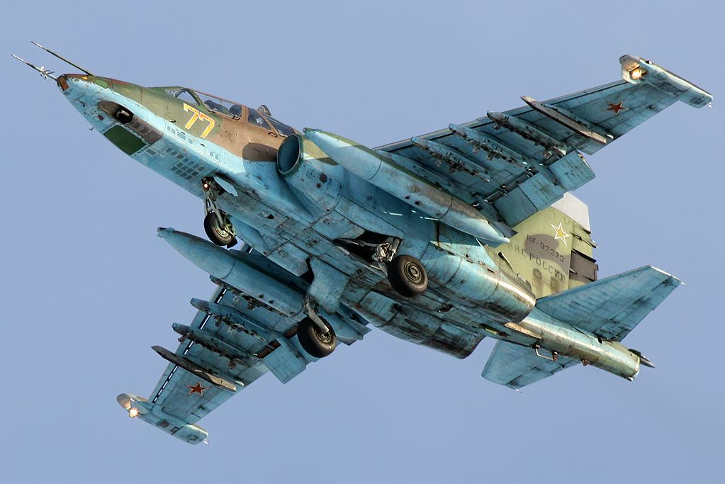

**17th Air Army**: Primarily focused on basic and advanced training for the entire VVS, this Army is under command of the Kiev Military District and produces thousands of trained pilots every year.

|  |  |  |  |  |  |  |
| --- | --- | --- | --- | --- | --- | --- |
| Corps/Army | Division | Regiment | Location | Number | Aircraft type | Remarks |
|  |  | 255th Mixed | Borispol | 2 | Tu-134 |  |
|  |  |  |  | 2 | Tu-154 |  |
|  |  |  |  | 7 | Mi-8 |  |
|  |  |  |  | 2 | Mi-6 |  |
|  |  |  |  |  | An-12/24/26 |  |
|  |  | 228th Ind EW Sqn | Borispol | 15 | Mi-8PPA |  |
|  | Chernigov School | 105th Trg | Konotop | 101 | L-39C |  |
|  |  | 701st Trg | Chernigov | 101 | L-39C |  |
|  |  | 702nd Trg | Uman | 136 | MiG-21UM |  |
|  |  | 703rd Trg | Gorodnya | 101 | L-39C |  |
|  | Kharkov School | 443rd Trg | Velikaya | 101 | L-39C |  |
|  |  | 809th Trg | Akhtyrka | 102 | L-39C |  |
|  |  | 810th Trg | Chuguev | 103 | MiG-21UM |  |
|  |  | 812th Trg | Kupyask | 102 | MiG-21UM |  |
|  | Voroshilovgrad S | 46th Trg | Voroshilovgrad | 40 | An-26 |  |
|  |  | 130th Trg | Mariupol | 10 | Be-12 |  |
|  |  |  |  | 24 | An-12Bsh/BKsh |  |
|  |  | 228th Trg | Bagerovo | 120 | MiG-21bis |  |
|  |  |  |  | 20 | L-29 |  |

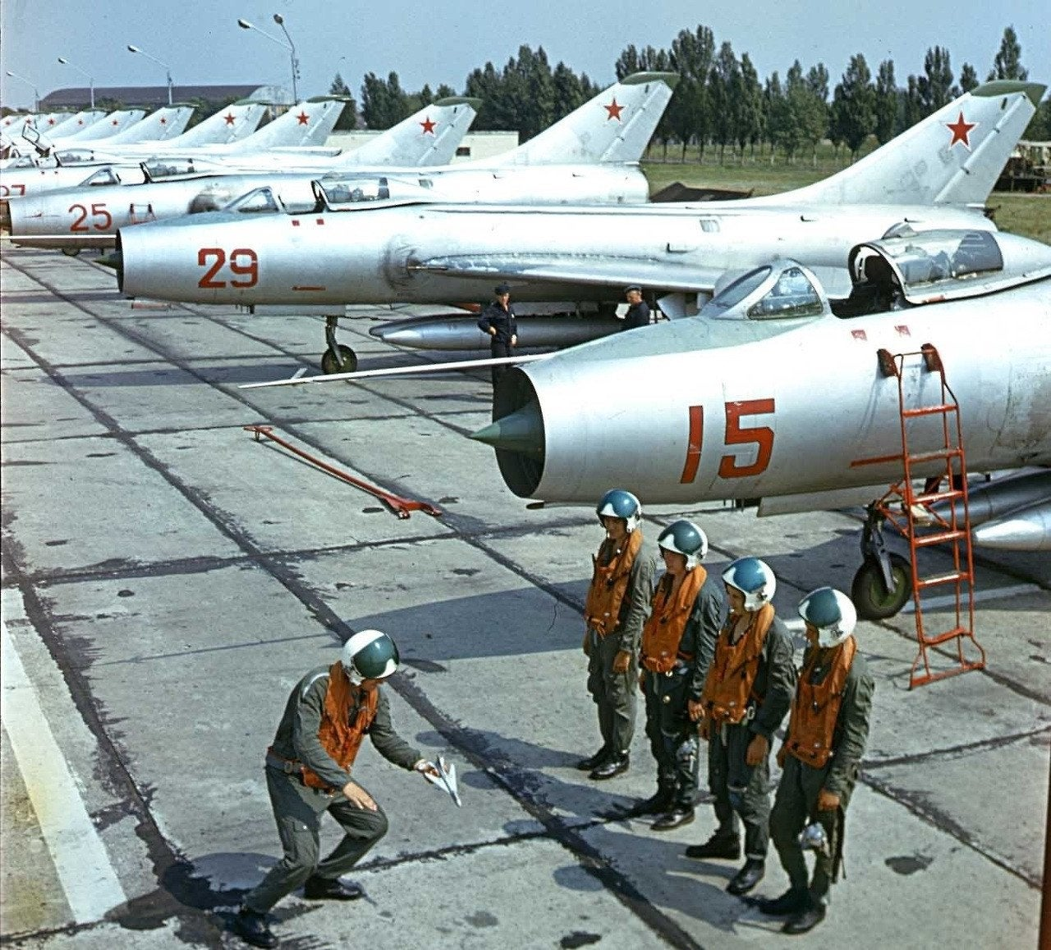

**23rd Air Army**: A relatively small Air Army located in the Trans Baikal region. Primarily situated to support action in China, if there is no threat in this region this force of primarily Fighter-Bombers is ideally situated to reinforce the Far Eastern Military District and the Pacific Fleet.

|  |  |  |  |  |  |  |
| --- | --- | --- | --- | --- | --- | --- |
| Corps/Army | Division | Regiment | Location | Number | Aircraft type | Remarks |
|  | 21st Bmbr | 2nd Gds Bmbr | Dzhida | 24 | Su-24M |  |
|  |  | 21st Bmbr | Bada | 24 | Su-24M |  |
| Army Units |  | 189th Gds Ftr-Bmr | Borzya-2 | 24 | Su-24M |  |
|  |  | 266th Ftr-Bmbr | Step | 36 | Su-17M4 |  |
|  |  | 120th Ftr | Domna | 41 | MiG-29S |  |
|  |  | 101st Ind Recon | Borzya-2 | 22 | Su-17M/3R | ORAP |
|  |  | 125th Ind Recon | Domna | 28 | Su-17M/3R |  |
|  |  | 193rd Gds RB Rece | Ukurey | 24 | MiG-25RBU | Recon Trg |
|  |  |  |  | 12 | Su-17M2R |  |
|  |  | 36th Ind Mixed | Chita |  | Various |  |
|  |  | 150th Ind Mixed | Ulan-Ude |  | Various |  |

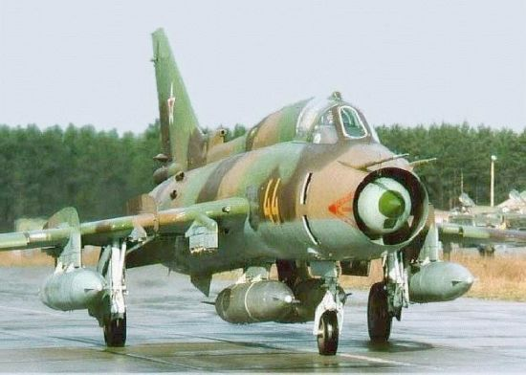

**24rd Air Army (VKG ON)**: Located in western Ukraine and Belarus, this force has been tasked with nuclear strike in the past and therefore could be placed under the control of the VKG, however over 150 Su-24 with plenty of fighter and electronic support would make a welcome reinforcement to any Front.

|  |  |  |  |  |  |  |
| --- | --- | --- | --- | --- | --- | --- |
| Corps/Army | Division | Regiment | Location | Number | Aircraft type | Remarks |
|  | 32nd Bmbr | 7th Bmbr | Starokonstantinov | 29 | Su-24M |  |
|  |  | 727th Bmbr | Kanatovo | 30 | Su-24M |  |
|  |  | 953rd Bmbr | Bobrovichi | 28 | Su-24 |  |
|  | 56th Bmbr | 230th Bmbr | Cherlyany | 30 | Su-24M |  |
|  |  | 947th Bmbr | Dubna | 30 | Su-24M |  |
|  | 138th RB Ftr | 168th Ftr | Starokonstantinov | 42 | MiG-23MLD |  |
|  |  | 190th Ftr | Kanatovo | 42 | MiG-23MLD |  |
|  |  | 831st Ftr | Mirgorod | 32 | Su-27D |  |
| Army Units |  | 456 Gds Ind Tpt | Vinnitsa |  | Various |  |
|  |  | 118th Ind EW | Chortkov | 6 | Su-24MP |  |
|  |  |  |  | 37 | Yak-28PP |  |
|  |  | 511th Ind Recon | Buyalyk | 6 | Su-24MR |  |

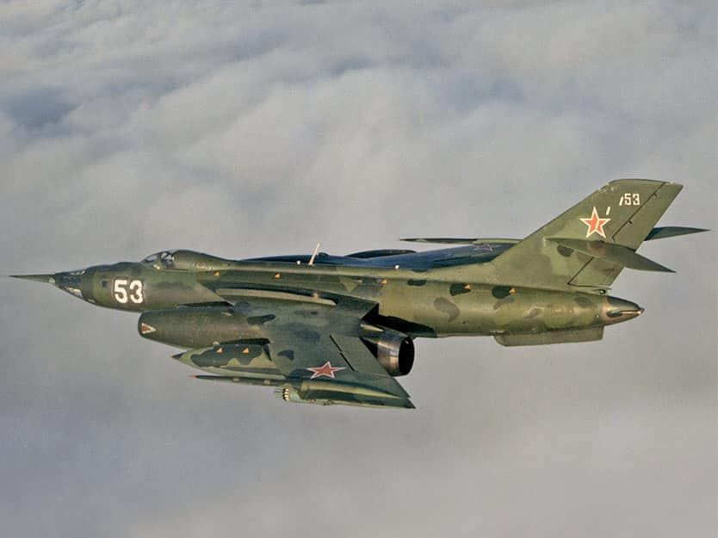

**26th Air Army**: Based in Belorussia, the primary task of this force is to back up any fight in Europe. Equipped with many of the latest aircraft, this Air Army would provide depth and challenge NATO’s latest fighter forces.

|  |  |  |  |  |  |  |
| --- | --- | --- | --- | --- | --- | --- |
| Corps/Army | Division | Regiment | Location | Number | Aircraft type | Remarks |
|  | 1st Gds Bmbr | 116th Gds RB Bmbr | Ross | 30 | Su-24M |  |
|  |  | 305th Bmbr | Postavy | 30 | Su-24M |  |
|  |  | 497th Bmbr | Lida | 29 | Su-24 |  |
|  | 145th RB Ftr | 665th Ftr | Odessa | 40 | Su-27S |  |
|  |  | 732nd Ftr | Odessa | 40 | Su-27S |  |
|  |  | 515th Ftr | Nikolayev | 40 | Su-27S |  |
|  | 239th Ftr | 159th RB Ftr | Besovets | 41 | Su-27S |  |
|  |  | 871st RB Ftr | Smolensk-N | 39 | MiG-23MLD |  |
|  |  | 976th RB Ftr | Schuchin | 45 | MiG-23MLD |  |
| Army Units |  | 813th Ind Ftr | Minsk | 41 | Su-27S |  |
|  |  | 50th Ind Mixed | Minsk |  | Various |  |
|  |  | 151st Ind EW | Schuchin | 4 | MiG-25RB |  |
|  |  |  |  | 16 | MiG-25BM |  |
|  |  |  |  | 4 | MiG-25R |  |
|  |  |  |  | 20 | Yak-28PP |  |
|  |  | 164th RB Recon | Shatalovo | 14 | MiG-25RB |  |
|  |  |  |  | 3 | Su-24MR |  |
|  |  |  |  | 2 | Su-24MP |  |
|  |  |  |  | 12 | Su-17M2R |  |
|  |  | 206th Ind Aslt | Lida | 29 | Su-25A | 7 L-39 |
|  |  |  |  | 12 | Su-25UBM |  |
|  |  | 378th Ind Aslt | Postavy | 32 | Su-25A | 6 L-39 |
|  |  |  |  | 12 | Su-25UBM |  |
|  |  | 397th Ind Aslt | Kobrin | 32 | Su-25A | 6 L-39 |
|  |  |  |  | 12 | Su-25UBM |  |
|  |  | 927th RB Ftr | Bereza-Osovitsy | 51 | MiG-29SM |  |
|  |  | 10th Ind RB Recon | Schuchin | 4 | MiG-25RB |  |
|  |  |  |  | 16 | MiG-25BM |  |
|  |  |  |  | 3 | MiG-25R |  |
|  |  |  |  | 6 | Su-24MR |  |
|  |  |  |  | 15 | MiG-21R |  |
|  |  | 302nd Ind EW Sqn |  | 13 | Mi-8PPA |  |

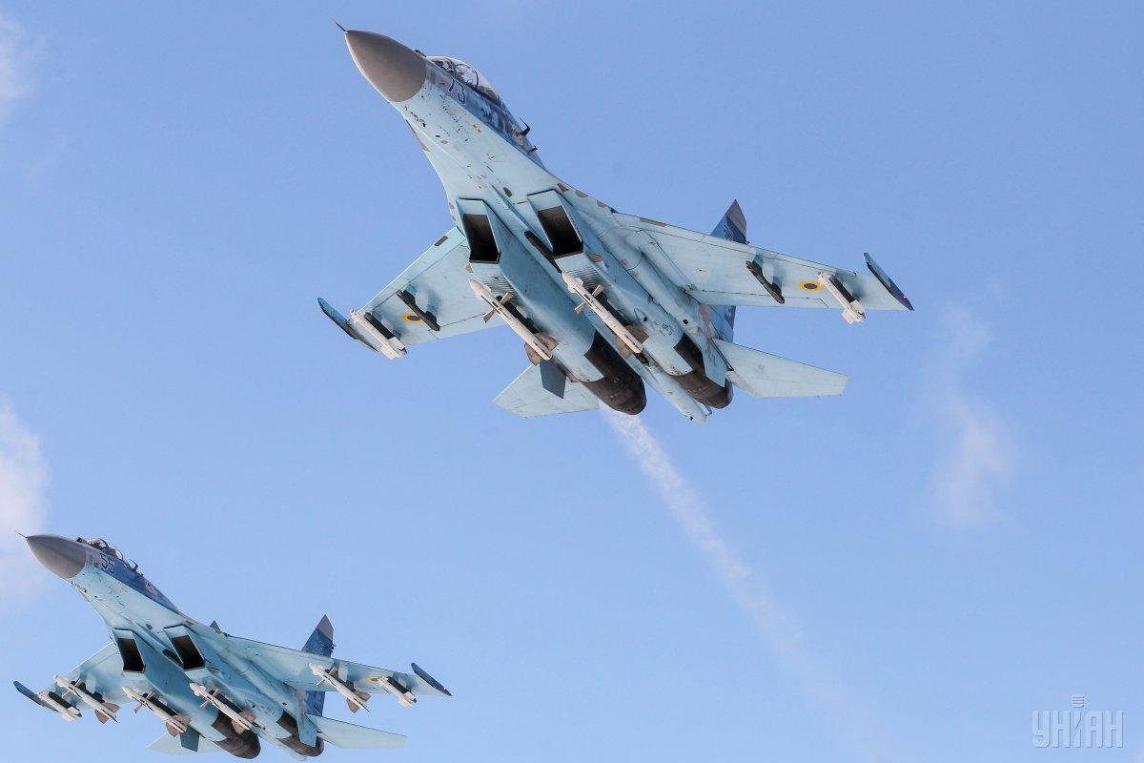

**34th Air Army**: Located in the Transcaucian region and primarily responsible for eastern Turkey and Iran, in Northern Fury, a good portion of this Air Army is deployed or is ready to deploy southward into the Persian Gulf Area. The 283rd Red Banner Fighter Division with two regiments plus an element of Su-24 bombers and support aircraft is deployed to Socotra Island in the Gulf of Aden, while elements of the 36th Bomber Division are in Yemen and Iran.

|  |  |  |  |  |  |  |
| --- | --- | --- | --- | --- | --- | --- |
| Corps/Army | Division | Regiment | Location | Number | Aircraft type | Remarks |
|  | 283rd RB Ftr | 176th Ftr | Sennoy | 41 | MiG-29S | 4 MiG-23U |
|  |  | 843rd Ftr | Meria | 52 | MiG-23M |  |
|  |  | 982nd Ftr | Tambov | 44 | MiG-23MLD |  |
|  | 36th Bmbr | 143rd Bmbr | Morozovsk | 28 | Su-24M |  |
|  |  | 168th Bmbr | Marinovka | 30 | Su-24M |  |
|  |  | 976th Bmbr | Totskoye | 29 | Su-24M |  |
| Army Units |  | 80th Ind Aslt | Sital-Chae | 30 | Su-25A |  |
|  |  |  |  | 4 | Su-25BM |  |
|  |  |  |  | 16 | Su-25UBM |  |
|  |  | 313th Ind Recon | Bada | 30 | Su-17M/3R | OAPREB |
|  |  | 882nd Ind Recon | Dallyar | 4 | MiG-25RB |  |
|  |  |  |  | 12 | MiG-25BM |  |
|  |  |  |  | 6 | Su-24MR |  |
|  |  |  |  | 15 | MiG-21R |  |
|  |  | 193rd Ind Mix Sqn | Novo-Alekseevka |  | Various |  |
|  |  | 300th Ind Mix Sqn | Kala |  | Various |  |
|  |  | 286th Ind EW Sqn | Dallyar | 17 | Mi-8PPA |  |

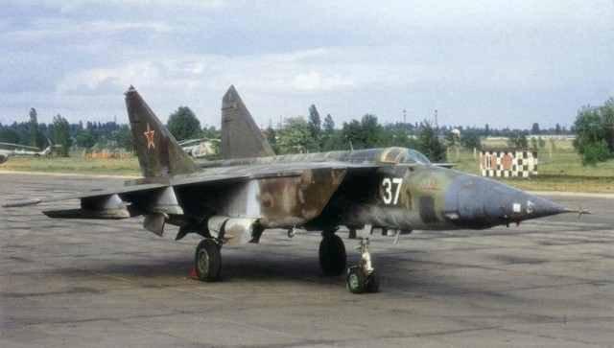

**36th Air Army**: Reinforcing the Army units’ based in Hungary, this Air Army, although small has some of the most advanced aircraft. The primary role will be to defeat NATO air forces based in Italy.

|  |  |  |  |  |  |  |
| --- | --- | --- | --- | --- | --- | --- |
| Corps/Army | Division | Regiment | Location | Number | Aircraft type | Remarks |
|  | 11th Gds RB Ftr | 5th Gds RB Ftr | Sármellék | 41 | MiG-29SM |  |
|  |  | 14th Gds RB Ftr | Khalino-Kursk | 41 | MiG-29A | 9 MiG-23UM |
|  |  | 515th Ftr | Tököl | 34 | MiG-29SMT |  |
| Army Units |  | 1st Gds Ftr-Bmbr | Lebyazhe | 42 | MiG-23ML |  |
|  |  | 88th Ftr-Bmbr | Olenya | 32 | MiG-27D | 10 MiG-23UM |
|  |  | 328th Ind Recon | Kunmadaras | 6 | Su-24MR |  |
|  |  |  |  | 15 | Su-17M/3R |  |
|  |  | 396th Gds Heli | Kagan-South |  | Mi-8 | ‘TV’ & ‘VKP’ |
|  |  | 201st Ind Mixed | Tököl |  | Various |  |
|  |  | 294th Ind EW Sqn | Debrecen | 17 | Mi-8PPA |  |

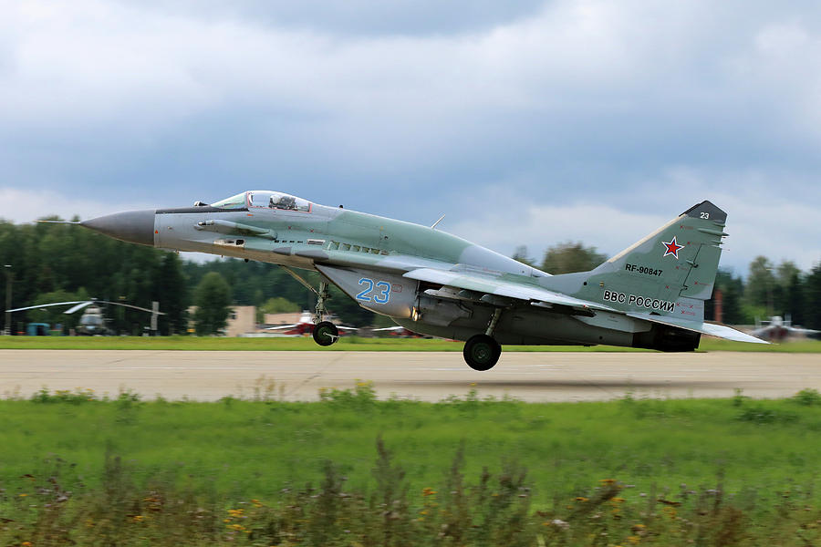

**49th Air Army**: Located in Turkestan the main role of this Air Army is to reinforce into the Persian Gulf or Turkey, whichever requires more effort.

|  |  |  |  |  |  |  |
| --- | --- | --- | --- | --- | --- | --- |
| Corps/Army | Division | Regiment | Location | Number | Aircraft type | Remarks |
|  | 34th Ftr-Bmbr | 136th Ftr-Bmbr | Chirchik | 41 | Su-17M3 |  |
|  |  | 217th Ftr-Bmbr | Kzyl-Arvat | 41 | Su-17M3 |  |
| Army Units |  | 155th Gds Ind Ftr | Kokaydy | 45 | MiG-29 |  |
|  |  | 735th Bmbr | Karshi-Khanabad | 24 | Su-24M |  |
|  |  | 372nd Ind Aslt | Dzhizak | 22 | Su-25A |  |
|  |  | 87th Ind Recon | Karshi-Khanabad | 8 | Su-24MR | 1 AE |
|  |  |  |  | 24 | Su-17M2R |  |
|  |  | 47th Ind Mix | Ak-Tepe |  | Various |  |

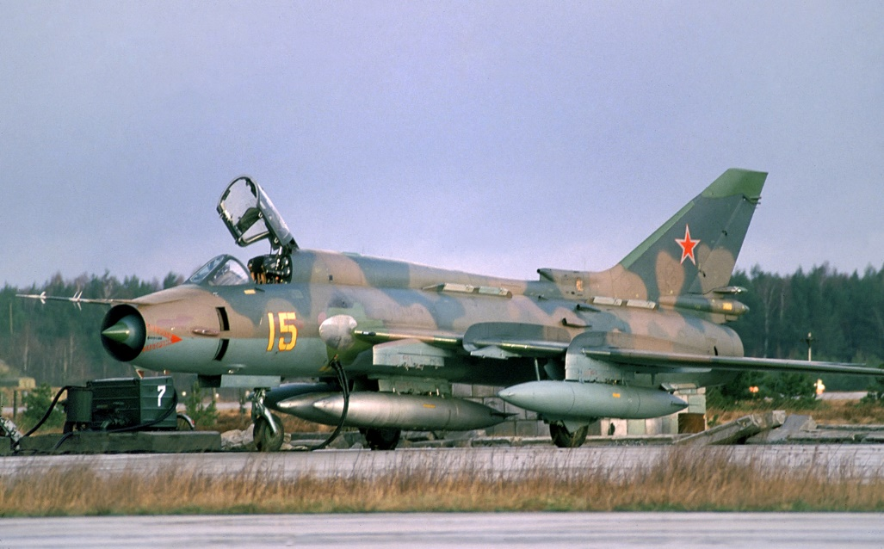

**73rd Air Army**: Equipped with second line aircraft this Air Army conducts some advanced training as well as reinforcing forces in either Central Asia, Turkey or the Persian Gulf.

|  |  |  |  |  |  |  |
| --- | --- | --- | --- | --- | --- | --- |
| Corps/Army | Division | Regiment | Location | Number | Aircraft type | Remarks |
|  | 24th Ftr Bmbr | 129th Ftr Bmbr | Taldy-Kurgan | 45 | MiG-23BN |  |
|  |  | 134th Ftr Bmbr | Zhangiz-Tobe | 45 | MiG-23BN |  |
|  | 10Th Trg Ctr | 27th Gds Ftr |  | 60 | MiG-21bis |  |
| Army Units |  | 115th Gds Ftr | Kokaydy | 44 | MiG-29 |  |
|  |  | 156th Ftr | Mary-2 | 42 | MiG-29 |  |
|  |  | 905th Ftr | Taldy-Kurgan | 42 | MiG-23MLD |  |
|  |  | 39th Ind Recon | Balkhash | 4 | MiG-25RB |  |
|  |  |  |  | 12 | MiG-25BM |  |
|  |  |  |  | 5 | Su-24MR |  |
|  |  | 381st Ind Recon | Chimkent |  | Su-17M3R |  |
|  |  | 218th Ind Mix | Alma-Ata |  | Various |  |

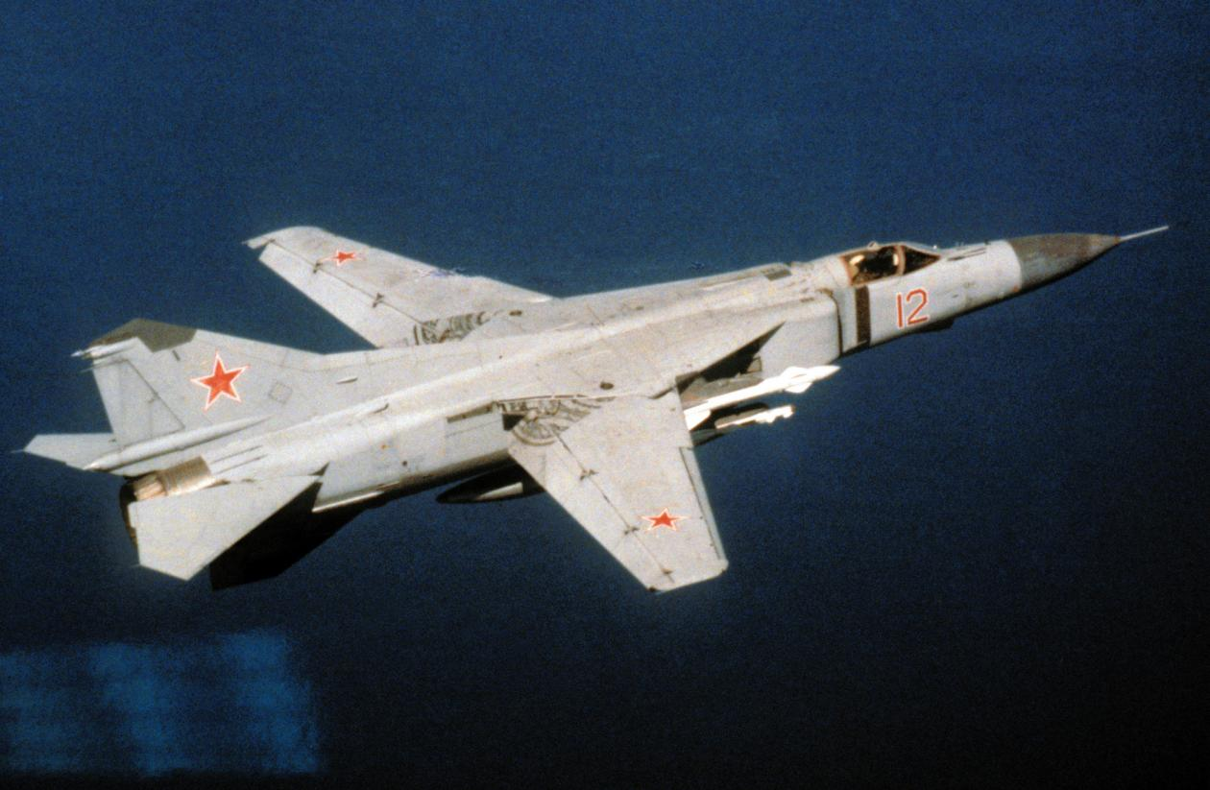

**76th Air Army**: Although headquartered in Leningrad, the primary focus of this Air Army is power projection in the north into Norway and the rest of Scandinavia. Equipped with about 120 each of Su-27 and Su-24, this force should easily overpower NATO defences in the north, especially when reinforced for the operation.

|  |  |  |  |  |  |  |
| --- | --- | --- | --- | --- | --- | --- |
| Corps/Army | Division | Regiment | Location | Number | Aircraft type | Remarks |
|  | 149th Bmbr | 3rd Bmbr | Lebyazhe | 20 | Su-24 |  |
|  |  | 42nd Gds Bmbr | Levashovo | 25 | Su-24M |  |
|  |  | 89th Bmbr | Siverskaya | 25 | Su-24M |  |
|  | 122nd Ftr | 778th Ftr | Levashovo | 41 | Su-27S |  |
|  |  | 768th Ftr | Monchegorsk | 41 | Su-27S |  |
|  |  | 769th Ftr | Poduzhem’ye | 41 | Su-27S |  |
|  | 246th Ftr | 104th Ftr | Marienkhof | 45 | MiG-23MLD |  |
|  |  | 126th Ftr | Dunayevka | 45 | MiG-23MLD |  |
| Army Units |  | 67th Ind Bmbr | Siverskiy-2 | 25 | Su-24M |  |
|  |  | 722nd Ind Bmbr | Smuravevo | 25 | Su-24M |  |
|  |  | 6th Ind Ftr-Bmbr | Veshchevo | 45 | Su-17M3 |  |
|  |  | 98th Gds RB Recon | Monchegorsk | 4 | MiG-25RB |  |
|  |  |  |  | 12 | MiG-25BM |  |
|  |  |  |  | 18 | Su-17M/3R |  |
|  |  | 138th Ind Mixed | Levashovo |  | Various |  |
|  |  | 227th Ind EW Sqn | Levashovo | 15 | Mi-8PPA | SMV |

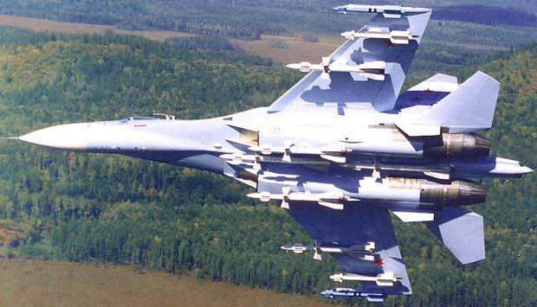

**Moscow Military District:** In addition to providing reinforcing forces forward, the air forces of the Moscow Military District are largely centered on training and demonstration elements. Although combat ready the demonstration teams represent a mixed bag of aircraft and are likely to be broken up as replacements rather than going to war with three or four different aircraft types in a regiment. Much of the training, particularly in 4th Training Division is specific to aircraft type, these will also likely provide ready replacements into combat units.

|  |  |  |  |  |  |  |
| --- | --- | --- | --- | --- | --- | --- |
| Corps/Army | Division | Regiment | Location | Number | Aircraft type | Remarks |
|  | 9th Mixed | 32nd Gds Ftr | Shatalovo | 45 | MiG-23MLD |  |
|  |  | 234th Gds RB Ftr | Kubinka | 16 | Su-27 | Demonstration |
|  |  |  |  | 16 | MiG-29S |  |
|  |  |  |  | 16 | MiG-23MLD |  |
|  |  | 274th Ftr-Bmbr | Migalovo | 38 | Su-17M4 |  |
| District Units |  | 73rd Gds RB Ftr | Shaikovka | 31 | MiG-29M | 4 MiG-23UM |
|  |  | 269th Ind Heli | Malino | 39 | Mi-8 |  |
|  |  | 378th Ind Mixed | Kubinka |  | Various |  |
|  |  | 297th Ind EW | Kubinka | 18 | Mi-8PPA |  |
|  |  | 455th Bmbr | Voronezh | 15 | MiG-25BM | Demonstration |
|  |  |  |  | 15 | Su-24 |  |
|  |  |  |  | 41 | Su-17M3 |  |
|  |  | 47th Gds RB Recon | Shatalovo | 17 | MiG-25RB |  |
|  |  |  |  | 4 | Su-24MR |  |
|  |  |  |  | 16 | Su-17M3R |  |
|  |  | 144th Ind LRRD | Ivanovo | 42 | A-50M |  |
|  | Frunz | 322nd Trg | Frunze-1 | 100 | MiG-21bis |  |
|  |  | 349th Trg | Novotroitskoye | 90 | MiG-23UB |  |
|  |  |  |  | 120 | L-29 |  |
|  |  | 715th Trg | Lugovaya | 22 | MiG-29 |  |
|  |  | 716th Trg | Tokmak-2 | 100 | L-39 |  |
|  | 4th Trg | 91st Instr | Lipetsk | 34 | MiG-29SMT |  |
|  |  |  |  | 15 | Su-27 |  |
|  |  | 760th Instr | Lipetsk | 16 | Su-25BM |  |
|  |  |  |  | 12 | Su-25UB |  |
|  |  |  |  | 16 | Su-25UBM |  |
|  |  |  |  | 41 | Su-17M3 |  |
|  |  |  |  | 34 | MiG-29M |  |
|  | 1080 Trg Ctr | 160th Instr | Borisoglebsk | 34 | MiG-29UB |  |
|  |  |  |  | 60 | MiG-21 |  |
|  |  |  |  | 16 | Su-25BM |  |
|  |  |  |  | 12 | Su-25UB |  |
|  |  |  |  | 16 | Su-25UBM |  |
|  |  | 186th Instr | Buturlinovka | 44 | Su-25A |  |
|  |  | 281st Instr | Totskoye | 66 | MiG-23UB |  |
|  |  | 343rd Instr | Sennoy | 42 | MiG-29UB |  |
|  | Tambov School | 127th Trg | Atashovo | 112 | L-39 |  |
|  |  | 644th Trg | Michurinsk | 108 | L-39 |  |
|  |  | 652nd Trg | Tambov | 96 | L-29 |  |
|  |  |  |  |  | Tu-134UBL |  |

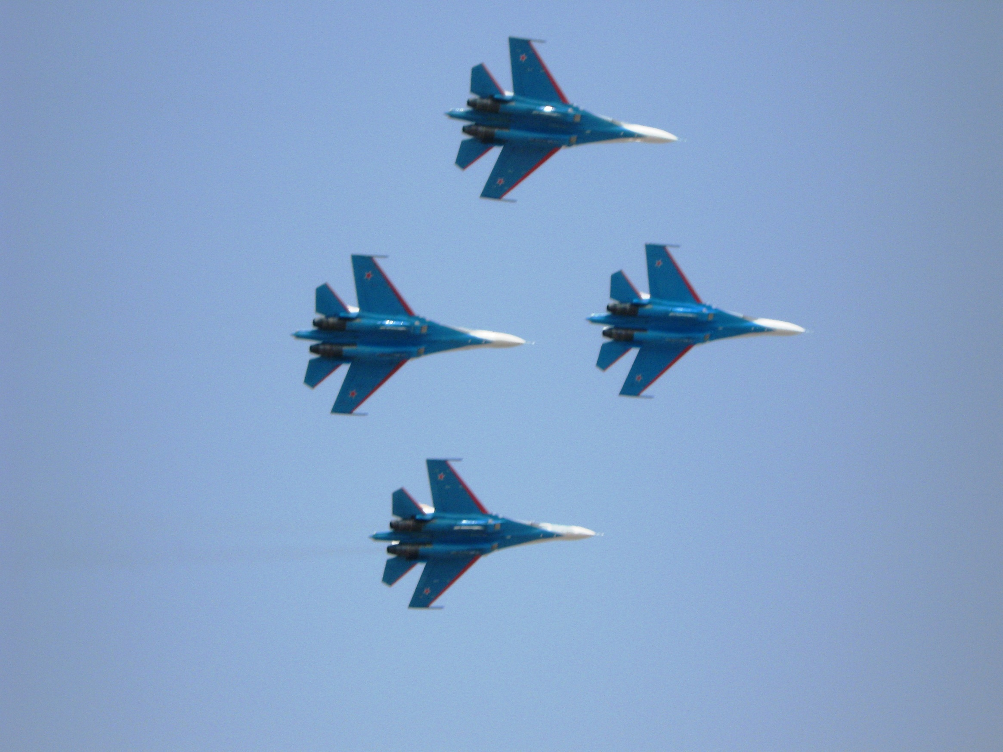

**North Caucasus Military District:** Almost exclusively devoted to training of Fighter Bomber units, this Air Command also conducts a significant amount of basic flight training as well.

|  |  |  |  |  |  |  |
| --- | --- | --- | --- | --- | --- | --- |
| Corps/Army | Division | Regiment | Location | Number | Aircraft type | Remarks |
|  |  | 138th Ind Mixed | Rostov |  | Various |  |
|  | 1070 Trg Ctr | 707th Trg | Lebyazhe | 46 | MiG-23BN |  |
|  |  |  |  | 46 | MiG-23UB |  |
|  |  | 963rd RB Trg | Taganrog | 70 | Su-17UM |  |
|  |  |  |  | 50 | Su-17UM3 |  |
|  | Borisoglebsk | 123rd Trg | Zherdevka | 92 | MiG-23UB |  |
|  | Kacha School | 122nd Trg | Morozovsk | 88 | L-39 |  |
|  |  |  |  | 88 | L-29 |  |
|  |  | 704th Trg | Kotelnikovo | 110 | MiG-21bis |  |
|  |  |  |  | 54 | L-39 |  |
|  |  | 706th Trg | Beketovsk | 80 | L-39 |  |
|  |  |  |  | 84 | L-29 |  |
|  | Yeysk School | 106th Trg | Zernograd | 80 | L-39 |  |
|  |  |  |  | 100 | L-29 |  |
|  |  | 801st Trg | Bataysk | 80 | L-39 |  |
|  |  |  |  | 100 | L-29 |  |
|  |  | 959th Trg | Yeysk | 80 | L-39 |  |
|  |  |  |  | 100 | L-29 |  |
|  | Krasnodar Tech | 797th Trg | Kushevskaya | 108 | MiG-21bis | Foreign Trg |
|  |  | 802nd Trg | Krasnodar | 12 | Su-25BM |  |
|  |  |  |  | 16 | Su-25UB |  |
|  |  |  |  | 16 | Su-25UBM |  |
|  |  |  |  | 15 | Su-24 |  |
|  |  |  |  | 70 | Su-22 |  |
|  |  | 960th Trg | Primorsko | 120 | L-39 |  |

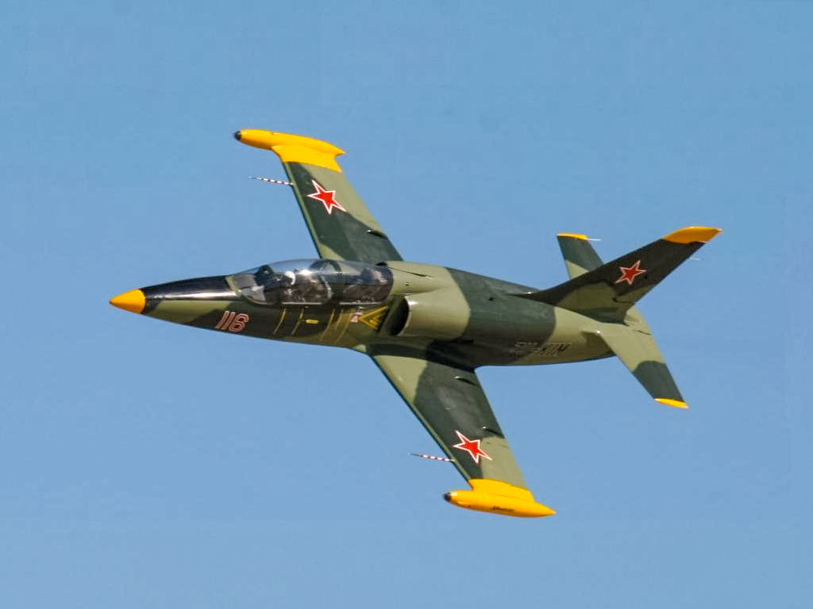

**Siberian Military District:** Focused entirely on basic flight and basic fighter/interceptor training.

|  |  |  |  |  |  |  |
| --- | --- | --- | --- | --- | --- | --- |
| Corps/Army | Division | Regiment | Location | Number | Aircraft type | Remarks |
| Barnaul School |  | 44th Trg | Kalmanka | 100 | L-29 |  |
|  |  |  |  | 62 | L-39 |  |
|  |  | 59th Trg | Slavgorod | 120 | MiG-21bis |  |
|  |  | 96th Trg | Kamen-na-Ob | 120 | MiG-21bis |  |

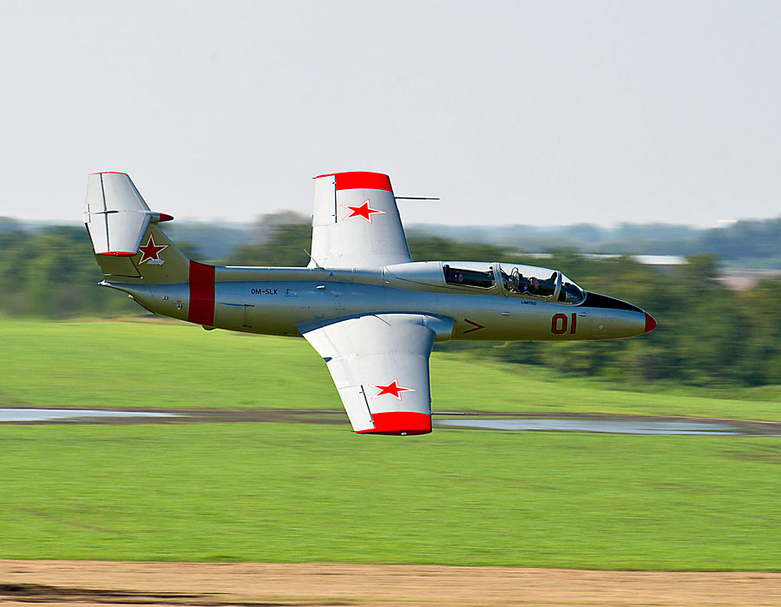

**Volga Military District:** The Volga Military District conducts both transport and helicopter training in addition to basic flight training for its students.

|  |  |  |  |  |  |  |
| --- | --- | --- | --- | --- | --- | --- |
| Corps/Army | Division | Regiment | Location | Number | Aircraft type | Remarks |
|  | Balashov School | 478th Trg | Petrovsk |  | An-26 | Transport Trg |
|  |  |  |  |  | L-410 |  |
|  |  | 606th Trg | Balashov |  | An-26 |  |
|  |  | 666th Trg | Rtischchevo | 70 | L-410 |  |
|  | Orenburg School | 750th Trg | Orsk |  | Tu-134UBL |  |
|  |  | 814th Trg | Orenburg-2 | 100 | L-29 |  |
|  |  | 904th Trg | Chebenki | 107 | L-29 |  |
|  |  | 910th Trg | Sol-Iletsk | 100 | L-29 |  |
|  | Syzran School | 131st Heli Trg | Sokol | 125 | Mi-8 |  |
|  |  | 484th Heli Trg | Syzran | 87 | Mi-24 |  |
|  |  | 626th Heli Trg | Pugachev | 136 | Mi-8 |  |
|  | Saratov School | 95th Heli Trg | Serdobsk |  | Mi-8 | Disbanded |
|  |  |  |  |  | Mi-2 |  |
|  |  | 437th Heli Trg | Ozinki |  | Mi-8 | Disbanded |
|  |  |  |  |  | Mi-2 |  |
|  | Ufa School | 198th Heli Trg | Davlekanovo | 168 | Mi-2 |  |
|  |  | 330th Heli Trg | Krasnyy Yar | 98 | Mi-8 |  |
|  |  | 851st Heli Trg | Bezenchuk | 139 | Mi-2 |  |
|  | Chelyabinsk | 108th Trg | Shadrinsk |  | Tu-134Sh | Navigation Trg |
|  |  | 604th Trg | Shagol |  | Tu-134Sh |  |
|  |  |  |  |  | An-26Sh |  |
|  |  |  |  |  | Tu-134UBL |  |
|  |  | 605th Trg | Kamensk-Uralskiy |  | Tu-134Sh |  |
|  |  | 607th Trg | Yuzhno-Uralskiy |  | Tu-134Sh |  |

