**Vertical Take Off and Landing (**[**VTOL**](http://www.airvectors.net/avredvt.html)**)** aircraft

Soviet VTOL aircraft designs closely parallel experimentation in the west, particularly British development of the technology. The original Harrier Jump Jet developing about the same time as the Yak-38 Forger

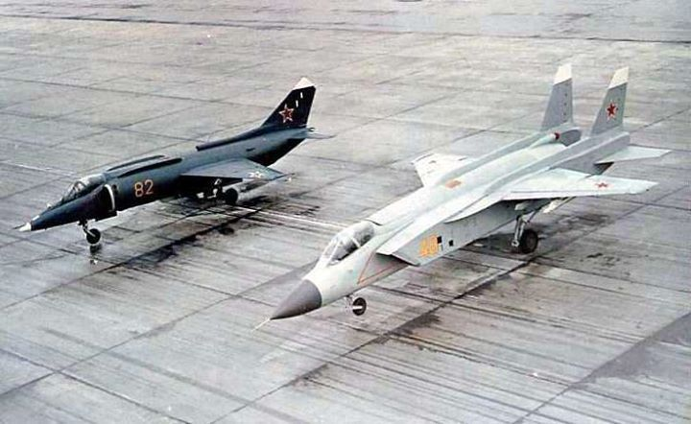

[**Yak-38 Forger**](https://en.wikipedia.org/wiki/Yakovlev_Yak-38)

Developed primarily for the Navy to provide a capable fixed wing ground support and air superiority fighter for the newly developing Kiev class aircraft carriers in the 1970s. These aircraft were a disappointment, both underpowered and short ranged they could only carry a limited bomb load and were not overly effective in air combat. About 140 of the original airframe were built but these have all been scrapped, what remains are 48 Yak-38M airframes with an improved engine with marginally better performance, and 38 Yak-38U twin seat trainers. Each of the Kiev class carriers has an air group with 12 Forgers.

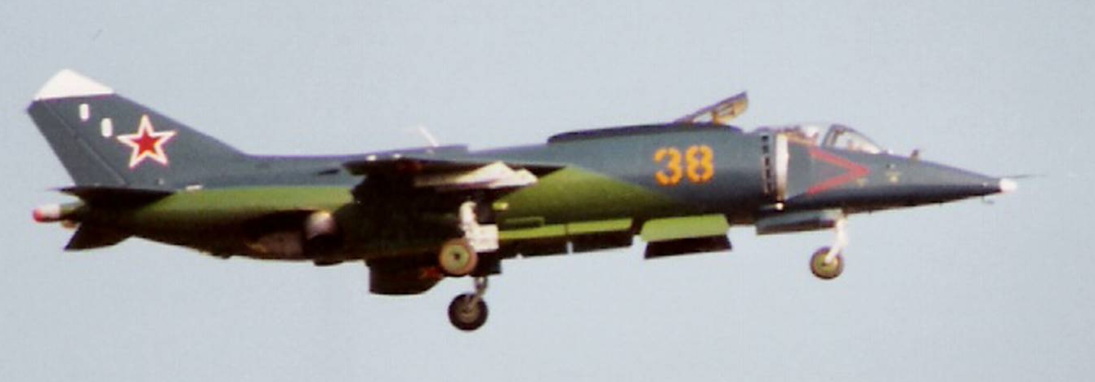

[**Yak-141 Freestyle**](https://en.wikipedia.org/wiki/Yakovlev_Yak-141)

A significantly improved VTOL aircraft to replace the Yak-38, the Freestyle never reached production due to the collapse of the Soviet Union. In Northern Fury however, they are built and 36 are available to the fleet at the start of the war.

Much more sophisticated, powerful and capable, the Freestyle prototypes accumulated several world class records during testing. They are able to use precision munitions, advance air to air missiles and were capable of supersonic flight.

In Northern Fury, each of the Kiev class carriers operates between 4 and 7 Freestyles while the remainder are make operationally ready.

