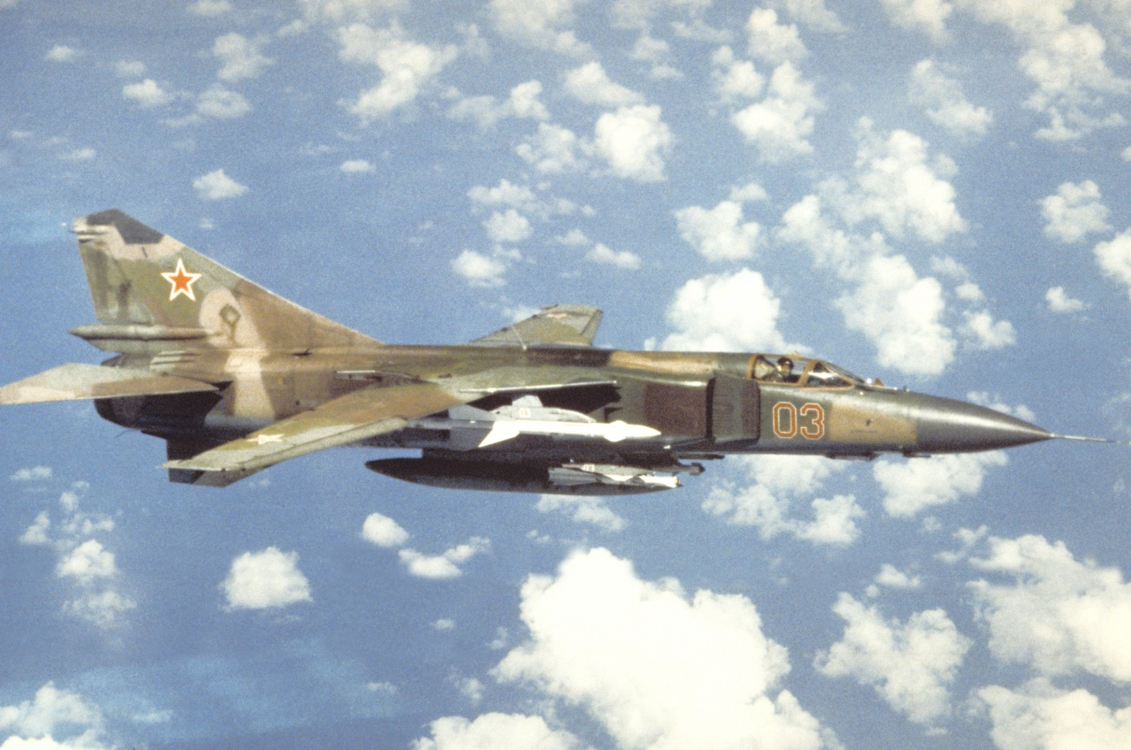

**[MiG-23 and MiG-27 ‘Flogger’](http://www.airvectors.net/avmig23.html)**

The MiG-23 Flogger is a mainstay in the Soviet Air Forces, primarily in the VVS (Frontal Aviation) but also in the PVO (Air Defence Forces), it is not used by the Naval Aviation Forces. Over 5000 aircraft were produced by 1985 and it was widely exported to almost every Soviet aligned country in the world with the two largest users being Syria and India. Further, there were over 1000 ground attack [MiG-27s](https://en.wikipedia.org/wiki/Mikoyan_MiG-27) built, and many of these were also exported.

The Flogger is considered a ‘3rd Generation’ fighter, of an age and ability equivalent to the American F-4 Phantom or French Mirage F.1 or Mirage III. It is a variable geometry fighter with a ‘look down/shoot down) capability. Later versions tended to specialize into the Air Defence or Ground Attack role which culminated in the MiG-27, so this is not a true multirole aircraft, but more of an aircraft which could conduct multiple tasks.

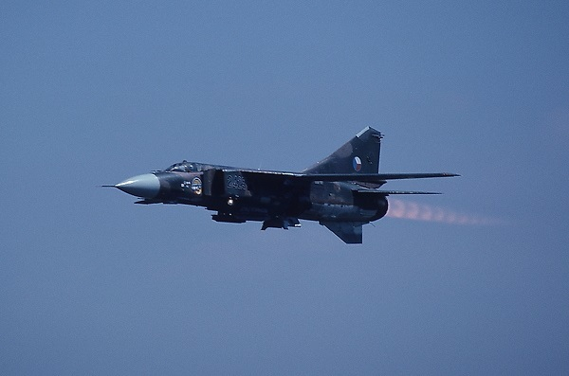

There are a bewildering array of variants and types which are all considered MiG-23 ‘Floggers’, for ease of categorization I’ll list them in line with the NATO identification:

**Flogger A**: Consisting of four variants which include prototype and early production models. Less than 200 were built all told and they considered a cumbersome disappointment, all were withdrawn from front line service by 1978.

**Flogger B/E**: With a much improved engine and a new wing as well as numerous other improvements, the MiG-23M, ‘MF’ and ‘MS’ types were becoming useful. Now able to engage targets Beyond Visible Range (BVR) with radar controlled R-23R (AA-7 Apex) missiles. The ‘MF’ was an export version with downgraded avionics and radar function for Warsaw Pact allies, even more downgraded for Cuba, India and Syria. Finally the ‘MS’ with even more downgrades was provided to other African and Middle Eastern counties and were known as the Flogger E. In total about 1300 of these were built with about 500 remaining in Soviet service, almost all in reserve status.

**Flogger C**: This was a two seat training version, initially built as the MiG-23U, then with an improved engine the new built and upgraded ‘U’ variants were called the MiG-23UB. There were 769 built including exports.

**Flogger D/F/H**: The initial ground attack variant which eventually became the MiG-27 focused on air to ground ordinance. The MiG-23B (Flogger F) had a limited production run of 24, the MiG-23BK and ‘BN’ (Flogger H) were export versions with about 100 of the 624 aircraft used by the Soviets and the rest exported. The main bombe version used by the VVS was the MiG-27 Flogger D, initially introduced as the ‘BM’ version of the base airframe. There were 360 MiG-27 built in the mid-1970s but these were all upgraded to the Flogger J.

**Flogger G**: The next evolution was a specialized air defence variant. For the PVO this was the MiG-23P and they obtained about 500 of them. The VVS used the ‘ML’ and ‘MLA’ versions – of the 1100 built, about 200 were exported in two different versions of downgrade and 800 were upgraded to ‘MLD’ versions (Flogger K, below). Historically only 560 were upgraded but an additional push was made in Northern Fury.

**Flogger J**: This is a baseline MiG-27 with a substantially upgraded avionics suite, a laser designator and camera targeting system for using precision guided munitions (PGM). This version was the MiG-27K (Flogger J2) and 200 were built. The actual Flogger J was a derivative of the ‘K’ version, the MiG-27M and 162 of these were built. All 360 of the previously built MiG-27s were upgraded to the ‘M’ standard as the MiG-27D. The MiG-27 ML was an export version provided to India. In total then, the Soviet VVS operated 722 Flogger J.

**Flogger K**: The definitive fighter variant of the MiG-23, it has improved maneuverability, is stronger, has improved avionics, a better radar, more and better defensive measures and able to use better air to air missiles. This Flogger cannot match an F-15 but will give F-16s, Mirage-2000s and Tornados a hard time. 800 MiG-23ML/MLA versions were upgraded to this standard (as opposed to the 560 that were modernized historically).

|  |  |  |  |  |  |
| --- | --- | --- | --- | --- | --- |
|  |  | VVS | PVO | Reserve | Remarks |
| Flogger A | MiG-23 |  |  | 200 |  |
| Flogger B | MiG-23M/MF/MS | 100 |  | 400 |  |
| Flogger C | MiG-23UB | 400 | 300 |  | Remainder exported |
| Flogger H | MiG-23B/BK/BN | 124 |  | 24 |  |
| Flogger G | MiG-23P |  | 500 |  |  |
| MiG-23ML/MLA | 100 |  |  |  |
| Flogger J | MiG-27K | 200 |  |  |  |
| MiG-27M | 162 |  |  |  |
| MiG-27D | 360 |  |  |  |
| Flogger K | MiG-23MLD | 800 |  |  | Increase for NF |
| Totals |  | 1622 | 800 | 624 |  |

