**KARELIAN FRONT**

In addition to the air and naval forces based on and around the Kola Peninsula, the major Army formation under North-Western TVD’s command is the KARELIAN FRONT, a formation last used in the Second World War. The KARELIAN FRONT is responsible for controlling all land forces in North-Western TVD and in addition to security of the Leningrad MD has the task of seizing Norway and other areas.

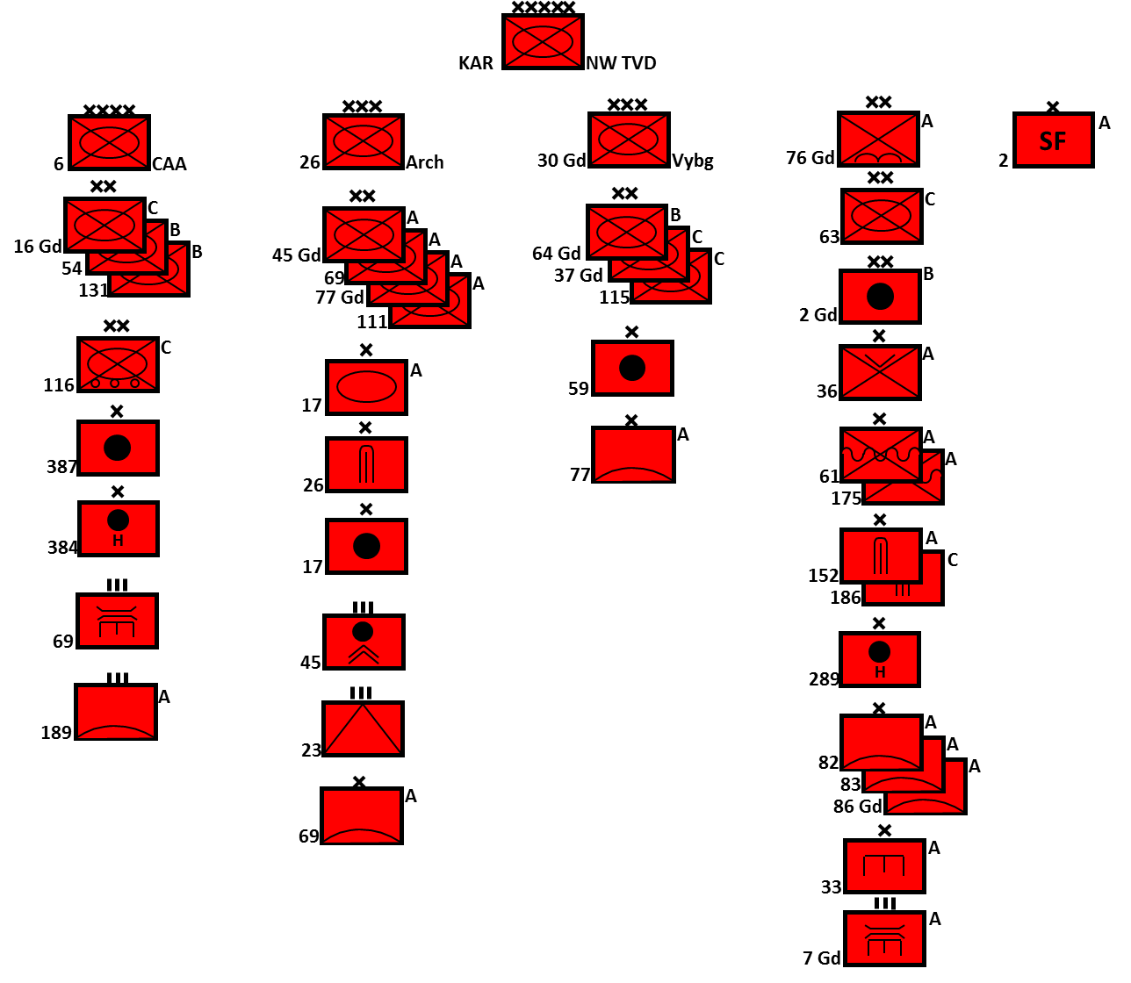

In a retrospectively obvious attempt at disinformation and deflection, the 6th Combined Arms Army (CAA) was significantly weakened in the months leading up to the start of hostilities while some shuffling occurred in the other formations. The lead formation of the Front became the 26th Army Corps, now referred to by the historical name **Archangel Corps**.

* **Archangel Corps (26th Army Corps)**, significantly reinforced from its pre-coup structure is responsible for seizing Norway. In the year preceding hostilities, the 115th Mobilization Motor Rifle Division (MRD) was shifted to the 30th Guards Army Corps (Vyborg Corps) in exchange for the full strength 45th Guards and 11th MRDs. Additionally, the 17th Tank Brigade which was formally known as the 6th Independent Guards ‘Berlin’ Motor Rifle Brigade, was added.
  + 45th Gds MRD (T-80, BMP-2, BTR-70/80)
  + 69th MRD (T-64/72, BMP-2, BTR-70/80)
  + 77th Gds MRD (T-80, MTLB)
  + 111th MRD (T-72, MTLB, BTR-60/70)
  + 17th Tank Brigade (T-72/64, BMP-3, BTR-80)
* **Vyborg Corps (30th Guards Army Corps)**, remains in the role of defending the Finnish frontier from Vyborg to Rayakoski, although it is heavily weighted to the south. The 37th Guards and the newly arrived 115th MRDs are now mobilized and both have a full Tank Regiment (TR). The 64th Guards MRD only has only a Tank Battalion but is equipped with very modern T-80s and, although rated as a Category ‘B’ Division, this formation is well trained and capable of offensive operations.
  + 64th Gds MRD (T-80/54, MTLB, BTR-50/60)
  + 37th Gds MRD (T-80/64, BMP-1, MTLB, BTR-60)
  + 115th MRD (T-64, BMP-1, BTR-60, BTR-152)
* **6th Combined Arms Army (CAA)** forms the second echelon force to the **Archangel Corps** but its primary role is the defence of the Kola Peninsula. Although Plan BOYAR calls for 6th CAA to occupy Norway once that country has collapsed, in its current construct this formation lacks offensive punch with only one BMP equipped Motor Rifle Regiment (MRR) and less than 200 modern tanks.
  + 16th Gds MRD (T-72/54, BMP-1, MTLB, BTR-152)
  + 54th MRD (T-80/54, BTR-60, MTLB, BTR-152)
  + 116th MRD (T-54, truck mounted infantry)
  + 131st MRD (T-80/54, MTLB, BTR-152)

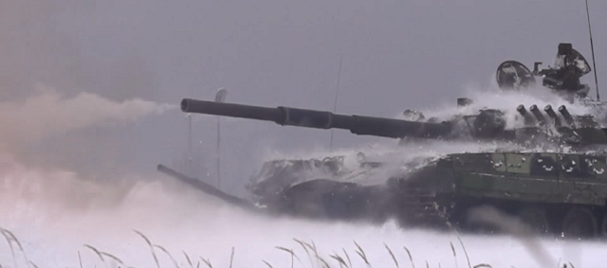

Supporting activities are controlled directly by the Front HQ and coordinated with the Northern Fleet, 76th Air Army, 6th and 10th Air Defence Armies as well as forces directly controlled by the Leningrad MD (such as 18th Air Defence Corps). The primary object of these operations is to reinforce the efforts of **Archangel Corps** or to distract and confuse NATO reactions.

**Operations in Norway**: For the most part the remainder of the Front troops, particularly 36th Air Landing (AL) Brigade, Naval Infantry, 2nd Guards Artillery Division and the bulk of the other artillery, engineering air defence and logistics (not shown above) units are supporting operations in Norway. Further, a large portion of 2nd Spetsnaz Brigade is involved in Norway. These elements fall into three broad roles: maneuver such as the AL, NI and Spetsnaz elements; fire support including artillery and air defence; and maneuver support including engineering and logistics forces.

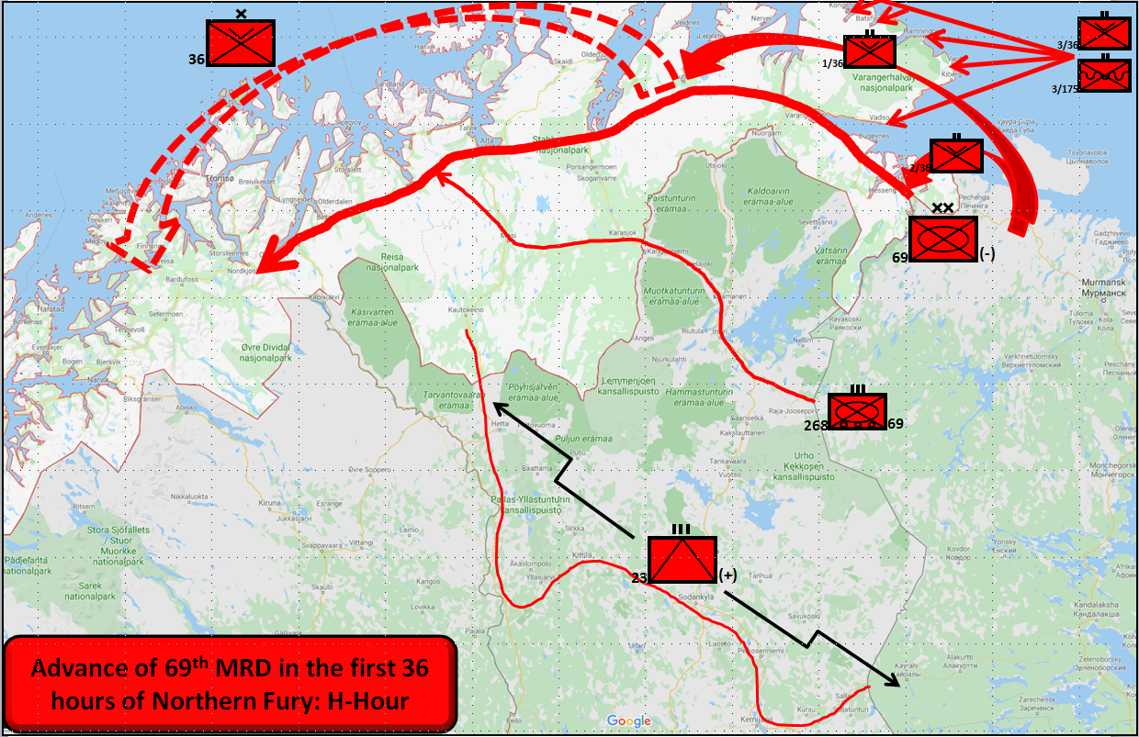

**SUPPORTING OPERATIONS**: Activities in Norway will consume the bulk of North-Western TVD’s attention and resources, but there is plenty of scope for other thrusts aimed at disrupting NATOs response by providing multiple dilemmas to deal with. To quote from the Commander North-Western TVD – “The Americans might have coined the phrase ‘Shock and Awe’, but it was the Russians who invented it!”

