**Soviet Littoral ASW Ships**

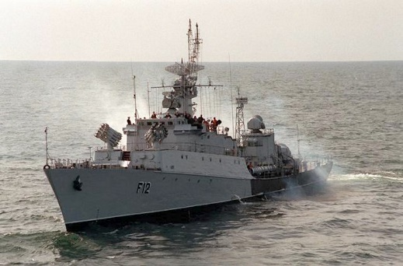The Soviet Navy relied heavily on small ships for coastal defence and littoral Anti Submarine Warfare (ASW) patrols. These ships are generally between 250 and 1000 tons and are suitable only for coastal duties under friendly air cover. Although most of these ships are considered Corvettes by traditional measure, the Soviets call them ‘Small Anti-Submarine Ship’ (‘Maly Protivolodochny Korabl' MPK).

[**Grisha Class**](https://en.wikipedia.org/wiki/Grisha-class_corvette)

This class of ASW corvette was built in five different versions. All of the Grisha I ships were retired but there are 82 of the other four sub-classes in operation. All are about 1000 tons, with a crew of 60 and a top speed of 34 knots.

|  |  |  |  |  |  |  |  |  |
| --- | --- | --- | --- | --- | --- | --- | --- | --- |
| Class | Total | Northern | Pacific | Black Sea | Baltic | Guns | SAM | Remarks |
| Grisha II | 17 | 7 | 4 | 4 | 2 | 2x2 57mm | none |  |
| Grisha III | 34 | 16 | 8 | 5 | 5 | Twin 57mm | 20x SA-N-4 | 30mm CIWS |
| Grisha IV | 1 | 1 |  |  |  | Twin 57mm | 24x SA-N-9 | 30mm CIWS |
| Grisha V | 30 | 15 | 10 | 5 |  | 1x 76mm | 20x SA-N-4 | 30mm CIWS |

[**Pauk Class**](https://en.wikipedia.org/wiki/Pauk-class_corvette)

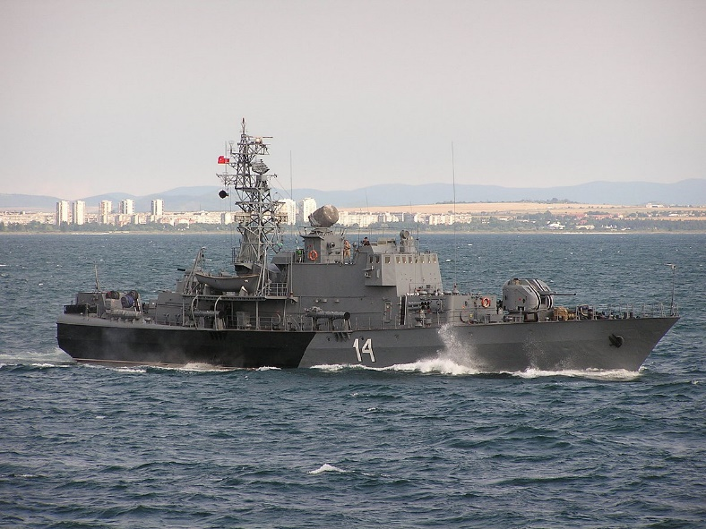At half the size of the Grisha class, the Pauk or Molniya-2 class have some limitations, their Variable Depth Sonar (VDS) is active only, the air defence is the much less capable [SA-N-5 Grail](https://en.wikipedia.org/wiki/9K32_Strela-2), essentially a pedestal mounted MANPADS (Man portable Air Defence System), and it only has 1/3 the fuel range. But the ASW weapons are similar and it has both a 76mm gun and a 30mm CIWS (Close in Weapon System). The Soviet Navy operated 42 of these ships after transferring one to Cuba and two to Bulgaria.

|  |  |  |  |  |  |  |
| --- | --- | --- | --- | --- | --- | --- |
| Class | Total | Northern | Pacific | Black Sea | Baltic | Remarks |
| Pauk | 42 | 20 | 8 | 6 | 8 |  |

[**Parchim II Class**](https://en.wikipedia.org/wiki/Parchim-class_corvette)

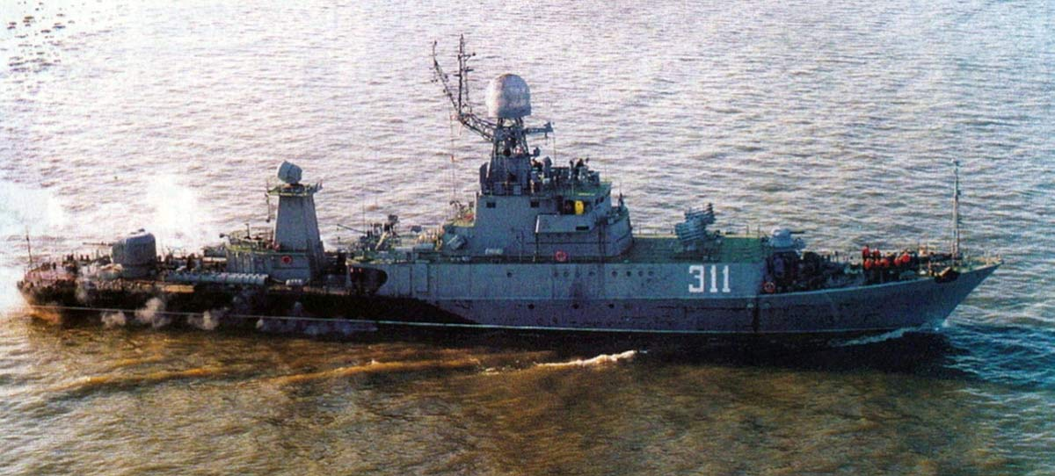These ships did not fit into the Soviet plan for ASW ships but were purchased from and built in East Germany, essentially subsidizing this class for the DDR. They are 800 tons, with a crew of 80, double the complement of a Pauk and larger than the Grisha. These ships have the same guns as the Grisha and the same air defence as the Pauk – the weaker in both cases. They do have an active/passive VDS similar t the Grisha with similar ASW armaments.

|  |  |  |  |  |  |  |
| --- | --- | --- | --- | --- | --- | --- |
| Class | Total | Northern | Pacific | Black Sea | Baltic | Remarks |
| Parchim II | 12 | 6 |  |  | 6 |  |

[**Stenka Class**](https://en.wikipedia.org/wiki/Stenka-class_patrol_boat)

Called an ASW patrol boat, these are built on the same hull as the famous Osa class missile boats. At only 180 tons with a crew of 32 these potent little ships have the same VDS as the Grisha class and can engage with torpedoes, depth charges or machine guns. Its only air defence however is two 30mm CIWS Gatling guns. Of the 117 built, nine have been transferred (4 to Cuba, 5 to Cambodia), only five of the remaining are operated by the Navy and the remainder are operated by the KGP Maritime border guard (Coast Guard).

|  |  |  |  |  |  |  |
| --- | --- | --- | --- | --- | --- | --- |
| Class | Total | Northern | Pacific | Black Sea | Baltic | Remarks |
| Stenka | 108 | 50 | 34 | 12 | 12 |  |

