**Soviet Navy Aircraft Carriers**

The Soviets have had a long and difficult relationship with this class of ship. Fundamentally it is not within Soviet Naval doctrine to engage in power projection, but this has traditionally been the main role of an aircraft carrier. Instead, the Soviet fleet tends to use these ships to provide air superiority and/or anti-submarine warfare (ASW) protection for other major units, particularly submarines and especially Ballistic Missile Submarines (SSBN). The hard line government in northern Fury however has other ideas; it sees the fleet as a tool to be used aggressively to achieve strategic goals, in other words – power projection.

[**Kuznetsov Class**](http://www.military-today.com/navy/kuznetsov_class.htm)

The panicle of Soviet naval aviation is this class of two medium sized nuclear powered carriers. They do not compare favorably to American fleet carriers but they are much more capable than anything that European NATO countries have. These are called Aviation Cruisers in Russian, and that is an important distinction – they have many of the characteristics of an air defence and ASW cruiser, and they carry aircraft. The ship is equipped with 12 of the appropriately named Shipwreck ([SS-N-19](http://www.ausairpower.net/APA-Rus-Cruise-Missiles.html#mozTocId109867)) missiles, 192 Gauntlet ([SA-N-9](http://weaponsystems.net/weaponsystem/EE05%20-%20SA-15%20Gauntlet.html)) Surface to Air Missiles (SAM), Anti-Submarine Warfare (ASW) and close in defence weapons. Aircraft include a wing of 24 [Su-33](http://www.military-today.com/aircraft/su_33.htm) air superiority fighters, 8-12 [Ka-27](http://www.military-today.com/helicopters/kamov_ka27_helix.htm) and 3 [Ka-31](http://www.military-today.com/helicopters/kamov_ka31.htm) (often called Ka-27RLD) Airborne early warning (AEW) helicopters. Historically the Su-33 was being developed in the late ‘80s but that was stalled in the early ‘90s, Northern Fury has that development continuing with 60 of them ready by 1994. Another major change in this alternate history is the second ship in this class. The Varyag was launched in 1988 but never completed, eventually she was sold to the Chinese, restored and entered service with them in 2012. Northern Fury has her completed under tight security and being and unpleasant surprise for NATO. Both ships are in the Northern Fleet and based at Severomorsk.

|  |  |  |  |  |
| --- | --- | --- | --- | --- |
| Class | Pennant | Name | Status | Remarks |
| Kuznetsov | 063 | Admiral Kuznetsov | Northern Fleet | Flagship Northern Fleet |
| Varyag | 077 | Varyag | Northern Fleet |  |

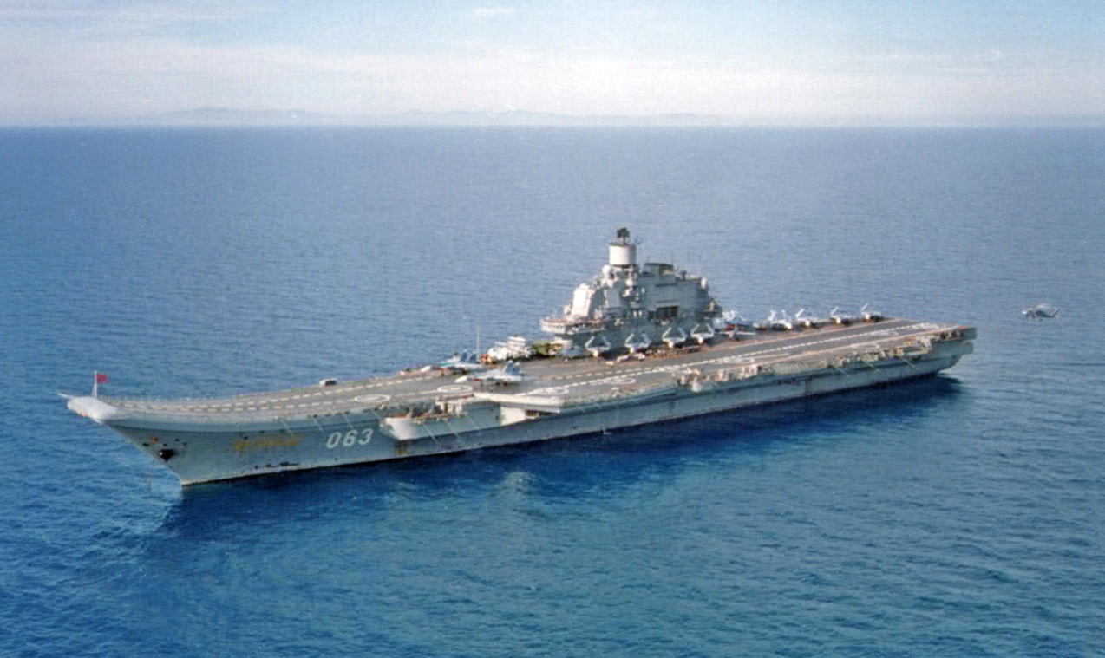

[**Kiev Class**](http://www.military-today.com/navy/kiev_class.htm)

These four ships were very much more of a hybrid cruiser and carrier than the Kuznetzov. Commissioned between 1975 and 1987, all were scrapped or sold by 1993 in the real world, in Northern Fury they were all retained. The anti-air, anti-surface and ASW armament varied between them, to the point that some references categorize them as three different classes. As for air groups – these were primarily ASW by design with 16 Ka-27, including 2 or 3 AEW versions, but they also included the [Yak-38](http://www.airvectors.net/avredvt.html) Vertical Take Off and Landing (VTOL) fighter to provide limited strike and air superiority, in Northern Fury the historically canceled [Yak-41 Freestyle](http://www.military-today.com/aircraft/yak_141.htm) was also coming on line.

|  |  |  |  |  |
| --- | --- | --- | --- | --- |
| Class | Pennant | Name | Status | Remarks |
| Kiev | 121 | Kiev | Northern Fleet |  |
|  | 011 | Minsk | Pacific Fleet |  |
|  | 137 | Novorossiysk | Pacific Fleet | Pacific Fleet Flagship |
|  | 103 | Baku | Northern Fleet |  |

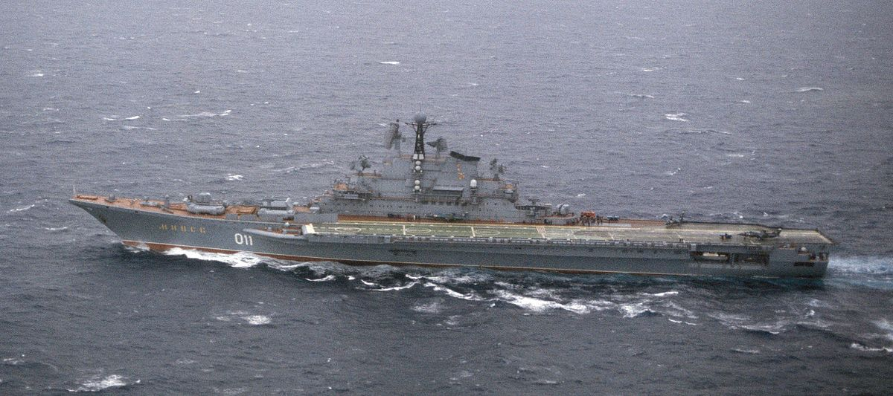

[**Moskva Class**](https://en.wikipedia.org/wiki/Moskva-class_helicopter_carrier)

The first of the large Aviation Cruisers, the two ships of the Moskva class were commissioned in the late ‘60s and were plagued with mechanical and seaworthiness problems. They spent most of their life in the Mediterranean and Black Seas. Unlike the later designs, these are pure helicopter carriers; they only have self-defence weapons systems and are unable to embark fixed wing aircraft, although a Yak-38 could use the deck in emergencies. They can carry 18 helicopters a mix of the Ka-27 and the older [Ka-25](http://www.military-today.com/helicopters/kamov_ka25_hormone.htm).

|  |  |  |  |  |
| --- | --- | --- | --- | --- |
| Class | Pennant | Name | Status | Remarks |
| Moskva | 113 | Moskva | Black Sea/Med | Flagship Black Sea Fleet |
|  | 109 | Leningrad | Black Sea/Med |  |

