**Soviet Navy Cruisers**

Cruisers are key warships in the Soviet Navy’s arsenal; they provide both area air defence with Surface to Air Missiles (SAM) and area Anti-Submarine Warfare (ASW) systems and striking power in the form of Surface to Surface missiles (SSM). These ships often act as flagships of ASW groups or Surface Action Groups (SAG) but are fully capable of operating alone in low threat enviornments.

[Kirov class Battle Cruisers](http://www.military-today.com/navy/kirov_class.htm) (BCGN)

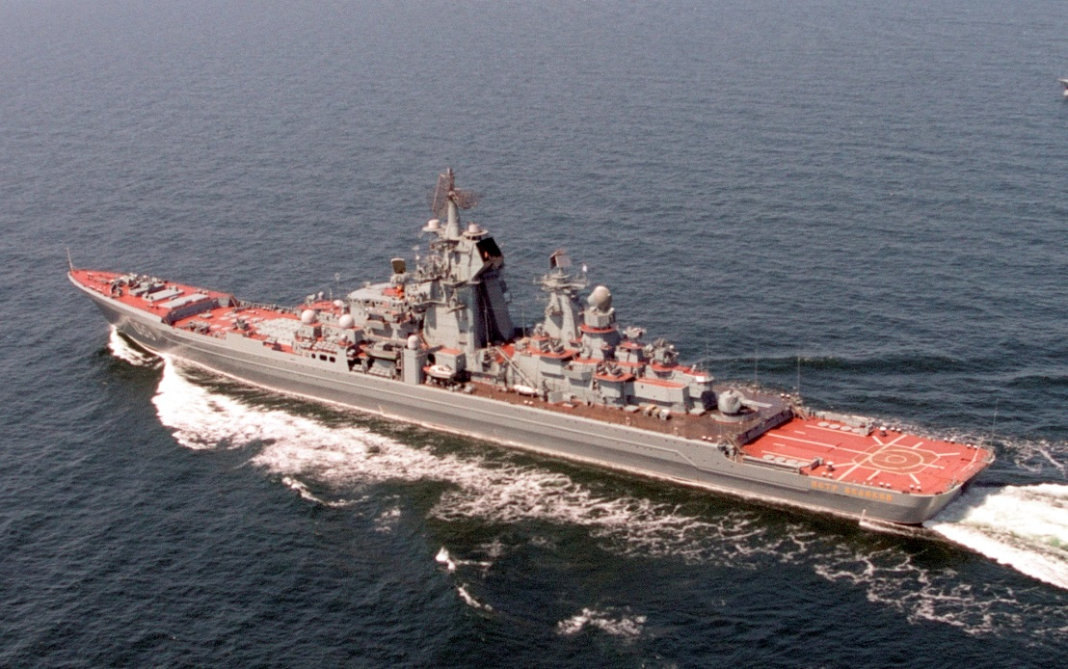These three impressive ships are literally in a class of their own. They were slightly smaller than the US Navy’s Iowa class Battleships, only half the displacement, but much more modern and significantly more capable of surviving. These nuclear powered ships were designed to do two things; hunt and kill American aircraft carriers, or conduct commerce raiding on a grand scale. With 20 Shipwreck ([SS-N-19](http://www.ausairpower.net/APA-Rus-Cruise-Missiles.html#mozTocId109867)) missiles capable of engaging out to 300 nautical miles with a 750kg (1,650lb) conventional or a nuclear warhead, the idea is to hit hard and withdraw. If attacked the Kirov class is more than capable of defending itself with three layers of air defence: 96x [SA-N-6](https://fas.org/nuke/guide/russia/airdef/s-300pmu.htm) area air defence SAMs, 128x [SA-N-9](http://www.military-today.com/missiles/tor.htm)  short range SAMs, and 40x [SA-N-4](http://weaponsystems.net/weaponsystem/EE05%20-%20SA-8%20Gecko.html) point defence SAMs as well as six Close in Weapons System (CIWS) [Kashtan](https://en.wikipedia.org/wiki/Kashtan_CIWS) gun/missile systems. These ships will normally operate three Ka-27 helicopters, when operating separate from air support one of these will be an AEW variant. A fourth ship is under construction but will be at least a year before commissioned (Yuri Andropov, named Petr Veliky by Russia). Although these ships will often lead powerful SAGs, when combined with an aircraft carrier, their ability to penetrate NATOs defences is greatly improved with the added air superiority cover.

|  |  |  |  |  |
| --- | --- | --- | --- | --- |
| Class | Pennant | Name | Status | Remarks |
| Kirov | 080 | Kirov | Northern Fleet |  |
|  | 052 | Frunze | Pacific Fleet |  |
|  | 015 | Kalinin | Northern Fleet |  |

[**Slava Class**](http://www.military-today.com/navy/slava_class.htm)

Designated at Missile Cruiser these ships are powerful, adaptable and have significant armament. They are designed to replace many of the older Kynda and Kresta classes but are much more formidable. The primary offensive weapons system is the [SS-N-12](http://www.ausairpower.net/APA-Rus-Cruise-Missiles.html#mozTocId225318) Sandbox, with 16 of these able to reach 550 nautical miles. Defensively, the Slava class is only marginally less capable than the Kirov class fielding a mix of 64x [SA-N-6](https://fas.org/nuke/guide/russia/airdef/s-300pmu.htm) area air defence SAMs, and 40x [SA-N-4](http://weaponsystems.net/weaponsystem/EE05%20-%20SA-8%20Gecko.html) point defence SAMs as well as six CIWS gun systems. They carry one Ka-27 helicopter and have an impressive ASW suite of sensors and weapons. The original Soviet plan was to build 20 of these ships which were reduced to four. In Northern Fury there has been a reduction but to 12 hulls, six of which have already been commissioned.

|  |  |  |  |  |
| --- | --- | --- | --- | --- |
| Class | Pennant | Name | Status | Remarks |
| Slava | 121 | Slava | Northern Fleet |  |
|  | 055 | Admiral Lobov | Pacific Fleet |  |
|  | 011 | Chervona Ukraina | Pacific Fleet |  |
|  | 108 | Oktyabrskaja Revolyutsiya | Northern Fleet |  |
|  | 417 | Admiral Gorshkov | Black Sea Fleet |  |
|  | 713 | Sevastopol | Black Sea Fleet | Newly commissioned |

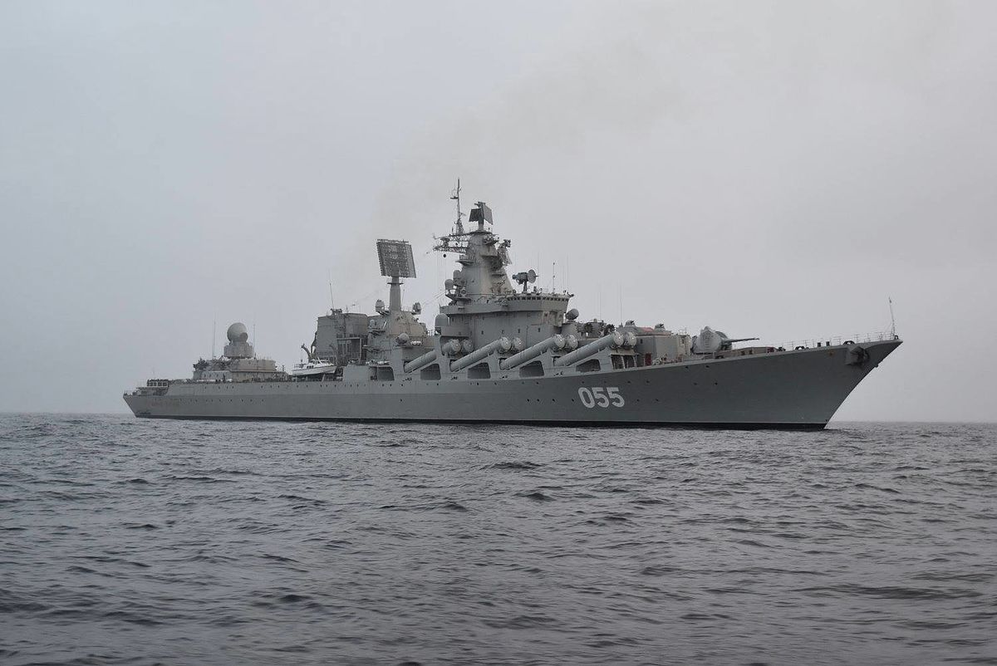

[**Kara Class**](https://en.wikipedia.org/wiki/Kara-class_cruiser)

This seven ship class entered service in the mid ‘70s and were essentially a gas turbine powered version of the previous Kresta II class with improved air defences. The ships have substantial ASW capabilities but by 1994 it is quite dated, although some carry the newer Ka-27 vice the Ka-25 helicopter. These are potent air defence ships, six of the class have a mix of [SA-N-3 Goblet](https://en.wikipedia.org/wiki/M-11_Shtorm) (80 missiles) and [SA-N-4 Gecko](https://en.wikipedia.org/wiki/9K33_Osa) (40 missiles) SAMs, while the Azov was the testbed for the SA-N-6 Grumble (24 missiles) in addition to the standard suite. These ships form the core of the Black Sea Fleet and all are still in service in the Northern Fury world.

|  |  |  |  |  |
| --- | --- | --- | --- | --- |
| Class | Pennant | Name | Status | Remarks |
| Kara | 703 | Nikolayev | Black Sea Fleet |  |
|  | 539 | Ochakov | Black Sea Fleet |  |
|  | 713 | Kerch | Black Sea Fleet |  |
|  | 547 | Azov | Black Sea Fleet | SA-N-6 (Kara Mod) |
|  | 583 | Petropavlovsk | Pacific Fleet |  |
|  | 535 | Tashkent | Pacific Fleet |  |
|  | 657 | Vladivostok | Black Sea Fleet |  |

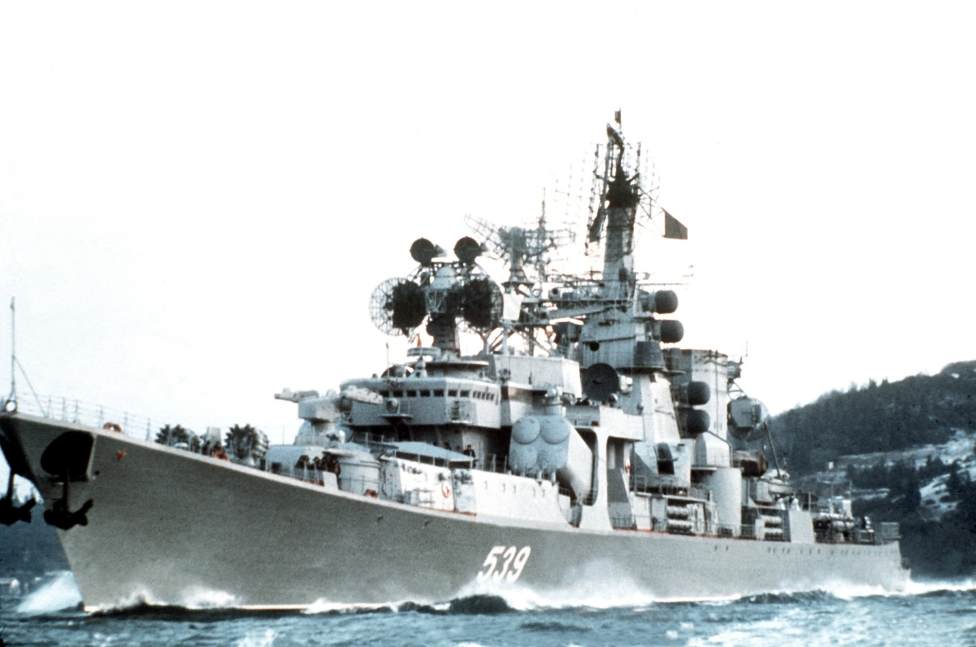

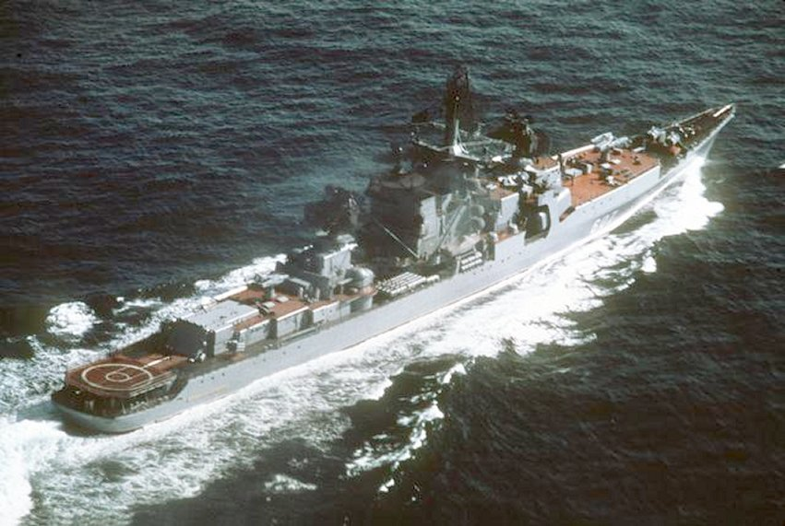[**Kresta II Class**](https://en.wikipedia.org/wiki/Kresta_II-class_cruiser)

These 10 ships were fitted to be an ASW variant of the Kresta I class. They were completed in the early to mid ‘70s and are all still in service for Northern Fury. Equipped with the new (for the time) [SS-N-14 Silex](https://everything2.com/title/SS-N-14+Silex) ASW system, and [SA-N-3 Goblet](https://en.wikipedia.org/wiki/M-11_Shtorm) (40 missiles) air defence SAM, these were quite capable for the time. They operated one Ka-25 helicopter primarily for ASW work.

|  |  |  |  |  |
| --- | --- | --- | --- | --- |
| Class | Pennant | Name | Status | Remarks |
| Kresta II | 657 | Kronstadt | Northern Fleet |  |
|  | 679 | Admiral Isakov | Northern Fleet |  |
|  | 690 | Admiral Nakhimov | Northern Fleet |  |
|  | 635 | Admiral Makarov | Pacific Fleet |  |
|  | 504 | Marshal Voroshilov | Pacific Fleet |  |
|  | 531 | Admiral Oktyabrsky | Pacific Fleet |  |
|  | 688 | Admiral Isachenkov | Northern Fleet |  |
|  | 655 | Marshal Timoshenko | Northern Fleet |  |
|  | 590 | Vasily Chapaev | Pacific Fleet |  |
|  | 627 | Admiral Yumashev | Northern Fleet |  |

[**Kresta I**](https://en.wikipedia.org/wiki/Kresta_I-class_cruiser)

This class was originally intended to have 21 ships but the Navy’s priorities changed in the late ‘60s and the ship was redesigned resulting in the ASW focused Kresta II. The focus for the Kresta I was Anti-surface warfare, but the SSM intended for the class (SS-N-12) was not ready and they were fitted with four [SS-N-3 Shaddock](https://fas.org/nuke/guide/russia/theater/ss-n-3.htm) SSMs. They were equipped with 44 [SA-N-1 Goa](https://en.wikipedia.org/wiki/S-125_Neva/Pechora) SAMs which were completely inadequate by 1994. A Ka-25B helicopter was carried for targeting. ASW defences were limited to hull mounted sonar and torpedoes.

|  |  |  |  |  |
| --- | --- | --- | --- | --- |
| Class | Pennant | Name | Status | Remarks |
| Kresta I | 052 | Admiral Zozulya | Black Sea Fleet |  |
|  | 068 | Vize-Admiral Drozd | Black Sea Fleet |  |
|  | 034 | Admiral Golovko | Pacific Fleet | Renamed from Vladivostok |
|  | 033 | Admiral Isakov | Pacific Fleet | Renamed from Sevastopol |

[**Kynda**](https://en.wikipedia.org/wiki/Kynda-class_cruiser)

Developed in the late ‘50s and commissioned in the early ‘60s these ships were the Soviet Navy’s first missile cruisers and represented a significant leap in capability. By 1994, although all four are still serving, they are long overdue for retirement. They have a similar armament to the Kresta I but no helicopter and older sonar. They are able to fire eight Shaddock missiles then reload for another volley, unfortunately with only 16 SA-N-1 SAMs they may not have a chance. The Grozny is the Flagship of Baltic Fleet.

|  |  |  |  |  |
| --- | --- | --- | --- | --- |
| Class | Pennant | Name | Status | Remarks |
| Kynda | 052 | Groznyy | Baltic Fleet |  |
|  | 068 | Admiral Fokin | Pacific Fleet |  |
|  | 034 | Admiral Golovko | Black Sea Fleet |  |
|  | 033 | Soobrazitelny | Pacific Fleet | Renamed from Varyag |

