**Soviet Navy Destroyers**

The Soviet navy has a large fleet of destroyers, three of the four classes fit the Soviet classification of Large Anti Submarine Warfare (ASW) ships ('bolshoy protivolodochny korabl' or BPK) while the Sovremennys are classified as a true Destroyer because of its anti-ship role (Squadron Mine Vessel ‘Eskadrenny Minonosets’ EM). By most standards however they are classed as Destroyers based on their size, role and weapon suite. All classes are well rounded ocean going ships with the capacity to lead small task groups or form part of an escort for a carrier or battle cruiser. All have an ASW capability but the Udaloy is the master of this domain, while all have some form of anti surface capability, even if simply guns, but the Sovremenny is the best for this task. All have some form of air defence missile capability but the two older classes are very vulnerable due to the age and technology of their defensive systems. In total there are 60 Destroyers in the fleet, and 38 of them are very modern and potent units.

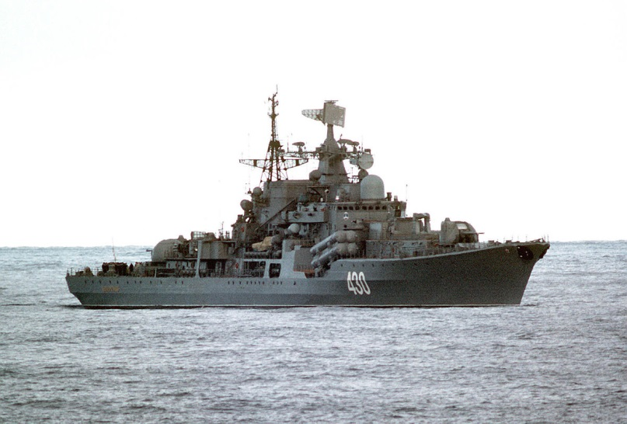[**Sovremenny Class**](https://www.naval-technology.com/projects/sovremenny/)

This is a modern, highly capable destroyer which focuses on the anti-ship and anti-air defences of a task group while augmenting the Udaloy class ships in the anti-submarine warfare (ASW) role. The key weapons for anti-ship strikes are the eight [SS-N-22 Sunburn](https://everything2.com/title/SS-N-22+Sunburn) (P-80 Zubr) hypersonic SSM (Surface to Surface Missile), with a range of 60 nautical miles (130Km) and a 660lb (300Kg) warhead traveling at Mach 2.5. The later ships of this class (hull # 15 and onward) use the SSN-N-22M (P-270 Moskit) which increases the range to 130 nautical miles (240Km). Air defence is achieved by three layered systems; primarily the [SA-N-7 Gadfly](http://www.military-today.com/missiles/buk.htm) Surface to Air Missile (SAM) (48 missiles), two twin turret 130mm dual purpose guns, and finally by four Close in Weapons System (CIWS) 30mm Gatling guns. ASW is a secondary role of these ships and is accomplished with hull mounted sonar, a Ka-27 helicopter and a mix of ASW rocket launchers and torpedoes. All 23 of these ships are in service by the start of Northern Fury, although this is a [more aggressive](https://www.forecastinternational.com/archive/disp_old_pdf.cfm?ARC_ID=1787) schedule than existed, there are four more building of a planned 32 ships.

|  |  |  |  |  |
| --- | --- | --- | --- | --- |
| Class | Pennant | Name | Status | Remarks |
| Sovremennyy | 618 | Sovremennyy | Northern Fleet |  |
|  | 417 | Otchayannyy | Northern Fleet |  |
|  | 705 | Otlichnyy | Black Sea Fleet |  |
|  | 676 | Osmotritelnyy | Baltic Fleet |  |
|  | 455 | Bezuprechnyy | Black Sea Fleet |  |
|  | 796 | Boyevoy | Pacific Fleet |  |
|  | 719 | Stoikyy | Black Sea Fleet |  |
|  | 424 | Okrylennyy | Black Sea Fleet |  |
|  | 671 | Burnyy | Northern Fleet |  |
|  | 439 | Gremyashchiy | Pacific Fleet |  |
|  | 770 | Bystryy | Northern Fleet |  |
|  | 420 | Rastoropnyy | Northern Fleet |  |
|  | 672 | Bezboyaznennyy | Baltic Fleet |  |
|  | 435 | Bezuderzhannyy | Northern Fleet |  |
| Sovremennyy Mod | 620 | Bespokoynyy | Pacific Fleet |  |
|  | 610 | Nastoychivy | Pacific Fleet |  |
|  | 694 | Besstrashnyy | Northern Fleet | In Service 8/1992 |
|  | 715 | Vnushitelnyy | Northern Fleet | In Service 2/1993 |
|  | 755 | Vedushchiyy | Pacific Fleet | In Service 1/1993 |
|  | 531 | Sobrazitelny | Northern Fleet | In Service 5/1993 |
|  | 139 | Buynyy | Pacific Fleet | In Service 8/1993 |
|  | 403 | Vdumchivyy | Pacific Fleet | In Service 12/1993 |
|  | 605 | Vazhnyy | Pacific Fleet | In Service 1/1994 |

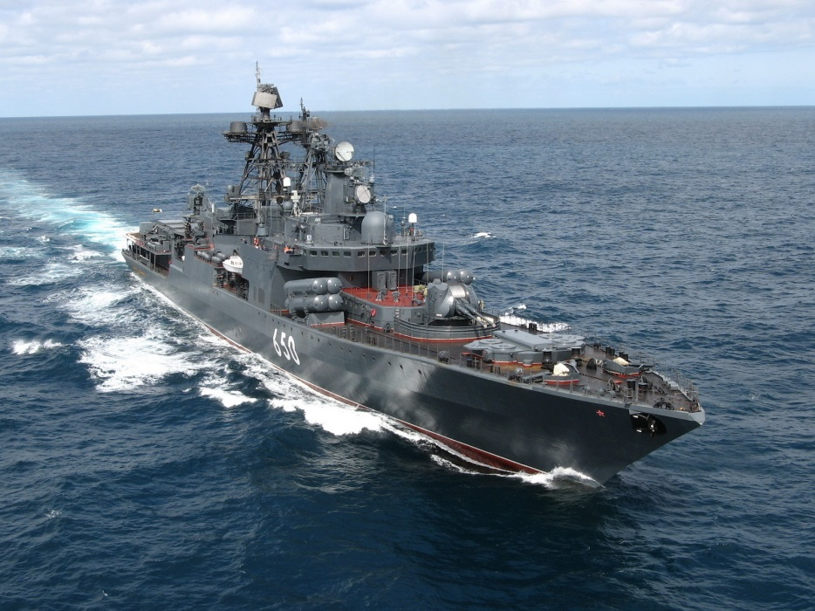[**Udaloy Class**](http://www.military-today.com/navy/udaloy_class_destroyer.htm)

The Udaloy class specialize in ASW, they have an excellent Variable Depth Sonar (VDS) suite, potent long and short range ASW weapons and two Ka-27 helicopters. These ships are designed to lead ASW hunter groups or lead the escort of a major formation protecting either a Kuznetzov class aircraft carrier or Kirov class Battle Cruiser. They have good air defence capability with 64 [SA-N-9 Gauntlet](https://en.wikipedia.org/wiki/Tor_missile_system) SAMs and four CIWS 30mm Gatling guns. A sub class is the **Udaloy II**, much improved overall; it has [SS-N-22 Sunburn](https://everything2.com/title/SS-N-22+Sunburn) (P-270 Moskit) hypersonic SSMs similar to a modified Sovremennyy; an improved close ASW capability with the [UDev-1](http://www.harpoondatabases.com/encyclopedia/Entry3163.aspx) system; and also adds the SA-N-11 close defence SAM. Many references consider the Udaloy II a separate class. Overall 12 Udaloy I and three Udaloy II are in service at the start of Northern Fury.

|  |  |  |  |  |
| --- | --- | --- | --- | --- |
| Class | Pennant | Name | Status | Remarks |
| Udaloy I | 673 | Udaloy | Northern Fleet |  |
|  | 626 | Vice-Admiral Kulakov | Northern Fleet |  |
|  | 687 | Marshal Vasilyevsky | Northern Fleet |  |
|  | 513 | Admiral Zakharov | Northern Fleet |  |
|  | 555 | Admiral Spiridonov | Northern Fleet |  |
|  | 564 | Admiral Tributs | Pacific Fleet |  |
|  | 543 | Marshal Shaposhnikov | Pacific Fleet |  |
|  | 619 | Simferopol | Pacific Fleet |  |
|  | 605 | Admiral Levchenko | Northern Fleet |  |
|  | 572 | Admiral Vinogradov | Pacific Fleet |  |
|  | 678 | Admiral Kharlamov | Northern Fleet |  |
|  | 548 | Admiral Panteleyev | Pacific Fleet |  |
| Udaloy II | 534 | Admiral Chabanenko | Northern Fleet |  |
|  | 493 | Admiral Basisty | Pacific Fleet | In Service 8/1993 |
|  | 659 | Admiral Kucherov | Northern Fleet | In Service 2/1994 |

[**Kashin Class**](http://www.military-today.com/navy/kashin_class.htm)

Commissioned from the mid ‘60s to the mid ‘70s these ships were the first in the Soviet Union to have a full Nuclear, Biological, Chemical (NBC) defence system and the first to carry a helicopter, they were also the first gas turbine ships in the world. The 19 of the original 20 ships were fitted with [SA-N-1 Goa](https://www.armyrecognition.com/russia_russian_missile_system_vehicle_uk/sa-3_goa_s-125_neva_pechora_ground_to_air_missile_system_technical_data_sheet_specifications_uk.html) SAMs (32 missiles), guns and ASW weapons but the final ship (*Sderzhanny*) had a lengthened hull, a VDS and helicopter facilities added, and four SS-N-2C Styx SSM. Five other ships were upgraded to this standard and called the Kashin Mod subclass. The Kashin Mod can carry a Ka-25 ASW helicopter but do not have a hanger for extended deployments. In 1990 the [*Smetivy*](http://www.kchf.ru/eng/ship/largeaswdestroyers/smetlivy.htm)was converted to the testbed for the [SS-N-25 Uran](https://en.wikipedia.org/wiki/Kh-35) (Switchblade) SSMs, the conversion was completed in ’93. These ships have had a long and interesting career, with the exception of the *Otvazhny* which sank in the black sea in 1974 and the *Smely* which was sold to Poland as the *Warszawa* they all remain in service.

|  |  |  |  |  |
| --- | --- | --- | --- | --- |
| Class | Pennant | Name | Status | Remarks |
| Kashin | 170 | Komsomolets Ukrainy | Black Sea Fleet |  |
|  | 604 | Soobrazitelnyy | Northern Fleet |  |
|  | 713 | Provornyy | Black Sea Fleet |  |
|  | 435 | Obraztsovyy | Baltic Fleet |  |
|  | 587 | Odarennyy | Northern Fleet |  |
|  |  | Otvazhnyy | Stricken | Sunk by fire 1974 |
|  | 624 | Steregushchy | Northern Fleet |  |
|  | 179 | Krasny Kavkaz | Black Sea Fleet |  |
|  | 818 | Reshitelny | Black Sea Fleet |  |
|  | 580 | Strogiy | Pacific Fleet |  |
|  | 814 | Krasny Krym | Black Sea Fleet |  |
|  | 578 | Sposobnyy | Pacific Fleet |  |
|  | 805 | Skoryy | Black Sea Fleet |  |
| Kashin Mod | 602 | Ognevoy | Northern Fleet |  |
|  | 348 | Slavnyy | Baltic Fleet |  |
|  | 660 | Stroynyy | Northern Fleet |  |
|  | 644 | Smyshlenyy | Pacific Fleet |  |
|  |  | Smely | Stricken | Sold to Poland 1992 |
|  | 804 | Sderzhannyy | Pacific Fleet |  |
| Smetlivy | 810 | Smetlivyy | Black Sea Fleet | SS-N-25 Testbed |

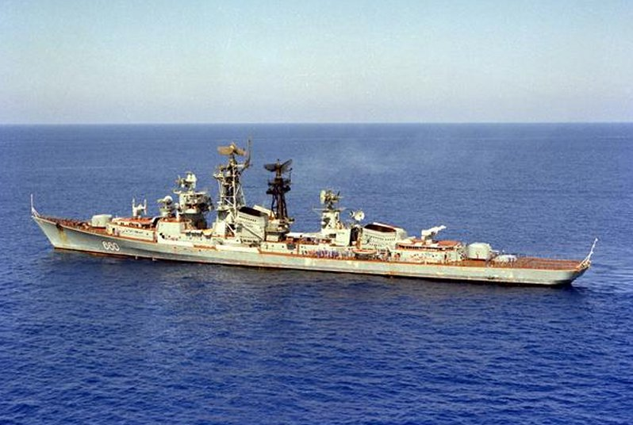

[**Kanin Class**](https://www.onwar.com/weapons/warships/boats/Kanin-class-destroyer.html)

The Soviet navy’s first guided missile destroyers, these ships were designed in the late ‘50s as anti surface ships and housed two SS-N-1 Scrubber launchers with six reloads each for a total of 14 missiles. This missile however was a disappointment and the ships were converted to general ASW destroyers in the Mid ‘60s, given a hull mounted sonar, SA-N-1 SAMs (32 missiles), two quadruple 57mm guns and a helipad to support a Ka-25 helicopter. Four of the original eight ships survive but they are relegated to second line duties.

|  |  |  |  |  |
| --- | --- | --- | --- | --- |
| Class | Pennant | Name | Status | Remarks |
| Kanin |  | Gremyashchiy | Striken | Mothballed |
|  | 647 | Zhguchiy | Northern Fleet |  |
|  | 888 | Zorkiy | Baltic Fleet |  |
|  | 851 | Derzkiy | Northern Fleet |  |
|  |  | Gnevnyy | Striken | Mothballed |
|  | 518 | Upornyy | Pacific Fleet |  |
|  |  | Boykiy | Striken | Mothballed |
|  |  | Gordyy | Striken | Mothballed |

