Soviet Fast Attack Craft (FAC)

Small, fast, agile, cheep to produce and deadly are the bywords of FACs and the Soviets pioneered the type with the venerable [Komar class](https://en.wikipedia.org/wiki/Komar-class_missile_boat) which became the first platform to sink a warship with missiles (Israel’s Destroyer Eilat in 1967). These boats are widely exported and used in all fleets of the Soviet Navy.

[**Osa Class**](https://en.wikipedia.org/wiki/Osa-class_missile_boat)

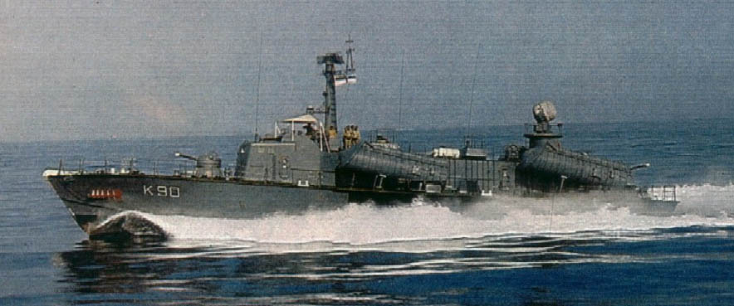Over 400 of these boats were built and another 120 of the same design in China. The Osa was a significant improvement over the, now retired Komar class, it had a steel hull and was much more seaworthy, it carried four missiles (vice two in the Komar) and varous forms of self defence weapons. These 230 ton boats could reach 40knts and packed a very solid punch. By 1994 the Soviets had sold many of their Osa boats off to sympathetic countries, but they also shared the hull with Stenka ASW boats many other designs were based on this boat.

|  |  |  |  |  |  |  |  |  |
| --- | --- | --- | --- | --- | --- | --- | --- | --- |
| Class | Total | Northern | Pacific | Black Sea | Baltic | Missile | SAM | Remarks |
| Osa I | 22 | 4 | 6 | 6 | 6 | 4x [P-15](https://en.wikipedia.org/wiki/P-15_Termit) |  | 30mm CIWS |
| Osa II | 32 | 12 | 4 | 8 | 8 | 4x P-15U | SA-N-5 some | 30mm CIWS |
| Osa II M | 20 | 15 | 5 |  |  | 4x P-15M | SA-N-5 some | 30mm CIWS |

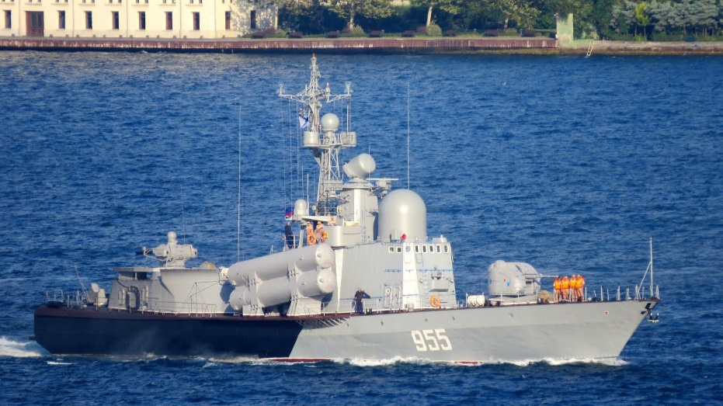[**Tarantul Class**](https://en.wikipedia.org/wiki/Tarantul-class_corvette)

These 500 ton boats are based on the Pauk class hull, are capable of 36-42knts and have a crew of 50. Equipped with a [76mm AK-176 gun](https://en.wikipedia.org/wiki/AK-176), two [AK-630 30mm CIWS](https://en.wikipedia.org/wiki/AK-630) and [SA-N-5](https://en.wikipedia.org/wiki/9K32_Strela-2) SAMs for air defence, these ships have much better survivability than the Osas. There were four versions of this class, 21 of the 22 Tarantul-I were sold to Bulgaria, Egypt, India, Viet Nam, Poland and Rumania, with one being kept for training. The 14 Tarantul-II each have four P-20 ‘Improved Styx’ missiles with a 45nm range and can achieve 36knts.

There were two major variants of the Tarantul-III, all could achieve a 42knt speed with greatly improved engines and had improved electronic counter measures (ECM). The major difference is that the 24 Tarantul-III carried four [P-80 Zuber/SS-N-22 Sunburn](https://en.wikipedia.org/wiki/SS-N-22) missiles, while the 34 Tarantul-IIIM used the improved [P-270 Moskit](https://en.wikipedia.org/wiki/P-270_Moskit) version of the Sunburn.

|  |  |  |  |  |  |  |  |
| --- | --- | --- | --- | --- | --- | --- | --- |
| Class | Total | Northern | Pacific | Black Sea | Baltic | Missile | Remarks |
| Tarantul-II | 14 | 4 | 4 | 4 | 2 | 4x P-20 |  |
| Tarantul-III | 24 | 8 | 6 | 2 | 8 | 4x P-80 |  |
| Tarantul-III M | 34 | 16 | 8 | 6 | 4 | 4x P-270 |  |

[**Nanuchka Class**](https://en.wikipedia.org/wiki/Nanuchka-class_corvette)

At 600 tons these ships were similar but larger than the Tarantuls and based around six [P-120 Malakhit (SS-N-9 Siren)](https://en.wikipedia.org/wiki/P-120_Malakhit). Versions of this ship built for export had the much less capable [P-15 Termit (SS-N-2 Styx)](https://en.wikipedia.org/wiki/P-15_Termit) missile used on the Osa boats. The Soviets used the Nanuchka I and III both of which had the [SA-N-4 (Gecko)](https://en.wikipedia.org/wiki/9K33_Osa) SAM, the key difference between the two was the gun, a [twin 57mm](https://en.wikipedia.org/wiki/AK-257) in the Nanuchka I and a [76mm AK-176 gun](https://en.wikipedia.org/wiki/AK-176), supported by a [AK-630 30mm CIWS](https://en.wikipedia.org/wiki/AK-630) in the Nanuchka III. The export version was the Nanuchka II. In total there were 48 built (including 1 historically canceled) with ten Nanuchka II being exported and Nanuchka I one sunk by accidental missile fire. A single [Nanuchka IV](http://www.ww2.dk/new/navy/nanuchka4.htm) was built as a testbed for the [P-160 Oniks (SS-N-26)](https://en.wikipedia.org/wiki/P-800_Oniks) missile.

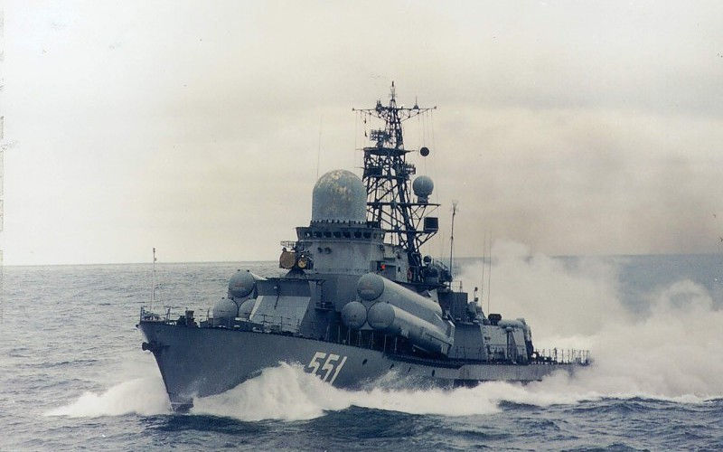

|  |  |  |  |  |
| --- | --- | --- | --- | --- |
| Class | Pennant | Name | Fleet | Remarks |
| Nanuchka I | P-624 | Burya | Black Sea |  |
|  | P-403 | Briz | Pacific |  |
|  | P-904 | Vikhr | Pacific |  |
|  | P-505 | Volna | Northern |  |
|  | P-528 | Grad | Baltic |  |
|  | P-619 | Groza | Black Sea |  |
|  | P-622 | Grom | Black Sea |  |
|  | P-621 | Zarnica | Black Sea |  |
|  | P-595 | Molniya | Baltic |  |
|  | P-567 | Shkval | Baltic |  |
|  | P-511 | Zaria | Northern |  |
|  | P-518 | Myetyel | Northern |  |
|  | P-577 | Shtorm | Baltic |  |
|  | P-564 | Raduga | Baltic |  |
|  | P-444 | Tsiklon | Pacific |  |
|  | P-400 | Tayfun | Pacific |  |
|  | P-414 | Musson |  | Sunk 1987 |
| Nanuchka I | P-608 | urun | Baltic |  |
|  | P-524 | Vyetyer | Northern |  |
|  | P-620 | Shtil | Northern |  |
|  | P-535 | Aysberg | Northern |  |
|  | P-505 | Tucha | Northern |  |
|  | P-533 | Uragan | Baltic |  |
|  | P-540 | Priboy | Baltic |  |
|  | P-562 | Priliv | Baltic |  |
|  | P-617 | Mirazh | Black Sea |  |
|  | P-590 | Meteor | Baltic |  |
|  | P-520 | Rassvyet | Northern |  |
|  | P-560 | Zyb’ | Baltic |  |
|  | P-555 | Geyzer | Baltic |  |
|  | P-570 | Passat | Baltic |  |
|  | P-534 | Perekat | Northern | Completed 1992 |
|  | P-551 | Livien’ | Baltic |  |
|  | P-405 | Smerch | Pacific |  |
|  | P-415 | Iney | Pacific |  |
|  | P-409 | Moroz | Pacific |  |
|  | P-450 | Razliv | Pacific |  |
| Nanuchka IV | P-526 | Nakat | Northern |  |

**[Bora Class](http://survincity.com/2013/07/rocket-hovercraft-simoom/)**

This is a class of missile hovercraft that was caught up in the disintegration of the Soviet Union and were never produced in numbers although considered quite [successful](https://motherboard.vice.com/en_us/article/9aky4y/russia-is-using-guided-missile-hovercraft-to-help-blockade-crimea). Built on a catamaran hull, the ship appears to be more of a surface effects or hydrofoil design then hovercraft but the designation. While historically only two of these craft were built, and very slowly – in Northern Fury there are eight with several more building. These 1000 ton ships can travel as fast as 55knts but cruise at 12. They carry eight [P-270 Moskit SS-N-22 Sunburn](https://en.wikipedia.org/wiki/P-270_Moskit) anti-ship missiles, [9K33 Osa SA-N-4 Gecko](https://en.wikipedia.org/wiki/9K33_Osa) SAMs, a [76mm AK-176 gun](https://en.wikipedia.org/wiki/AK-176), and two [AK-630 30mm CIWS](https://en.wikipedia.org/wiki/AK-630). In Northern Fury they are evenly split between the Black and the Baltic Sea fleets.

|  |  |  |  |  |
| --- | --- | --- | --- | --- |
| Class | Pennant | Name | Fleet | Remarks |
| Nanuchka I | P-616 | Bora | Black Sea |  |
|  | P-615 | Samum | Baltic |  |
|  | P-632 | MRK-37 | Black Sea |  |
|  | P-621 |  | Baltic |  |
|  | P-630 |  | Baltic |  |
|  | P-609 |  | Black Sea |  |
|  | P-634 |  | Black Sea |  |
|  | P-605 |  | Baltic |  |

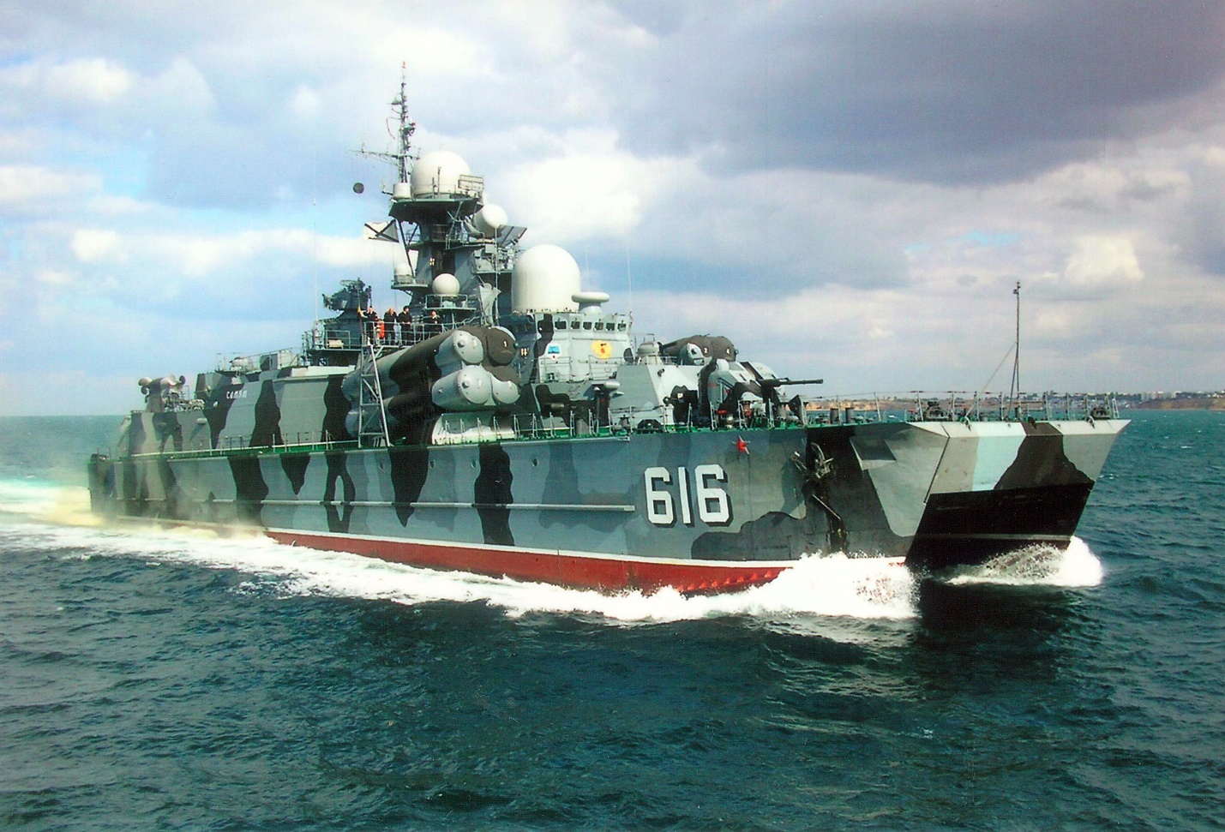

[**Lun Class**](https://en.wikipedia.org/wiki/Lun-class_ekranoplan) **ekranoplan**

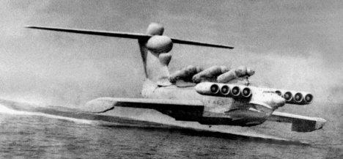It is difficult to determine if this Ground Effects Vehicle is a [ship or an aircraft](https://gizmodo.com/this-caspian-sea-monster-was-a-giant-soviet-spruce-go-1456423681) but its unique design seems to fit best here. The KM-08, or Duck as NATO called it is a high speed strike vehicle that can travel at 300knts and deliver six [P-270 Moskit SS-N-22 Sunburn](https://en.wikipedia.org/wiki/P-270_Moskit). Historically only two were built by the time that the Soviet Union collapsed but in Northern fury 12 of them have formed a potent squadron in the Black Sea Fleet. They are quite susceptible to rough weather.

