**Soviet Navy Frigates**

Soviet naval doctrine stresses the need for Submarine and Anti Submarine Warfare (ASW) in an effort to protect Ballistic Missile Submarines in arctic and Northern Pacific waters, this in order to preserve their nuclear options. A key factor in that doctrine are groups of ASW ships both in littoral waters and in the open ocean. Frigates, or in Russian ‘Guard’ or ‘Escort’ or ‘Sentry’ ship, essentially the same role, size and armament as western or other Frigates conduct this task in open water. Although the Neustrashimyy class is leading the Soviets into a new age, the Krivak is the mainstay of this type and can be found either protecting larger ships from, or hunting, submarines.

[**Neustrashimyy Class**](https://www.naval-technology.com/projects/neustrashimy/)

This class was intended to be a modern replacement for the Krivak class Frigates, seven were planned but the fall of the Soviet Union disrupted those plans. In Northern Fury however six of these ships have been commissioned into service. Equipped with excellent sonar and ASW equipment, 16 [SS-N-25 Uran](https://en.wikipedia.org/wiki/Kh-35) (Switchblade) SSMs, 32 [SA-N-9 Gauntlet](https://en.wikipedia.org/wiki/Tor_missile_system) SAMs, and the [SA-N-11 Grison](https://en.wikipedia.org/wiki/Kashtan_CIWS) air defence gun/missile air defence system, these ships are a significant step forward in both technology and capability. These ships have a hangar and operate a Ka-27 ASW helicopter.

|  |  |  |  |  |
| --- | --- | --- | --- | --- |
| Class | Pennant | Name | Status | Remarks |
| Neustrashimyy | 772 | Neustrashimyy | Northern Fleet |  |
|  | 777 | Nepristupnyi | Black Sea Fleet |  |
|  | 712 | Tuman | Northern Fleet |  |
|  | 727 | Yaroslav Mudry | Baltic Fleet |  |
|  | 691 | Yastreb | Pacific Fleet |  |
|  | 693 | Albatros | Northern Fleet | Commissioning 2/94 |

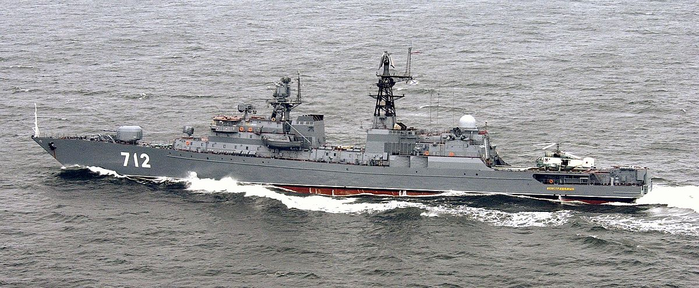

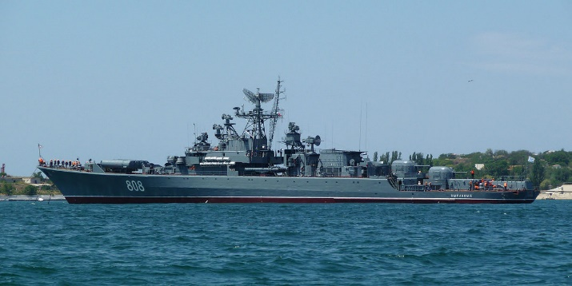[**Krivak Class**](https://en.wikipedia.org/wiki/Krivak-class_frigate)

This was a highly successful class of ship has two primary users, 32 were built, in two versions for the Navy while another nine were built for the Coast Guard. The Krivak I, and Krivak II built for the navy in the ‘70s and ‘80s are primarily ASW ships, the Kivak II replaced the two twin 76mm guns with single 100mm turrets and has an improved Variable Depth Sonar (VDS). Eight (historically 4) of the Krivak I’s have been modernized to carry the SS-N-25 Switchblade SSM, new radar, sonar and ECM equipment and are called Krivak IVs. The nine ships of the Krivak III sub-class are quite different, the SS-N-14 ASW missiles are removed, they only have a single 100mm gun which is move to the bow, and they have a helicopter deck and hangar, they were operated by the KGB Maritime Border Guard.

|  |  |  |  |  |
| --- | --- | --- | --- | --- |
| Class | Pennant | Name | Status | Remarks |
| Krivak I | 500 | Silnyy | Baltic Fleet |  |
|  | 953 | Doblestnyy | Northern Fleet |  |
|  | 663 | Storozhevoy | Baltic Fleet |  |
|  | 601 | Razumnyy | Northern Fleet |  |
|  | 640 | Razyashchiy | Northern Fleet |  |
|  | 754 | Druzhnyy | Pacific Fleet |  |
|  | 811 | Deyatelnyy | Northern Fleet |  |
|  | 605 | Retivyy | Black Sea Fleet |  |
|  | 807 | Bezzavetnyy | Pacific Fleet |  |
|  | 955 | Zadornyy | Pacific Fleet |  |
|  | 802 | Bezukoriznennyy | Northern Fleet |  |
|  | 801 | Ladnyy | Pacific Fleet |  |
|  | 618 | Poryvistyy | Pacific Fleet |  |
| Krivak II | 952 | Rezvyy | Pacific Fleet |  |
|  | 660 | Rezkiy | Baltic Fleet |  |
|  | 640 | Razitelnyy | Baltic Fleet |  |
|  | 621 | Grozyashchiy | Northern Fleet |  |
|  | 731 | Neukrotimyy | Northern Fleet |  |
|  | 968 | Gromkiy | Pacific Fleet |  |
|  | 963 | Bessmennyy | Northern Fleet |  |
|  | 641 | Gordelivy | Northern Fleet |  |
|  | 689 | Ryanyy | Northern Fleet |  |
|  | 662 | Revnostnyy | Black Sea Fleet |  |
|  | 808 | Pytlivyy | Pacific Fleet |  |
| Krivak III | 116 | Menzhinskiy | Northern Fleet |  |
|  | 097 | Dzerzhinskiy | Northern Fleet |  |
|  | 156 | Oryol | Pacific Fleet |  |
|  | 175 | Pskov | Black Sea Fleet |  |
|  | 148 | Anadyr | Pacific Fleet |  |
|  | 110 | Kedrov | Baltic Fleet |  |
|  | 052 | Vorovskiy | Northern Fleet |  |
|  | 149 | Hetman Sahaydachniy | Pacific Fleet | (ex-Kirov) |
|  | 059 | Krasny Vympel | Northern Fleet |  |
| Krivak IV | 930 | Legkiy | Northern Fleet |  |
|  | 645 | Letuchiy | Northern Fleet |  |
|  | 809 | Pylkiy | Northern Fleet |  |
|  | 921 | Zharkiy | Northern Fleet |  |
|  | 707 | Bditelnyy | Northern Fleet |  |
|  | 710 | Bodryy | Pacific Fleet |  |
|  | 978 | Dostoynyy | Black Sea Fleet |  |
|  | 719 | Svirepyy | Black Sea Fleet |  |