**Soviet Navy**

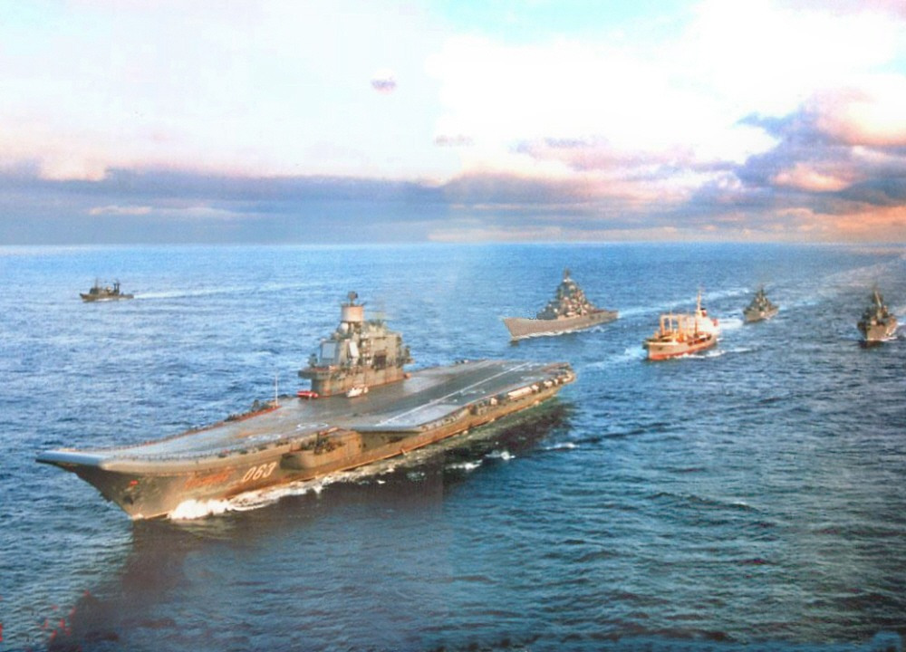

The Soviet Navy or Red Fleet is large, about 500,000 personnel and over 1000 ships and a small air force, it is a major element in the Soviet strategic plan in times of war. Unlike the US Navy, the Red Fleet is broken into named and not numbered Fleets:

* **The Red Banner Northern Fleet**; based largely on the Kola Peninsula and responsible for defending the Arctic sea and coastline as well as operations in the Atlantic Ocean. The Northern Fleet is that largest in the navy by a significant margin.
* **The Red Banner Pacific Fleet**; based largely in the Vladivostok area but with bases on the Kamchatka Peninsula and elsewhere. Although it is the second largest fleet, it has a very wide operating area including the entire Pacific Ocean, the South China Sea, Indian Ocean and even ventures as far as the South Atlantic and Mediterranean.
* **The Black Sea Fleet**; based in the Crimea and operating in both the Black and Mediterranean Seas.
* **The Twice Red Banner Baltic Fleet**; based mostly in Kaliningrad, but also further north in Kronstadt and Leningrad. Primarily responsible for all operations in the Baltic Sea and extending into the North Sea in cooperation with the Northern Fleet.
* **The Caspian Flotilla**; based at Baku and responsible for brown water operations on the Caspian Sea and Volga river. This is a small group of ships and geographically secure and convenient for experimentation and testing. Ships of up to 140M length can transit the Volga-Don Canal to gain access to the Black Sea; up to 210M length to access the Baltic via the Volga Baltic Waterway; or up to 135M length for access to the Arctic via the White Sea-Baltic Canal. All of these waterways are integrated into the [Unified Deep Water System of European Russia](https://en.wikipedia.org/wiki/Unified_Deep_Water_System_of_European_Russia). Most of the ships in this Flotilla are small so their numbers are counted in with the Black Sea Fleet.

In addition to ships, the Navy structure includes [Naval Aviation](https://en.wikipedia.org/wiki/Soviet_Naval_Aviation) with elements in each fleet and over 1,000 aircraft, [Naval Infantry](https://en.wikipedia.org/wiki/Naval_Infantry_(Russia)) comparable to US Marines organized into a Division in the Pacific, and four independent Brigades as well as Naval Spetsnaz, and Coastal Artillery forces.

|  |  |  |  |  |  |
| --- | --- | --- | --- | --- | --- |
|  | Northern | Pacific | Black | Baltic | Total |
| SSBN | 33 | 19 |  |  | 52 |
| SSGN/SSG | 37 | 35 | 2 | 7 | 81 |
| SSN | 52 | 22 |  |  | 74 |
| SSK/SS | 68 | 43 | 14 | 16 | 139+54(Res) |
| CV/CVH | 4 | 2 | 2 |  | 8 |
| BCGN | 2 | 1 |  |  | 3 |
| CG | 8 | 10 | 10 | 3 | 31 |
| DD/DDG | 25 | 19 | 11 | 5 | 60+4(Res) |
| FF/FFG | 22 | 13 | 6 | 6 | 47 |
| FAC | 69 | 41 | 35 | 46 | 191 |
| FFL | 50 | 34 | 12 | 12 | 108 |
| Amphibious | 26 | 71 | 78 | 68 | 243 |
| AGI | 12 | 39 | 8 | 23 | 82 |
| Totals | 406 | 327 | 170 | 166 | 1069 (Active) |

