**Soviet SS/SSNs**

With well over 200 attack submarines, both nuclear and conventionally powered Soviet Navy has more than twice as many as the US Navy and roughly the same number as all of NATO combined. The key difference however is that some of the submarines serving in the Soviet fleet are old, very old – and therefore quite obsolete. At the other end of the spectrum there are a few examples that are ultra-modern, capable of challenging the latest western technologies; these however are quite few in number.

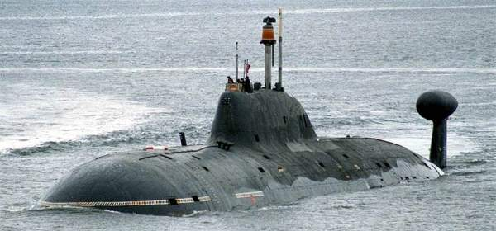

**SSN**

The 73 nuclear powered boats are classified by ‘generations’: All of 1st generation (late 1950’s, early 1960’s) boats are retired but most of the fleet, 48 boats are 2nd generation ‘Victor’ types with 11 ‘Sierra’ and ‘Alpha’ types making up the 3rd generation and 14 variations of the ‘Akula’ 4th generation in service. Additionally there are five ‘Yankee’ class SSNs converted from Ballistic Missile submarines (SSBN) remaining that are held in reserve and mothballed. The three main tasks of Soviet SSNs are to hunt NATO submarines, interdict NATO’s Strategic Lines of Communications (SLOC) and protect Soviet surface ships. The long endurance, relative stealth, lethal weapon load and independence make these boats very capable adversaries for these roles but also for information gathering, protecting Ballistic Missile submarines (SSBN) and harassing NATO task forces.

**[Victor Class](https://en.wikipedia.org/wiki/Victor-class_submarine)**

Consisting of three variations of the original design, the Project 671 **Shchuka** boats are capable but have aging technologies and some of the Victor I (15) hulls are approaching retirement age. All have the ability to launch Torpedoes and various forms of Anti-Submarine missiles as well as Surface to Air Missiles (SAM) to keep NATO patrol aircraft at bay. The Victor II (7) program was terminated early after it was discovered that they were easily trackable by US sonars. The Victor III (27) sub class has a retractable towed array passive sonar system. One variation from historical deployments has three additional Victor IIIs in the Northern Fleet, re-deployed from the Pacific in the months preceding hostilities.

|  |  |  |  |  |
| --- | --- | --- | --- | --- |
| Class | Pennant | Name | Fleet | Remarks |
| [Victor I](http://russianships.info/eng/submarines/project_671.htm) | K-38 | K-38 | Pacific | Project 671 |
|  | K-69 | K-69 | Northern |  |
|  | K-147 | K-147 | Northern |  |
|  | K-53 | K-53 | Pacific |  |
|  | K-306 | K-306 | Northern |  |
|  | K-323 | K-323 | Northern |  |
|  | K-370 | K-370 | Northern |  |
|  | K-438 | K-438 | Northern |  |
|  | K-367 | K-367 | Northern |  |
|  | K-314 | K-314 | Northern | Project 671V |
|  | K-398 | K-398 | Northern |  |
|  | K-454 | K-454 | Pacific | Project 671V |
|  | K-462 | K-462 | Northern |  |
|  | K-469 | K-469 | Northern | Project 671V |
|  | K-481 | K-481 | Northern |  |
| [Victor II](http://russianships.info/eng/submarines/project_671rt.htm) | K-371 | K-371 | Northern | Project 671RT |
|  | K-387 | K-387 | Northern | Project 671RT |
|  | K-467 | K-467 | Northern | Project 671RT |
|  | K-488 | K-488 | Northern | Project 671RT |
|  | K-495 | K-495 | Northern | Project 671RT |
|  | K-513 | K-513 | Northern | Project 671RT |
|  | K-517 | K-517 | Northern | Project 671RT |
| Victor III | K-138 | K-138 | Northern | Project 671RTMK |
|  | K-218 | K-218 | Northern | Project 671RTM |
|  | K-242 | Amur | Pacific | Project 671RTM |
|  | K-244 | K-244 | Northern | Project 671RTM |
|  | K-247 | K-247 | Pacific | Project 671RTM |
|  | K-251 | K-251 | Pacific | Project 671RTM |
|  | K-254 | K-254 | Northern | Project 671RTM |
|  | K-255 | K-255 | Northern | Project 671RTM |
|  | K-264 | K-264 | Pacific | Project 671RTM |
|  | K-292 | K-292 | Northern | Project 671RTMK |
|  | K-298 | K-298 | Northern | Project 671RTM |
|  | K-299 | K-299 | Northern | Project 671RTM |
|  | K-305 | K-305 | Northern | Project 671RTM |
|  | K-324 | K-324 | Northern | Project 671RTM |
|  | K-355 | K-355 | Pacific | Project 671RTM |
|  | K-358 | Murmansky | Northern | Project 671RTM |
|  | K-360 | K-360 | Northern | Project 671RTM |
|  | K-388 | K-388 | Northern | Project 671RTMK |
|  | K-412 | K-412 | Northern | Project 671RTM |
|  | K-414 | K-414 | Northern | Project 671RTMK |
|  | K-448 | K-448 | Northern | Project 671RTMK |
|  | K-492 | K-492 | Pacific | Project 671RTM |
|  | K-502 | K-502 | Northern | Project 671RTM |
|  | K-507 | K-507 | Pacific | Project 671RTM |
|  | K-524 | K-524 | Northern | Project 671RTM |
|  | K-527 | K-527 | Northern | Project 671RTM |

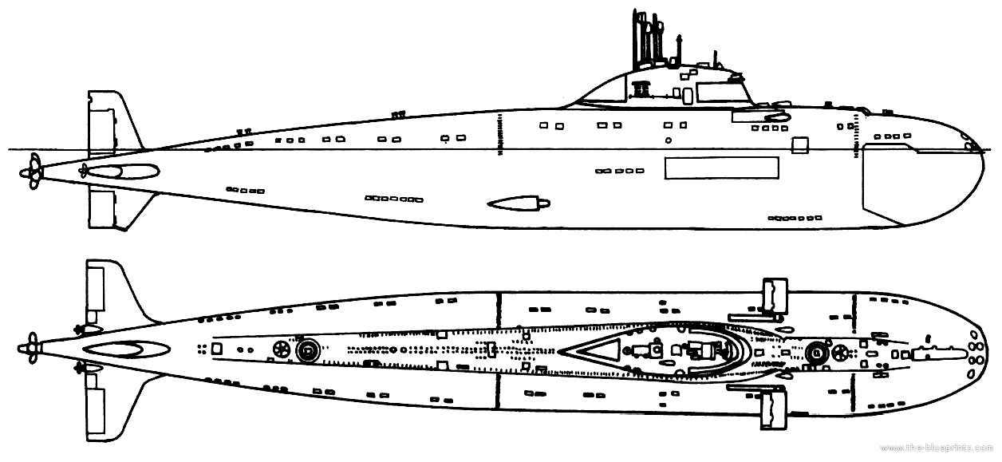

Victor I

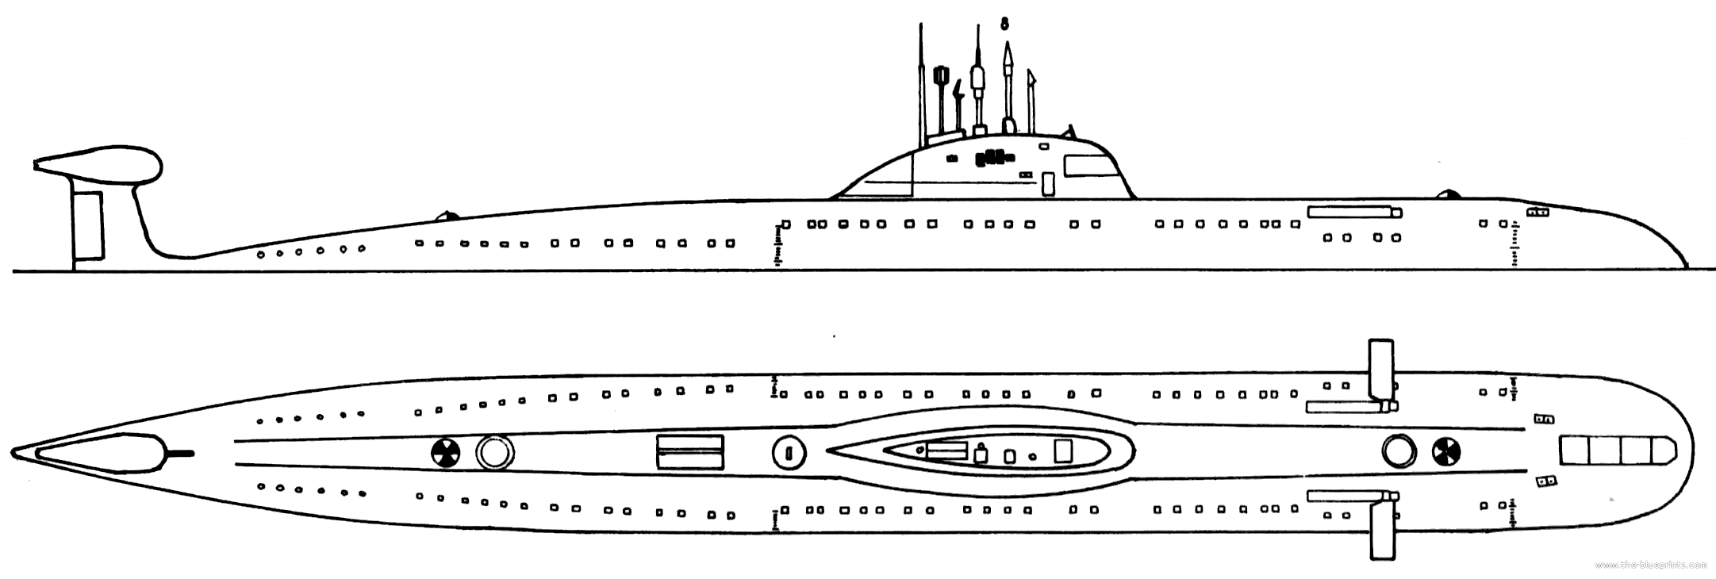

Victor III

**[Alpha Class](http://russianships.info/eng/submarines/project_705.htm)**

With the exception of the single Papa Class prototype, the Project 705 ‘Lira’ class, known as Alpha Class in the west, were the fastest class of submarines built. The radical design incorporated several innovative technologies including a Titanium hull and liquid metal cooled reactor, allowing for a small hull size, high speeds and deep diving depths. With a crew of only 30-40, a speed of over 40 Knots and a diving depth exceeding 400 Meters, these submarines sent shudders through NATO and caused revolutionary re-designs of torpedoes, sonars and other systems in an effort to counter this threat. In reality these boats were difficult to maintain and operate but the technology developments were used as a basis for the follow on Akula design. The lead boat in this class, K-64, had a major coolant leak in 1972 resulting in superheated liquid metal contacting cold surfaces and instantly freezing, causing significant internal damage which was too expensive to repair, after being broken up it became a training platform. Only six other boats were built

|  |  |  |  |  |
| --- | --- | --- | --- | --- |
| Class | Pennant | Name | Fleet | Remarks |
| Alpha | K-123 | K-123 | Northern |  |
|  | K-316 | K-316 | Northern |  |
|  | K-432 | K-432 | Northern |  |
|  | K-373 | K-373 | Northern |  |
|  | K-493 | K-493 | Pacific |  |
|  | K-463 | K-463 | Pacific |  |

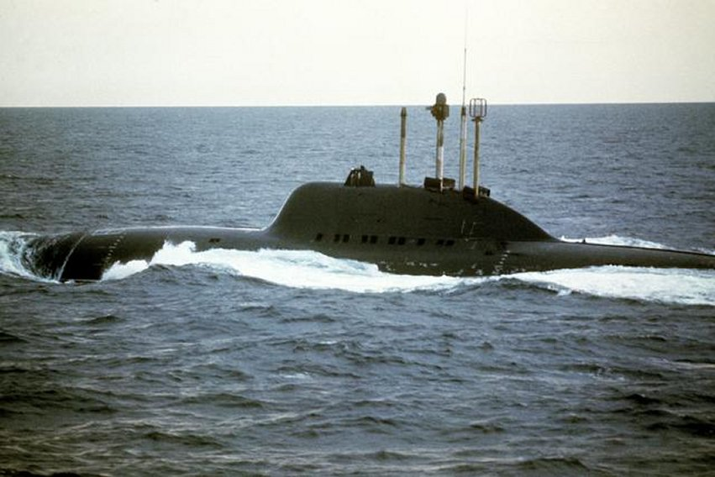

**[Sierra Class](http://russianships.info/eng/submarines/project_945.htm)**

The Project 945 Barrakuda, or Sierra class in the west was an evolutionary design of the Victor III with technologies trialed in the Alpha. The titanium hull allows for a deep diving depth (450M) and relatively small crew (60-70) at speeds of 35 Knots. These are very potent adversaries but are limited in numbers in three sub classes; two Sierra I; two Sierra II with improved sonars and other improvements; and a single Sierra III which historically was scrapped before completion but is in service for Northern Fury.

|  |  |  |  |  |
| --- | --- | --- | --- | --- |
| Class | Pennant | Name | Fleet | Remarks |
| Sierra I | K-276 | Kostroma | Northern | Project 945 |
|  | K-239 | Carp | Pacific | Project 945 |
| Sierra II | K-336 | Pskov | Northern | Project 945A |
|  | K-534 | Nizhniy Novgorod | Northern | Project 945A |
| Sierra III | K-536 | Mars | Northern | Project 945AB |

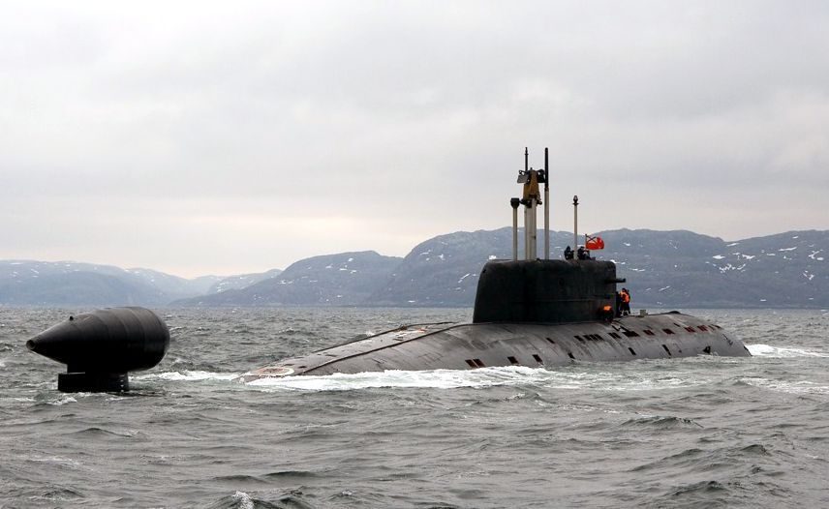

[**Akula Class**](https://fas.org/nuke/guide/russia/slbm/667AR.htm)

This is the most modern Soviet SSN, its production surprised the west and its capabilities caused some significant concern. Designated as the Project 971 Shchuka-B or Bars, they are collectively referred to as the Akula in NATO. Naming is further confused as the Typhoon SSBN is called the ‘Akula’ by the Soviets. Northern Fury accelerates production of a couple boats by several months and the final hull, K-157 ‘Vepr’ by about a year. The seven Akula I boats are sometimes compared to the US Los Angeles class SSNs, while the six ‘Improved’ Akula are quieter yet and have better sonars. The Final boat, the Akula II ‘Vepr’ has been compared to the Improved Los Angeles class.

|  |  |  |  |  |
| --- | --- | --- | --- | --- |
| Class | Pennant | Name | Fleet | Remarks |
| Akula I | K-317 | Pantera | Northern | Project 971 |
|  | K-480 | Ak Bars | Northern | Project 971 |
|  | K-331 | Magadan | Pacific | Project 971 |
|  | K-391 | Bratsk | Pacific | Project 971 |
|  | K-322 | Kashalot | Pacific | Project 971 |
|  | K-263 | Delfin | Pacific | Project 971 |
|  | K-284 | Akula | Pacific | Project 971 |
| Akula Impr | K-154 | Tigr | Northern | Project 971-I |
|  | K-328 | Leopard | Northern | Project 971-I |
|  | K-461 | Volk | Northern | Project 971-I |
|  | K-295 | Samara | Pacific | Project 971-I |
|  | K-419 | Kuzbass | Pacific | Project 971-I |
|  | K-152 | Nerpa | Pacific | Project 971-I |
| Akula II | K-157 | Vepr | Northern | Project 971U |

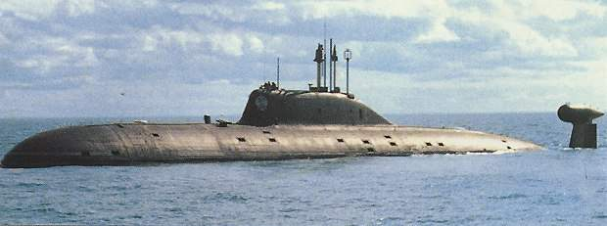

**SSK**

[**Echo II class**](https://en.wikipedia.org/wiki/Echo-class_submarine)

These obsolete and accident prone boats are considered ‘First Generation’ SSGNs. The preceding Echo I class were all retired by 1994 but all surviving Echo IIs remain active in the Northern Fury campaign. These boats must surface to launch their missiles, and must remain in that vulnerable state until the missiles receive mid-course guidance updates – up to 20 minutes. Modern submariners would consider this as suicidal. These boats have gone through a series of upgrades to carry more modern missiles, the original boats carried eight [SS-N-3a "Shaddock"](https://en.wikipedia.org/wiki/SS-N-3_Shaddock) anti-ship missiles, 14 were converted to carry the [P-500 Bazalt SS-N-12 "Sandbox",](https://en.wikipedia.org/wiki/P-500_Bazalt) and of five of these (3 historically) were converted to the improved P-1000 version with a better radar and extended range. Of the 29 boats, one has been sunk in a collision but there have been 13 major collisions, fires, or reactor accidents involving these boats. Three boats had been converted to receive targeting data directly from satellites, and historically, one of the boats was converted to support divers and Special Forces, in Northern Fury four of the original boats have undergone this conversion.

|  |  |  |  |  |  |
| --- | --- | --- | --- | --- | --- |
| Class | Pennant | Name | Fleet | SSM | Remarks |
| Echo II ST | K-1 |  | Northern |  | Sat Tgt |
| Echo II M | K-127 |  | Northern | P-500 |  |
|  | K-10 |  |  |  | Sunk in collision, 1982 |
| Echo II ST | K-22 | Krasnovardeets | Northern |  | Sat Tgt |
|  | K-23 |  | Pacific |  |  |
| Echo II M | K-428 |  | Pacific | P-500 |  |
|  | K-431 |  | Northern |  | Reactor accident, Reserve |
| Echo II M | K-134 | Kefal | Northern | P-500 |  |
| Echo II ST | K-35 |  | Northern |  | Sat Tgt |
| Echo II SOF | K-47 |  | Northern |  | SOF |
| Echo II MKV | K-48 |  | Northern | P-1000 |  |
|  | K-56 |  | Pacific |  |  |
| Echo II M | K-557 |  | Northern | P-500 |  |
| Echo II MKV | K-74 |  | Northern | P-1000 |  |
| Echo II SOF | K-86 |  | Northern |  | SOF |
| Echo II M | K-90 |  | Pacific | P-500 |  |
| Echo II SOF | K-94 |  | Pacific |  | SOF |
| Echo II M | K-144 |  | Pacific | P-500 |  |
| Echo II MKV | K-108 |  | Northern | P-1000 |  |
|  | K-116 |  | Pacific |  | Reactor accident, Reserve |
| Echo II M | K-125 |  | Northern | P-500 |  |
| Echo II MKV | K-128 |  | Pacific | P-1000 |  |
| Echo II M | K-135 |  | Northern | P-500 |  |
| Echo II SOF | K-166 |  | Pacific |  | SOF |
| Echo II M | K-172 |  | Northern | P-500 |  |
|  | K-175 |  | Pacific |  |  |
| Echo II MKV | K-184 |  | Pacific | P-1000 |  |
|  | K-189 |  | Pacific |  |  |
|  | K-192 |  | Pacific |  | Reactor accident, Reserve |

