**Spanish Army**

With a strength of 201,000 and 142,000 ready reserves, the Spanish Army was quite a large force but somewhat under equipped in comparison to other armies in NATO. Most formations were designed to be light, with only 300 tanks that could be considered modern in 1994 (AMX-30). Structurally Spain would provide a Corps HQ organized either as a mechanized or a mountain formation to reinforce the land fight in southern Europe, probably Turkey or Greece. There were no forward deployed forces. Divisions were comprised of two brigades, each having two regiments and in turn these had two battalions; slightly smaller than a standard division (8 battalions vice 9) but very heavy on the command element. There are also a number of independent brigades of various types.

A good summary of the Spanish Army in 1989 is located [here](https://en.wikipedia.org/wiki/Structure_of_the_Spanish_Army_in_1989), very little changed between ’89 and ’94 when Northern Fury commences.

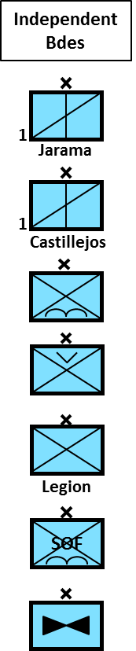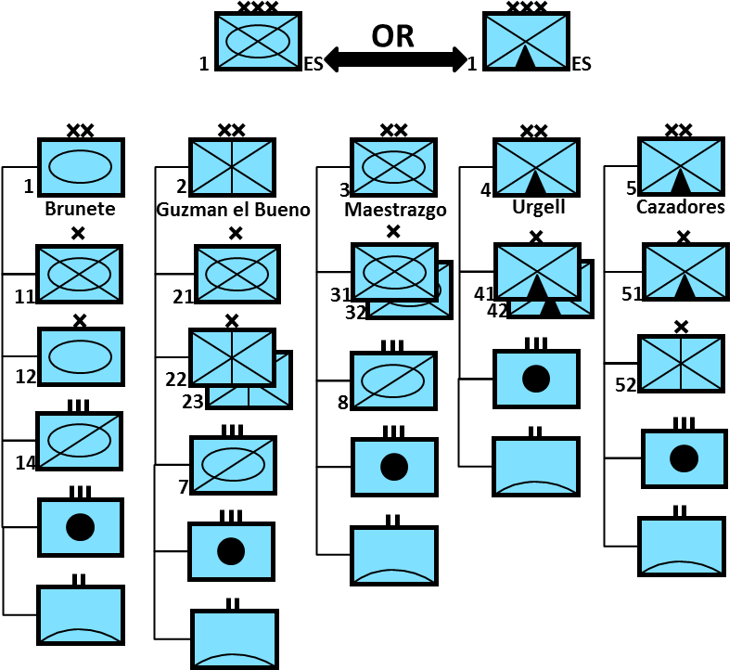

In addition to the field army there were elements of supporting forces and also territorial defence forces for Spanish colonies.

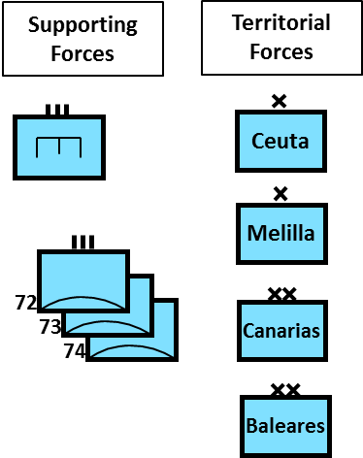

**Main Battle Tanks (MBT)**

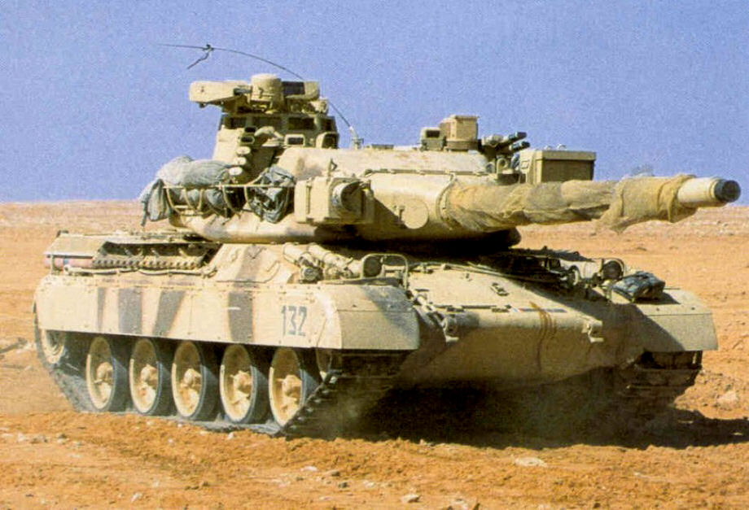Spain had quite a mix of mostly obsolete MBTs, concentrated in 1st and 3rd Division, there were some older MBTs in 2nd Division as well.

**AMX-30**

Spain built most of its 299 AMX-30E (E for Spanish) under licence from France. They also purchased 10 AMX-30D recovery vehicles and 18 AMX-30R carrying the Roland SAM system. The AMX-30 could be considered on par with the Leopard I, and Spain considered that tank but opted for the AMX when France offered to produce it in Spain. All of the Spanish AMX’s had been upgraded to the ‘M2’ standard with an improved fire control system, improved engine and drive train as well as many other improvements. Historically only half of the AMX’s were improved while the remainder received a cheaper and more problematic upgrade, in Northern Fury all were upgraded to ‘M2’ standard. The Tank is used extensively in the 1st Armored Division and also within the mechanized brigades of 3rd Division.

**M60A3**

Between 1990 and 1993, the United States provided Spain with 244 M60A3 Patton MBTs to replace their aging fleet of M47 and M48 tanks (also provided by the US). These tanks were used in the 2nd Division, the Cavalry Regt of 3rd Division and the two independent Cavalry regiments. Although more reliable and updated than the M48, these tanks were still obsolete.

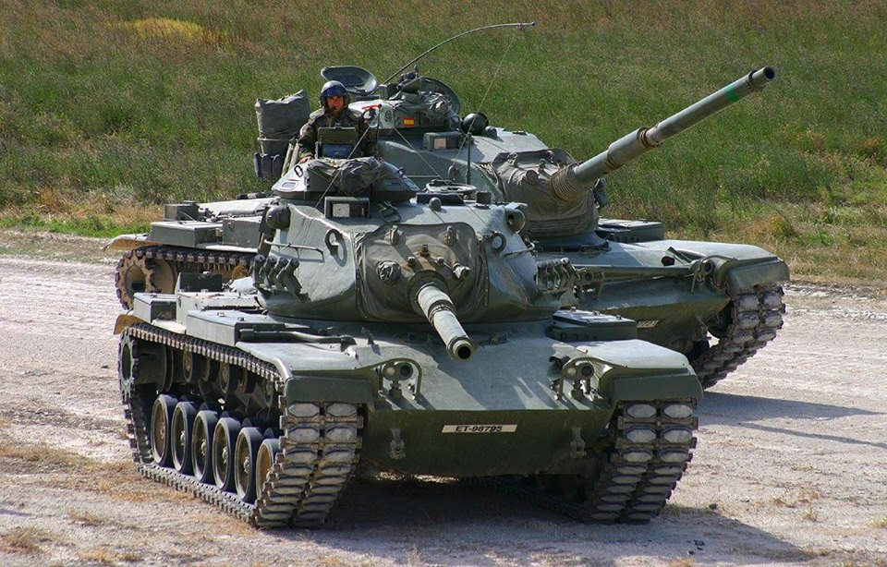

**M47/M48**

By 1994 these tanks had been retired from Spanish service; however they were still quite numerous and had only been retired in the previous couple years, so were available:

* 162x M48A5E2
* 329x M47E1
* 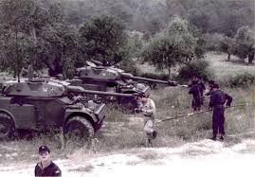46x M47E2

**Reconnaissance Vehicles**

**AML 60/90**

Spain used ~100 of each type in their reconnaissance units.

**BMR-VEC**

This is a Spanish built, six-wheel reconnaissance vehicle equipped with a 25mm chain gun. There were 240 of the six-wheeled version built and 100 four-wheeled variants which have since been retired.

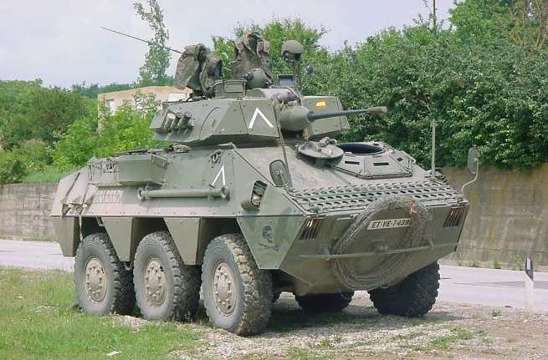

**Armored Personnel Carries (APC)**

In addition to over 1,200 of the ubiquitous M113, the Spanish had another ‘home grown’ solution. The BMR-600.

[**BMR-600**](https://army-guide.com/eng/product2069.html)

This Six-wheeled APC is small, versatile and fast. The basic troop carrying version has a crew of two and can carry eight or nine infantrymen and mounts a .50 Calibre MG. There are several variants including mortar carrier, recovery vehicle, ambulance, engineering and anti-tank, and command. Spain has over 1000 of these vehicles including variants.

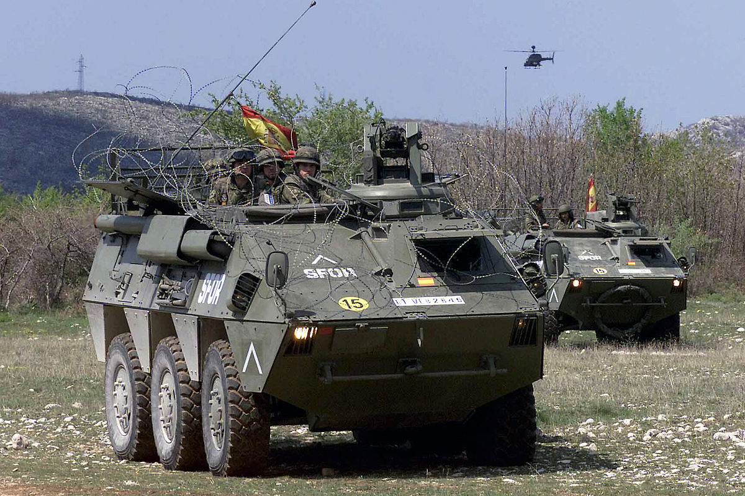

**Artillery**

Spain employed a wide variety of artillery systems, it was in the process up upgrading its M107 (175mm Self Propelled) Howitzers to the M110 (203mm). Northern Fury accelerates that process by a few months.

* 48x M108 Self Propelled (SP) 105mm Howitzer
* 400x M-26 Towed 105mm Howitzer
* 170x M-56 Pack/Towed 105mm Howitzer
* 176x 122mm Towed Gun
* 78x M109A1 SP 155mm Howitzer
* 84x M114/23 Towed 155mm Howitzer
* 24x M115 Towed 203mm Howitzer
* 24x M110A2 SP 203mm Howitzer (M107’s converted to M110’s)
* 12x Teruel 140mm SP Multiple Launch Rocket (MRL) (Spanish built)

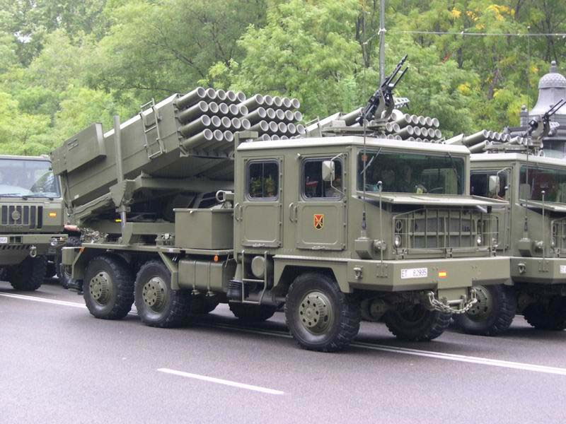

**Air Defence Systems**

Spain has a large number of air defence systems; the Nike-Hercules was retired in 1990 but negotiations to procure the American Patriot system are still ongoing.

* 329x GAO-BOI 20mm Towed AA Guns
* 96x GDF-002 35mm Twin Towed AA Guns
* 240x Bofors 40mmL/70 Towed AA Guns
* 132x M55 12.7mm Quad Towed MG
* 9x Roland 1 SAM (on AMX-30R)
* 9x Roland 2 SAM (on AMX-30R)
* 13x Aspide/Skyguard Fire units (3 or 4 launchers each)
* 48x I-Hawk