**SPS Principe de Asturias Battle Group**

The flagship of the Spanish Navy, the light aircraft carrier Principe de Asturias was the centerpiece of a battle group focused on either sea dominance in the Mediterranean along with other NATO battle groups or the focus of an Anti-Submarine Warfare group in the eastern Atlantic. At war start she was conducting a tour of the South Atlantic and was at port in Rio de Janeiro, Brazil. The battle group consists of

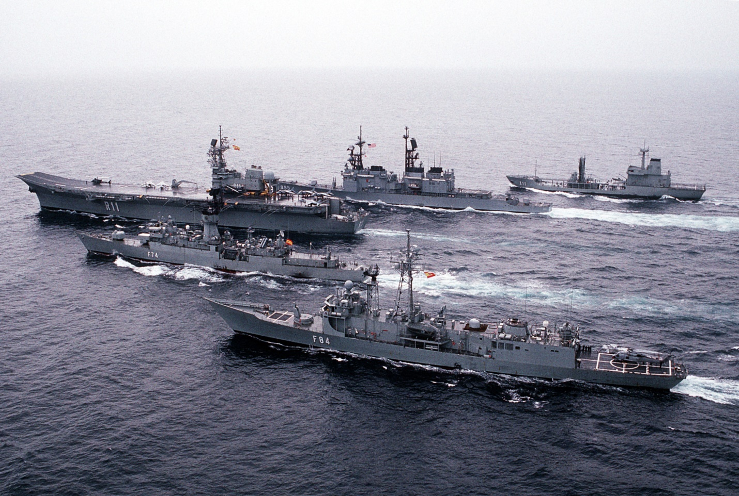

* R 11 SPS Principe de Asturias
  + 9th Esc: 12x EAV-8S Matador
  + 5th Esc: 6x SH-3H Sea King ASW
  + 5th Esc: 2x SH-3W Sea King AEW
  + 3rd Esc: 4x AB-212 ASW
  + 3rd Esc: 2x AB-212 ASW
* F-74 SPS Asturias
  + 10th Esc 1x SH-70B-1 ASW
* F-84 SPS Reina Sofia
* A-14 SPS Patino
  + 5th Esc: 6x SH-3G Sea King Util