**Italian Army**

The [Italian Army](https://en.wikipedia.org/wiki/Structure_of_the_Italian_Army_in_1989#5th_Army_Corps) is quite large; a standing army of 270,000 will be augmented by an immediate reserve of about 240,000 and a follow on reserve of another 280,000 troops. Additionally there are over 100,000 para-military Carabinieri, a national police force with several units dedicated to Army service. Active units and formations are deployable within 48-72 hours while reserve units will take a week or so to mobilize and further reserves from the territorial structure will be available within a month. 4th Alpine Corps in the North East will mobilize quickly and establish a defensive posture while 3rd Corps in the North followed by 5th Corps from Central and Southern Italy form and prepare for offensive or further defensive tasks.

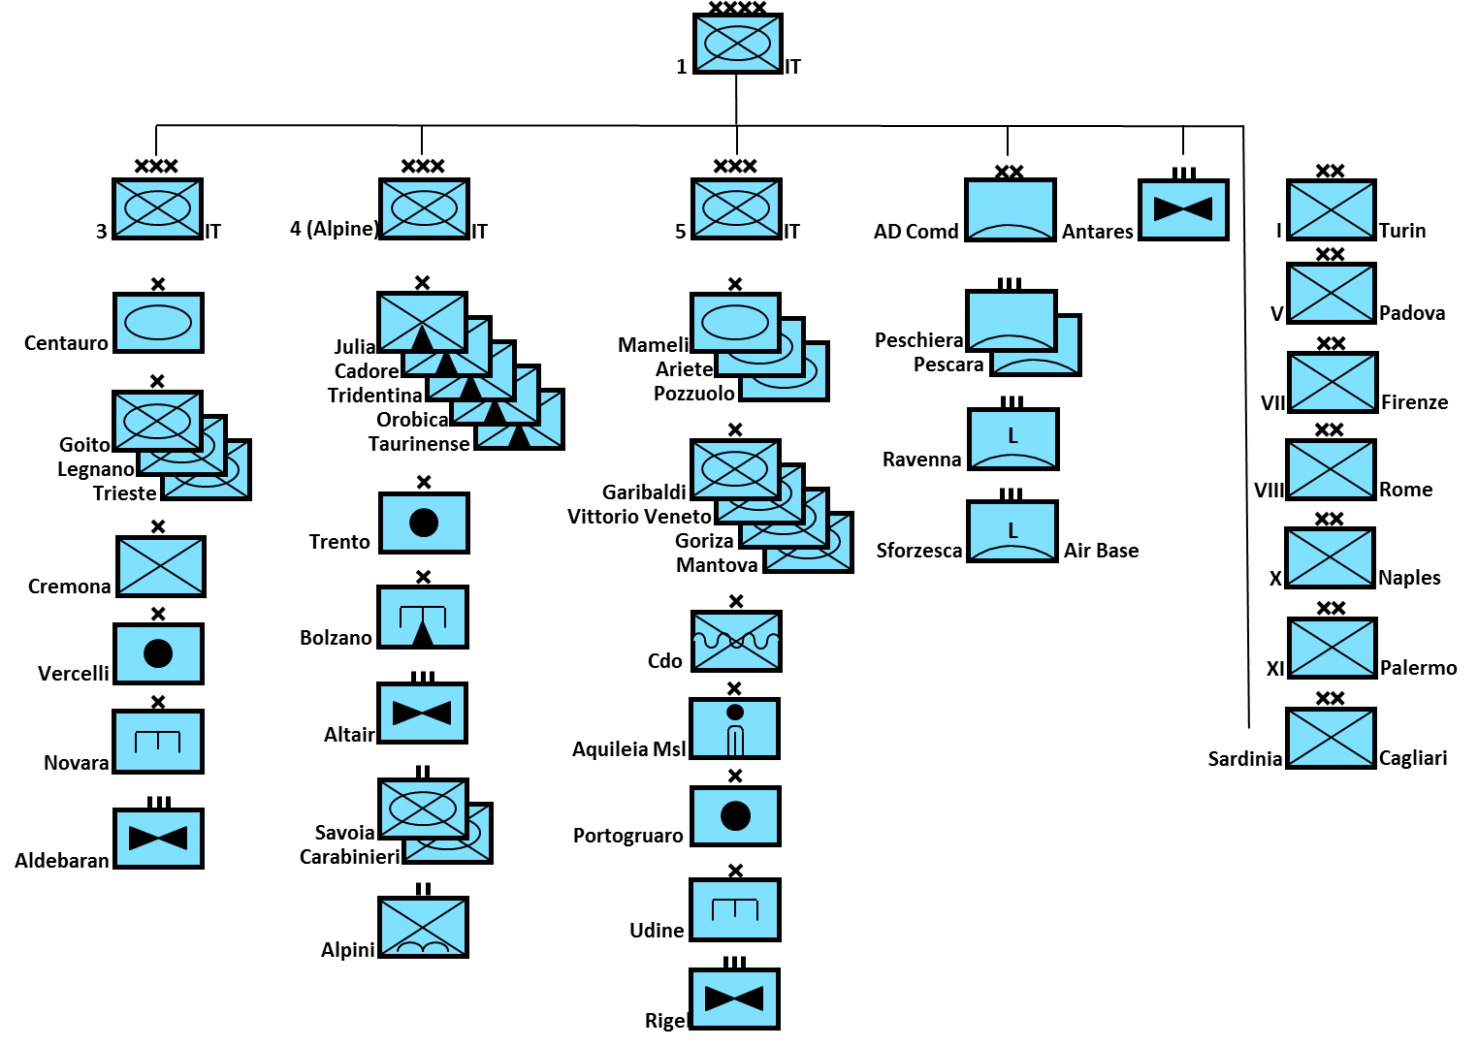

**Main Battle Tanks (MBT)**

[**Leopard 1**](http://www.tanks-encyclopedia.com/coldwar/West_Germany/Leopard-I.php): Italy purchased 200 of these tanks from Germany and produced another 520, most were of the A2 standard but 120 were of the A5 variant. Italy also operated 136 ARV (Armored Recovery Vehicles), 40 AEV (Armored Engineer Vehicles), and 64 AVLB (Armored Vehicle Launched Bridges). Besides Germany, Italy was the largest user of this tank which was used in all formations except the *Ariete* and *Mameli* armored and *Garibaldi* mechanized Brigades.

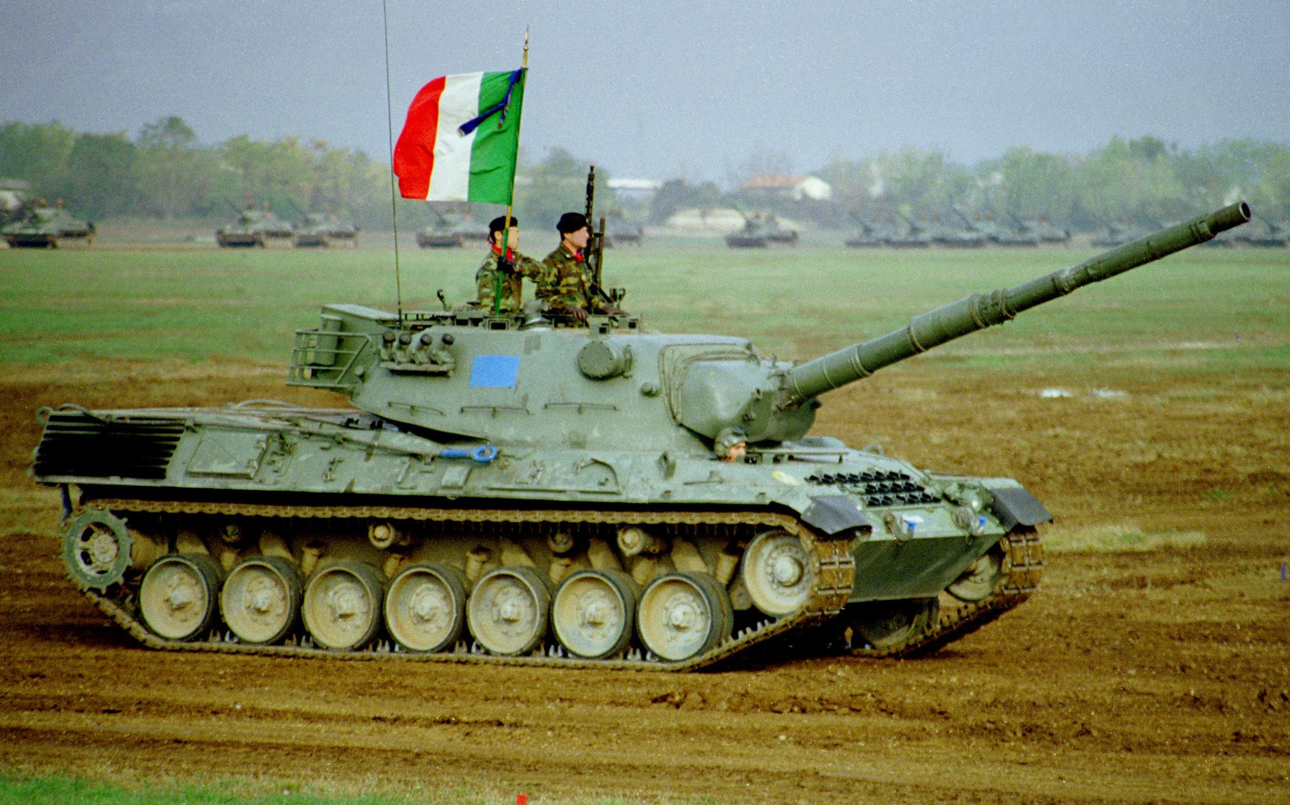

[**M60A1**](http://www.tanks-encyclopedia.com/coldwar/US/M60_Patton.php)**:** Of the 300 M60s in service, 200 were built in Italy under license. These tanks are used in the *Ariete* and *Mameli* armored and *Garibaldi* mechanized Brigades.

[**M47 Patton**](http://www.tanks-encyclopedia.com/coldwar/US/M47_Patton.php): Italy operated about 2,500 M47s but they are all either in storage or scrapped. Probably about 400 are in ready reserve.

**Tank Destroyer**

[**B1 Centauro**](http://www.military-today.com/artillery/centauro_b1.htm)**:** This eight wheeled armored vehicle was designed to provide firepower to reconnaissance elements. The fully stabilized 105mm high velocity gun has a full range of ammunition types and can engage targets out to 3000 meters. The Centauro entered service in 1991 and all 400 were produced by 1996. An estimate of 250 is available for Northern Fury.

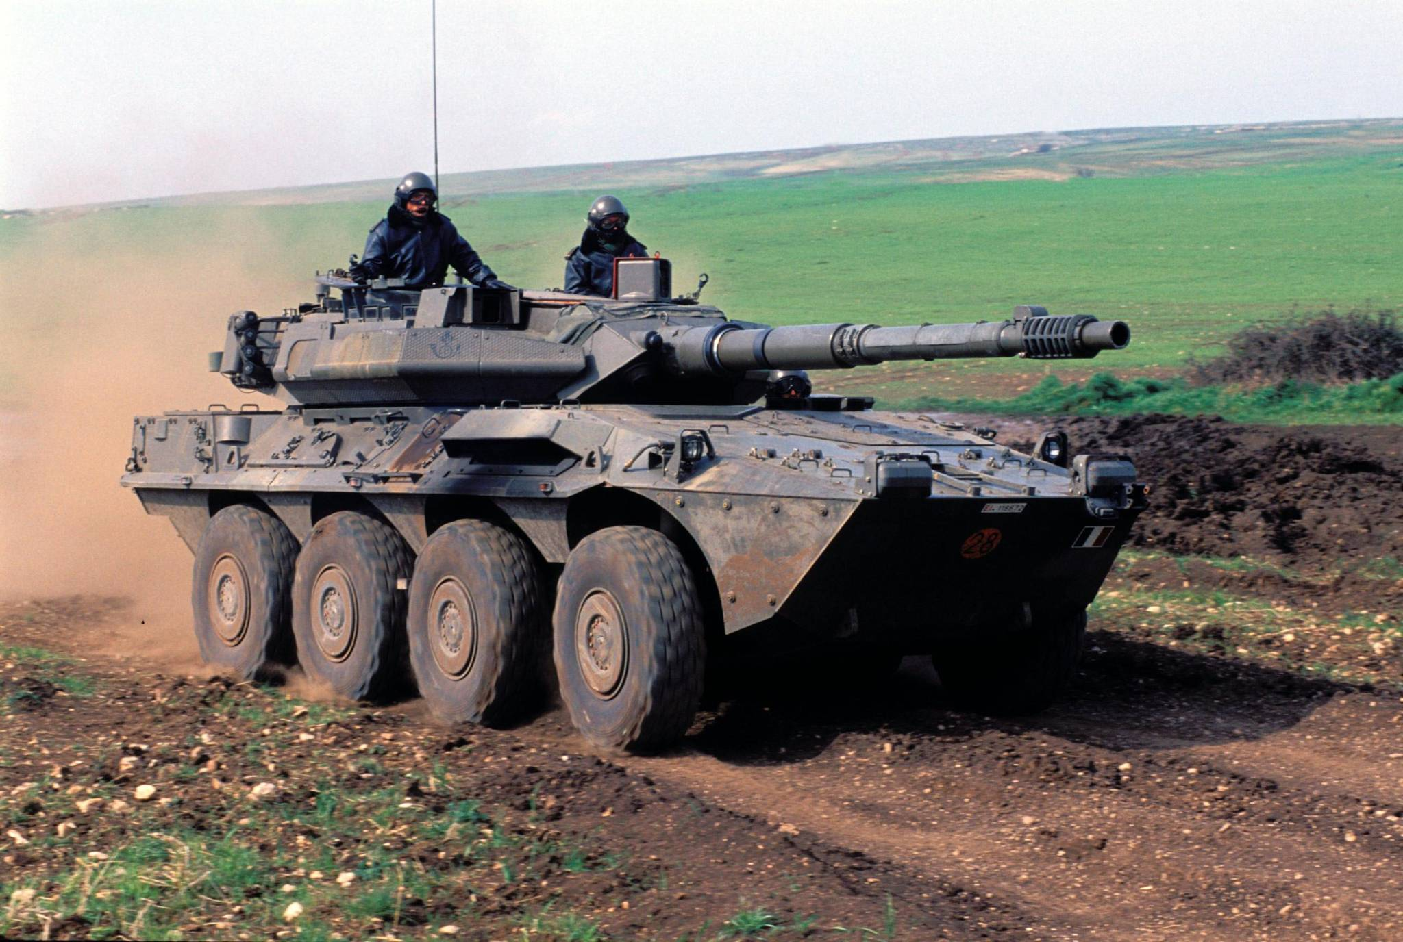

**Infantry Combat Vehicles (ICV)**

[**VCC-1 Camillino**](http://www.tanks-encyclopedia.com/coldwar/Italy/VCC-1_Camillino.php)**:** This is an Italian designed and built derivative of the M113. The armor is improved and a turret provided for the .50 Calibre Machine Gun, the fuel tanks were placed on the outside rear and smoke dischargers were provided. 560 were available for the Italian Army.

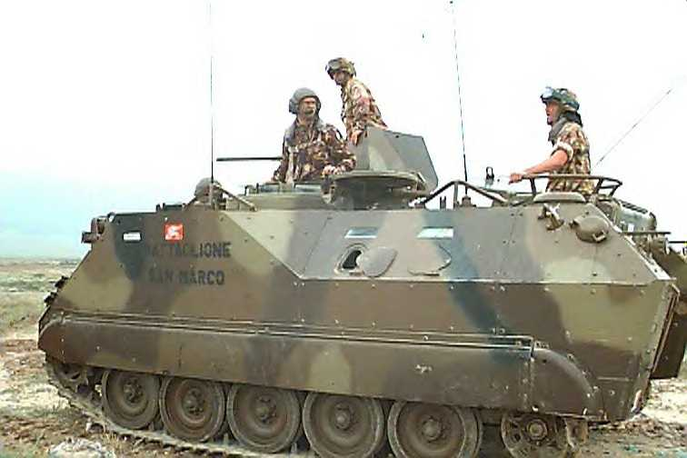

[**VCC-2**](http://tanknutdave.com/the-italian-vcc-1-apc/): A modification on the VCC-1 with applique armor, firing ports and an improved crew compartment. About 12300 of these were built.

[**AMX-VCI**](http://www.tanks-encyclopedia.com/coldwar/France/AMX-VCI.php): About 450 of these are in reserve stocks.

**Armoured Personnel Carriers** (APC)

**M113:** About 3300 M113s are in service within the Italian Army broken down as follows:

* 2,400 personnel carriers
* 270 M233 TOW carriers
* 6 M688 Lance ramp
* 6 M527 Lance transport
* 420 M125 mortar carriers
* 200 M106 mortar carriers
* 211 M548 supply vehicles
* 199 M577 command vehicles
* 140 Ammo carriers for SIDAM

**BV-206:** 90 available for mountain units

**Artillery**

Italy operates a wide range of artillery, much of it produced or modified by OTO-Melara. In particular the M.56 105mm pack howitzer is produced in Italy and marketed throughout the world. Close support units generally have three batteries of six guns each per brigade (18) with a gun system appropriate to the maneuverability of that brigade. General support organizations are held in the Corps Artillery Groups and are mostly composed of FH-70 howitzers. The territorial formations tend to have the older towed 155 systems and the heavy artillery units.

* 360 M.56 105/24mm pack howitzers
* 42 M59, 155/45mm towed howitzer
* 423 M114, 155/23mm towed howitzer
* 164 FH-70, 155/39mm towed howitzer
* 108 M44, 155mm SP howitzer (in storage)
* 260 M109L (A3), 155/39mm SP howitzer
* 18 M107, 175mm SP howitzer
* 36 M115, 203/23mm towed howitzer
* 36 M55, 203mm SP howitzer (in storage)
* 23 M110, 203mm SP howitzer
* 32 [FIROS-30](http://www.military-today.com/artillery/firos.htm), 122mm MLR
* 22 M270, MLRS
* 6 LANCE missile launchers

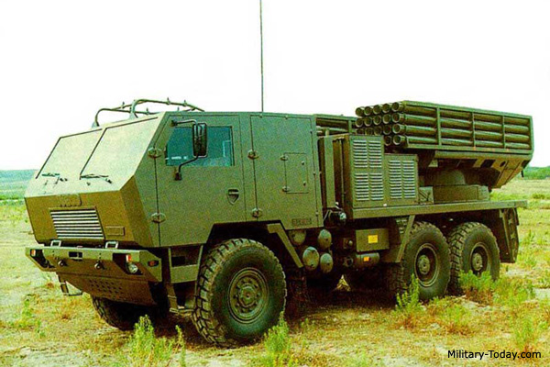

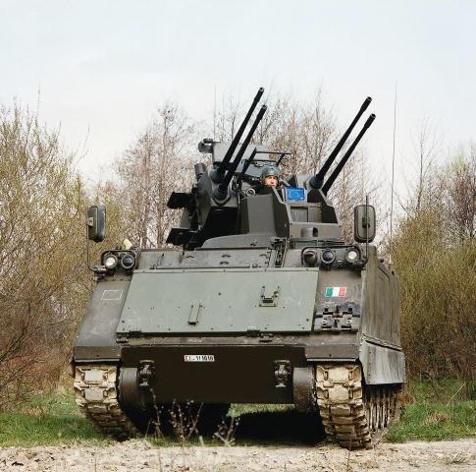**Air Defence**

Italy is in the midst of upgrading many of its air defence systems the OTO-Breda SIDAM-25 is a good example of innovation. Both the Mistral and SPADA systems are European based and very modern. Although the [Nike Hercules](https://theaviationist.com/2010/06/09/the-nike-hercules-of-the-italian-air-force-museum/) was in the process of retiring, Italy was the last user of the system and used them until 2006.

* 109 M55, 12.7mm towed Quad AAA
* 230 40mm L/70 towed AAA
* 275 [SIDAM-25](http://www.tanks-encyclopedia.com/coldwar/Italy/SIDAM-25.php), SP 25mm Quad AAA
* Stinger MANPADS
* Mistral MANPADS
* 24 SPADA (Skyguard/Aspide) + 7 with air force
* 60 I-Hawks
* 96 Nike Hercules

