**Italian Navy**

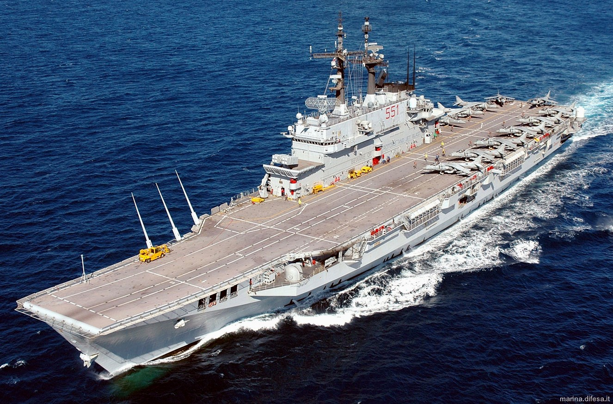

Italy is a maritime nation and one of the premier navies in the Mediterranean. Much of her equipment is of Italian design, building on a very long history of shipbuilding. As NATO navies go, Italy’s is certainly one of the middle power navies, sporting all capabilities but not very great numbers. Globally her interests are solidly in the Mediterranean, Red Sea and Indian Ocean where her former colonies give her some historic linkage. As with many countries, Italy has had some drastic financial constraints imposed on her forces and her navy in particular.

Of particular focus over the previous few years is the situation in the Former Republic of Yugoslavia (FRY); the shattering of the Communist governments in the FRY and in Albania have created significant turmoil on Italy’s doorstep and traditional sphere of influence. The influx of migrants, drugs and weapons across the Adriatic was having a very negative impact on the Italian Government’s ability to fight organized crime and thus they fully supported the international communities move to stop the flow of support to dissidents in the Balkans. NATO established first **Operation Maritime Guard** in 1992 and then **Operation Sharp Guard** in 1993 to enforce UN sanctions on the rival factions in the FRY (Serbia, Croatia, Bosnia etc), and had the side benefit of intercepting contraband headed for Italy. The Italian navy was decisively engaged in supporting these operations.

