**Portuguese Army**

The Portuguese army is a small conscript force which maintains key functions at high readiness and maintains basic skill sets for rapid mobilization. Structurally they have a Corps HQ, but in reality this formation would function at the Divisional level and either remain in Portugal to enable mobilization or deploy with the Mechanized Brigade to NATO’s Southern Army Group (SOUTHAG). The standing army was 44,000 personnel with about 175,000 reserves.

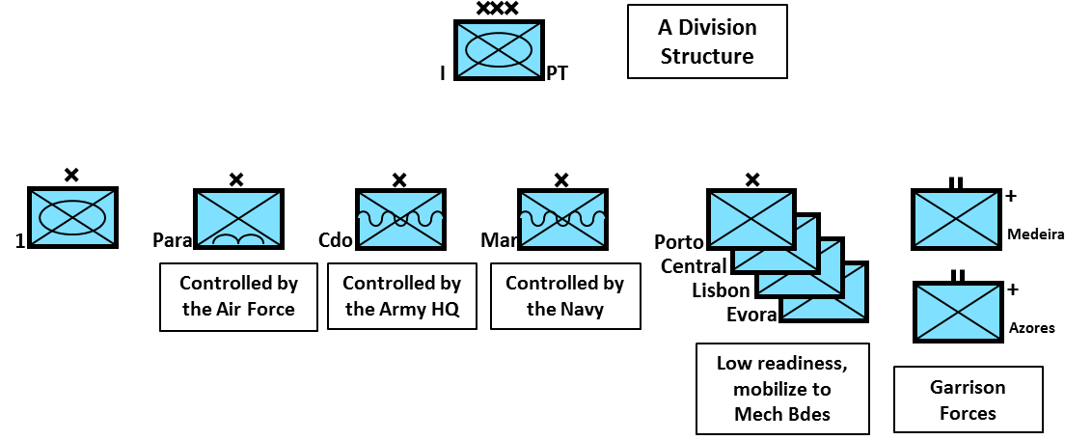

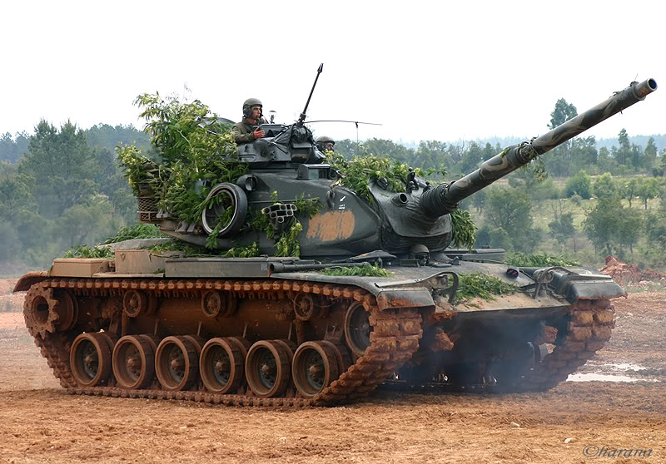The majority of the Portuguese Army is ‘light’. The units are either specialized light infantry such as the Paratroop Brigade which is controlled by the Air Force, the Marines which are controlled by the Navy or the Commandos who are tasked by the national HQ, or lightly equipped regional forces. The one mechanized formation ‘1a Brigada Mista Independiente’ or 1st Mixed Brigade has an armored battalion (M60A3 TTS), a mechanized battalion (M-113) and a motorized battalion (trucks). The garrison units are unique; they are based on a light infantry battalion but have a battery of 105mm artillery, a reconnaissance squadron and air defence.

[**M60A3 TTS Main Battle Tank (MBT)**](https://en.wikipedia.org/wiki/M60_Patton#Variants)

The US provided Portugal with 93 M60A3 TTS as well as several bridge layer, engineering, recovery and driver training variants in 1991. These replaced M-48s which were returned to the US. These are standard M60A3 with a Thermal imaging targeting site added to improve night and poor visibility operations. Most, (53) of these MBTs are in the Armored Battalion of the Mixed Brigade while the remainder are in the Cavalry (Reconnaissance) Squadron and training school.

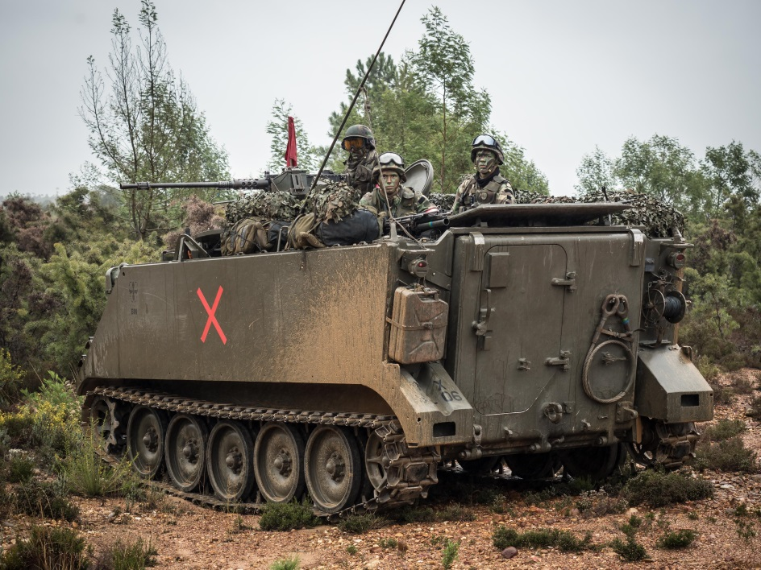[**M113**](https://en.wikipedia.org/wiki/M113_armored_personnel_carrier)

The Mechanized Battalion of the Mixed Brigade operates 42 of the 123 M113 Armored Personnel Carriers in the Portuguese Army. Other variants of this family of vehicles being used are the command post (M577), the TOW missile carrier (M901), the 107mm mortar carrier (M106) and the 81mm mortar carrier (M125), and 20mm Vulcan (M163A1). The remainder of the M113s are spread throughout the regional brigades and training schools.

**Artillery**

Portugal employed a wide variety of artillery systems.

* 23x 5.5 inch guns
* 6x M109A2 SP 155mm Howitzer
* 40x M114/23 Towed 155mm Howitzer
* 60x M-101 Towed 105mm Howitzer
* 6x M108 Self Propelled (SP) 105mm Howitzer

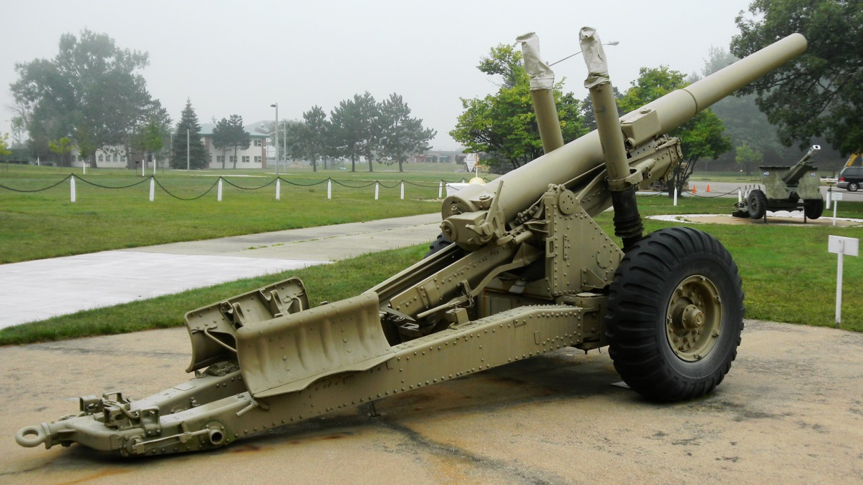

5.5 Inch Gun

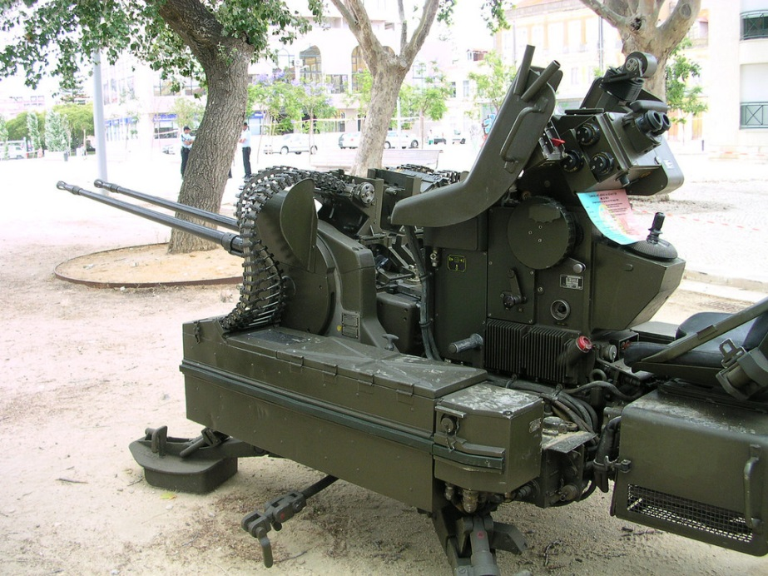**Air Defence Systems**

RH202 20mm AA Gun

Portugal has a large number of light air defence systems.

* 332x Bofors, 40mmL/70 Towed AA Guns
* 30x RH202, 20mm Towed AA Guns
* 34x M163A1 20mm Vulcan SP AA Guns
* 57x Blowpipe SAM