NATO/US Navy/Amphibious Forces/USMC Air

**USMC Air Element**

The US Marine Corps has an air Element that would rival most Air Forces. With over 1300 airframes, half of which are fixed wing, and the remainder rotary wing, they can bring over 700 combat aircraft to battle, many more than most NATO allies. All but the F/A-18s normally deploy on the various amphibious ships to form the Marine Air Ground Task Force (MAGTAF), in direct support of the ground element in any landing or operation. The Squadrons are highly flexible often deploying on multiple ships or employing aircraft of other squadrons on independent missions.

**F/A-18**: Hornet. The F/A-18’s provide the USMC with an air attack capability as well as the option to conduct air superiority missions, although that is not their primary role. Hornets will normally operate from a land base but are often flow off of USN aircraft carriers, and routinely form part of a Carrier Air Wing (CAW). The USMC uses two types of the F/A-18, the ‘A’ variant in its VMFA Squadrons (Marine Fighter Attack) and the ‘D’ variant in its VMFA(AW) (Marine Fighter Attack – All Weather Capable). Due to transition issues, two Sqns in the Pacific are temporarily equipped with the F/A-18C(N) which is a night capable single seat version of the ‘D’. The only major variation from history is that in Northern Fury all USMC Reserve Squadrons will receive the F/A-18A, these are ‘hand-me-downs’ from the USN F/A-18 Sqns which are all transitioning to the ‘C’ variant early after the demise of the A-6E. With this change in effect, all but one of them have received their aircraft but five of those are still going through conversion training. All F/A-18 Sqns have 12 aircraft except VMFAT-101, the training Sqn which has 30 airframes.

|  |  |  |  |  |
| --- | --- | --- | --- | --- |
| USMC Aircraft | | | | |
| Sqn # | Nickname | Airframe | Task | Remarks |
| Atlantic | | | | |
| VMFA-115 | Silver Eagles | F/A-18A | Med |  |
| VMFA-122 | Werewolves | F/A-18A | CVW 14 |  |
| VMFA-251 | Thunderbolts | F/A-18A | CVW 6 |  |
| VMFA-312 | Checkerboards | F/A-18D | CVW 3 |  |
| VMFA-332 | Polka Dots | F/A-18D | Cherry Pt |  |
| VMFA-451 | Warlords | F/A-18A | Med |  |
| VMFA-533 | Hawks | F/A-18D | CVW 8 |  |
| Pacific | | | | |
| VMFA-121 | Green Knights | F/A-18C (N) | CVW 17 |  |
| VMFA-212 | Lancers | F/A-18C (N) | Kaneohe Bay |  |
| VMFA-224 | Bengals | F/A-18D | Iwakuni Jap |  |
| VMFA-225 | Vikings | F/A-18D | CVW 17 |  |
| VMFA-232 | Red Devils | F/A-18D | CVW 17 |  |
| VMFA-235 | Death Angels | F/A-18A | Kaneohe Bay |  |
| VMFA-242 | Bats | F/A-18D | Japan |  |
| VFMA-314 | Black Knights | F/A-18A | CVW 11 |  |
| VMFA-323 | Death Rattlers | F/A-18A | El Toro |  |
| VMFA-333 | Shamrocks | F/A-18A | Iwakuni Jap |  |
| VMFA-531 | Grey Ghosts | F/A-18A | El Toro |  |
| Reserves | | | | |
| VFMA-112 | Cowboys | F/A-18A | Dallas | Trained |
| VMFA-124 | Wistling Death | F/A-18A | Ft Worth | Converting |
| VMFA-131 | Dimondbacks | F/A-18A | NAS Willow Grv | Converting |
| VMFA-133 | Dragons | F/A-18A | Alameda | Converting |
| VFMA-134 | Smoke | Nil | El Toro | Waiting for AC |
| VMFA-142 | Flying Gators | F/A-18A | NAS Cecil Fd | Converting |
| VFMA-321 | Hell's Angels | F/A-18A | Andrews | Trained |
| VMFA-322 | Ftg Gamecocks | F/A-18A | NAS Waymouth | Converting |
| Non Operational | | | | |
| VMFAT-101 | Sharpshooters | 30x F/A-18A/D | El Toro | Training |

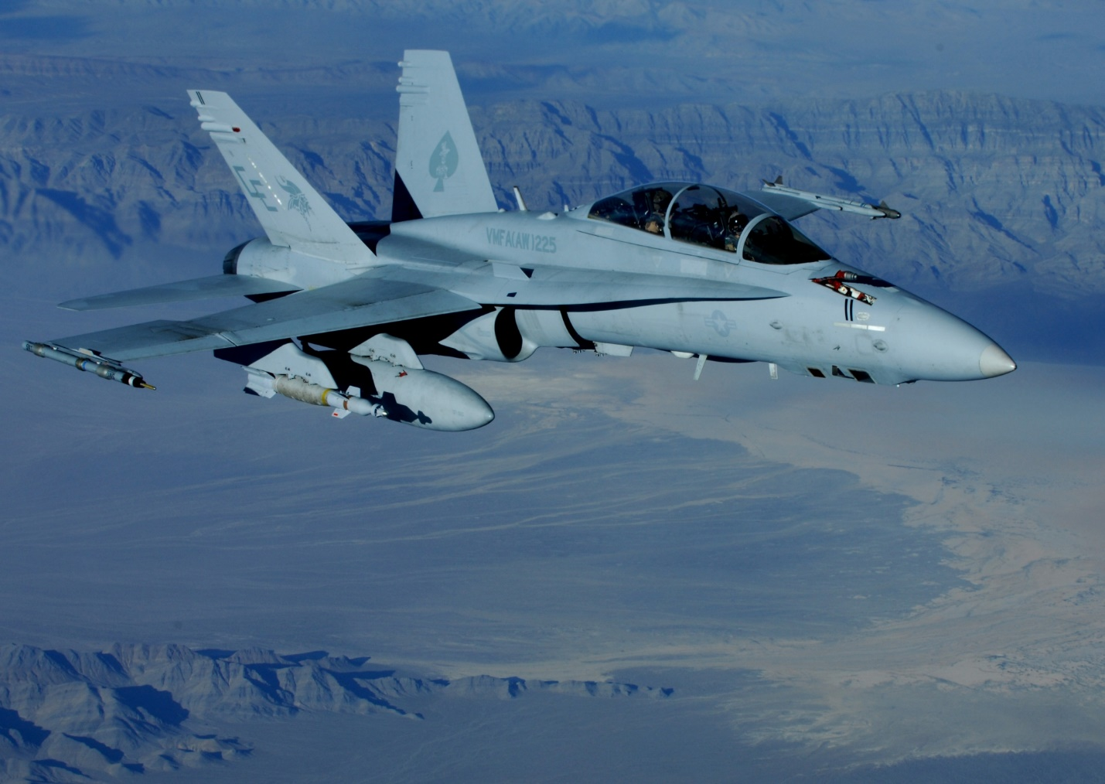

F/A-18D from VMFA(AW)-225 ‘Vikings’

**AV-8B Harrier II/II+**: The USMC is the only service in the US which uses the Harrier and it has done so since 1968. The current version is the Harrier II+ which will eventually equip six Sqns, however only 4 are equipped with this version at the moment (this is a more rapid transition than historical). The key improvement between the Harrier II and the II+ is the provision of the AN/APG-65 Radar allowing the use of the AIM-7 Sparrow and AIM-120 AMRAAM air to air missiles. The Harriers primary mission is to fly off the LHD/LHA ships in support of Marine ground units ashore. The TAV variant is a two seat trainer, solely for use in conversion training

|  |  |  |  |  |
| --- | --- | --- | --- | --- |
| USMC Aircraft | | | | |
| Sqn # | Nickname | Airframe | Base | Remarks |
| Atlantic | | | | |
| VMA-223 | Bulldogs | 22x AV-8B Harrier II | Cherry Pt |  |
| VMA-231 | Ace of Spades | 22x AV-8B Harrier II+ | Cherry Pt |  |
| VMA-331 | Bumblebees | 22x AV-8B Harrier II+ | Cherry Pt |  |
| VMA-542 | Flying Tigers | 22x AV-8B Harrier II | Cherry Pt | Will convert |
| Pacific | | | | |
| VMA-211 | Wake Avengers | 22x AV-8B Harrier II+ | Iwakuni Jap |  |
| VMA-214 | Black Sheep | 22x AV-8B Harrier II | Yuma | In Kuwait |
| VMA-311 | Tomcats | 22x AV-8B Harrier II+ | Yuma |  |
| VMA-513 | Flying Nightmares | 22x AV-8B Harrier II | Yuma | Will convert |
| Non Operational | | | | |
| VMAT-203 | Hawks | 16 AV-8B, 26 TAV-8B | El Toro | Training |

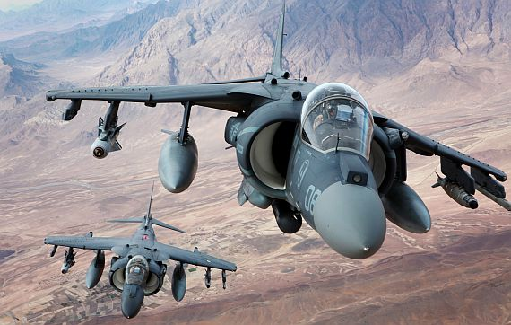

Two USMC AV-8B Harrier II loaded with AGM-65 Maverick, AIM-9 Sidewinder and GBU-16s

**EA-6B**: The USMC uses the same Electronic Warfare (EW) as the USN. The EA-6B Sqns are mostly located at MCAS Cherry Point NC but operate detachments around the world when required.

|  |  |  |  |  |
| --- | --- | --- | --- | --- |
| USMC Aircraft | | | | |
| Sqn # | Nickname | Airframe | Base | Remarks |
| VMAQT-1 | Banshee | 2 EA-6B | Cherry Pt | Training |
| VMAQ-2 | Panthers | 5x EA-6B | Cherry Pt |  |
| VMAQ-3 | Moon Dogs | 5x EA-6B | Cherry Pt |  |
| VMAQ-4 | Seahawks | 5x EA-6B | Cherry Pt |  |
| Deployed | | | | |
| VMAQ-2 Det | Panthers | 2x EA-6B | Iwakuni Jap |  |

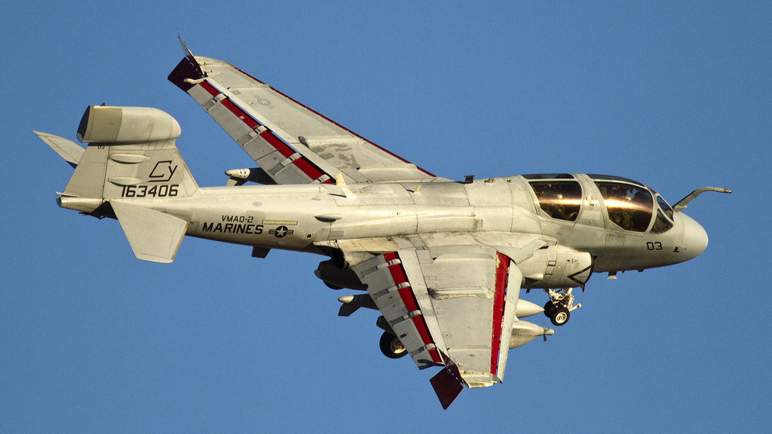

EA-6B from VMAQ-2 ‘Panthers’

**OV-10D:** Although the OV-10 Bronco was supposed to be retiring in 1995, increased tension meant that since there was nothing available to replace them, they were retained. This decision freed up other resources such as the Harriers and USAF A-10s to focus on major threat areas while the Bronco looked after the low intensity Counter Insurgency (COIN) conflicts, primarily in Central America. Of the 130 originally produced for the USMC, 51 remain.

|  |  |  |  |  |
| --- | --- | --- | --- | --- |
| USMC Aircraft | | | | |
| Sqn # | Nickname | Airframe | Base | Remarks |
| Atlantic | | | | |
| VMO-1 | Yazoo | 22x OV-10D | New River |  |
| Pacific | | | | |
| VMO-2 | Cherry Deuce | 22x OV-10D | El Toro |  |
| VMO-2 Det |  | 7x OV-10D | Iwakuni Jap |  |

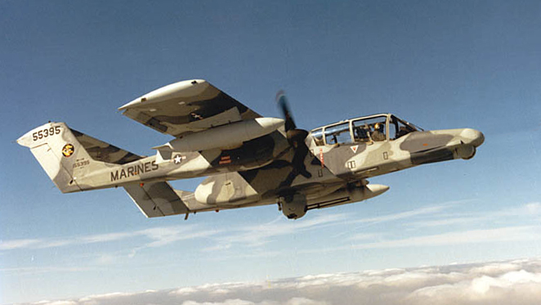

OV-10D Observation and light attack aircraft

**KC-130**: The USMC uses the venerable C-130 Hercules almost exclusively in the ‘Tanker’ role, light tactical transport is also conducted but they rely on the USN and USAF to provide surge tactical transport when needed. Pilot and crew training is also conducted with the USAF, although specific air to air refuelling and currency training is conducted by VMGRT-253. Because of the deployed nature of USMC forces there is a need for deployed KC-130 elements throughout the globe to support Amphibious Ready Groups (ARG) and other elements – this support is almost always provided by VMGR-252 which usually has between 10 and 20 KC-130s deployed. Three versions of the ‘Hurc’ are in use in 1994; legacy KC-130F which date from the 1960’s, improved KC-130R and the latest KC-130T with updated avionics.

|  |  |  |  |  |
| --- | --- | --- | --- | --- |
| USMC Aircraft | | | | |
| Sqn # | Nickname | Airframe | Base | Remarks |
| Atlantic | | | | |
| VMGR-252 | Otis | 8x KC-130F, 4x KC-130R | Cherry Pt |  |
| VMGR-252 | Otis (Depl Det) | 9x KC-130F, 12x KC-130R | Cherry Pt |  |
| VMGRT-253 | Titans | 6x KC-130F | Cherry Pt |  |
| Pacific | | | | |
| VMGR-152 | Sumos | 13x KC-130 | Futenma Jap |  |
| VMGR-352 | Raiders | 3x KC-130F, 10x KC-130R | El Toro |  |

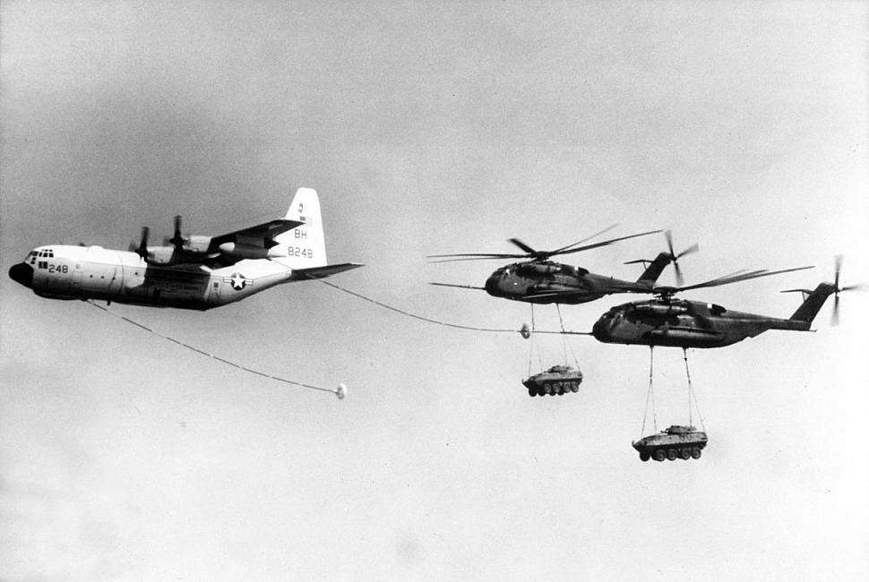

KC-130F from VMGR-252 ‘Otis’ refuelling CH-53E’s

**AH-1W**: The ‘Whiskey Cobra’. The Cobra has been key to USMC ground support since early in the Viet Nam war, the ‘Whiskey’ is the standard version used in 1994, it is night capable and able to fire either 8x TOW or Hellfire missiles.

**UH-1N**: Twin Huey. HMLA (Marine Helicopter Light Attack) Sqns are equipped both with the Whiskey Cobra and the UH-1N Huey. These two aircraft work together to provide ground support with the Huey conducting the reconnaissance and observation while the Cobra maneuvers to the best engagement position before exposing itself. In the USMC Reserve each Sqn is equipped with a single aircraft but they are grouped for operations.

|  |  |  |  |  |
| --- | --- | --- | --- | --- |
| USMC Aircraft | | | | |
| Sqn # | Nickname | Airframe | Base | Remarks |
| Atlantic | | | | |
| HMLA-167 | Warriors | 14x AH-1W, 12x UH-1N | New River |  |
| HMLA-269 | Gunrunners | 14x AH-1W, 12x UH-1N | New River |  |
| HMLA-467 | Sabers | 14x AH-1W, 12x UH-1N | New River |  |
| Pacific | | | | |
| HMLA-169 | Vipers | 14x AH-1W, 12x UH-1N | El Toro |  |
| HMLA-267 | Stingers | 14x AH-1W, 16x UH-1N | El Toro |  |
| HMLA-367 | Scarface | 17x AH-1W,  7x UH-1N | El Toro |  |
| HMLA-369 | Gunfighters | 12x AH-1W, 14x UH-1N | Futenma Jap |  |
| Det | Gunfighters | 4x AH-1W,  3x UH-1N | Okinawa |  |
| Reserves | | | | |
| HMA-773 | Red Dogs | 15x AH-1W | NAS Atlanta |  |
| HMA-775 | Coyotes | 15x AH-1W | MCAS Pendleton |  |
| HML-767 | Nomads | 13x UH-1N | NAS New Orleans |  |
| HML-771 | Hammers | 8x UH-1N | NAS S Waymouth |  |
| HML-776 | Gangsters | 7x UH-1N | NAS Glenview |  |
| Non Operational | | | | |
| HMLAT-303 | Atlas | 10x AH-1W,  7x UH-1N | Pendleton | Training |

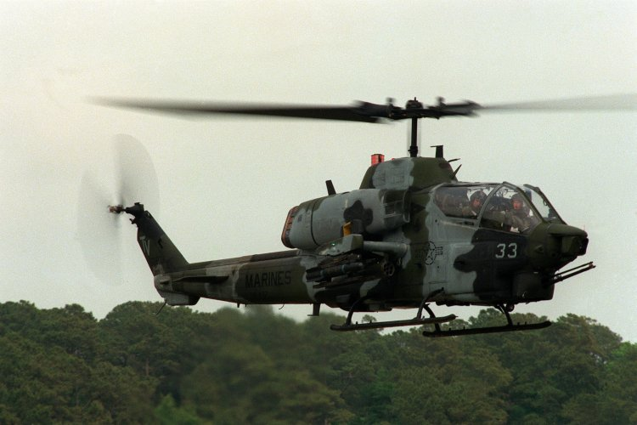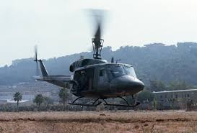

AH-1W ‘Whiskey Cobra’ UH-1N ‘Twin Huey’

**CH-46E**: ‘Sea Knight’. Known as ‘Phrogs’ these twin rotor workhorses are the standard medium lift helicopter in the USMC. They can carry 24 Marines fully loaded with their combat equipment or 2.5 tons of cargo either internally or slung underneath. Additionally, they are often configured for Combat Search and Rescue (CSAR), or Medical Evacuation (MEDEVAC) missions where they can carry 15 stretchers. An upgrade program to extend the range of the ‘Sea Knight’ is ongoing and most Squadrons have at least 2-4 of these upgraded ‘Phrogs’.

|  |  |  |  |  |
| --- | --- | --- | --- | --- |
| USMC Aircraft | | | | |
| Sqn # | Nickname | Airframe | Base | Remarks |
| Atlantic | | | | |
| HMM-162 | Golden Eagles | 12x CH-46E | New River |  |
| HMM-261 | Raging Bulls | 12x CH-46E | New River |  |
| HMM-263 | Thunder Eagles | 12x CH-46E | New River |  |
| HMM-264 | Black Knights | 12x CH-46E | New River |  |
| HMM-265 | Blue Knights | 12x CH-46E | New River |  |
| HMM-266 | Fighting Griffons | 12x CH-46E | New River |  |
| Pacific | | | | |
| HMM-161 | Greyhawks | 12x CH-46E | Okinawa |  |
| HMM-163 | Evil Eyes | 12x CH-46E | Tustin |  |
| HMM-164 | Knightriders | 12x CH-46E | Tustin |  |
| HMM-165 | White Knights | 12x CH-46E | Kaneohe Bay |  |
| HMM-166 | Sea Elks | 12x CH-46E | Tustin |  |
| HMM-262 | Flying Tigers | 12x CH-46E | Kaneohe Bay |  |
| HMM-265 | Dragons | 12x CH-46E | Futenma Jap |  |
| HMM-268 | Red Dragons | 12x CH-46E | Tustin |  |
| HMM-364 | Purple Foxes | 12x CH-46E | Kaneohe Bay |  |
| HMM-161 | Greyhawks | 12x CH-46E | Okinawa |  |
| Reserves | | | | |
| HMM-764 | Moonlighters | 12x CH-46E | El Toro |  |
| HMM-774 | Wild Goose | 14x CH-46E | NAS Norfolk |  |
| Non Operational | | | | |
| HMMT-301 | Windwalkers | 10x CH-46 | Tustin | Training |
| HMMT-204 | Raptors | 10x CH-46 | New River | Training |

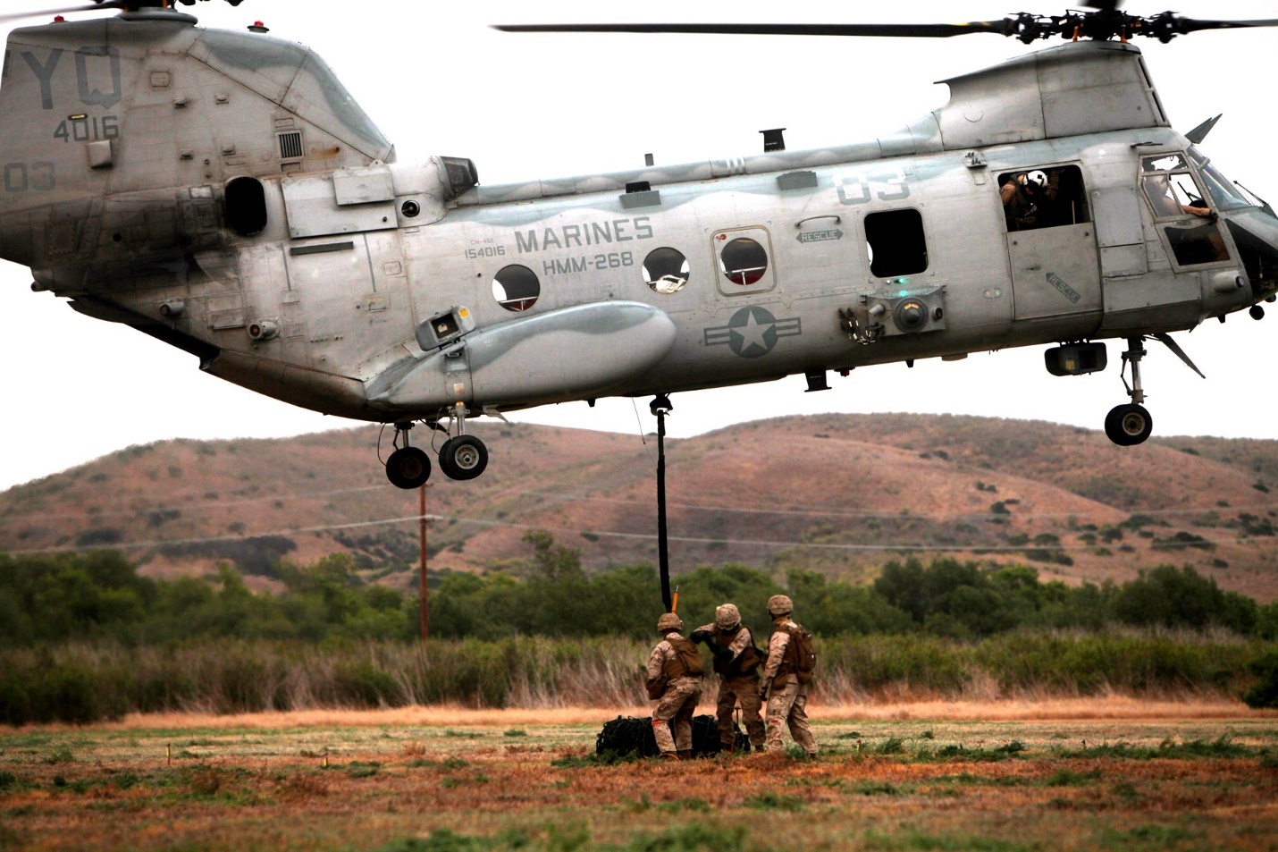

CH-46E from HMM-268 ‘Red Dragons’ picks up a slung load.

**CH-53**: In 1994 the USMC flew both the CH-53D ‘Sea Stallion’ and the CH-53E ‘Super Stallion’. These aircraft provide the USMC with the heavy lift it needs to deploy Marine ground elements quickly onto the battlefield with the combat power needed to win the day. The ‘Sea Stallion’ is one of the fastest helicopters in the world even when carrying a heavy load. The ‘Super Stallion’ in addition to keeping the speed of the earlier model is one of the largest helicopters in the world.

|  |  |  |  |  |
| --- | --- | --- | --- | --- |
| USMC Aircraft | | | | |
| Sqn # | Nickname | Airframe | Base | Remarks |
| Atlantic | | | | |
| HMH-362 | Ugly Angles | 16x CH-53D | New River |  |
| HMH-366 | Hammerheads | 16x CH-53E | New River |  |
| HMH-461 | Ironhorse | 18x CH-53E | New River |  |
| HMH-464 | Condors | 18x CH-53E | New River |  |
| HMH-362 | Ugly Angles | 16x CH-53D | New River |  |
| Pacific | | | | |
| HMH-361 | Flying Tigers | 16x CH-53E | Tustin |  |
| HMM-363 | Red Lions | 16x CH-53D | Futenma Jap |  |
| HMH-462 | Heavy Haulers | 16x CH-53E | Tustin |  |
| HMH-463 | Pineapples | 16x CH-53D | Kaneohe Bay |  |
| HMH-465 | War Horses | 16x CH-53E | Tustin |  |
| Det | War Horses | 4x CH-53E | Okinawa |  |
| HMH-466 | Wolf Pack | 16x CH-53E | Tustin |  |
| HMH-769 | Titan | 16x CH-53E | Tustin |  |
| Reserves | | | | |
| HMH-772 | Hustler | 7x CH-53D | NAS Alameda |  |
| Det | Hustler | 6x CH-53D | NAS Dallas |  |
| Det | Hustler | 6x CH-53D | NAS Willow Gr |  |
| Non Operational | | | | |
| HMHT-302 | Phoenix | 12x CH-53D, 12x CH-53E | New River | Training |

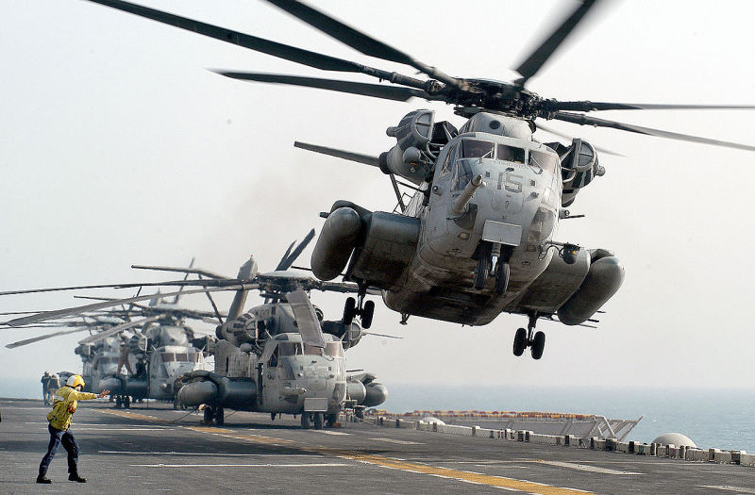

CH-53E taking off from an LHD (Wasp Class)