**Patrol Aircraft**

The USN operates three types of patrol aircraft, the primary being ASW patrol (Anti-Submarine Warfare) but also for intelligence gathering and strategic communications. These aircraft are all based on civilian airliners and have long endurance, large crews, very modular equipment which is easy to upgrade but are quiet vulnerable to enemy action. These are highly valuable aircraft so any loss would have a significant impact and gain high level attention.

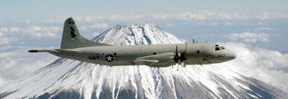

[**P-3 Orion**](http://www.p3orion.nl/index.html)

The US land based ASW fleet consists of only one aircraft type, the Lockheed P-3 Orion. Although it’s used across NATO, the USN is by far the most important operator with 24 ‘Fleet’ squadrons of 9 aircraft each, augmented by 13 Reserve squadrons, two Fleet Replacement squadrons and numerous testing, support and special duty units. All told the USN operates about 400 P-3s of various versions. Introduced in 1962, the last of the original P-3As have been retired and all of the P-3Bs have been relegated to reserve and training squadrons, special purpose units or test and evaluation establishments. All 24 regular fleet squadrons as well as 4 of the reserve squadrons fly P-3C, but there are five different upgrade levels of that airframe in the mix. The most modern and capable version are the 37 P-3C Update III and the 121 older aircraft that have been upgraded to that standard (P-3C Update IIIR). Plans exist to bring all of the ‘Update I’ and ‘Update II’ airframes up to the ‘IIIR’ standard, but the ‘Update II.5’ will take a different path in the late ‘90s. Historically several squadrons were retired between 1991 and 1994 but in Northern Fury this does not happen and therefore 5 reserve squadrons held onto the P-3B longer than in real life.

|  |  |  |  |  |  |
| --- | --- | --- | --- | --- | --- |
| Sqn | Name | Location | No. | Type | Remarks |
| VP-1 | Screaming Eagles | NAS Barbers Point, Hawaii | 9 | P-3C UIIIR |  |
| VP-2 | Skinny Dragons | NAS Barbers Point, Hawaii | 9 | P-3C UIIIR |  |
| VP-5 | Mad Foxes | NAS Jacksonville, Fla | 9 | P-3C UIIIR |  |
| VP-6 | Blue Sharks | NAS Barbers Point, Hawaii | 9 | P-3C UII.5 |  |
| VP-8 | Tigers | NAS Brunswick, Maine | 9 | P-3C UIIIR |  |
| VP-9 | Golden Eagles | NAS Barbers Point, Hawaii | 9 | P-3C UIIIR |  |
| VP-10 | Red Lancers | NAS Brunswick, Maine | 9 | P-3C UII.5 |  |
| VP-11 | Pegasus | NAS Brunswick, Maine | 9 | P-3C UII.5 |  |
| VP-16 | War Eagles | NAS Jacksonville, Fla | 9 | P-3C UIIIR |  |
| VP-17 | White Lightning | NAS Barbers Point, Hawaii | 9 | P-3C UIIR |  |
| VP-19 | Big Red | NAS Moffett Field, Calif | 9 | P-3C UI |  |
| VP-22 | Blue Geese | NAS Barbers Point, Hawaii | 9 | P-3C UIIIR |  |
| VP-23 | Seahawks | NAS Brunswick, Maine | 9 | P-3C UII |  |
| VP-24 | Batmen | NAS Jacksonville, Fla | 9 | P-3C UIIIR |  |
| VP-26 | Tridents | NAS Brunswick, Maine | 9 | P-3C UII.5 |  |
| VP-30 | Pro's Nest | NAS Jacksonville, Fla | 25 | Mixed | Fleet Replacement Sqn |
| VP-31 | Black Lightning’s | NAS Moffett Field, Calif | 22 | Mixed | Fleet Replacement Sqn |
| VP-40 | Fighting Marlins | NAS Whidbey Island, Wash | 9 | P-3C UIII |  |
| VP-44 | Golden Pelicans | NAS Brunswick, Maine | 9 | P-3C UII |  |
| VP-45 | Pelicans | NAS Jacksonville, Fla | 9 | P-3C UIIIR |  |
| VP-46 | Grey Knights | NAS Whidbey Island, Wash | 9 | P-3C UIIIR |  |
| VP-47 | Golden Swordsmen | NAS Barbers Point, Hawaii | 9 | P-3C UIII |  |
| VP-48 | Boomers | NAS Moffett Field, Calif | 9 | P-3C UIII |  |
| VP-49 | Woodpeckers | NAS Jacksonville, Fla. | 9 | P-3C UIIIR |  |
| VP-50 | Blue Dragons | NAS Moffett Field, Calif | 9 | P-3C UIIIR |  |
| VP-51 | Dragons | NAS Jacksonville, Fla. | 9 | P-3C UIIIR |  |
| VP-60 (R) | Cobras | NAS Glenview, Ill | 9 | P-3B MOD |  |
| VP-62 (R) | Broadarrows | NAS Jacksonville, Fla. | 9 | P-3B TAC/NAV | Held onto P-3B for NF |
| VP-64 (R) | Condors | NAS Willow Grove, Pa | 9 | P-3C UII |  |
| VP-65 (R) | Tridents | NAS Point Mugu, Calif | 9 | P-3B MOD | Held onto P-3B for NF |
| VP-66 (R) | Liberty Bells | NAS Willow Grove, Pa | 9 | P-3C UI |  |
| VP-67 (R) | Golden Hawks | NAS Memphis, Tenn. | 9 | P-3B TAC/NAV |  |
| VP-68 (R) | Blackhawks | Andrews AFB, Md | 9 | P-3B TAC/NAV | Held onto P-3B for NF |
| VP-69 (R) | Totems | NAS Whidbey Island, Wash | 9 | P-3C UI |  |
| VP-90 (R) | The Lions | NAS Glenview, Ill. | 9 | P-3B MOD |  |
| VP-91 (R) | Black Cats | NAS Moffett Field, Calif. | 9 | P-3B TAC/NAV | Held onto P-3B for NF |
| VP-92 (R) | Minutemen | NAS Brunswick, Maine | 9 | P-3C UII |  |
| VP-93 (R) | Executioners | NAF Detroit, Mich. | 9 | P-3B TAC/NAV |  |
| VP-94 (R) | Crawfishers | NAS New Orleans, La | 9 | P-3B TAC/NAV | Held onto P-3B for NF |

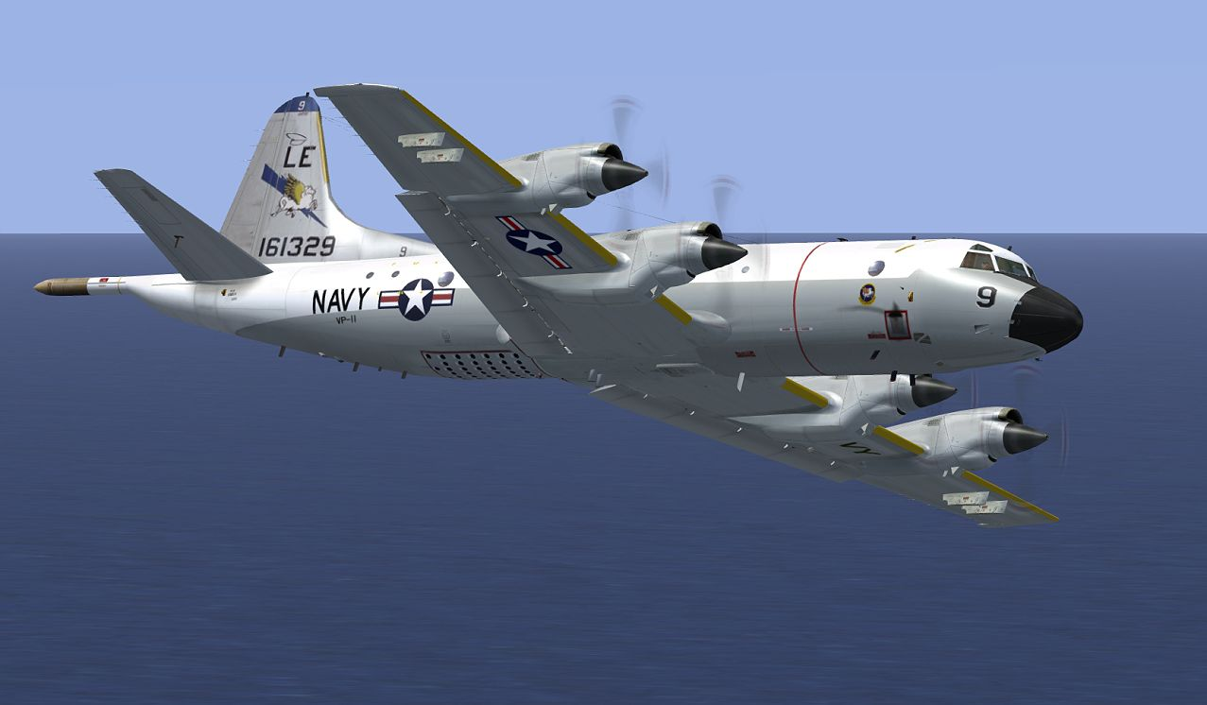

[**EP-3E ARIES & ARIES II**](https://fas.org/irp/program/collect/ep-3_aries.htm)

Exclusively focused on ELINT or Electronic Intelligence gathering, two versions of the EP-3E are in service at the start of 1994. All 12 of the original EP-3E ARIES are available, although some are at a reduced state of readiness, these are based on the P-3A and P-3B airframes with all ASW equipment removed and replaced with electronic monitoring systems, two of the 12 had a very interesting [life](http://www.p3orion.nl/sneaky.html) in the CIA and elsewhere before conversion. The EP-3E ARIES II were new build P-3C airframes loaded with more modern and advances equipment and antennae, historically these were delayed due to negotiations with the USAF and Congress, however in Northern Fury production was expedited and 8 of the planed 12 airframes are available. The two squadrons flying this type have a mix of the ARIES and ARIES II airframes and have global responsibilities, the aircraft are routinely deployed to any potential conflict zone or area where interesting electronic intelligence may be available or of use.

|  |  |  |  |  |  |
| --- | --- | --- | --- | --- | --- |
| Sqn | Name | Location | No. | Type | Remarks |
| VQ-1 | World Watchers | NAS Whidbey Island, Wash | 9 | EP-3E Mix | 2 at Atsugi Japan |
| VQ-2 | Batmen | NAS Rota Spain | 9 | EP-3E Mix | 2 at Souda Bay Crete |

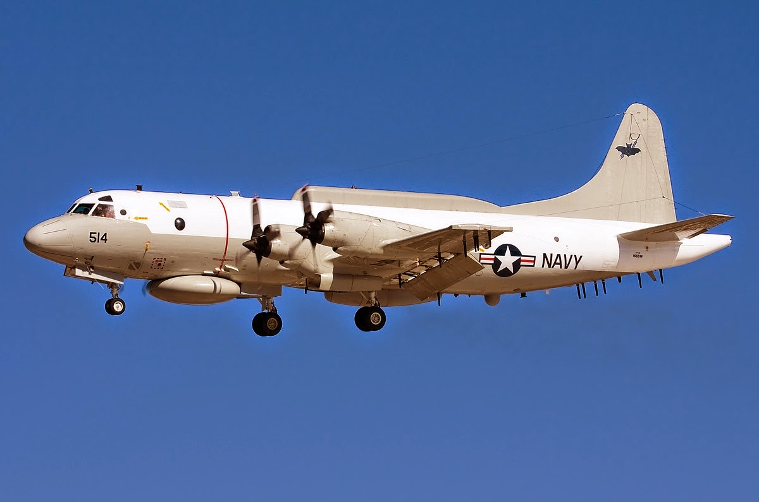

[**E-6A Mercury**](https://fas.org/nuke/guide/usa/c3i/e-6.htm)

These Boing 707 based aircraft serve as a survivable command link to the US Ballistic Missile submarines (SSBN) and are the equivalent to the USAFs EC-135C ‘Looking Glass’. Developed under the navy’s TACAMO (take charge and move out) program they have transferred to US Strategic Command (USSTRATCOM) for direct control of the nuclear missiles, however the USN still operates the aircraft and uses them to relay messages to all submarines, not just the SSBNs. The original production schedule had the last 4 airframes arriving in 1994, this has been accelerated slightly and all but the last aircraft have been received and the 16th will arrive in March 1994.

|  |  |  |  |  |  |
| --- | --- | --- | --- | --- | --- |
| Sqn | Name | Location | No. | Type | Remarks |
| VQ-3 | Ironman | Tinker AFB | 8 | E-6A |  |
| VQ-4 | Shadows | Tinker AFB | 7 | E-6A | 8th AC in Mar 94 |

