NATO/US Navy/US Navy BBTGs

BBTG Iowa (BB-61)

USS Iowa, was lead ship of her class and saw service in World War Two and the Korean War. She was retired in 1958, reactivated after a massive upgrade and refurbishment. In 1989 she suffered from a turret explosion which killed 47 sailors. Historically she was decommissioned again in 1990, in the Northern Fury world, this 2nd decommissioning did not happen however Turret # 2 was never put back into a serviceable state and the Iowa only has 6 functioning 16” guns.

At war start she is on patrol in the Mediterranean.

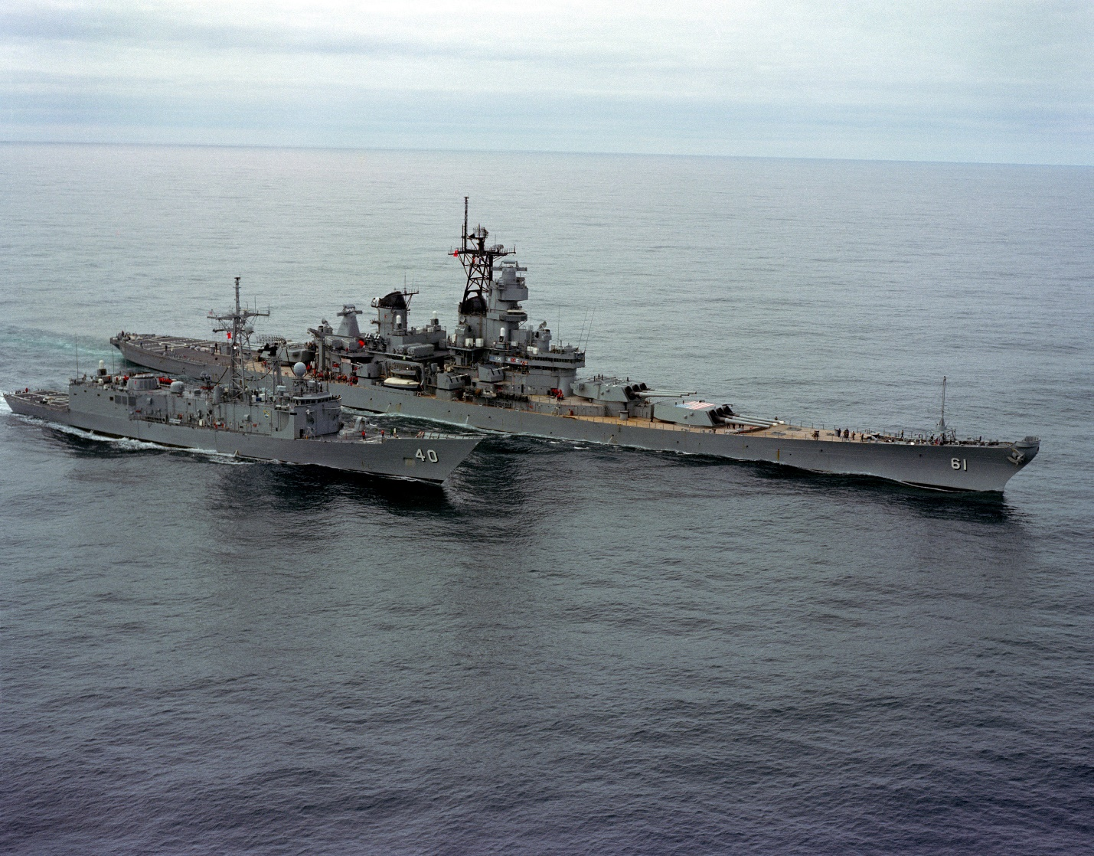

USS Iowa with USS Halyburton

TG Iowa:

* BB-61 USS Iowa
  + VC-6 'Firebees' 5x RQ-2A
* CG-23 USS Halsey
* FFG-9 USS Wadsworth
  + HSL-38 2x SH-2F