NATO/US Navy/US Navy CVBGs

**CVBG Enterprise (CVN-65)**

The Enterprise rushed through here Complex overhaul and refueling, putting to sea for initial tests in late Jan 94. She and elements of her Battle Group depart Norfolk on 4th of Feb to carry out workup tests and training in Puerto Rico, where the rest of the Battle Group assembles. On 11 Feb, 4 days into a 10 day testing and training schedule she is ordered north at best speed, destination Iceland. The start of the war finds her steaming northward toward her first engagement on the 17th of Feb.

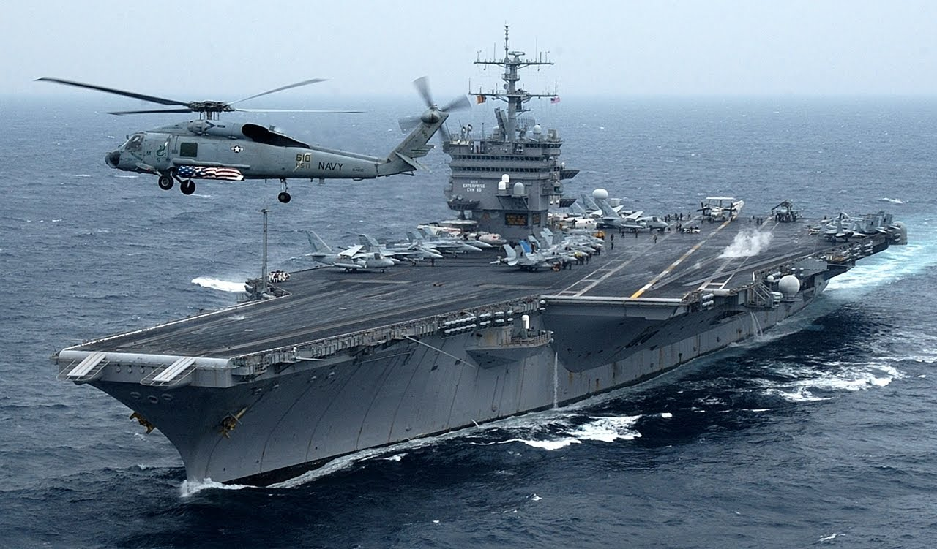

CVBG Enterprise

* CVN 65 Enterprise (FLAG)
* CVW 6
* VF-51,          Screamin’ Eagles (F-14A)
* VF-111,        Sundowners (F-14B)
* VFA-132,     Privateers (F/A-18C & C+)
* VFA-137,     Kestrels (F/A-18A)
* VFA-252,     Knighthawks (F/A-18C)          From 18 Feb
* VMFA-251, Thunderbolts (F/A-18A)         Until 26 Feb
* VA-176,       Thunderbolts (A-6E)
* VAQ-133,    Wizards (EA-6B)
* VS-28,          Gamblers (S-3B)
* VAW-122,   Steeljaws (E-2C)
* VQ-4 (El),    Shadows (ES-3A)
* HS-15,         Red Lions (SH-60F & HH60H)
* CG 17 Yarnell
* CG 63 Cowpens
* CG 68 Anzio
* DD 987 O’Bannon
* DD 988 Thorne
* FFG 38 Curts
* FFG 56 Simpson
* AOE 3 Seattle
* SSN 707 Portsmouth
* SSN 721 Chicago
* SSN 751 San Juan

**CVN-65 Timeline 1994**

|  |  |  |
| --- | --- | --- |
| **Date** | **Activity** | **Remarks** |
| 10-Jan | Exit Drydock & move to Norfolk |  |
| 15-Jan | Outfit ship |  |
| ~20 Jan | Day sail |  |
| ~28 Jan | 3 Day sail |  |
| 01-Feb | Prep to depart Norfolk |  |
| 04-Feb | Depart Norfolk with CG & 2 DD | 1200nm |
| 07-Feb | Enterprise arrives Puerto Ricco, links with remainder of BG and starts a scheduled 10 day training period |  |
| 11-Feb | Enterprise departs Puerto Ricco for Iceland | @18Knts = 6 days |