NATO/US Navy/US Navy CVBGs

USS Ranger (CV-61)

USS Ranger, was commissioned in 1957 as the third of four Forrestal class carriers, she does not complete a Service Life Extension Program (SLEP), only a Complex overhaul in 1985/85. After service in the Gulf War, she was due for de-commissioning until heightened tensions caused an adjustment of that plan. Instead she followed CV-41 Midway into the Reserve fleet when that carrier was decommissioned in early 92. Since that time she has been tied up but will activate again at the start of the war, sailing for the Western Pacific in direct support of the USMC 3rd Marine Amphibious Force, and then the Indian Ocean to relieve her sister ship CV-60 Saratoga, allowing ‘Sara’ some badly needed and overdue maintenance time.

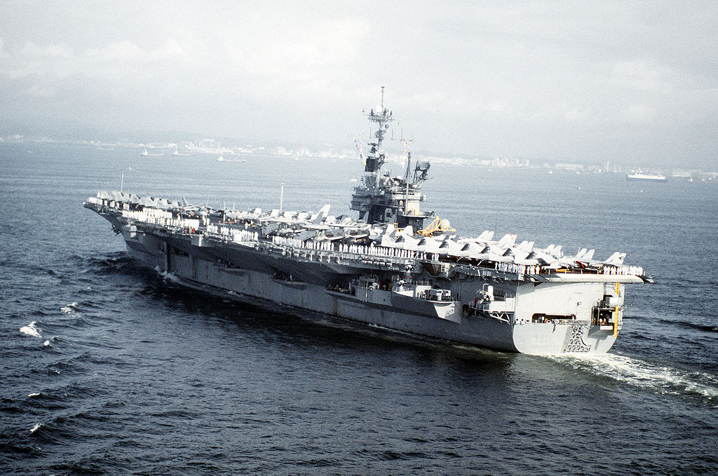

* USS Ranger

CV-62 Independence

* + USMC/uSN Composite wing (April – Jul 94)
    - VF-191 Satan's Kittens F-14A
    - VMFA-232 Red Devils F/A-18D
    - VMFA-121 Green Knights F/A-18C (N)
    - VMFA-225 Vikings F/A-18D
    - VA-155 Silver Foxes A-6E SWIP
    - VMAQ-4 Seahawks EA-6B
    - VAW-127 Seabats E-2C
    - VS-21 Redtails S-3B
    - HS-17 Neptune's Raiders SH-3H
  + In July 94 when CV-60 Saratoga is relieved, partial cross decking with CVW-17 will take place when the USMC Sqns are able to establish on land bases.
  + Escorts as needed