NATO/US Navy/US Navy CVBGs

**CVBG Theodore Roosevelt (CVN-71)**

The USS Theodore Roosevelt (CVN-71) is finishing up a four month Scheduled ‘Selected Restricted Availability’ (SRA) maintenance period at Norfolk.  She was planning to put to sea again in late February of 94 but hostilities hastened that departure slightly.  She and her Battle Group will move north with the amphibious units during the last week of February.

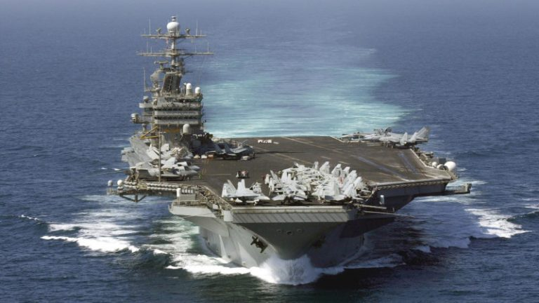

CVBG Theodore Roosevelt

* CVN-71 Theodore Roosevelt (FLAG)
* CVW 8
* VF-41,            Black Aces              (F-14A)
* VF-114,          Aardvarks               (F-14A
* VFA-15,        Valions                      (F/A-18C)
* VFA-87,        Golden Warriors     (F/A-18C (N))
* VMFA-533, Hawks                        (F/A-18D) Until 25 Feb
* VA-145,        Swordsmen             (A-6E) From 27 Feb
* VAQ-141,     Shadowhawks        (EA-6B)
* VAQ-209,    Star Warriors          (EA-6B) Until 30 Feb
* VS-24,           Scouts                       (S-3B)
* VAW-121,    Bear Aces                 (E-2C)
* VQ-6 (El),     Black Ravens           (ES-3A)
* HS-3,            Tridents                    (SH-60F & HH60H)
* CG-20 Richmond K Turner
* CG-60 Normandy
* CG-66 Hue City
* DDG-55 Stout
* DDG-995 Scott
* FFG-50 Taylor
* FFG-58 Samuel B Roberts
* FFH-330 Halifax  (CAN)