AI-Powered Clinical Risk Prediction and Healthcare Intelligence System
HealthConnect Rwanda | Week 6 Machine Learning Project
Executive Summary | Educational prototype using synthetic project data

1. Project overview
This project explores how machine learning and data analytics can organize healthcare information into useful operational insights. The workflow integrates appointment-level information with related patient, billing, feedback and insurance data where available. It then demonstrates classification, regression, clustering, anomaly screening and feature-importance analysis.
The intended users are healthcare administrators, analysts and operational teams who need accessible summaries rather than raw tables. The work is a prototype, not a deployed clinical decision system. The available data and model performance do not justify using its outputs to diagnose patients, determine treatment or deny services.

Project objectives
- Prepare and integrate available healthcare datasets.
- Explore prediction of insurance claim status and patient satisfaction.
- Demonstrate a rule-generated screening-priority proxy and billing-amount regression.
- Explore patient and facility clusters and unusual billing records.
- Present results, limitations, explainability and a proposed deployment architecture.

2. Methods and results
Data preparation and feature engineering produced an appointment-level analytical dataset with approximately 5,000 records and 49 columns. The workflow also saved model comparison tables, confusion matrices, feature-importance outputs, clustering assignments and billing anomaly flags.
Task | Reported result | Interpretation
Insurance claim status | 49.8% accuracy | Logistic Regression; weak performance on the test set.
Patient satisfaction | 36.6% accuracy | Logistic Regression; weak performance across satisfaction classes.
High-risk screening proxy | 88.5% accuracy | Not a clinical risk model; the Random Forest predicted all test cases as higher priority.
Billing amount regression | R² = 0.941 reported | Preliminary only; potential leakage from related billing/claim variables has not been ruled out.
Billing anomaly screening | 150 of 5,000 flagged | Isolation Forest flagged 3% as unusual; these are not confirmed fraud cases.
Clustering | Patient and facility clusters saved | Exploratory patterns requiring domain interpretation.
Feature-importance files were generated from logistic-regression coefficients. Several of the largest coefficients correspond to department identifiers. These signals may reflect category-specific patterns and should not be interpreted as causal effects. SHAP and LIME explanations have not yet been generated.

3. Interpretation and operational value
The main contribution is an integrated analytical workflow that demonstrates how healthcare data can be transformed into reusable tables, baseline models and operational summaries. The saved outputs can support further analysis and help stakeholders identify where better data or improved modelling is needed.

Potential uses after further validation
- Monitor data completeness and consistency across patient, appointment, billing and claim records.
- Review claim-status patterns and satisfaction feedback as operational indicators.
- Investigate unusual billing records with authorized finance staff.
- Explore patient or facility segments to formulate questions for further analysis.
- Provide a dashboard with filters, trends, model limitations and links to underlying records.

4. Limitations and responsible use
- The project data are synthetic or educational and are not evidence of real-world clinical effectiveness.
- No explicit, reliable hospital-admission outcome was identified in the available tables.
- No suitable length-of-stay target was identified, so a valid length-of-stay model could not be completed.
- No laboratory-results table was identified in the reviewed dataset inventory.
- The high-priority label was generated using a rule; it is not an independently verified clinical outcome.
- The high-risk proxy model's confusion matrix indicates it classified all test examples as higher priority, so its accuracy is misleading.
- The billing regression predicts appointment-level BillingAmount, not future monthly hospital revenue. Related billing or claim variables may cause target leakage.
- Satisfaction prediction performance is weak and should not be used for individual decisions.
- Anomaly flags identify unusual records, not confirmed fraud, errors or misconduct.
- Clustering is exploratory. SHAP/LIME and validated clinical/geographic assessments are not complete.
Ethical safeguards: keep a human reviewer in the decision loop; restrict access to sensitive records; document data provenance; assess performance across relevant groups; communicate uncertainty; and never use this prototype alone to make clinical, insurance eligibility or patient-access decisions.

5. Proposed deployment architecture
The proposed architecture separates source data, preparation, modelling and user-facing reporting. The current project has produced local/Drive artifacts; this diagram describes a future deployment design, not a live deployed service.
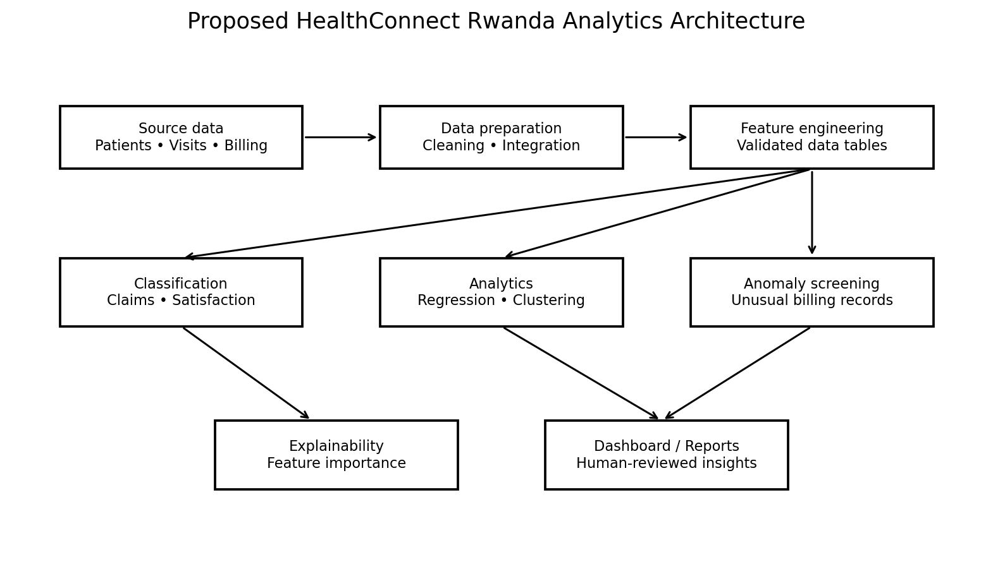

Recommended next steps
- Confirm the permitted use, provenance and meaning of every source field.
- Resolve leakage risks before reporting regression performance as reliable.
- Use appropriate train/test separation and class-wise metrics for classification.
- Obtain valid admission and length-of-stay outcomes before modelling those targets.
- Add SHAP or LIME only after selecting and reviewing a suitable model.
- Build a dashboard with clear model limitations, timestamps, filters and human review.
- Conduct privacy, fairness, security and domain-expert reviews before any real-world pilot.

6. Conclusion
HealthConnect Rwanda demonstrates a broad machine-learning workflow across healthcare operations data. The integration, saved baseline models, exploratory clustering, anomaly screening and reporting artifacts provide a foundation for continued development. However, the classification results are weak, the screening proxy is not clinically validated, and the billing regression needs a leakage review. Missing targets also prevent defensible admission and length-of-stay prediction.
The appropriate conclusion is that this is an educational analytics prototype with useful technical outputs, not a validated clinical system. Future work should prioritize trustworthy targets, leakage-free evaluation, transparent explanations, data governance and human oversight.

Deliverables produced
- Cleaned and feature-engineered appointment dataset
- Classification and regression result tables
- Confusion matrices and feature-importance outputs
- Patient and facility cluster assignments
- Billing anomaly screening output
- Limitations and ethics notes
- Proposed deployment architecture diagram
- Executive summary and presentation

