**Genome-wide analysis of dsRNAs that target mRNA degradation *via* Ago-2 guided cleavage in *Drosophila***

Claude Pasquier1*, Sandra Agnel2, Alain Robichon2

1Université Côte d’Azur, CNRS, I3S, France.

2Université Côte d'Azur, INRA, CNRS, ISA, France.

*Correspondence to: claude.pasquier@unice.fr

**Supplemental information**

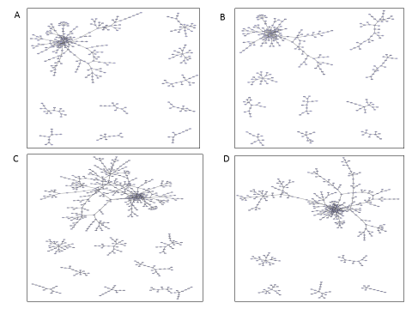

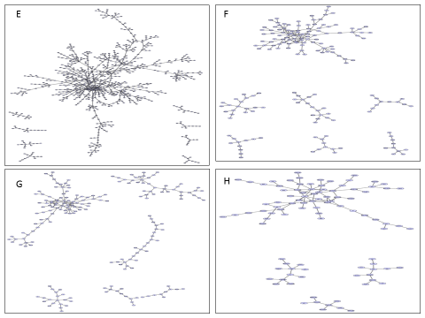

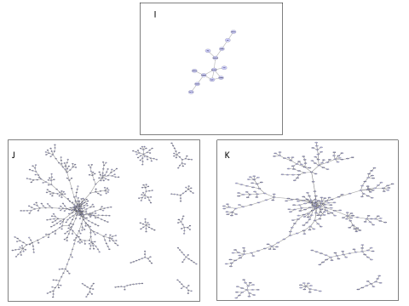

**Figure S1: Networks of genes in developmental stages theoretically making dsRNA within co-expressed genes lists**

Network of interactions between genes potentially engaged in dsRNAs in (A) embryos 0-4 hours, (B) embryos 4-8 hours, (C) embryos 8-12 hours, (D) embryos 12-16 hours, (F) embryos 16-20 hours, (F) embryos 20-24 hours, (G) larvae L1, (H) larvae L2, (I) larvae L3, (J) pupae, (K) adult female. These networks have been obtained with the filtered original list for only the co-expressed genes.

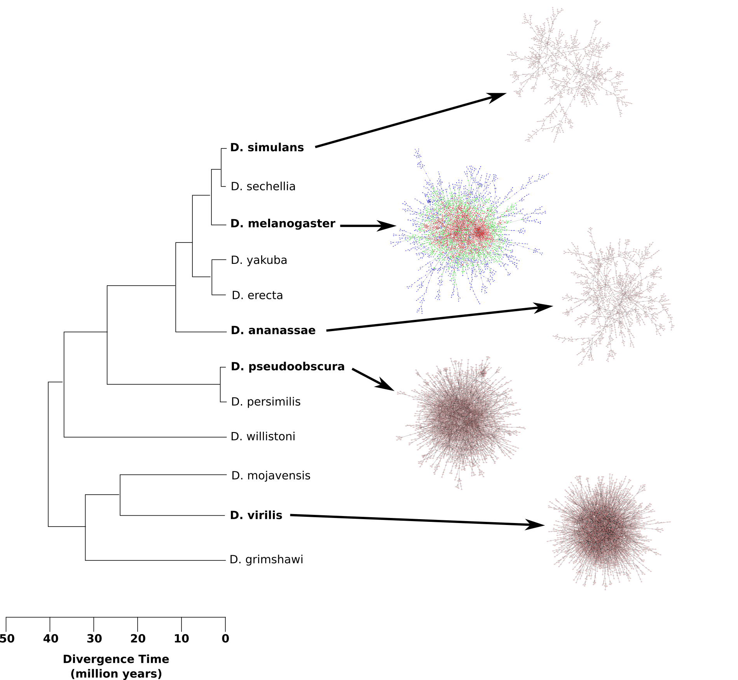

**Supplemental figure S2: illustration of the topology of ds interaction networks for other drosophila species**

The graph illustrate the network analysis carried out with minimal 20 bases pairing length in parallel with 4 *Drosophila* species. The computational search leading to the network of genes theoretically engaged in dsRNA as illustrated in figure 7 for Drosophila melanogaster was extended to the other species.