TON DUC THANG UNIVERSITY - FACULTY OF INFORMATION TECHNOLOGY
Software Engineering - Semester 1, 2026-2027

LAB GROUP ASSIGNMENT 1
Smart Ticketing System
Ticket Vendor Machine (TVM) - Requirements, UML Design, Architecture and C#/MSSQL Prototype

Instructor: P.T.K. Trung
Group members: 524K0028 - 524V0018 - 523V0007

No. | Student ID | Full name | Role | Contribution (%)
1 | 524K0028 | Nguyễn Lê Toàn Thắng | Leader - requirements (Q&A, SRS), report | 33.33 %
2 | 524V0018 | Võ Hữu Phước | UML modelling, UI/UX wireframes, architecture | 33.33 %
3 | 523V0007 | Hà Văn Thành Đạt | C# / MSSQL demo, testing, GitHub | 33.33 %

GitHub repository: https://github.com/claudeprogrammorpheus-png/TicketVendor
Submission date: 31 October 2026

Table of Contents
Right-click here and choose 'Update Field' (or press F9) to build the table of contents.

1. Introduction

1.1 Business context
The Smart Ticketing System sells public-transport tickets (MRT and Bus) through unattended Ticket Vendor Machines (TVMs) installed at stations. A passenger presses Start, chooses a destination, chooses how to pay (credit/debit card, bank QR code or digital wallet) and receives a paper ticket carrying a machine-readable code. The original problem statement only describes the happy path of card and wallet payments and leaves many aspects ambiguous (ticket types, failure handling, timeouts, refunds, reliability and response-time targets).

1.2 Objectives and scope of this report
- Phase 1 - Requirements engineering: clarification Q&A (26 questions) and a formal SRS with functional, non-functional and domain requirements.
- Phase 2 - UML modelling: use case diagram and descriptions, two activity diagrams, sequence, state chart and class diagrams for 'Buy a Ticket'.
- Phase 3 - UI/UX and architecture: kiosk wireframes, MVC architecture and deployment diagram.
- Phase 4 - Implementation: Visual Studio forward/backward engineering and Code Map, GitHub collaboration, AI-assisted development, and a working C# WinForms + MS SQL Server prototype.

1.3 Deliverables
Artefact | File / location in repository
Clarification Q&A (Excel) | 01_Requirements/Clarification_QA.xlsx
Requirements Specification (Excel) | 01_Requirements/Requirements_Specification.xlsx
UML diagrams (PlantUML source + PNG) | 02_UML/*.puml, *.png
Wireframes / mockups (HTML + PNG) | 03_UI/tvm_mockup.html, 03_UI/*.png
Architecture & deployment diagrams | 04_Architecture/*.puml, *.png
C# solution (WinForms demo + xUnit tests) | 05_Source/TVM.sln
Database script (MS SQL Server) | 05_Source/Database/TVM_DB.sql
Demo screenshots | 06_Screenshots/*.png

2. Phase 1 - Requirements Engineering

2.1 Clarification Q&A
Each ambiguity or omission found in the problem statement was turned into a question for the stakeholders (transport operator, payment partners, maintenance team). Because the stakeholders are not available, the team recorded a logical assumed answer that the design is based on. The full list is in Clarification_QA.xlsx; the most important items are summarised below.
Table 1: Clarification questions and assumed answers
ID | Category | Clarifying question | Assumed answer (design basis)
Q01 | Scope | Which transport modes must the TVM support in release 1? | Bus and MRT only. Other modes (e.g. waterbus) are added later through configuration, not code changes.
Q02 | Ticket types | Which ticket types are sold (single trip, return, day pass, monthly pass)? Are concession fares (student, elderly) supported? | Single-trip and Day-pass. Concession fares are out of scope for the TVM (they need ID verification at the counter).
Q03 | Quantity | Can a passenger buy several tickets in one transaction? | Yes, 1 to 10 tickets of the same type and destination per transaction.
Q04 | Origin | How is the origin station determined? | The origin is the station where the TVM is installed (configured per machine).
Q05 | Fare | How is the fare calculated and who maintains the fare table? | Fare is distance/zone based and read from the central Fare table; the TVM caches it and refreshes every 15 min.
Q06 | Destination menu | How many destinations can exist and how are they ordered/searched? | Up to 200 stations; shown grouped by line, alphabetically, with a search box and the 8 most-popular as shortcuts.
Q07 | Payment modes | How does 'QR Code linked to a banking system' differ from 'Digital Wallet'? | QR Code = dynamic VietQR (NAPAS 247) paid from any banking app; Digital Wallet = MoMo / ZaloPay / VNPay QR. Both show a QR on screen; they differ only in the gateway used.
Q08 | Cash | Must the TVM accept cash? | No. The machine is cashless (reduces maintenance and theft risk).
Q09 | Card handling | Which card technologies and schemes are supported? Is a PIN required? | EMV chip (insert) and NFC contactless (tap) for Visa, Mastercard, JCB and NAPAS debit. PIN only when requested by the issuer (above contactless limit).
Q10 | Charge timing | Is the card charged before or after the ticket is printed? | Authorize first, print, then capture. If printing fails the authorization is voided (no charge).
Q11 | Declined payment | What happens when a card is declined or the wallet payment fails? | Show the reason, allow up to 3 retries or another payment method, then return to the home screen.
Q12 | QR validity | How long is the on-screen QR valid and how does the TVM learn that payment succeeded? | QR expires after 120 s. The TVM receives a gateway webhook (IPN) through the Central Server and also polls every 3 s as a fallback.
Q13 | Session timeout | What happens if the passenger walks away mid-transaction? | After 60 s of inactivity a 10 s countdown is shown, then the session is cancelled and the screen resets.
Q14 | Cancellation | Can the passenger cancel at any step? | Yes, a Cancel button is visible on every screen until payment is confirmed.
Q15 | Ticket medium | Is the code a 1D barcode or a 2D QR code, and what does it encode? | 2D QR code (ISO/IEC 18004) encoding ticket ID, route, validity and an HMAC signature so gates can validate offline.
Q16 | Ticket validity | How long is a ticket valid after purchase? | Single-trip: until 23:59 of the purchase day, one entry. Day-pass: until 23:59, unlimited rides.
Q17 | Digital ticket | Does a wallet payment also issue a paper ticket, or an e-ticket? | A paper ticket is always printed; an e-receipt can optionally be shown as a QR to scan.
Q18 | Printer failure | What if the printer runs out of paper or jams after payment? | Before payment the TVM checks printer status; if out of paper it shows 'Out of service'. If a jam occurs after capture the payment is refunded automatically and an incident is logged.
Q19 | Network loss | Can the TVM sell tickets when the network is down? | No - payments need online authorization. The TVM shows 'Temporarily out of service' and keeps queued logs to upload later.
Q20 | Receipt / invoice | Is a receipt or VAT e-invoice required? | The ticket doubles as a receipt. A VAT e-invoice can be requested via a lookup code printed on the ticket (Decree 123/2020/ND-CP).
Q21 | Languages | Which languages must the UI support? | Vietnamese (default) and English, switchable on every screen.
Q22 | Accessibility | Must the TVM support disabled passengers? | Yes: touch targets >= 15 mm, high-contrast mode, screen height usable from a wheelchair (WCAG 2.1 AA inspired).
Q23 | Operators | Who maintains the machine and what can they do? | Maintenance staff log in with a staff card to refill paper, view logs, and take the machine in/out of service. Admins manage fares and destinations on the central server.
Q24 | Reporting | What sales reports are required? | Daily sales report per TVM and per payment method, plus reconciliation with gateway settlement files.
Q25 | Security | Will the TVM store card numbers? | Never. The card reader is a PCI PTS certified device that sends encrypted data directly to the acquirer; the TVM only stores a masked PAN and the auth code.
Q26 | Volumes | How many TVMs and transactions per day are expected? | Up to 300 TVMs, peak 30 transactions per TVM per hour, 150,000 transactions per day system-wide.

2.2 Functional requirements
Functional requirements use 'shall' statements, MoSCoW priority and a fit criterion so that each one can be tested.
Table 2: Functional requirements
ID | Requirement | Priority | Fit criterion
FR-01 | The TVM shall display an idle/welcome screen with a 'Start' button and language selector when no session is active. | Must | Idle screen appears after boot and after every completed/cancelled session.
FR-02 | When the passenger presses 'Start', the TVM shall display the list of destinations reachable from the current station, grouped by transport mode/line. | Must | List shows all active stations from the cached Station table except the origin.
FR-03 | The TVM shall let the passenger choose a ticket type (Single-trip or Day-pass). | Must | Both types selectable; default Single-trip.
FR-04 | The TVM shall provide a search box and 'popular destination' shortcuts on the destination screen. | Should | Typing 2+ characters filters the list.
FR-05 | The TVM shall let the passenger select a quantity from 1 to 10 and shall display the unit fare and total amount in VND before payment. | Must | Total = unit fare x quantity, shown before the payment step.
FR-06 | The TVM shall offer three payment methods: Credit/Debit Card, Bank QR (VietQR) and Digital Wallet (MoMo, ZaloPay, VNPay). | Must | All three buttons are shown; unavailable methods are greyed out.
FR-07 | For card payment the TVM shall prompt the passenger to insert or tap a card and request an authorization from the acquirer for the total amount. | Must | Authorization request sent within 1 s of card read.
FR-08 | For Bank QR or Digital Wallet payment the TVM shall request a dynamic payment QR from the selected gateway and display it with the amount and a 120 s countdown. | Must | QR displayed; countdown visible; expires at 0.
FR-09 | The TVM shall confirm a QR/wallet payment on receipt of the gateway IPN or, as fallback, by polling the transaction status every 3 s. | Must | Paid status detected by either mechanism.
FR-10 | After a successful payment the TVM shall print one paper ticket per unit containing a signed QR code, ticket ID, origin, destination, type, fare, purchase time and validity. | Must | Printed ticket scans successfully at a gate.
FR-11 | The TVM shall show a 'Cancel' button on every screen until payment is confirmed; pressing it shall void any pending authorization/QR and return to the idle screen. | Must | No charge after cancel.
FR-12 | The TVM shall cancel a session after 60 s of inactivity followed by a 10 s on-screen countdown. | Must | Session reset at 70 s without input.
FR-13 | The TVM shall support Vietnamese and English, switchable on every screen. | Must | All strings available in both languages.
FR-14 | On decline or failure the TVM shall show the reason and allow retry or a different method, up to 3 attempts per session. | Must | 4th attempt not allowed; session ends.
FR-15 | The TVM shall check printer, card reader and network status before accepting payment and shall disable payment methods whose devices/services are unavailable. | Must | Out-of-paper -> 'Out of service' screen.
FR-16 | If ticket printing fails after payment capture, the TVM shall automatically request a refund/void and print or display a refund reference. | Must | Refund requested within 10 s of print failure.
FR-17 | Each ticket shall carry a lookup code that the passenger can use to request a VAT e-invoice online. | Should | Code is unique and resolvable on the portal.
FR-18 | The TVM shall let an authenticated technician view device status, refill paper, read logs and switch the machine in/out of service. | Must | Technician menu reachable only with a staff card + PIN.
FR-19 | The Central Server shall let an administrator manage stations, fares, ticket types and TVM configuration and push them to all TVMs. | Must | Changes visible on TVMs within 15 min.
FR-20 | The Central Server shall produce daily sales reports per TVM and per payment method and reconcile them against gateway settlement files. | Should | Report generated by 06:00 for the previous day.
FR-21 | The TVM shall log every transaction step (selection, payment request/response, print result) with timestamp and session ID. | Must | 100% of sessions traceable end to end.

2.3 Non-functional requirements
Critical focus - reliability and response time. Instead of vague wording such as 'the machine must be fast', every non-functional requirement has a measurable limit (percentile, time, rate). NFR-01..NFR-07 define response times; NFR-08..NFR-11 define reliability (correctness of money handling, availability, fault tolerance, MTBF/MTTR).
Table 3: Non-functional requirements
ID | Category | Requirement | Measurable metric | Pri.
NFR-01 | Performance - Response time | UI response to any touch input (screen transition, button feedback). | <= 0.5 s at the 95th percentile; <= 1 s maximum. | Must
NFR-02 | Performance - Response time | Time from pressing 'Start' until the destination list is fully displayed. | <= 1 s (95th percentile), served from local cache. | Must
NFR-03 | Performance - Response time | Destination search result refresh after a key press. | <= 300 ms for 200 stations. | Should
NFR-04 | Performance - Response time | Card authorization round trip (card read to approve/decline shown). | <= 5 s (95th percentile); hard timeout 30 s, then treated as failure and voided. | Must
NFR-05 | Performance - Response time | Payment QR generation and display after choosing a QR/wallet method; detection of a completed QR payment. | QR shown <= 3 s (p95); payment confirmation shown <= 3 s after the gateway reports success. | Must
NFR-06 | Performance - Throughput | Central server capacity. | Handle 300 TVMs x 30 tx/h with p95 API latency <= 500 ms; sustain 3x peak load (27,000 tx/h). | Must
NFR-07 | Performance - End-to-end | Complete purchase of one ticket by a trained user (Start to ticket in tray). | <= 45 s for card, <= 60 s for QR/wallet; ticket printing <= 3 s per ticket. | Must
NFR-08 | Reliability - Correctness | No passenger shall be charged without receiving a ticket or a refund. | 0 unresolved double-charges or charge-without-ticket per 1,000,000 transactions; all such cases auto-refunded within 24 h. | Must
NFR-09 | Reliability - Availability | Availability of each TVM (excluding planned maintenance 01:00-04:00). | >= 99.5 % per month (<= 3.6 h downtime/month); Central server >= 99.9 %. | Must
NFR-10 | Reliability - Fault tolerance | Behaviour on network or gateway failure. | Detect loss within 10 s, show 'out of service' for affected methods, buffer logs locally for >= 72 h, resume automatically within 30 s of recovery. | Must
NFR-11 | Reliability - MTBF / MTTR | Hardware and software robustness. | MTBF >= 2,000 operating hours; MTTR <= 2 h; software crash auto-restart <= 60 s; transaction success rate >= 99.5 % (excluding customer declines). | Must
NFR-12 | Usability / Accessibility | Ease of use for first-time and disabled passengers. | 90 % of first-time users complete a purchase without help in usability test; touch targets >= 15 mm; contrast ratio >= 4.5:1; max 5 screens per purchase. | Must
NFR-13 | Usability | Error messages. | Every error shows cause + next action in the current language; no technical codes visible to passengers. | Should
NFR-14 | Maintainability | Adding a new transport mode, station, fare or gateway. | Stations/fares/modes changed via configuration with 0 code changes; a new gateway adapter implementable in <= 5 person-days. | Should
NFR-15 | Maintainability | Remote software and data update. | Fare/station data synced every 15 min; software updates deployable remotely to all TVMs overnight without site visit. | Should
NFR-16 | Security - Data | Protection of payment and personal data. | No full PAN, CVV or PIN stored or logged; TLS 1.2+ for all traffic; gateway secrets kept in encrypted store. | Must
NFR-17 | Security - Integrity | Ticket forgery protection. | Ticket QR signed with HMAC-SHA256; forged tickets rejected by gates 100 % in test. | Must
NFR-18 | Security - Access | Maintenance/admin access. | Role-based access; staff card + PIN; lock-out after 5 failed attempts; all admin actions audit-logged. | Must
NFR-19 | Environmental | Operation in outdoor/semi-outdoor stations in Vietnam. | Operating 0-50 °C, humidity up to 95 %, IP54 enclosure, screen readable at 1,000 nits in daylight. | Should
NFR-20 | Portability / Scalability | Growth of the fleet. | Adding new TVMs requires only registration on the Central Server; architecture supports >= 1,000 TVMs. | Could

Summary of the reliability and response-time budget
Table 4: Response-time and reliability budget
Step of the purchase | Target (p95) | Hard limit / behaviour
Touch feedback / screen change | <= 0.5 s | 1 s
Destination list shown after Start | <= 1 s | served from local cache
Card authorization | <= 5 s | 30 s timeout -> void, show error
Payment QR displayed | <= 3 s | QR valid 120 s, then expires
Wallet payment confirmed on screen | <= 3 s after gateway success | IPN + polling every 3 s
Ticket printing | <= 3 s per ticket | failure -> automatic refund
Whole purchase (card / QR) | <= 45 s / <= 60 s | inactivity 60 s + 10 s countdown
TVM availability | >= 99.5 % / month | MTTR <= 2 h, auto-restart <= 60 s
Charge without ticket | 0 unresolved per 10^6 tx | auto-refund within 24 h

2.4 Domain requirements
Table 5: Domain requirements
ID | Requirement | Source
DR-01 | Card payments shall comply with EMV Level 1/2 and PCI DSS v4.0; the card reader shall be PCI PTS certified so that card data never reaches TVM software in clear text. | Payment card industry regulation
DR-02 | Bank QR payments shall follow the NAPAS VietQR (EMVCo Merchant-Presented QR) specification. | State Bank of Vietnam / NAPAS
DR-03 | Fares shall follow the tariff approved by the transport authority; the fare for a trip is determined by the origin station, the destination station and the ticket type. | Transport operator fare policy
DR-04 | A single-trip ticket allows one entry and is valid until 23:59 of the purchase day; a day-pass allows unlimited rides until 23:59 of the purchase day. | Operator ticketing rules
DR-05 | The ticket code shall be a QR code per ISO/IEC 18004 readable by existing gate scanners. | Gate hardware compatibility
DR-06 | Sales shall support e-invoice issuance in accordance with Decree 123/2020/ND-CP and Circular 78/2021/TT-BTC. | Vietnamese tax law
DR-07 | Personal data (e.g. phone number for e-invoice) shall be processed according to Decree 13/2023/ND-CP on Personal Data Protection. | Vietnamese privacy law
DR-08 | All amounts are in Vietnamese Dong (VND), integer values without decimals; VAT is included in the displayed fare. | Vietnamese accounting practice
DR-09 | A transaction is complete only when payment is captured and the ticket has been printed; otherwise it shall be voided or refunded. | Business rule / consumer protection

3. Phase 2 - UML Modelling & System Design

3.1 Use case model
Actors: Passenger (primary), Technician, Administrator and two external systems - the Card Payment Processor and the QR/Wallet Gateway (VietQR, MoMo, VNPay, ZaloPay). 'Buy a Ticket' includes Select Destination, Make Payment and Print Ticket. Make Payment is specialised into Pay by Card and Pay by QR/Digital Wallet. Refund Payment extends Print Ticket when printing fails after payment.
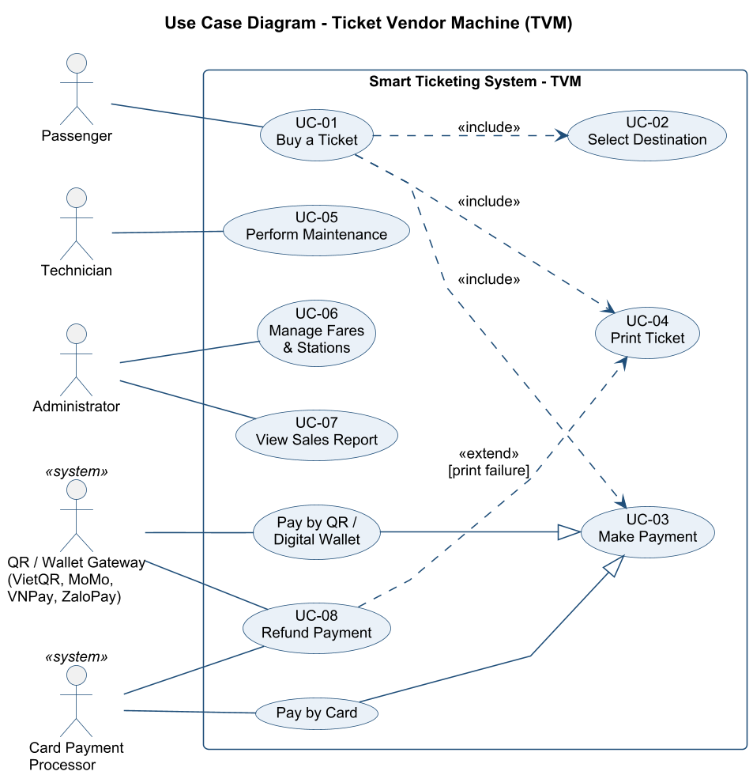
Figure 1: Use case diagram of the TVM

Use case descriptions
Use case | UC-01 Buy a Ticket
Actors | Passenger (primary); Card Payment Processor, QR/Wallet Gateway (secondary)
Goal | Passenger obtains a valid paper ticket to the chosen destination and pays for it.
Trigger | Passenger presses 'Start'.
Pre-conditions | TVM is in service, devices are healthy, idle screen is shown.
Post-conditions | Payment captured, ticket(s) printed, transaction logged. On failure: no charge remains.
Main flow | 1. Passenger presses 'Start'.  2. TVM displays the destination list.  3. Passenger selects a destination (include UC-02 Select Destination).  4. TVM displays ticket types and quantity selector.  5. Passenger selects ticket type and quantity.  6. TVM calculates and displays the total fare and the payment methods.  7. Passenger selects a payment method and pays (include UC-03 Make Payment).  8. TVM prints the ticket(s) (include UC-04 Print Ticket).  9. TVM displays a 'Thank you' screen and returns to idle after 10 s.
Alternative / exception flows | 3a. Passenger searches by name - TVM filters the list.  7a. Payment declined/failed - TVM shows the reason; passenger retries or selects another method (max 3 attempts), else use case ends.  8a. Printing fails - TVM voids/refunds the payment and shows a refund reference (extend UC-08 Refund Payment).  *a. Passenger presses Cancel before payment confirmation - TVM voids pending payment and returns to idle.  *b. 60 s inactivity - countdown 10 s, then session cancelled.
Related NFRs | NFR-01, NFR-02, NFR-04, NFR-05, NFR-07, NFR-08

Use case | UC-02 Select Destination
Actors | Passenger
Goal | Choose the destination station.
Trigger | Included by UC-01.
Pre-conditions | Session started.
Post-conditions | Destination and fare zone determined.
Main flow | 1. TVM shows stations grouped by line plus popular shortcuts.  2. Passenger taps a station or searches by name.  3. TVM highlights selection and enables 'Next'.
Alternative / exception flows | 2a. No search result - TVM shows 'No station found'.
Related NFRs | NFR-02, NFR-03

Use case | UC-03 Make Payment
Actors | Passenger; Card Payment Processor; QR/Wallet Gateway
Goal | Obtain an approved payment for the order total.
Trigger | Included by UC-01.
Pre-conditions | Order total is known.
Post-conditions | Payment authorized (card) or paid (QR/wallet).
Main flow | 1. Passenger selects a method.  2. Specialisation 'Pay by Card': TVM prompts insert/tap, reads card, sends authorization request, receives approval.  3. Specialisation 'Pay by QR/Wallet': TVM requests a dynamic QR from the gateway, displays it with a 120 s countdown, passenger scans and confirms in the app, gateway notifies the server, TVM receives 'paid'.  4. TVM records the payment and continues.
Alternative / exception flows | 2a. Card declined or timeout - return failure to UC-01.  3a. QR expired - offer to regenerate or choose another method.
Related NFRs | NFR-04, NFR-05, NFR-16

Use case | UC-04 Print Ticket
Actors | (internal) Ticket Printer
Goal | Issue the signed paper ticket(s).
Trigger | Included by UC-01.
Pre-conditions | Payment authorized/paid.
Post-conditions | Tickets printed; card payment captured.
Main flow | 1. TVM generates ticket ID and signed QR.  2. TVM sends ticket layout to printer.  3. Printer confirms success.  4. TVM captures the card authorization (card only) and logs the sale.
Alternative / exception flows | 3a. Printer error - extend UC-08 Refund Payment.
Related NFRs | NFR-07, NFR-17

Use case | UC-05 Perform Maintenance
Actors | Technician
Goal | Keep the TVM operational.
Trigger | Technician opens the service door / taps staff card.
Pre-conditions | Technician has staff card + PIN.
Post-conditions | Machine status updated; actions logged.
Main flow | 1. Technician authenticates.  2. TVM shows device status and logs.  3. Technician refills paper / clears jam / restarts device.  4. Technician puts machine back in service.
Alternative / exception flows | 1a. 5 wrong PINs - card locked.
Related NFRs | NFR-18

Use case | UC-06 Manage Fares & Stations
Actors | Administrator
Goal | Maintain reference data.
Trigger | Tariff or network change.
Pre-conditions | Administrator logged into the Central Server back-office.
Post-conditions | New data pushed to TVMs within 15 min.
Main flow | 1. Admin edits stations / fares / ticket types.  2. System validates data.  3. System publishes a new data version.  4. TVMs download it on the next sync.
Alternative / exception flows | 2a. Invalid fare (<= 0) - rejected.
Related NFRs | NFR-14, NFR-15

Use case | UC-07 View Sales Report
Actors | Administrator
Goal | Monitor revenue and reconcile with gateways.
Trigger | Admin request or daily schedule.
Pre-conditions | Admin logged in.
Post-conditions | Report displayed/exported.
Main flow | 1. Admin selects date range, TVM and payment method.  2. System aggregates transactions.  3. System displays the report and reconciliation differences.  4. Admin exports to Excel/PDF.
Alternative / exception flows | 2a. No data - empty report shown.
Related NFRs | FR-20

Use case | UC-08 Refund Payment
Actors | Card Payment Processor; QR/Wallet Gateway
Goal | Return money when a paid ticket cannot be issued.
Trigger | Extends UC-04 on print failure, or UC-01 on cancel after authorization.
Pre-conditions | Payment authorized/captured but ticket not issued.
Post-conditions | Void/refund requested; refund reference given to passenger.
Main flow | 1. TVM sends void (if not captured) or refund (if captured) request.  2. Gateway confirms.  3. TVM shows/prints refund reference and logs an incident.
Alternative / exception flows | 2a. Gateway unreachable - queue refund for retry, escalate after 24 h.
Related NFRs | NFR-08

3.2 Activity diagram - passenger buys a ticket
Swimlanes separate the passenger's actions from the TVM's. The flow mirrors an ATM: device check, selection, payment loop (maximum 3 attempts) and the print/refund decision. Cancel and the 60 s inactivity timeout are available on every step before payment confirmation.
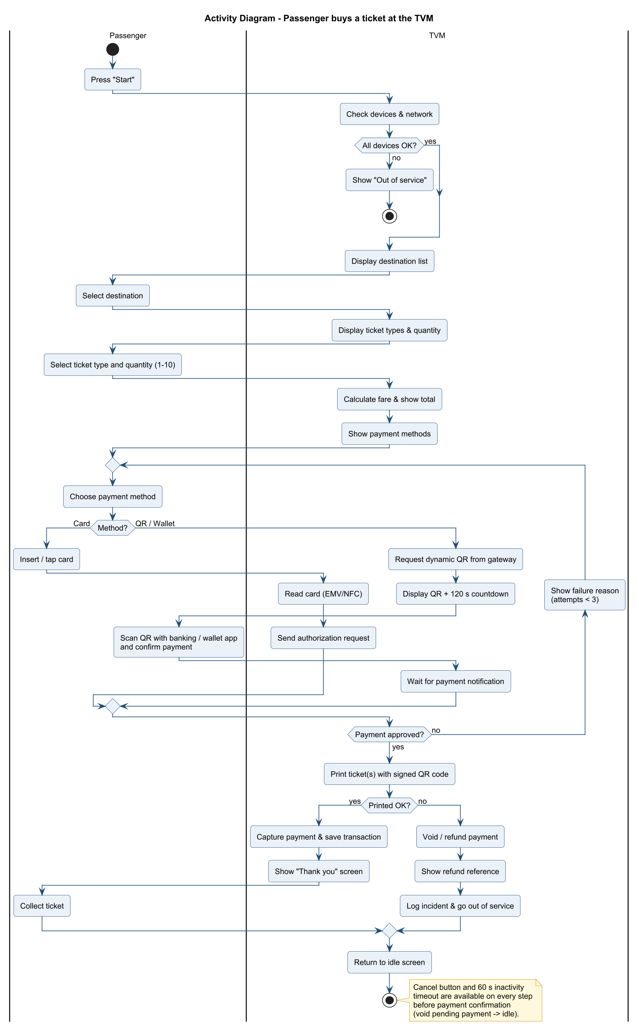
Figure 2: Activity diagram - buying a ticket at the TVM

3.3 Activity diagram - integration with external payment gateways
The TVM never talks to MoMo/VNPay/ZaloPay directly: the Central Server's Payment Service selects a gateway adapter (Strategy pattern), signs the request with the merchant secret (HMAC-SHA256), stores the payment as PENDING and returns the QR content. Two concurrent paths confirm the payment: the gateway's IPN webhook (verified signature) and the TVM's 3-second polling fallback. A print failure triggers the gateway Refund API; expired QRs trigger Cancel. Settlement files are reconciled nightly.
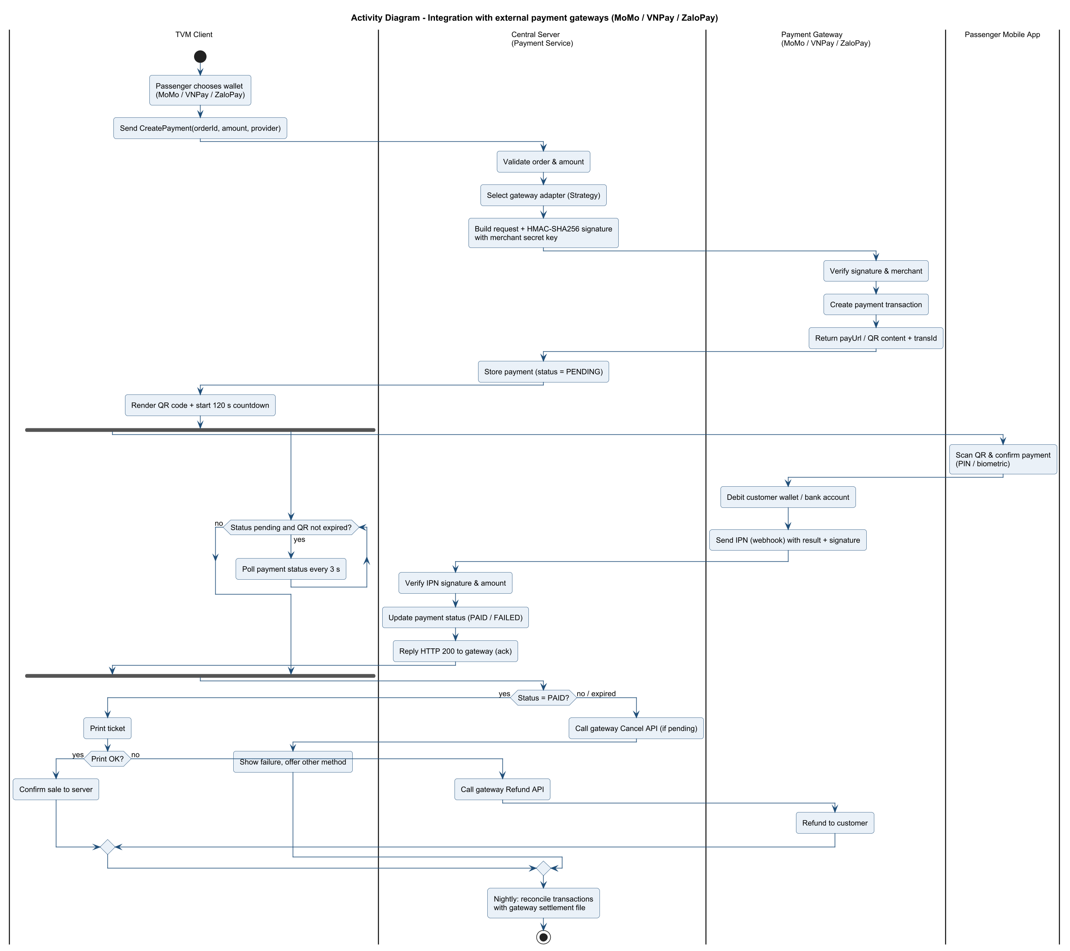
Figure 3: Activity diagram - payment gateway integration

3.4 Sequence diagram - Buy a Ticket
Objects follow the Boundary-Control-Entity convention and use the same names as the class diagram and the C# code (KioskView = MainForm, TicketController, FareService, PaymentService, IPaymentGateway, TicketPrinter, TransactionRepository). The card is authorized first, tickets are printed, and only then is the payment captured (requirement FR-10/DR-09).
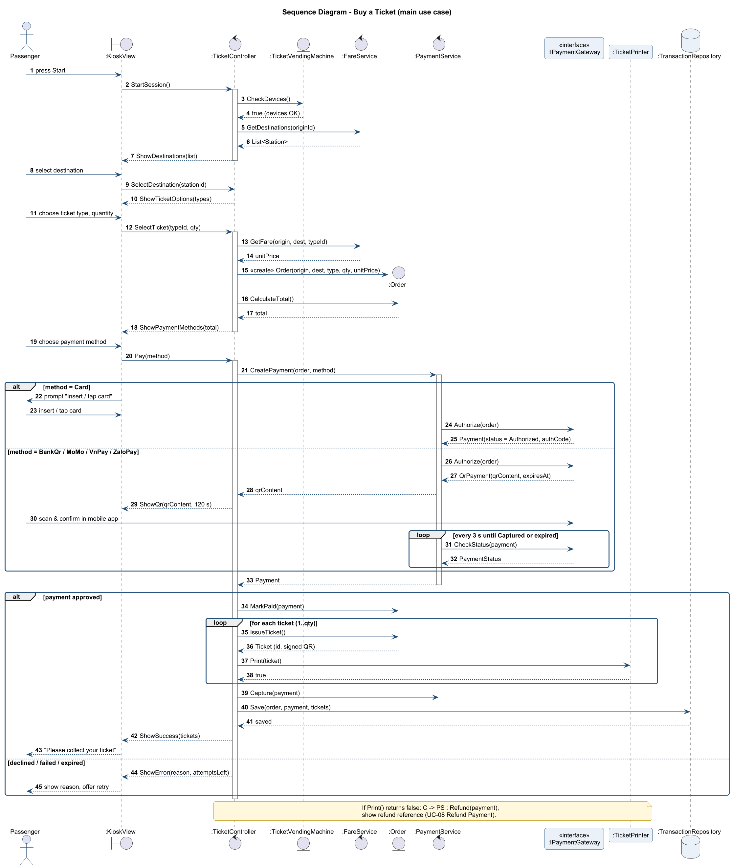
Figure 4: Sequence diagram - Buy a Ticket

3.5 State chart diagram - TVM
The composite state 'Transaction Session' groups the selection and payment states so that the Cancel/timeout transition applies to all of them at once. The same states are implemented by the TvmState enumeration in TicketController.cs.
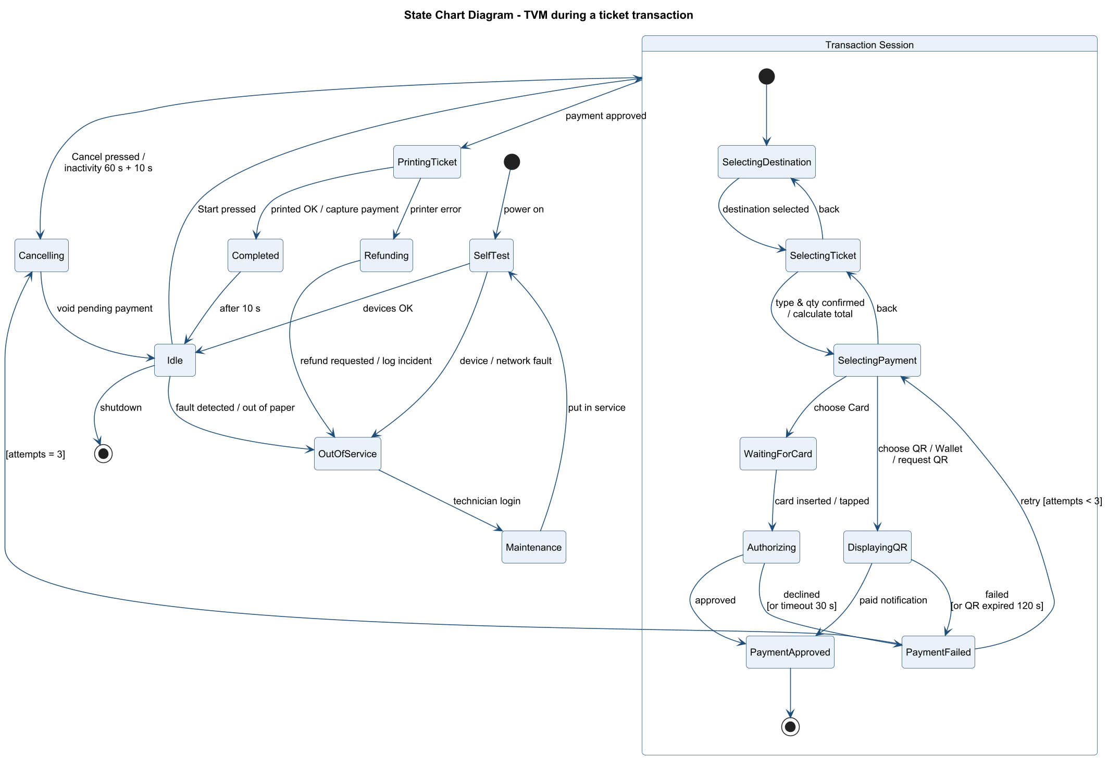
Figure 5: State chart of the TVM during a transaction

3.6 Class diagram - core domain model
Key design decisions: Payment is abstract with CardPayment and QrPayment subclasses; IPaymentGateway is the Strategy interface implemented by CardGateway and QrWalletGateway, so adding a new wallet does not change the controller (NFR-14). Order composes 1..10 Tickets; Fare links two Stations and a TicketType (DR-03).
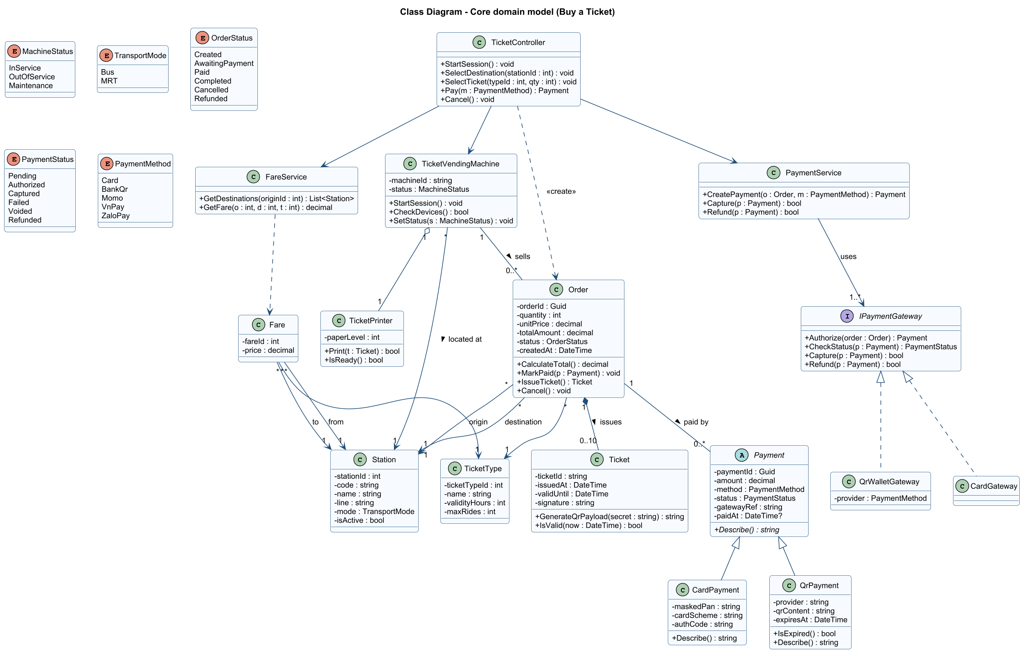
Figure 6: Class diagram - core domain model

3.7 Consistency between models
Table 6: Traceability of the main concepts across diagrams and code
Concept | Use case | Activity | Sequence | State chart | Class / code
Select destination | UC-02 | Select destination | SelectDestination() | SelectingDestination | TicketController.SelectDestination
Ticket type & qty | UC-01 step 5 | Select ticket type and quantity | SelectTicket() | SelectingTicket | Order(…, qty), CalculateTotal()
Pay by card | Pay by Card | Insert/tap card | Authorize(order) | WaitingForCard -> Authorizing | CardGateway, CardPayment
Pay by QR/wallet | Pay by QR | Request dynamic QR | CheckStatus loop | DisplayingQR | QrWalletGateway, QrPayment
Retry (max 3) | UC-01 alt 7a | repeat loop | alt declined | PaymentFailed [attempts<3] | TicketController.MaxAttempts
Print & capture | UC-04 | Print ticket(s) | Print(), Capture() | PrintingTicket -> Completed | TicketPrinter.Print, PaymentService.Capture
Refund | UC-08 <<extend>> | Void / refund payment | note: Refund() | Refunding | PaymentService.Refund

4. Phase 3 - UI/UX & Architecture

4.1 UI/UX design
The mockups (03_UI/tvm_mockup.html, rendered to PNG) target a 21.5-inch landscape touch screen. Design principles:
- Maximum 3 steps before payment, shown by a progress bar (NFR-12: max 5 screens per purchase).
- Large touch targets (>= 15 mm), high contrast navy/white palette, one primary action per screen placed bottom-right.
- Cancel always bottom-left in red; Back next to it; inactivity countdown text in the footer.
- Vietnamese/English switch on every screen (FR-13); prices always shown in VND with the total before payment.
- Error screens state the cause, that the passenger has not been charged, and the next action (NFR-13).
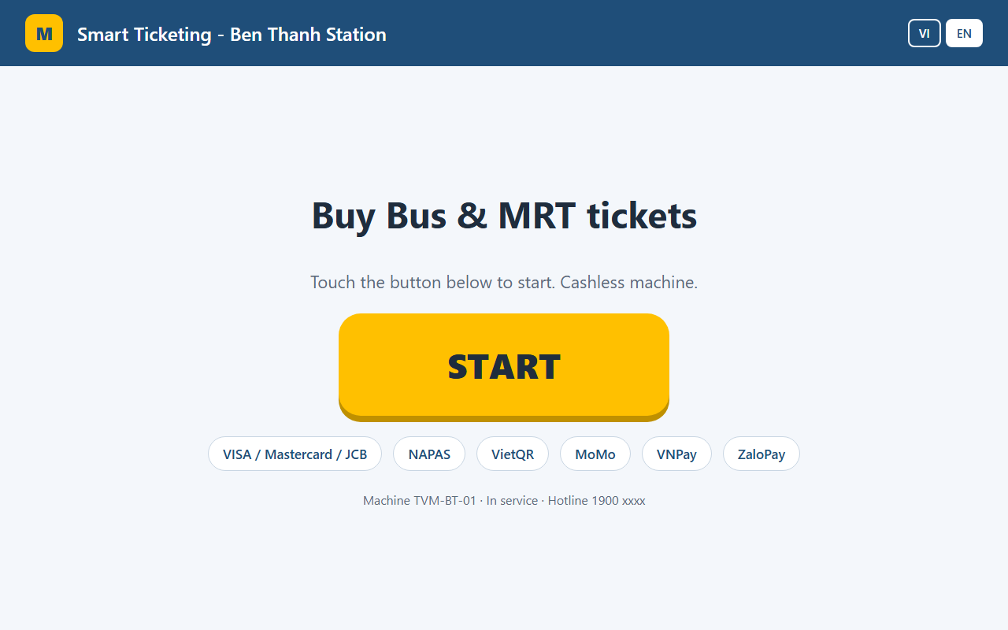
Figure 7: Wireframe - Welcome / idle screen
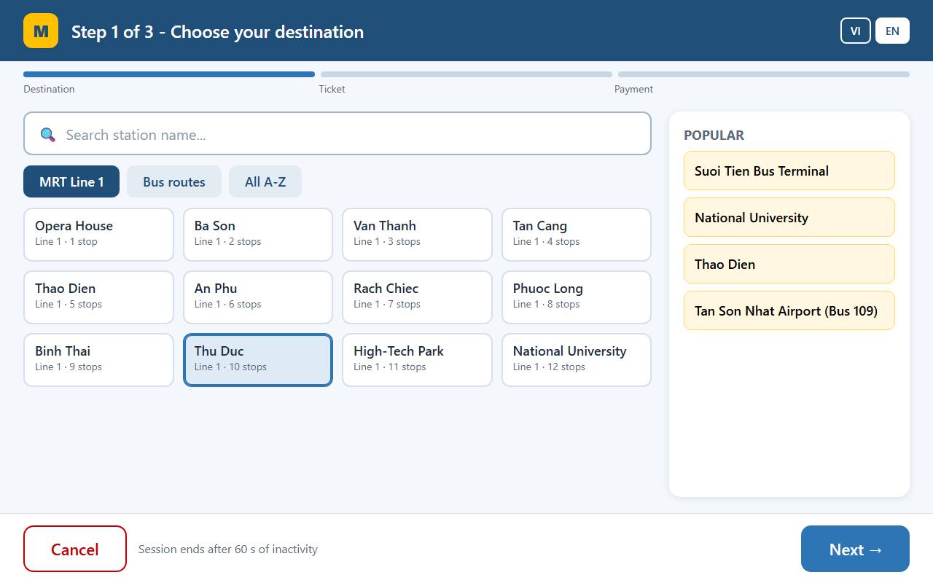
Figure 8: Wireframe - Step 1 - destination with search and popular shortcuts
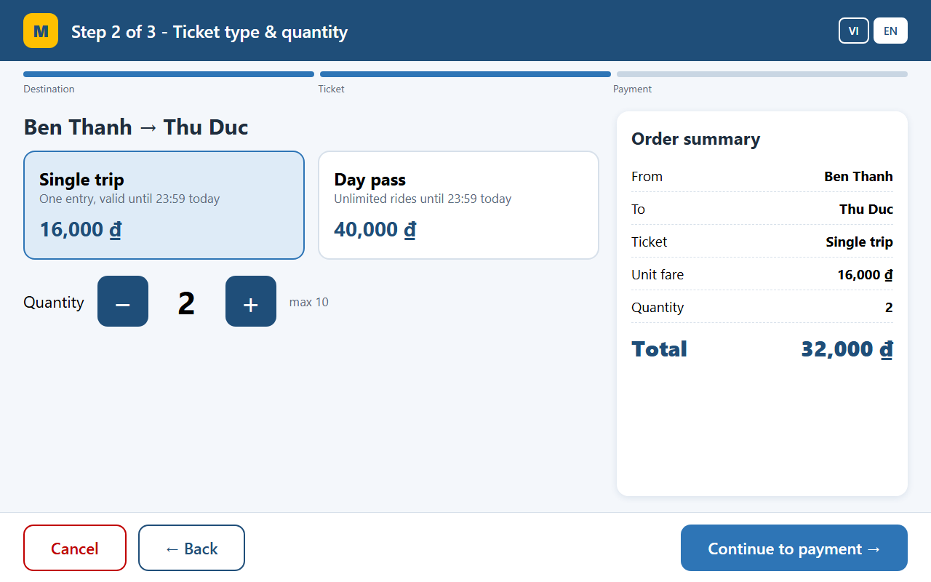
Figure 9: Wireframe - Step 2 - ticket type, quantity and order summary
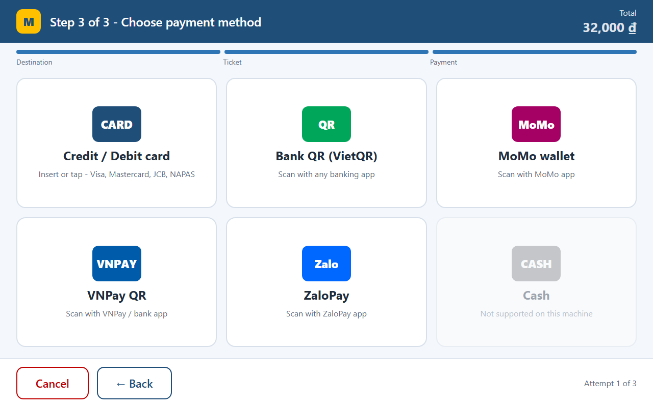
Figure 10: Wireframe - Step 3 - payment method
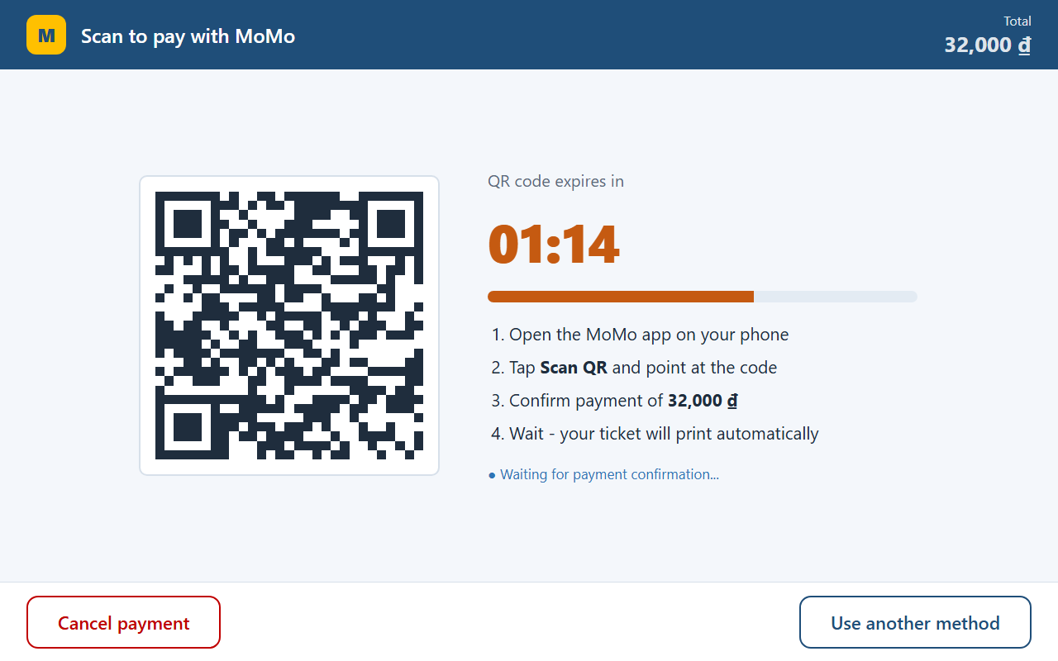
Figure 11: Wireframe - Wallet QR payment with 120 s countdown
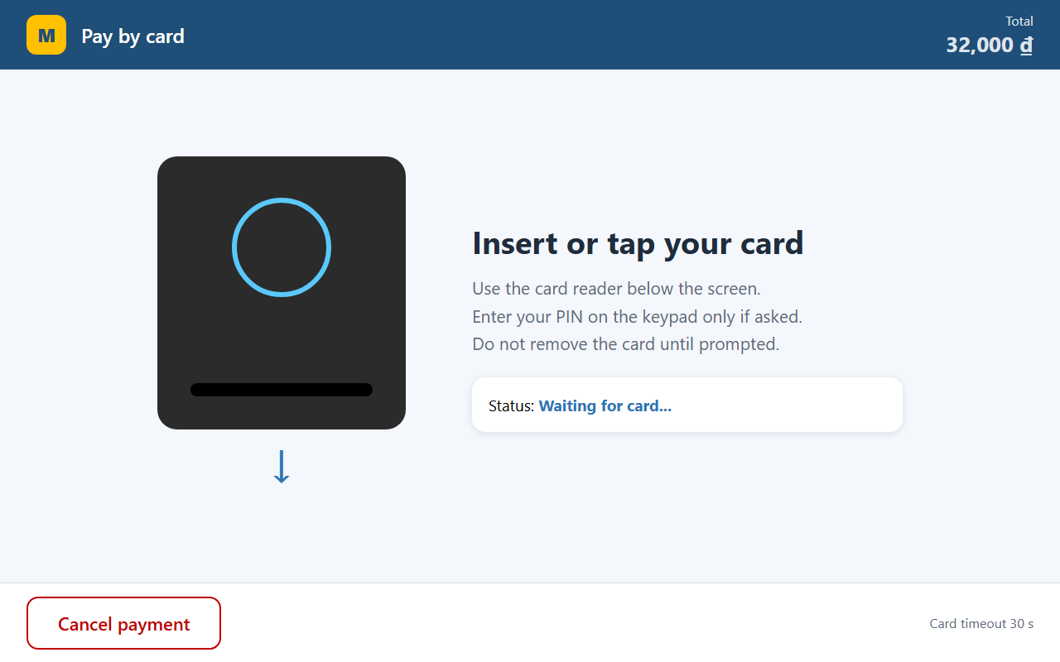
Figure 12: Wireframe - Card payment
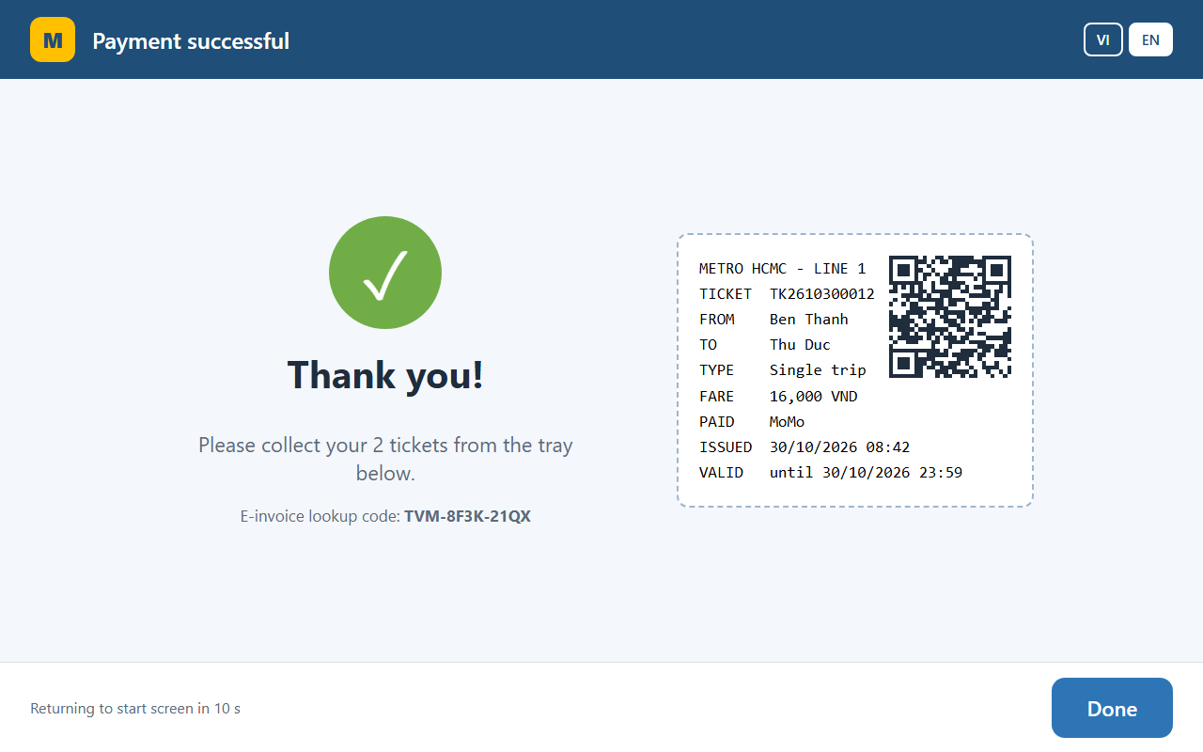
Figure 13: Wireframe - Success screen with ticket preview
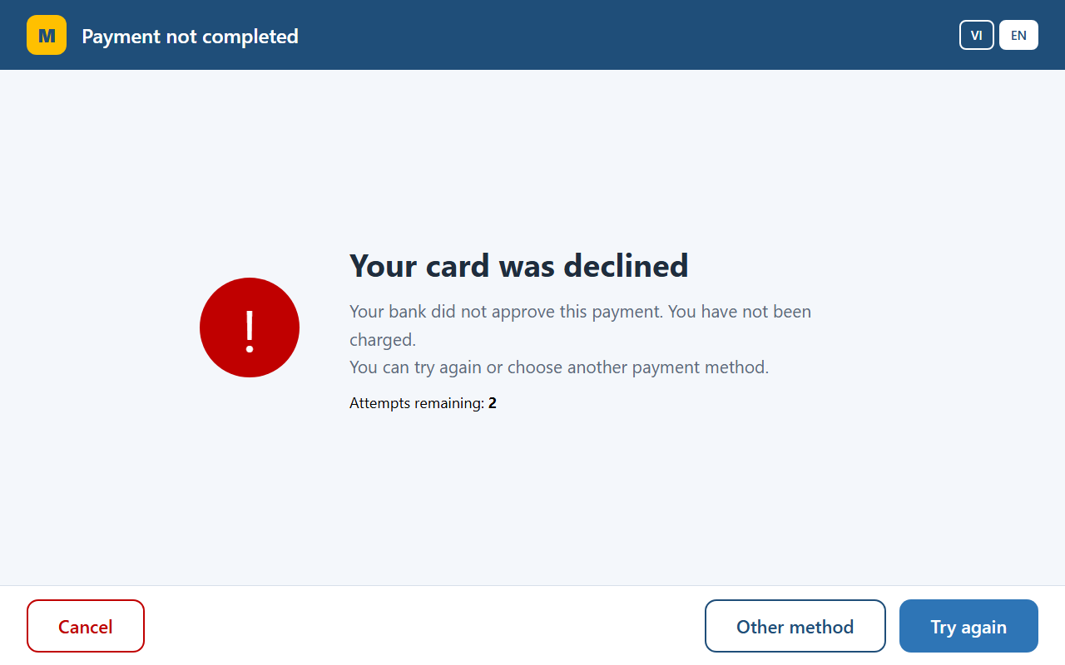
Figure 14: Wireframe - Payment declined screen

4.2 Architecture design (MVC, system-in-a-box)
The kiosk application is layered. Views (WinForms pages) only display data and forward input to the Controller. TicketController implements the state machine of the use case and coordinates the Model (domain entities and services). Infrastructure isolates everything that touches the outside world: SQL repositories, payment gateway adapters, the device hardware abstraction layer (card reader, printer) and the sync agent. Because devices and gateways are behind interfaces, the same controller runs with simulated devices in the demo and real drivers on the kiosk.
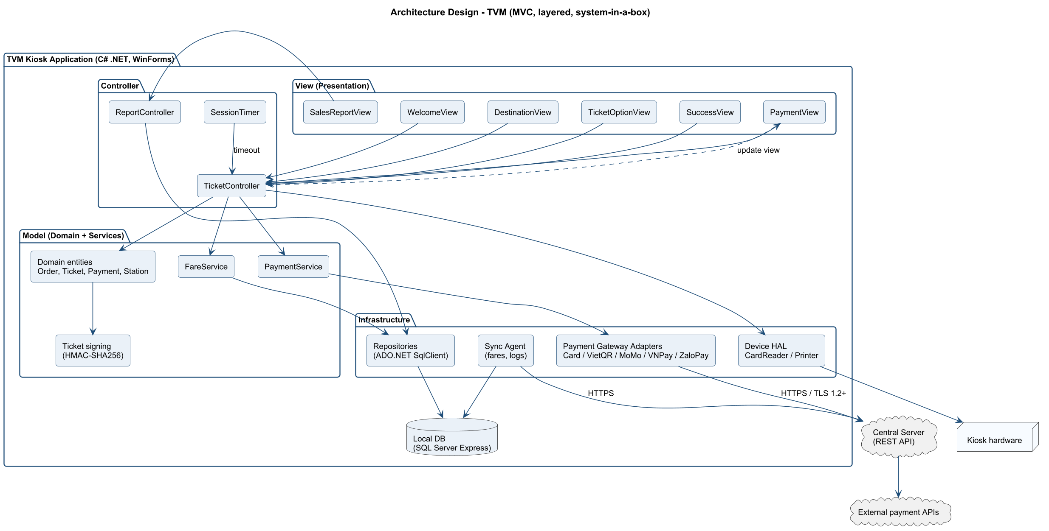
Figure 15: Architecture design - MVC layers of the TVM application

4.3 Deployment diagram
Each TVM is an industrial PC running the kiosk application with a local SQL Server Express cache, connected over 4G/fibre VPN to the central data centre. The App Server cluster (two nodes behind a load balancer) hosts the ticketing, payment, sync and report services on top of an Always On SQL Server pair. Payment adapters call the card acquirer (ISO 8583/REST), NAPAS VietQR, MoMo, VNPay and ZaloPay; wallets call back with IPN webhooks. Card data goes from the PCI PTS reader to the acquirer encrypted (P2PE) and never appears in clear text in TVM software.
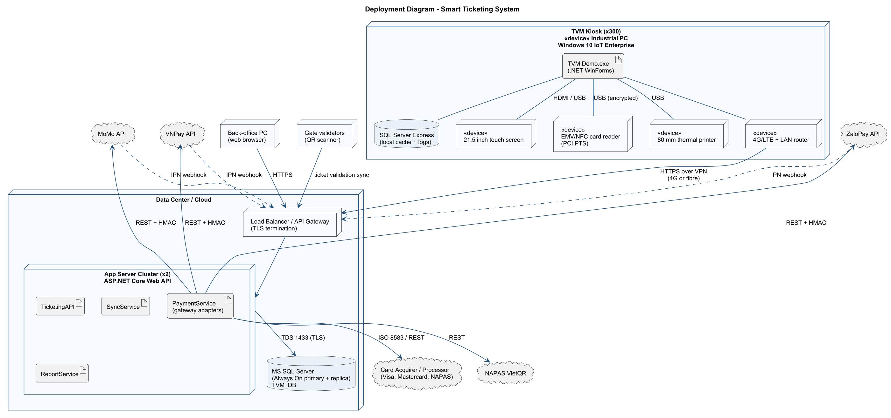
Figure 16: Deployment diagram - TVM hardware, servers and external APIs

5. Phase 4 - Implementation, Tooling & Demo

5.1 Visual Studio engineering (model-to-code)
Visual Studio 2022 is used with the 'Class Designer' and 'Architecture and modeling tools / Code Map' components (Visual Studio Installer > Modify > Individual components). Code Map generation requires Visual Studio Enterprise; Community/Professional can open and edit .dgml maps.

Forward engineering (model -> code)
- Add a new Class Diagram (.cd) to the TVM.Demo project (Add > New Item > Class Diagram).
- From the Toolbox create the classes, enum and interface of Figure 'Class diagram - core domain model' (Station, TicketType, Fare, Order, Payment (abstract), CardPayment, QrPayment, Ticket, IPaymentGateway, …).
- Add attributes/methods in the Class Details window and draw Inheritance and Association links.
- Visual Studio generates the C# skeleton files immediately; save and build. These skeletons were then completed manually (see Models/Domain.cs, Services/PaymentGateways.cs).
[TO DO BY THE GROUP] Insert screenshots: (1) the Class Designer with the domain classes, (2) the generated C# skeleton in the editor.

Backward engineering (code -> model)
- After manual changes (e.g. adding SimulateJam to TicketPrinter, IsExpired() to QrPayment, Supports() to IPaymentGateway), right-click the Models and Services folders > View > View Class Diagram.
- Visual Studio reverse-engineers the code into ClassDiagram1.cd; compare it with the PlantUML class diagram and update 06_Class_Domain.puml so the UML stays aligned with the code.
[TO DO BY THE GROUP] Insert screenshot of the reverse-engineered class diagram and a short note on the differences found.

Code Map
- Build the solution, then Architecture > Generate Code Map for Solution (VS Enterprise).
- Group by namespace (Models, Services, Data, Controllers, Views) to show the MVC dependency direction: Views -> Controllers -> Services/Models -> Data. No arrow should point from Models back to Views.
[TO DO BY THE GROUP] Insert the Code Map screenshot (Architecture > Generate Code Map for Solution).

5.2 GitHub & source control
The repository contains all artefacts in the folder structure of section 1.3. Recommended workflow for the group:
- Branches: main (protected) <- dev <- feature/<member>-<topic> (e.g. feature/an-uml-sequence).
- Commits: small, meaningful messages (feat:, fix:, docs:, test:), each member commits their own work.
- Pull requests: every feature branch is merged through a PR reviewed by another member.
- Ignored files: bin/, obj/, .vs/ (see .gitignore) - binaries are never committed.
[TO DO BY THE GROUP] Insert screenshots of the GitHub commit history / Insights > Contributors graph showing every member's commits.

5.3 AI-assisted development
Generative AI was used as a pair programmer. This section documents the prompts, what the AI produced and how the output was validated. The tool used for the generated artefacts in this repository was Claude Code (an AI coding assistant comparable to GitHub Copilot).
Table 7: Prompts and AI contribution
# | Prompt (summary) | How the AI assisted
1 | Read the assignment PDF and complete all phases of the TVM assignment. | Proposed the folder structure, Q&A list, SRS, use cases and the overall design.
2 | Write PlantUML for use case, activity, sequence, state chart, class, MVC and deployment diagrams. | Generated the .puml sources; diagrams were rendered and visually reviewed, then corrected (e.g. undirected actor associations).
3 | Create a T-SQL script for stations, fares, orders, payments, tickets and a sales report view, with seed data. | Generated TVM_DB.sql including the fare rule and 40 sample transactions.
4 | Implement the Buy a Ticket flow in C# WinForms following the class diagram, with simulated card/QR gateways. | Generated boilerplate (models, repositories, forms) and the controller state machine.
5 | Write xUnit tests for the domain and payment gateways. | Generated 19 tests (order totals, Luhn, decline, QR expiry, refunds, signatures).

Validation of AI-generated code
AI output was never accepted without checking. Validation steps and the defects they revealed:
- Compilation and unit tests: dotnet build and dotnet test - 19/19 tests pass.
- Database script: executed on SQL Server LocalDB; the first version failed because CHOOSE(... NEWID() ...) re-evaluates NEWID() per branch and returned NULL. Fixed by computing the random index first.
- Automated end-to-end UI run: the app has a --screenshots mode that clicks through three scenarios (wallet payment, declined card then approved card, printer jam with refund) and saves each screen. It revealed two real bugs: (1) ticket IDs based on seconds collided when two orders were sold within the same second - fixed by adding part of the order GUID; (2) the sales report showed 'Failed' for an order whose first card attempt was declined and second approved - fixed by ordering payments by status in vw_SalesReport.
- Visual review: screenshots exposed layout defects (an '&' swallowed as a mnemonic, clipped buttons, single-line radio buttons) that were fixed.
- Security review: checked that only the masked PAN is stored, SQL uses parameters only, and tickets are HMAC-signed.
[TO DO BY THE GROUP] Each member: add the GitHub Copilot prompts you used yourself (prompt, Copilot suggestion screenshot, what you kept/changed).

5.4 Demo application (C# WinForms + MS SQL Server)

Solution structure
Folder / file | Responsibility (MVC layer)
Models/Domain.cs | Model - entities and enums: Station, TicketType, Fare, TicketVendingMachine, Order, Payment, CardPayment, QrPayment, Ticket, TicketPrinter
Services/PaymentGateways.cs | Model/Infrastructure - IPaymentGateway, CardGateway, QrWalletGateway, PaymentService
Data/Repositories.cs | Infrastructure - FareService, TransactionRepository (atomic save + offline queue), ReportRepository
Controllers/TicketController.cs | Controller - Buy a Ticket state machine (TvmState), retry limit, cancel, refund
Views/MainForm.cs | View - kiosk pages: welcome, destination, ticket, payment, card, QR, success, failure, out of service
Views/SalesReportForm.cs | View - output report (summary by method + transactions, CSV export)
Database/TVM_DB.sql | Schema, constraints, vw_SalesReport view and seed data
TVM.Tests/DomainTests.cs | xUnit tests

How to run
- Create the database: sqlcmd -S "(localdb)\MSSQLLocalDB" -i 05_Source\Database\TVM_DB.sql (or open the script in SSMS and execute).
- If you use another SQL Server instance, edit ConnectionString in TVM.Demo/appsettings.json.
- Open 05_Source/TVM.sln in Visual Studio 2022 (.NET 9 SDK) and press F5.
- Test cards: 4242 4242 4242 4242 (approved), 4000 0000 0000 0002 (declined). For QR/wallet payments press 'Simulate: passenger paid in app'. Tick 'Simulate printer jam' on the welcome screen to see the refund flow.

Database schema
Table | Purpose
Station | MRT/Bus stations with line and sequence (fare distance)
TicketType | Single trip, Day pass
Fare | Price per origin/destination/ticket type (612 rows)
Machine | Registered TVMs and their station/status
SalesOrder | Input of the purchase: route, type, quantity, totals, status
Payment | Each payment attempt (method, status, gateway ref, masked PAN, auth code)
Ticket | Issued tickets with validity and HMAC signature
TransactionLog | Step-by-step audit log per session (FR-21)
vw_SalesReport | View used by the output report

Screenshots of the running prototype
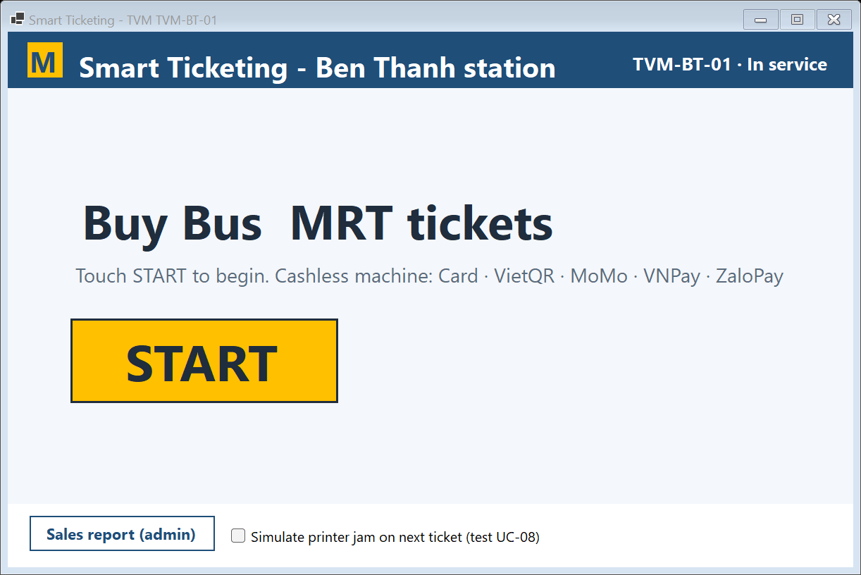
Figure 17: Demo - Welcome screen
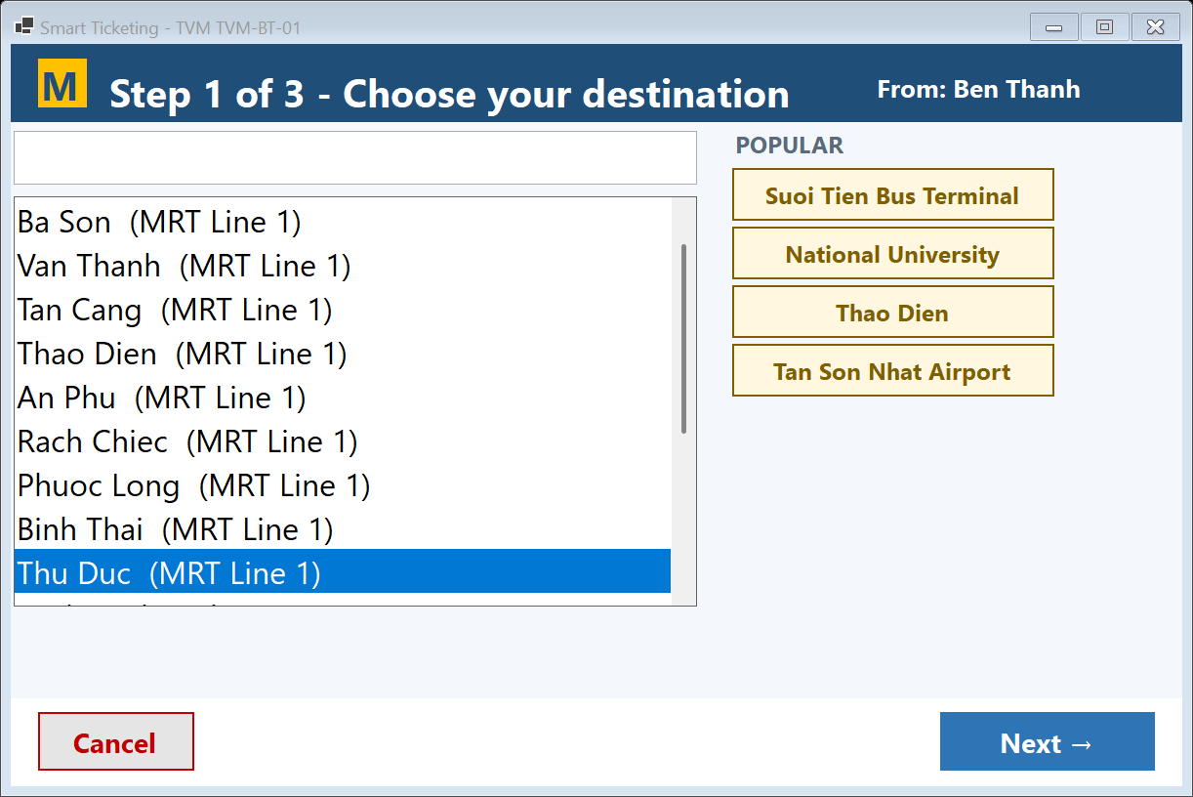
Figure 18: Demo - Input form - destination
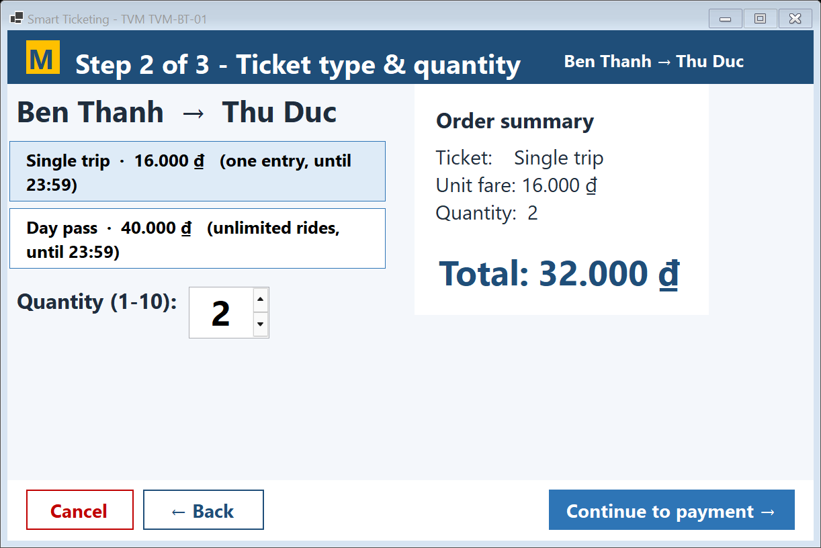
Figure 19: Demo - Input form - ticket type and quantity
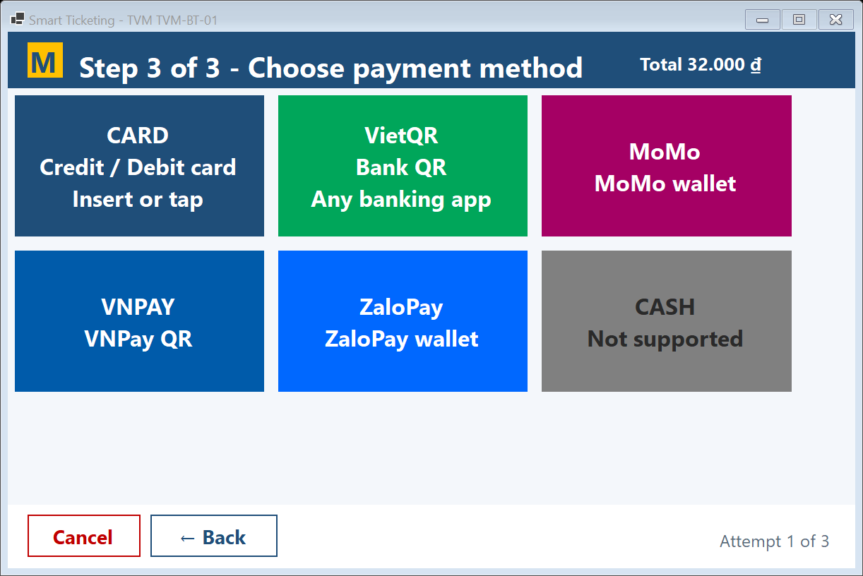
Figure 20: Demo - Input form - payment method
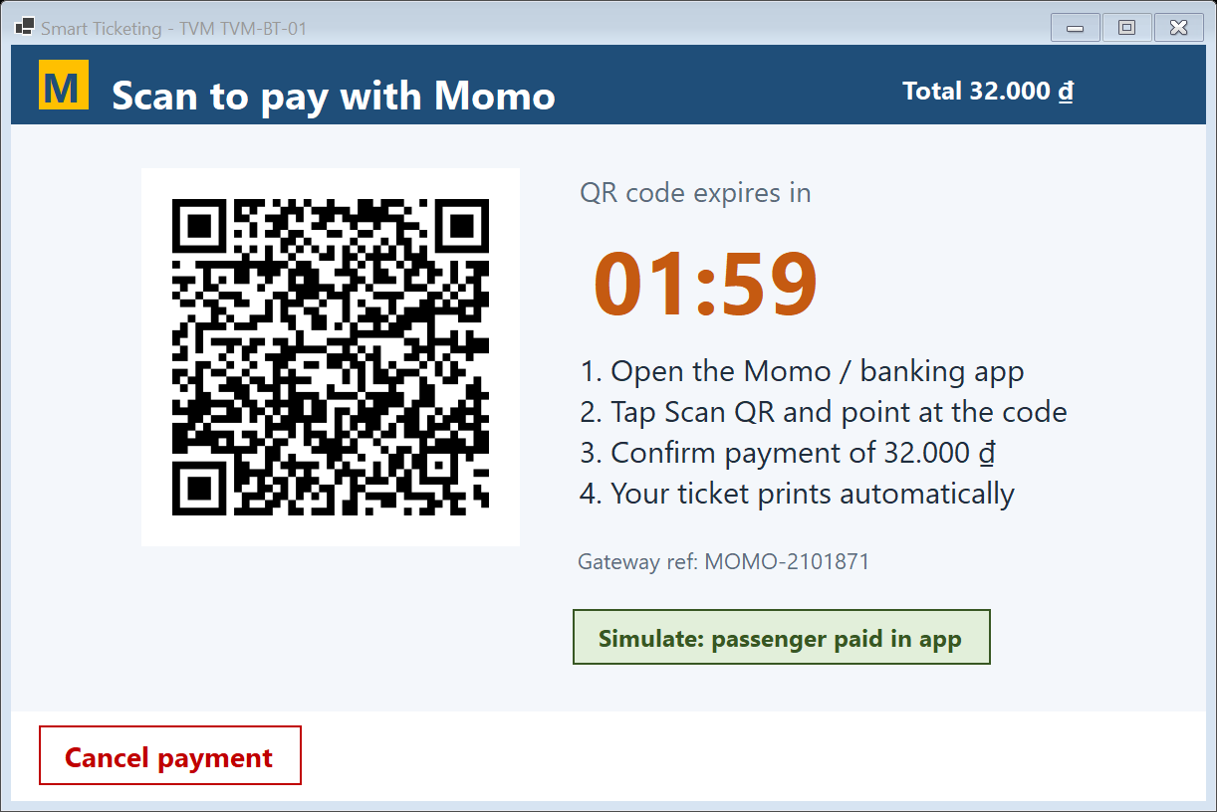
Figure 21: Demo - MoMo QR payment (real QR generated by QRCoder)
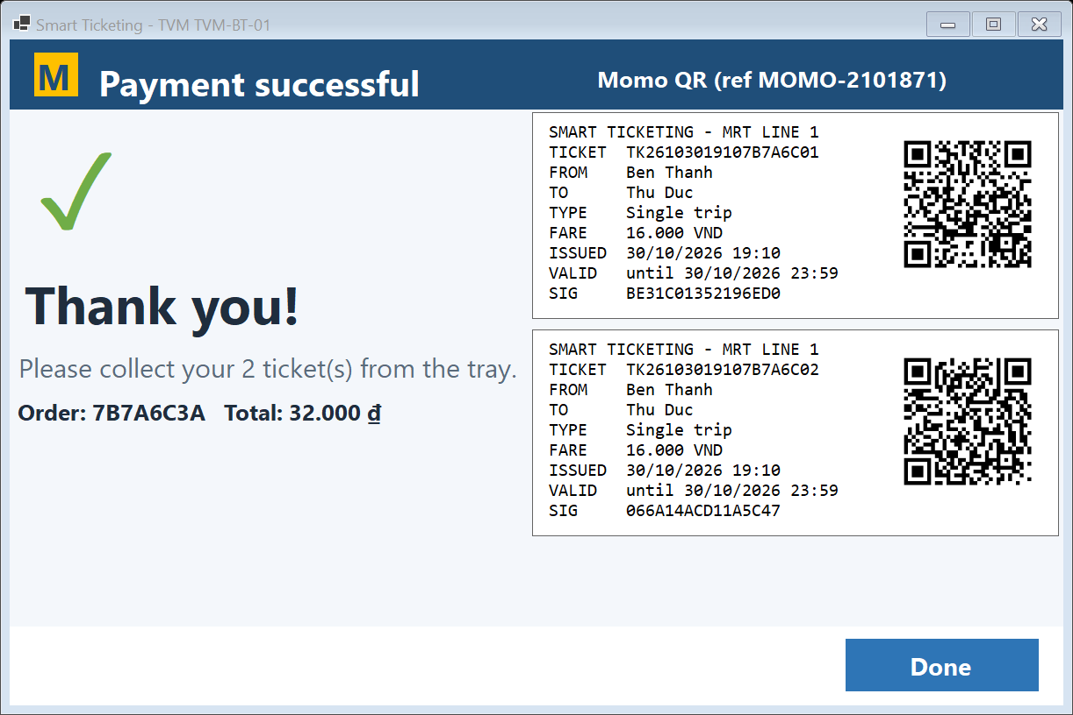
Figure 22: Demo - Success screen with two signed tickets
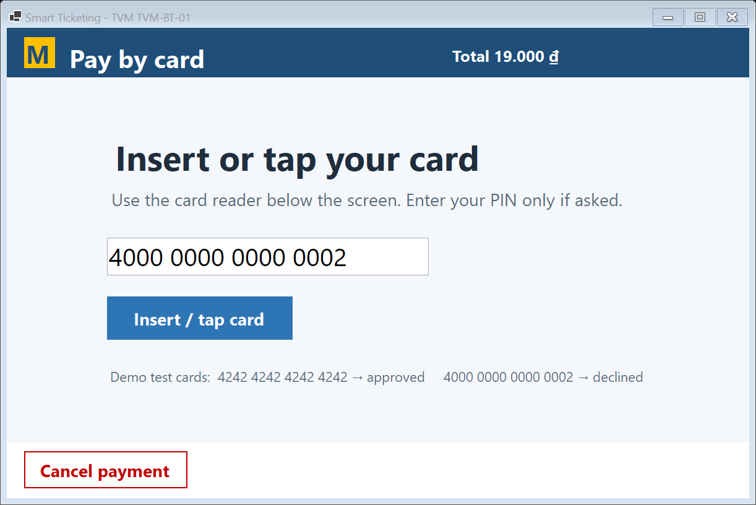
Figure 23: Demo - Card payment
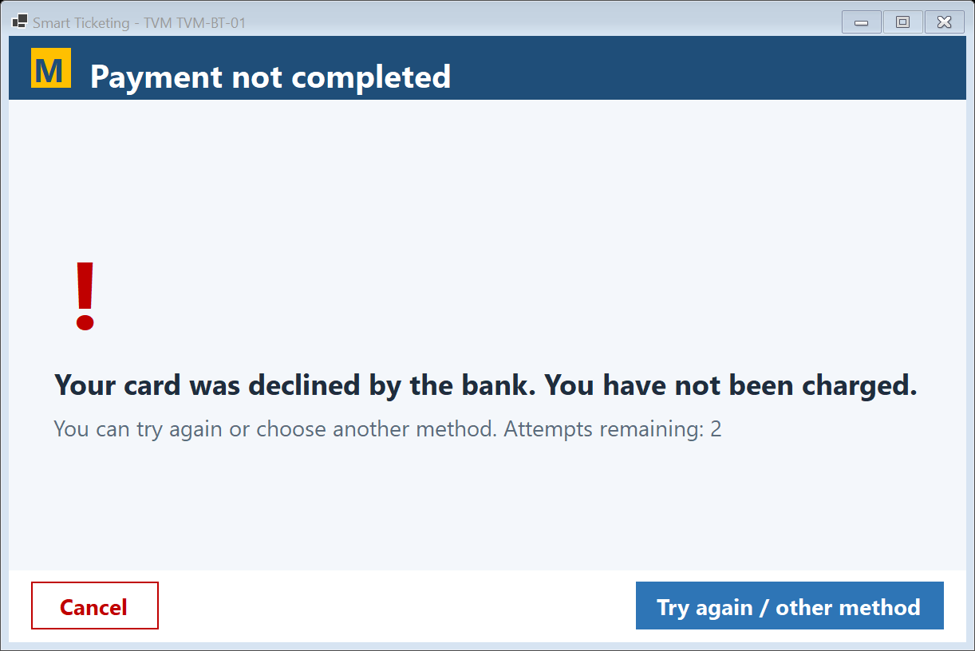
Figure 24: Demo - Declined card - retry offered
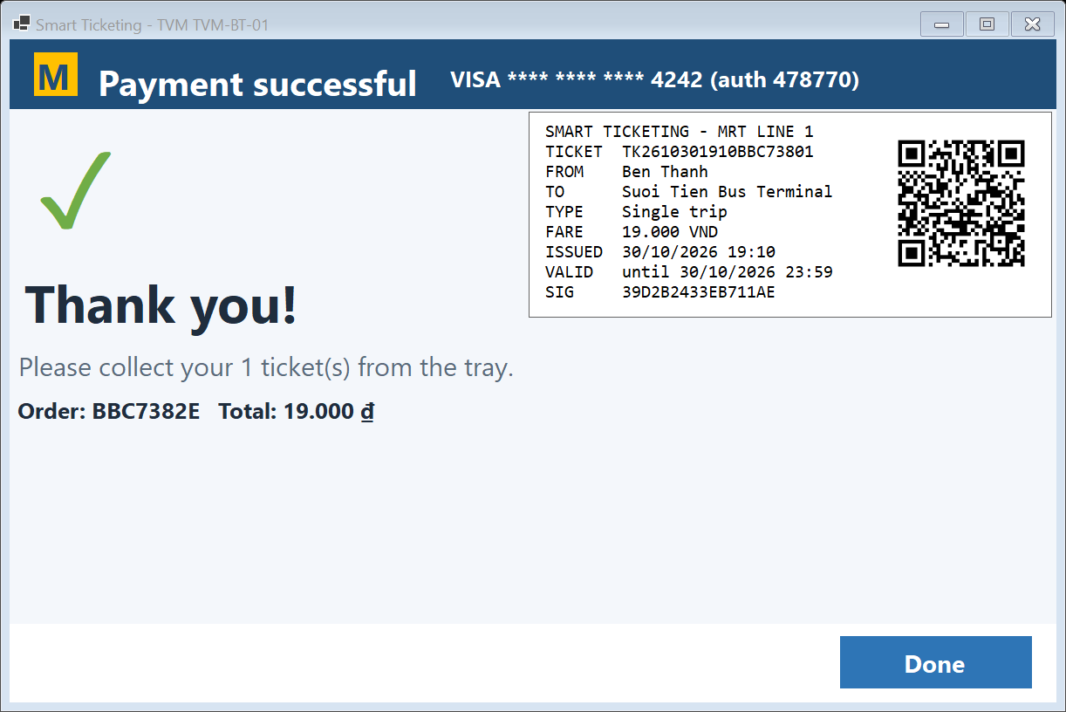
Figure 25: Demo - Success after retry with a valid card
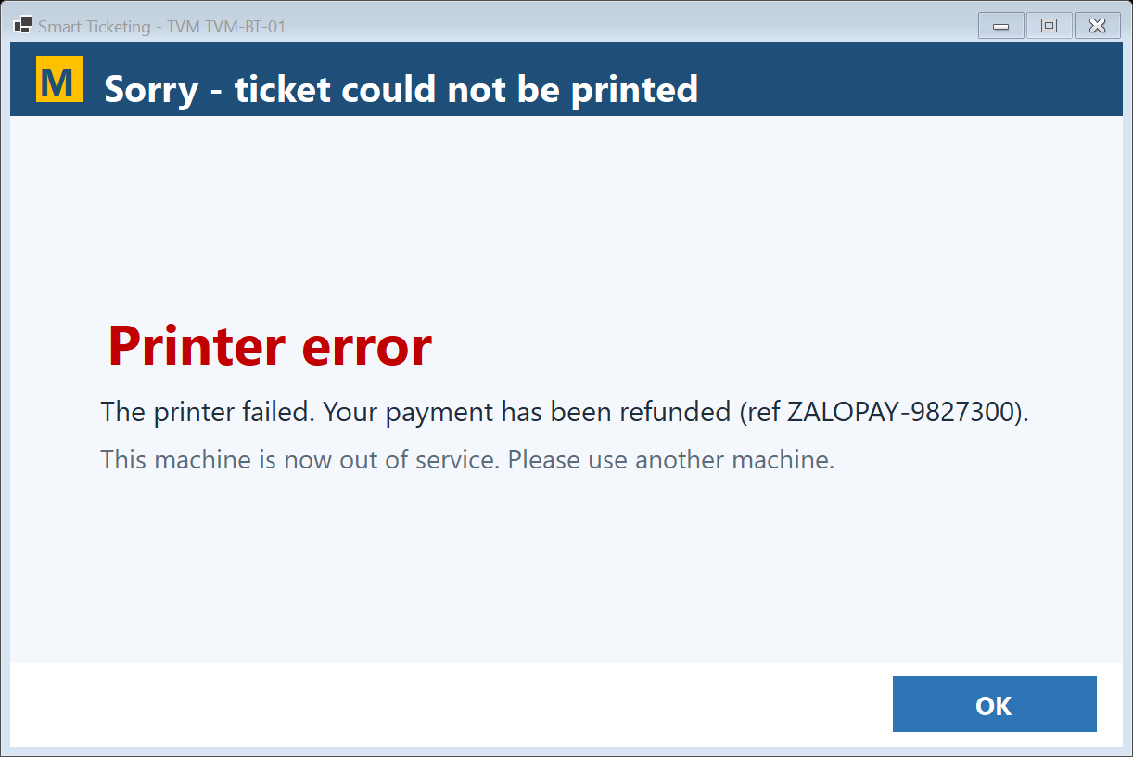
Figure 26: Demo - Printer jam after payment - automatic refund (UC-08)
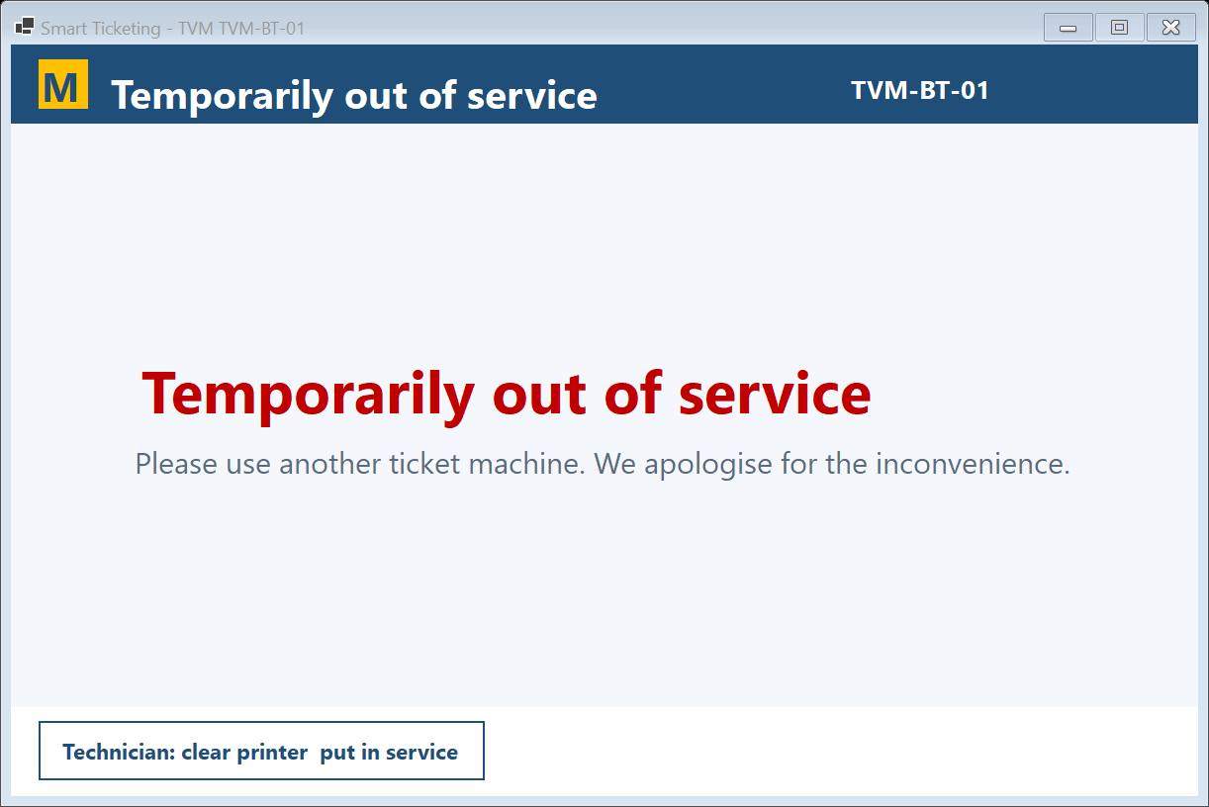
Figure 27: Demo - Machine out of service
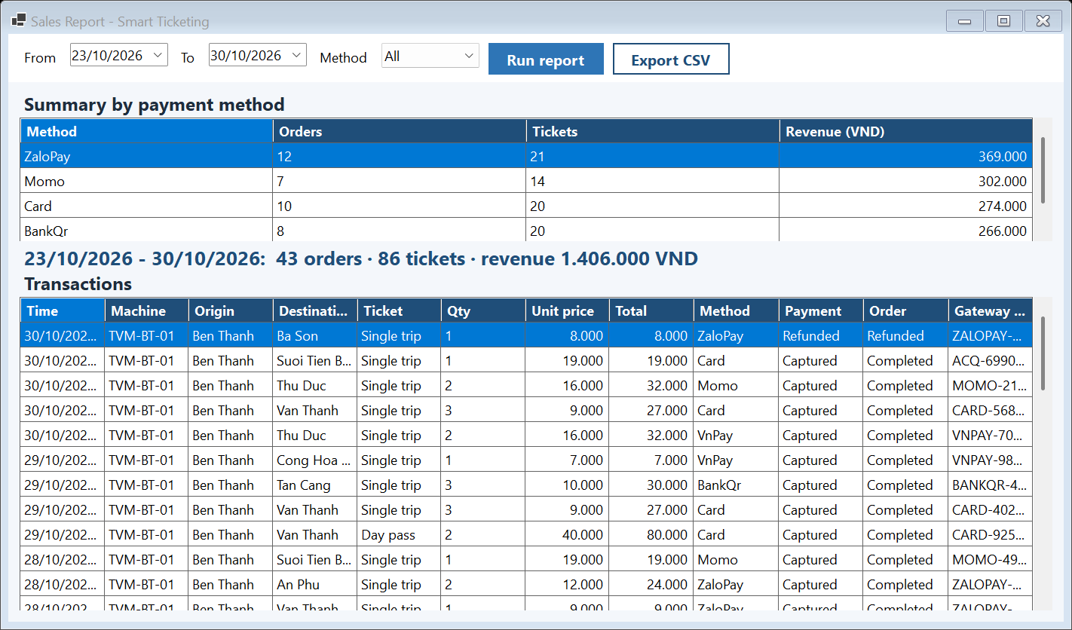
Figure 28: Demo - Output report - sales by payment method and transactions

6. Conclusion
The team clarified the incomplete TVM statement, specified measurable requirements with emphasis on reliability and response time, designed a consistent set of UML models, and implemented a working prototype whose classes, states and flows match those models. The prototype covers the complete 'Buy a Ticket' flow including declined payments, retries, cancellation, inactivity timeout and automatic refund on printer failure, stores every transaction in MS SQL Server and produces a sales report. Future work: real gateway sandboxes (MoMo/VNPay test environments), the Central Server REST API, and Vietnamese UI resources.

Appendix - Contribution of each member
Student ID | Full name | Main tasks | Contribution (%)
524K0028 | Nguyễn Lê Toàn Thắng | Leader - requirements (Q&A, SRS), report | 33.33 %
524V0018 | Võ Hữu Phước | UML modelling, UI/UX wireframes, architecture | 33.33 %
523V0007 | Hà Văn Thành Đạt | C# / MSSQL demo, testing, GitHub | 33.33 %

