510035

CACAO

Fully integrated CLIR system.

Deliverable number | D.1.4
Dissemination level | Public
Delivery date | 28 Nov 2008
Status | Final
Author(s) | Alessio Bosca, Daniele Gobbetti


eContentplus

This project is funded under the eContentplus programme,
a multiannual Community programme to make digital content in Europe more accessible, usable and exploitable.

Table Of Contents

1 Goal 3
1.1 CLIR System and CACAO Architecture 3
2 Query Manager 5
2.1 processQuery 6
2.2 processQueryAndSearch 6
2.3 searchRetrieveSRW 6
2.4 CACAO CLIR XML Response Document 7
3 Search Component 7
4 Natural Language Processing Web Service 7
5 Translation WS 8
6 Thesaurus WS 9
7 Word2Category Component 9
7.1 Offline operations 10
7.2 Online operations 10
7.2.1 Word2Category method 11
7.2.2 Category2Word method 11
7.2.3 Word2Word method 11
7.3 Using Word2Category in terms disambiguation 11
7.3.1 Using Word2Category in dealing with False Friends 12
7.3.2 Using Word2Category in dealing with Term Ambiguity 12
7.3.3 Using Word2Category in dealing with Term Ambiguity in the target language 12
8 CorpusThesaurus Component 13
9 CLIR demo 13
10 References 15
Annex A: Query Manager response XML document example 16

WP1: Multilingual access

Work package number : | 1 |  |  | Start date: |  |  | 0 |  | End date: |  |  | 15
Work package title: | Multilingual access
Applicants involved: | 1 | 2 | 3 |  | 7 | 8

Goal
This work package focuses on multilingual access and it aims at providing the CACAO infrastructure with a Cross Language Information Retrieval system (CLIR) enabling the users to express their informational needs in their own language (by means of keywords) in order to retrieve pertinent documents in all the languages, in which they are interested, among the ones supported by the system.
The capabilities of the CLIR system originate in the processing and analysis of collected data (i.e. text lemmatisation, words distribution over categories) as well as in the translation and enrichment of the query terms in order to yield documents in other languages.
In the context of the work package the goal of the present report consists in describing the fully integrated CLIR system implemented by the end of the first year of the project; the document describes the different software modules integrated in the system, their interactions, how to access the functionalities they expose and the response documents they produce and provide to the clients.

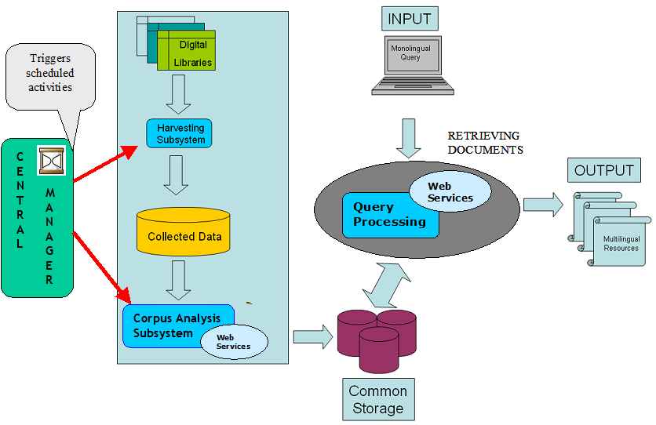
CLIR System and CACAO Architecture
Figure 1- CACAO Architecture Overview

Figure 1 presents a general overview of the architecture of CACAO system (described with finer details in the first deliverable of WP3). The three main activities of the CACAO framework (depicted in the diagram as light blue squares) comprise data harvesting, corpus analysis and query processing. The first two activities are off-line tasks scheduled by the Central Manager, while the last one is triggered by user requests.
The Corpus Analysis subsystem aims at processing the data harvested from digital libraries in order to infer new information on the word distribution within librarian categories or the semantic distance between terms. The so obtained information is then exploited by the CLIR system; therefore deliverable 2 of work package 1, describing the Corpus Analysis subsystem, constitutes an important reference for the present document.

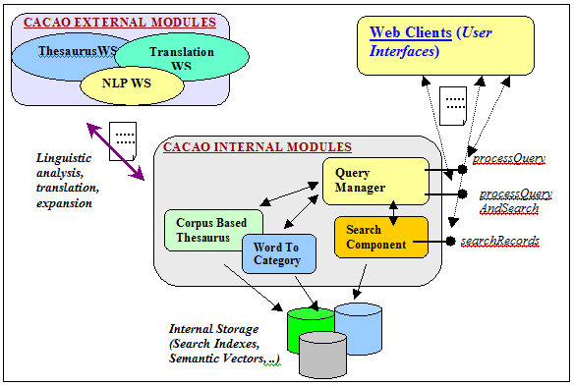
Figure 2 CACAO CLIR System overview

With respect to Figure 1, the functionalities of the CACAO CLIR engine are provided by the query processing subsystem; the services it offers emerge from the interactions of a set of internal and external modules. The internal components consist of “linguistic agnostic” modules that contain the core logic of the system and focus on the management of the information harvested from libraries and the data directly inferred from it (i.e. search indexes, corpus-based semantic vector, terms associated to library categories).The external components instead provide the CACAO architecture with linguistic analysis capabilities and resources (i.e. lemmatization and named entities recognition, bilingual dictionaries, thesauri) and consist of Web Services that adhere to the communication interface required by the CLIR system. This architectural solution enables a flexible integration of new resources in order to extend the system support to new languages; within the scope of CACAO project a set of services covering the main languages of the involved library partners has been developed.
This document presents the CLIR system from the point of view of clients interested in exploiting the offered services and focuses on how to access the service and on the description of the modules comprised in the system. The main part of these modules were introduced in deliverables 2 and 3 of work package 1, while the Search Component was introduced in deliverable 2 of work package 3 but during the integration phase has been partially modified. The internal modules comprised in the CLIR system consist of:

- Query Manager, the top level service exposing the entry point for the CLIR as it receives as input the monolingual request from users and returns a document listing the retrieved documents as well as details on the translation and expansion of the search terms; it coordinates the interactions of the other modules.
- Search component, performs the actual search task on the records collected from the libraries.
- Word2Category component, which provides a mapping facility between library categories and bag of words.
  - ClassificationExplorer component is a utility enabling the navigation within librarian classification system exploited internally by the Word2Category module (off-line operations, see section 7.1); the module is not described in the current document as it is not directly involved in the CLIR activities, more details can be found in deliverable 3 of work package 1.
- Corpus-Thesaurus component, providing information on the semantic distance between words (used for disambiguation and expansion activities).

The external modules comprised in the CLIR system consist of:
- Natural Language Processing WS (NLP WS), providing linguistic analysis of text.
- Translation WS, providing translation mechanisms between the supported languages.
- Thesaurus WS, providing data such as synonyms, hypernyms or hyponyms for a given term.

Many of the operations exposed by the different modules (see the following sections for each operation detail) require as a parameter the specification of the language in which the text to be analyzed or translated is expressed.

Query Manager
The Query Manager module constitutes the entry point for the CLIR system; it exposes a set of operations to clients that enables the processing of user input queries in order to translate them into the desired target languages as well as the enrichement of the search terms with additional keywords (i.e. synonyms, geographic names expansion, related terms) to increase the number of relevant documents retrieved. The translated and expanded query is then submitted to the Search component in order to retrieve the relevant documents from the data collected from the libraries.
This module performs the exposed operations by coordinating and integrating a set of Web Services (as the NLP WS or the Translation WS) and internal components (as the Search Component or the Corpus-Thesaurus). In particular the Query Manager performs a linguistic analysis of the user query exploiting the NLP WS and then translates to the target languages the keyword enriched with linguistic information by means of the Translation WS. The obtained search terms are then expanded by exploiting the Thesaurus WS and the Corpus-Thesaurus Component. Word2Category module instead comes into play both for translation disambiguation and query expansion. The resulting keywords are then submitted to the Search Component in order to yield relevant documents. Deliverable 2 of work package 1 describes in more details the various phases of the algorithm used for the translation and expansion process (see section 3.2 of that document).
The desired information is then returned to the clients as an XML document. The Query Manager offers to its clients 3 operations:

- String processQuery(String query, String langFrom, String[] targetLanguages);
- String processQueryAndSearch(String query, String langFrom, String[] targetLanguages, String[] facetsFields, int startFromResult, int totResults);
- String searchRetrieveSRW(String srwRequest);

processQuery
The processQuery operation only performs the translation and expansion of the query from the input language to the target ones, without retrieving any document; it requires as input the user query, its language and the target languages the query should be translated into. This operation is provided as a facility for the creation of rich clients that intend to provide an intermediate phase in the process in order to enable the users to refine and modify the enriched query before the actual documental search. The complementary operation for such a purpose is the searchRecords exposed by the Search Component.

processQueryAndSearch
The processQueryAndSearch operation performs both the query translation/expansion and the retrieval of documents. Therefore, it requires as input a few additional parameters: the fields that should be used as facets (it could be null if the feature is not desired), the information on the starting element of the returned documents and the maximum numbers of results returned. These last parameters are used for guiding the pagination of results.

searchRetrieveSRW
The searchRetrieveSRW operation allows for the interaction with the CACAO framework using the SRW protocol. SRW is a standard XML-focused search protocol for Internet search queries, utilizing CQL (Contextual Query Language), a standard syntax for representing queries. Standards for SRW, SRU and CQL are promulgated by the United States Library of Congress. The support for SRU/SRW protocol enables the CACAO framework to be compatible (and possibly integrated) with The European Library (TEL project). The standard SRW messages should be enriched with additional parameters in order to allow for CACAO CLIR system to work since SRW doesn’t natively support multilinguality.

CACAO CLIR XML Response Document
The Query Manager module has been implemented as a Web Service and can be accessed online at http://demo.celi.it:8095/axis2/services/CACAO_queryWS.
In the annex A of the present document (see section ) an example of an XML response document for the query “Roman Law” is presented. This XML document constitutes the response for the processQueryAndSearch operation; the processQuery operation returns the same document without the CACAO_Facets and CACAO_RetrievedRecords elements.

Search Component
The Search Component module performs the task of retrieving the documents from the collection of records gathered from libraries. This component uses as a search base the index built off-line by the Corpus Analysis subsystem (by the Index Manager component) starting from the data harvested from libraries; more details on the topic can be found in the deliverable 2 of work package 1.
This module exploits the Solr open source search engine released by the Apache consortium that is built on the well-known Lucene engine. The module is used as an internal component by the Query Manager module but it is also exposed as a web service in order to allow clients to set up rich interfaces that separate the query processing phase from the actual document retrieval, for query refining and tuning purposes (see section 2 of D1.2). The Web Service version of the Search Component can be accessed online at http://demo.celi.it:8095/axis2/services/CACAO_searchWS.

The operation exposed to clients consists in:
- searchRecords(String query, String[] facetFieldNames, int startFrom, int totResults)
The output of this operation consist in the same XML document presented in the previous section without the CACAO_InputQuery element.

Natural Language Processing Web Service
NLP Web Service is exploited by the Query Manager system in order to enhance the query terms with linguistic information, by reducing each word to one stem syntactically disambiguated as well as to individuate the so-called named entities (i.e. person names and geographical names) since they should be treated differently with respect to translations and expansions.
The service exposes the following operations:
- String parsePhrase(String text, String lang)
- String parseTerm(String text, String lang)
The parsePhrase operation interprets the textual content of a sentence and tries to disambiguate at its bests among the different possible part of speech categories of a given term in order to yield only one interpretation (when this is possible, a phrase consisting of a single term may yield more interpretations). The parseTerm operation instead works on a single term and returns all the possible interpretations.
At present time the NLP service fully supports 4 languages (English, French, German and Italian) out of the 6 targeted by CACAO project while the other 2 (Polish and Hungarian) are going under a refining and testing phase.
The service can be accessed online at http://demo.celi.it:8095/axis2/services/CACAO_nlpWS
Both operations return as a result an XML document with the same format; in the following an example XML response for the pharsePhrase(“Turkey history”,”en”) is presented.
From this example, it is possible to see how the word Turkey as been marked as a NOUN and recognized as a Named Entity showing that the system recognizes the reference to a country and not to an animal.

<?xml version="1.0" encoding="UTF-8"?>
<NLPanalysis>
<token category="NOUN" lemmatized="Turkey" namedEntity="true">Turkey</token>
<token category="NOUN" lemmatized="history" namedEntity="false">history</token>
</NLPanalysis>

Translation WS
The goal of this component consists in translating the query terms expressed by users in their own language into the different target languages covered by the system.
The translation service exposes the following operations:
- String translatePhrase(String text, String langFROM, String langTO)
- String translateTerm(String term, String POS, String langFROM, String langTO)

The translatePhrase operation translates one sentence from one language to another providing only one translation interpretation while translateTerm operates on a single term and provides as output a list of translations enriched with linguistic information.
Both operations return as result an XML document with the same format; in the following an XML example of results for translatePhrase(“il libro è sul tavolo”,”it”,”en”) and for translateTerm (“law”,”en”, “it”) are presented.
The translation service can be accessed online at http://demo.celi.it:8095/axis2/services/ CACAO_TranslationService and at present time it fully supports 4 languages out of the 6 targeted by CACAO project (English, French, German and Italian) while the other 2 (Polish and Hungarian) are going under a refining and testing phase.
From the following example, it is possible to see the list of translations proposed for the term “law” by the translation WS; each target element represents a candidate translation and presents the translation, the POS category associated with the term together with a confidence value computed by the translation system for this candidate.

<?xml version="1.0" encoding="UTF-8"?>
<TSresponse>
<translation>
<src>il libro è sul tavolo</src>
<target confidence="1">the book is on the table</target>
</translation>
</TSresponse>

<?xml version="1.0" encoding="UTF-8"?>
<TSresponse>
<translation>
<src category="NOUN">law</src>
<target category="NOUN" confidence="0.95" lemma="diritto">diritto</target>
<target category="NOUN" confidence="0.55" lemma="legge">legge</target>
<target category="NOUN" confidence="0.4" lemma="giurisprudenza">giurisprudenza</target>
<target category="NOUN" confidence="0.15" lemma="disciplina giuridico">disciplina giuridica</target>
<target category="NOUN" confidence="0.15" lemma="disposizione legislativo">disposizione legislativa</target>
<target category="NOUN" confidence="0.15" lemma="legislazione">legislazione</target>
<target category="NOUN" confidence="0.1" lemma="commissariato">commissariato</target>
</translation>
</TSresponse>

Thesaurus WS
The thesaurus yields data such as synonyms, hyperonyms or hyponyms for a given term (more details on the component can be found in deliverable 2 of work package 2). The Thesaurus WS exposes the following operation:
- String getThesaurus(String term, String POS, String language, SemanticEnum type)

This method returns the list of words which are related through the semantic relation type with term (with Part of Speech POS) for a given language.
The web services is currently under a refining and testing phase so no online access is currently available. An example XML response for the getThesaurus (“dog”,”NOUN”,”en”) is presented below:

<?xml version="1.0" encoding="UTF-8"?>
<ThesauriExpansionResponse>
<src category="NOUN">dog</src>
<expansion category="NOUN" lemma="frump">frump</expansion>
<expansion category="NOUN" lemma="blackguard">blackguard</expansion>
<expansion category="NOUN" lemma="cad">cad</expansion>
<expansion category="NOUN" lemma="bounder">bounder</expansion>
<expansion category="NOUN" lemma="wiener">wiener</expansion>
<expansion category="NOUN" lemma="click">click</expansion>
<expansion category="NOUN" lemma="heel">heel</expansion>
<expansion category="NOUN" lemma="hound">hound</expansion>
<expansion category="NOUN" lemma="pawl">pawl</expansion>
<expansion category="NOUN" lemma="andiron">andiron</expansion>
<expansion category="NOUN" lemma="detent">detent</target>
</ThesauriExpansionResponse>

Word2Category Component
The word sense ambiguity phenomenon is the biggest issue when dealing with multilingual resources, To solve this problem, we have implemented the module: Word2Category which exploits the natural clustering of digital records in libraries to support the translation services.
As anticipated in Deliverable 1.3, the core idea behind this approach is that target ambiguity can be determined by observing word distribution across different classification systems. Thus the component aims at creating a resource that associates words to one or more “librarian” classifications. Each classification notation is then linked to a number of words taken from actual document titles that the librarian have classified under that notation.

The Dewey Decimal Classification (DDC) is the most adopted Classification System (CS) in the world and has been chosen as the reference system. In the DDC all knowledge is organized into ten main classes. Each main class is subdivided into ten divisions, and each division has ten sections. A notation deeper in the hierarchy identifies a more specific topic. For example 300 identifies the class for "Social Sciences", 330 the division "Economics" and 332 the section "Financial Economics". Further specifications can be added after a point. For examples 332.1 identifies the topic "Banks" in the broader domain of "Financial Economics". Furthermore, a translation of the DCC is available for many languages.

Offline operations
Word2Category module builds its data structures when other offline operations are scheduled. This way it does not impact the performances of the running CACAO system. A detailed description of the operations and an explanation of the intended strategy follow.
It has to be taken into account that Word2Category module is deeply bound with the ClassificationExplorer module (a detailed description of this module is available in the deliverable 3 of work package 1).
The aim of the module is to populate two indexes relating words (appearing in documents' titles) and notations (appearing in a Classification System). In order to avoid huge indexes, not all title words are stored, but only Verbs, Nouns and Adjectives, based on the output of the NLP module. Internal tests have proven that this word selection perform well while being small enough. A list of all the CS notations which are actually in use is also built and checked against the tree provided by the ClassificationExplorer: if the labels are available for some categories, they are retrieved as well.
Once the lists are built, a second phase begins where the words are propagated across the CS tree (the ClassificationExplorer provides a tree-like structure of the categories): each node (i.e. classification notation) propagates its most frequent words to the descendants if they have only a few: this is meant to exploit the very nature of CS (where descendants are more specialized than ancestors, while sharing the topic) and helps the online operations because larger datasets will match the propagated words.

Online operations
There are three main functionalities exposed at runtime by the Word2Category module.

Word2Category method
The operation returns a list of notations in which the requested word appears. Due to the “word propagation” phase (performed offline) a single word may appear several times in a single branch. This is expected and the module purposely returns all the matching categories in the branch, in order to help the disambiguation module to find a possible match.
The operation is strictly mono-lingual: it will be called several time (once per language) and return a list of the matching categories. Since the disambiguation strategy is an intersection, it is better to return a list that is as large as possible for each language.

Category2Word method
The operation returns zero or more words related to the submitted category in the requested language. Thanks to the last step, which is performed offline, the module is able to always return some words, even if the library holdings do not contain a document for the requested classification notation.

Word2Word method
This function is only called when the Translation Web Service module is failing to translate a word. This mode has been added in order to optimise the precision (in past deliverables it was intended that a subsequent call of word2category(language1) and category2word(language2) would suit this use-case, but since the former has been altered to maximize the recall, this is not the case anymore).
The module returns a list of candidate translations of the requested word. It works by making at first a Word2Category-like call: the resulting category list is then enlarged by adding the first ancestor for the newly found branches. Since the whole purpose of the Word2Word call is to translate a word that is unknown to the Translation Web Service and since this happens with domain specific words, it is likely that a generalization will help the subsequent operations.
The category list is then used to perform several internal Category2Word calls in the target language. Only if an exact match is not returned (i.e. the original categories do not provide a list of word in the target language) does the enlarged list be taken into account.

Using Word2Category in terms disambiguation
The above described functions may be used when dealing with false friends (identical words having different meanings in different languages) and ambiguous/polysemous terms according to different scenarii. The following examples show how Word2Category is instantiated in order to deal with this kind of problem.

Using Word2Category in dealing with False Friends
An English speaking user entering in CACAO the query "stove" would obtain search results in both English and German, but "Herd", the German translation for "stove", is a false friend, since the same word, written exactly in the same way, does exist in English with a completely different meaning.
But offline operations described in chapter 7.1 have already assigned the term "stove" to the Dewey notation DDC 641 (Technology, Home & Family Management, Food and drink) and the Word2Category module provides this association on the fly. Therefore records with a Dewey notation which differs from DDC 641, such as, for example, resources in English on "Animal husbandry" catalogued with the notation DDC 636 (Technology, Agriculture, Animal husbandry) will have a lower ranking than resources about " Home & Family Management" or "Food and drink" in any available language.

Using Word2Category in dealing with Term Ambiguity
A common English polysemous word is "pipe", meaning either "a long tube" or "a device for smoking".
In this case a call to Word2Category module provides two completely different associations: DDC 394.1 (Social sciences, Customs, etiquette & folklore, General customs, Eating, drinking; using drugs) and DDC 621.8672 (Technology, Engineering, Applied physics, Machine engineering, Materials-handling equipment, Conveying equipment, Pipes).
The system will therefore be able to ask the user whether he is interested in the "General Custom" of smoking or in pipes as used in "Machine engineering".
Even if the notations are not as precise as in this example, thanks to the capability of the ClassificationExplorer to navigate through the hierarchy of the Classification System, the system will compare notations at a higher level, for instance DDC 394 (Social sciences, Customs, etiquette & folklore, General customs) and DDC 621 (Technology, Engineering, Applied physics), providing the user with at least two broad semantic areas among which he can choose.

Using Word2Category in dealing with Term Ambiguity in the target language
It is also possible that the term entered by the user has a univocal meaning in his language but the translated term is ambiguous or polysemous. If an Italian user looking for multilingual resources about the financial institution called in Italian "banca" should enter this term as a query, the English translation would be Bank, which indicates not only "an establishment for the custody, loan, exchange, or issue of money" but also "the rising ground bordering a lake, river, or sea". In this case a first call to the Word2Category function for the Italian term "banca" would return the association with DDC 332.1 (Social sciences, Economics, Financial economics, Banks). A second call to Word2Category for the translated English term Bank would return an association with DDC 627.133 (Technology, Engineering, Hydraulic engineering, Inland waterways, Canals, Bank protection and reinforcement). An intersection of the two notations, or of the notations at a higher hierachical level provided by ClassificationExplorer (in this example just DDC 332 and DDC 627) will enable the system to give on one hand a better ranking to records in English with the same classification of the search results in Italian (in this case DDC 332) and on the other hand to assign a very low ranking to search results with a completely different notation (in this case search results in English with DDC 627).

CorpusThesaurus Component
The CorpusThesaurus Manager creates a resource that associates to every word present in the corpus of collected data, a flat list of related terms as a means to perform monolingual query expansion as well as disambiguating translations. The idea behind this approach is that the meaning of a word can be derived from the context where it is expressed (i.e. the document, a text window.) The software module analyses the textual information and builds a semantic word space model by exploiting Latent Semantic Analysis or similar approaches in order to create such a term lists.
Vectors corresponding to different target words in multi-words queries will be accessed in order to measure semantic similarity among target translations, thus issuing a semantically coherent query to the system (for more details on the component see D.3.1, section 3.3.3.).
The CorpusThesaurus Component, in fact, accesses the so generated Semantic Vectors in order to provide means for translation disambiguation and query expansion. The module is used internally by the Query Manager and doesn’t directly expose any operations to the clients.
Since the component resources are based on a statistical analysis of the corpus, the module itself is language agnostic, although it performs better if the text analysed is enriched with linguistic information (as the part of speech tagging).

CLIR demo
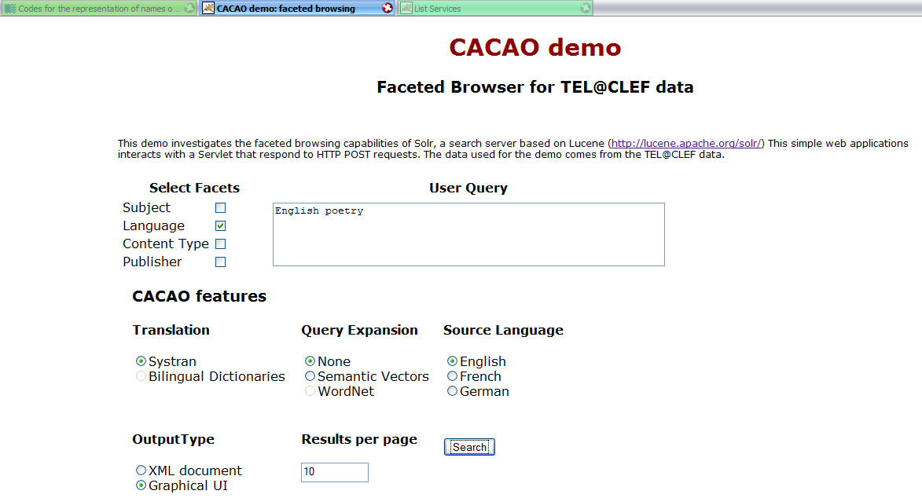
Figure 3 CACAO integration demo
A simple demonstrative application has been deployed for testing purposes and presents a web client that exploits the CACAO CLIR system; the web client is publicly available at the address http://demo.celi.it:8095/demoCACAO/ and it shows the CLIR features in action as well as faceted browsing capabilities natively present in the Solr search engine.
The demo presents on a first web page a form where the user can input a query (“English poetry” in the example) and choose one or more search facets (i.e. “language” in the example yields as output “en”,”fr”,”it”,.. instead “contentType” values as “text”,”audio”,”picture”..); by specifying in the web form the desired output type, the results can be viewed as an XML document or by means of a graphical UI . It is also possible to select some features of the CLIR system, mainly concerning the query translation and expansion, activating or deactivating them.
The user query is translated in the target languages and expanded (if so required); the result page shows the outcome of such translation and expansion activity along with the retrieved documents. At the moment only French, German and English languages are supported by the prototype since the corpus currently used as a search base is the one used for the TEL@CLEF track hold in 2008 that is focused on such languages.
.
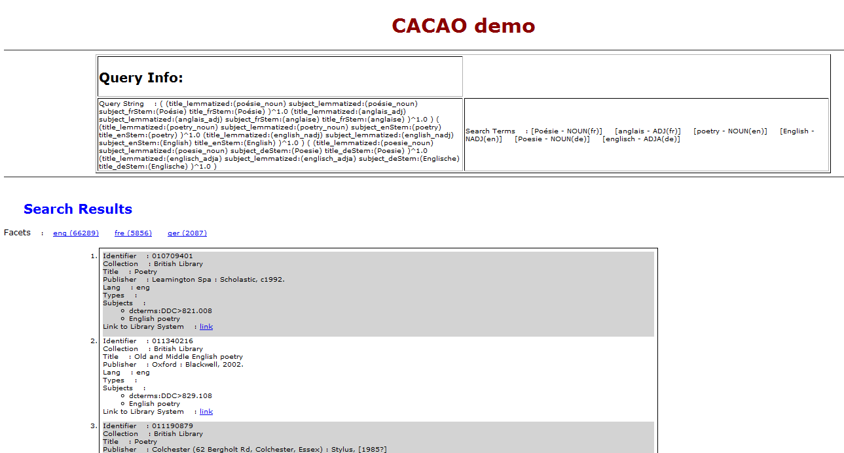
Figure 4 Output Example
The presented interface has been deployed for testing and debug purposes and is not intended as an end user interface; for more details on user interfaces see deliverable 1 of work package 4 on simple interfaces.

References
- SRU/SRW, http://www.loc.gov/standards/sru/index.html
- Solr, http://lucene.apache.org/solr/
- Language Codes, http://en.wikipedia.org/wiki/List_of_ISO_639-1_codes
- TEL project, http://search.theeuropeanlibrary.org/portal/en/index.html
- Cross Language Evaluation Forum, http://www.clef-campaign.org/

Annex A: Query Manager response XML document example

<?xml version="1.0" encoding="UTF-8"?>
<CACAO_ResponseDocument>
<CACAO_InputQuery inputLanguage="en">
<SearchTerm boost="1.0" category="ADJ" isNE="false"
isTranslation="true" lang="fr" lemma="romain" surface="romaine"/>
<SearchTerm boost="0.5" category="noun"
isExpandedTranslation="true" isNE="false" lang="fr"
lemma="législation" surface="législation"/>
<SearchTerm boost="1.0" category="NOUN" isNE="false"
isTranslation="true" lang="fr" lemma="loi" surface="Loi"/>
<SearchTerm boost="0.5" category="noun"
isExpandedTranslation="true" isNE="false" lang="fr"
lemma="projet" surface="projet"/>
<SearchTerm boost="1.0" category="NADJ" isNE="false" lang="en"
lemma="Roman" surface="Roman"/>
<SearchTerm boost="0.7" category="noun" isExpansion="true"
isNE="false" lang="en" lemma="rome" surface="rome"/>
<SearchTerm boost="1.0" category="NOUN" isNE="false" lang="en"
lemma="law" surface="law"/>
<SearchTerm boost="0.7" category="nadj" isExpansion="true"
isNE="false" lang="en" lemma="policier" surface="policier"/>
<SearchTerm boost="0.7" category="noun" isExpansion="true"
isNE="false" lang="en" lemma="empire" surface="empire"/>
<SearchTerm boost="0.7" category="noun" isExpansion="true"
isNE="false" lang="en" lemma="roman" surface="roman"/>
<SearchTerm boost="0.7" category="noun" isExpansion="true"
isNE="false" lang="en" lemma="anglai" surface="anglai"/>
<SearchTerm boost="0.5" category="noun"
isExpandedTranslation="true" isNE="false" lang="de"
lemma="untersuchung/s#haft" surface="untersuchung/s#haft"/>
<SearchTerm boost="0.5" category="noun"
isExpandedTranslation="true" isNE="false" lang="de"
lemma="gesetzgebung" surface="gesetzgebung"/>
<SearchTerm boost="0.5" category="noun"
isExpandedTranslation="true" isNE="false" lang="de"
lemma="recht" surface="recht"/>
<SearchTerm boost="0.5" category="noun"
isExpandedTranslation="true" isNE="false" lang="de"
lemma="verfassung/s#recht" surface="verfassung/s#recht"/>
<SearchTerm boost="0.5" category="noun"
isExpandedTranslation="true" isNE="false" lang="de"
lemma="zivil#prozess" surface="zivil#prozess"/>
<SearchTerm boost="0.5" category="noun"
isExpandedTranslation="true" isNE="false" lang="de"
lemma="recht/s#vergleich" surface="recht/s#vergleich"/>
<SearchTerm boost="0.5" category="noun"
isExpandedTranslation="true" isNE="false" lang="de"
lemma="schutz" surface="schutz"/>
<SearchTerm boost="1.0" category="NOUN" isNE="false"
isTranslation="true" lang="de" lemma="Gesetz" surface="Gesetz"/>
<SearchTerm boost="0.5" category="noun"
isExpandedTranslation="true" isNE="false" lang="de"
lemma="doppel#besteuerung/s#abkommen" surface="doppel#besteuerung/s#abkommen"/>
<SearchTerm boost="0.5" category="noun"
isExpandedTranslation="true" isNE="false" lang="de"
lemma="strafen#verfahren" surface="strafen#verfahren"/>
<SearchTerm boost="0.5" category="adja"
isExpandedTranslation="true" isNE="false" lang="de"
lemma="österreichisch" surface="österreichisch"/>
<SearchTerm boost="0.5" category="noun"
isExpandedTranslation="true" isNE="false" lang="de"
lemma="ost#mark" surface="ost#mark"/>
<SearchTerm boost="0.5" category="noun"
isExpandedTranslation="true" isNE="false" lang="de"
lemma="rechts#stellung" surface="rechts#stellung"/>
<SearchTerm boost="0.5" category="noun"
isExpandedTranslation="true" isNE="false" lang="de"
lemma="strafen#recht" surface="strafen#recht"/>
<SearchTerm boost="0.5" category="noun"
isExpandedTranslation="true" isNE="false" lang="de"
lemma="problem" surface="problem"/>
<SearchTerm boost="0.5" category="adv"
isExpandedTranslation="true" isNE="false" lang="de"
lemma="insbesondere" surface="insbesondere"/>
<SearchTerm boost="0.5" category="noun"
isExpandedTranslation="true" isNE="false" lang="de"
lemma="zivil#recht" surface="zivil#recht"/>
<SearchTerm boost="1.0" category="ADJA" isNE="false"
isTranslation="true" lang="de" lemma="römisch" surface="Römisches"/>
<SearchTerm boost="0.5" category="noun"
isExpandedTranslation="true" isNE="false" lang="de"
lemma="arbeitnehmer-schutz#gesetz" surface="arbeitnehmer-schutz#gesetz"/>
<SearchTerm boost="0.5" category="noun"
isExpandedTranslation="true" isNE="false" lang="de"
lemma="österreich" surface="österreich"/>
<SearchTerm boost="0.5" category="noun"
isExpandedTranslation="true" isNE="false" lang="de"
lemma="uwg" surface="uwg"/>
</CACAO_InputQuery>
<CACAO_Facets>
<FacetField field="language"/>
<Facet count="78753" filed="language" value="ger"/>
<Facet count="30369" filed="language" value="eng"/>
<Facet count="13619" filed="language" value="fre"/>
<Facet count="2" filed="language" value="tur"/>
<Facet count="1" filed="language" value="GER"/>
<Facet count="1" filed="language" value="kor"/>

<Facet count="1" filed="language" value="pol"/>
<Facet count="1" filed="language" value="spa"/>
</CACAO_Facets>
<CACAO_RetrievedRecords recordsReturned="10" recordsStartFrom="0">
<Record recordRelevance="0.2607718">
<identifier>011810515</identifier>
<collection>British Library</collection>
<URL>http://catalogue.bl.uk/F/-?func=direct-doc-set&amp;amp;l_base=BLL01&amp;from=TELgateway&amp;doc_number=011810515</URL>

<title>The digest of Roman law : theft, rapine, damage and insult</title>
<publisher>Harmondsworth : Penguin, 1979</publisher>
<language>eng</language>
<subject>dcterms:DDC&gt;343.7063/02632</subject>
<subject>Torts (Roman law)</subject>
<subject>Ancient Rome Torts Law</subject>

</Record>
<Record recordRelevance="0.23725757">
<identifier>011373747</identifier>
<collection>British Library</collection>
<URL>http://catalogue.bl.uk/F/-?func=direct-doc-set&amp;amp;l_base=BLL01&amp;from=TELgateway&amp;doc_number=011373747</URL>
<title>Roman private law : a translation.</title>

<publisher>Pretoria : University of South Africa, 1984.</publisher>
<language>eng</language>
<subject>dcterms:LCC&gt;LAW</subject>
<subject>dcterms:DDC&gt;340.5/4</subject>
<subject>Roman law.</subject>

<subject>Roman law</subject>
</Record>
<Record recordRelevance="0.2099896">
<identifier>oai:bnf.fr:catalogue/ark:/12148/cb36595386h/description</identifier>
<collection>Bibliothèque nationale de France</collection>
<URL>http://catalogue.bnf.fr/ark:/12148/cb36595386h/description</URL>
<title>Projets de loi et résolutions adoptés par le Sénat</title>

<publisher>Impr. des Journaux officiels (Paris)</publisher>
<language>fre</language>
<subject> Droit -- France -- Législation</subject>
<subject> Projets de loi -- France</subject>
<subject> France . Sénat ( 1958-....) -- Résolutions</subject>

</Record>
<Record recordRelevance="0.20577572">
<identifier>011527433</identifier>
<collection>British Library</collection>
<URL>http://catalogue.bl.uk/F/-?func=direct-doc-set&amp;amp;l_base=BLL01&amp;from=TELgateway&amp;doc_number=011527433</URL>
<title>Roman law and common law : a comparison in outline</title>

<publisher>Cambridge : University Press, 1965.</publisher>
<language>eng</language>
<subject>Roman law.</subject>
<subject>dcterms:LCC&gt;K B9243</subject>
<subject>Common law.</subject>
</Record>

<Record recordRelevance="0.2044267">
<identifier>011527435</identifier>
<collection>British Library</collection>
<URL>http://catalogue.bl.uk/F/-?func=direct-doc-set&amp;amp;l_base=BLL01&amp;from=TELgateway&amp;doc_number=011527435</URL>
<title>A text-book of Roman law : from Augustus to Justinian</title>

<publisher>Cambridge : University press, 1950.</publisher>
<language>eng</language>
<subject>Roman law.</subject>
</Record>
<Record recordRelevance="0.20326003">
<identifier>010888021</identifier>
<collection>British Library</collection>

<URL>http://catalogue.bl.uk/F/-?func=direct-doc-set&amp;amp;l_base=BLL01&amp;from=TELgateway&amp;doc_number=010888021</URL>
<title>Roman law in England.</title>
<publisher>Mediolani : Giuffre?, 1971.</publisher>
<language>eng</language>
<subject>Roman law History.</subject>

<subject>dcterms:DDC&gt;340/.0942</subject>
<subject>dcterms:LCC&gt;LAW</subject>
<subject>Law History.</subject>
<subject>Law, Medieval.</subject>
</Record>
<Record recordRelevance="0.1974177">

<identifier>011527432</identifier>
<collection>British Library</collection>
<URL>http://catalogue.bl.uk/F/-?func=direct-doc-set&amp;amp;l_base=BLL01&amp;from=TELgateway&amp;doc_number=011527432</URL>
<title>Roman law &amp; common law : a comparison in outline.</title>
<publisher>Cambridge : [Eng.] University Press, 1952.</publisher>

<language>eng</language>
<subject>dcterms:LCC&gt;LAW General Law Buck 1952</subject>
<subject>Roman law.</subject>
<subject>Common law.</subject>
</Record>
<Record recordRelevance="0.19109105">

<identifier>011357286</identifier>
<collection>British Library</collection>
<URL>http://catalogue.bl.uk/F/-?func=direct-doc-set&amp;amp;l_base=BLL01&amp;from=TELgateway&amp;doc_number=011357286</URL>
<title>The historical and institutional context of Roman law</title>
<publisher>Aldershot : Ashgate, c2003.</publisher>

<language>eng</language>
<subject>dcterms:DDC&gt;340.54</subject>
<subject>Roman law.</subject>
<subject>Civil law History.</subject>
</Record>
<Record recordRelevance="0.18526456">

<identifier>011804508</identifier>
<collection>British Library</collection>
<URL>http://catalogue.bl.uk/F/-?func=direct-doc-set&amp;amp;l_base=BLL01&amp;from=TELgateway&amp;doc_number=011804508</URL>
<title>The Bill of Rights and Roman law</title>
<publisher>Bethesda, Md. : Austin &amp; Winfield, c1995.</publisher>

<language>eng</language>
<subject>United States.</subject>
<subject>Roman law.</subject>
<subject>Civil rights</subject>
</Record>
<Record recordRelevance="0.18124962">
<identifier>011727807</identifier>

<collection>British Library</collection>
<URL>http://catalogue.bl.uk/F/-?func=direct-doc-set&amp;amp;l_base=BLL01&amp;from=TELgateway&amp;doc_number=011727807</URL>
<title>Women and the law in the Roman Empire : a sourcebook on marriage, divorce and widowhood</title>
<publisher>London : Routledge, 2002.</publisher>
<language>eng</language>

<subject>Women Legal status, laws, etc.</subject>
<subject>Married women Legal status, laws, etc.</subject>
<subject>dcterms:DDC&gt;346.370134</subject>
<subject>Women (Roman law) History</subject>
</Record>
</CACAO_RetrievedRecords>

</CACAO_ResponseDocument>

OJ L 79, 24.3.2005, p. 1.
Information about the interface for end users is provided in D4.1
The languages within CACAO framework are expressed using the 2 letter ISO 639-1 international code (i.e. ‘en’, ‘fr’, ‘de, ‘hu’, ..)
More details on the integration between CACAO and TEL can be found on deliverable 4 of work package 3.
The selection may be altered anytime, at the only cost of a full rebuild of the index
See the end of previous section for examples of notations and associated labels.
The list built upon the actual documents may be a subset of the whole CS tree as stored in the Classification Explorer.
Configuration options will be provided to set how many words are propagated and under which circumstances. At the time of this writing, the best values are yet to be discovered.
C.f. Deliverables D3.1, D3.2 and D3.3
C.f. Deliverables D3.1, D3.2 and D3.3
For every hit returned, the Classification tree is traversed in order to find the ancestor.
This is valid under some assumptions: this is true for a CS where deeper categories are more specialized and this will cause very specific terms to be translated with very general one (e.g. ???)
The most comprehensive resource on this topic, which is also been used in describing the examples in this section, is: Levergood, B., Farrenkopf S., Frasnelli, E., The Specification of the Language of the Field and Interoperability: Cross-Language Access to Catalogues and Online Libraries (CACAO), Proceedings of the International Conference on Dublin Core and Metadata Applications, Berlin, 22-26 September 2008, Göttingen 2008, pp. 191-198.
Merriam Webster Online Dictionary: http://www.merriam-webster.com/dictionary/bank[3]
Merriam Webster Online Dictionary: http://www.merriam-webster.com/dictionary/bank[1]

