



Projet Vowel : Exerciser
Generator of exercises
with automatic correction.

User Guide.

Vianney Grassaud

others contacts :

Frédérique Segond, Thibault Parmentier

Table of contents:
Preface. 3
Principles of the generator. 4
Generalities. 4
Connection to the web application. 4
Menu bar of the web application. 5
Teacher profile: create a new exercise. 6
Choose a text and attributes of the exercise. 6
Choose syntactic category to extract and level of the exercise. 7
Finalization of the exercise: choice of surfaces form. 8
View an exercise. 8
Student profile: Do an exercise. 10
Choose an exercise. 10
Do the exercise, fill in the blank. 10
Use automatic correction. 11
The data base. 13

Preface.

This document is a guide in order to use the web application « Exerciser ». It describes all the screens that you can see using the application. In order to have a better view and explain the different steps, some screenshots will be displayed.

Principles of the generator.

Generalities.

The exerciser is a application web to generate automatically exercises with blank from a text and some data given by a user.

Example :
The dog …….. (to eat) a bone.

To create an exercise, the user gives a text and syntactic categories to extract, i.e. verbs, nouns, adjectives… In the precedent example, the category was verb. Once the categories extraction made on the text, the user chooses words that he wants to extract and be replaced by a blank.
The web application provides an automatic correction. The corrector proposes the morphologic errors of a student if there are some.

Example :
The dog eat a bone: → error: +VI, +Non3sg.

There are 2 profiles in the exerciser. A teacher profile in order to create some exercises and do exercises. And a second profile: the student profile, to only do exercise.

Connection to the web application.

For a normal use (create exercise….):
- http://www.exills.com/Exerciser/VOWEL/index.jsp
or as it’s indicated in the Exills documentation :
- http://www.exills.com/Exerciser/VOWEL/index.jps?nickname=toto&exercise=exo.jsp.
With the second URL, the « Exerciser » suppose that the user is already connected.

For a normal use :

To use the web application, user need to be connected on it. User gives a login and a password. A default password exists :
Login : test
Password : xembsplg

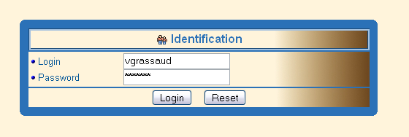
Figure 1: Identification

Menu bar of the web application.
The menu permits to execute some actions of the Exerciser. It’s specific for a given profile.

A teacher can from the menu :
- to logout.
- to create a new exercise.
- to do an exercise.

A student can from the menu:
- to logout.
- to do an exercise.


Figure 2 : menu for teachers
Teacher profile: create a new exercise.

The creation of an exercise takes 4 steps. These steps are described in the following sections. An exercise is a formulary that you need to fill. The name of the formulary is calculated like that:

Title + login + index + language

Example:
Test_grassaud_2002-05-12—10-44-16-486-english.jsp

NB: The name of the formulary is displayed in a readable way.

Choose a text and attributes of the exercise.

The first step is to give a text for the exercise. The attributes below are necessary.

1 Title of the exercise.
2 Author of the exercise.
3 Instruction for students.
4 Topic of the exercise.
5 Text permitting the exercise.
6 Next step.
7 reset the fields.
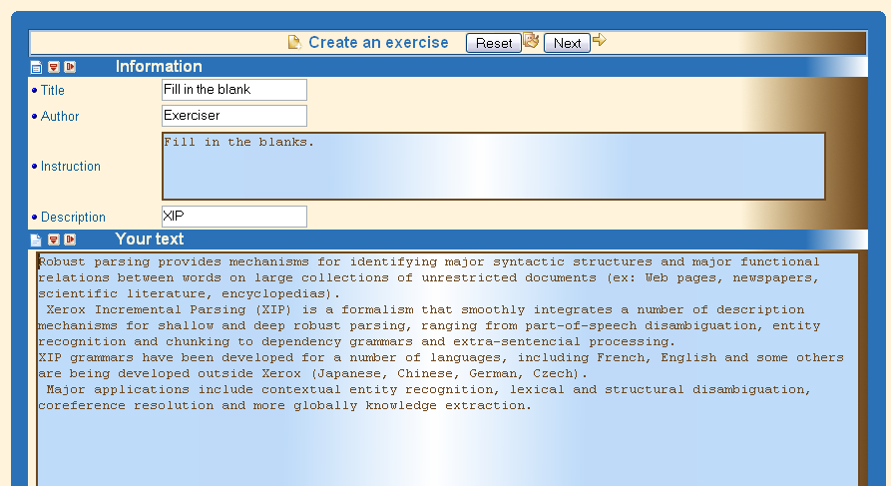
1
2
3
4
5
6
7

Figure 3 : Create an exercise

The text can be in the following language:
English, French, Spanish.

Choose syntactic category to extract and level of the exercise.

Once the text was analyzed, the teacher must choose some category that he wants to extract from his text.

The list of categories : (1)

Noun, Verb, pronoun, adjective, adverb, auxiliary, preposition, article, punctuation.

There are 3 levels in the « Exerciser » (2)

- Level 0, the most easy.
Example :
The dog …… (to eat ) a bone.
- Level 1, intermediate level:
Example :
The dog ………… a bone.
(to eat)
- Level 2, the most difficult:
- The dog ……… a bone.

The web application doesn’t use semantic dictionary of synonyms. The student must find the good lemma to get a good result with automatic corrector.
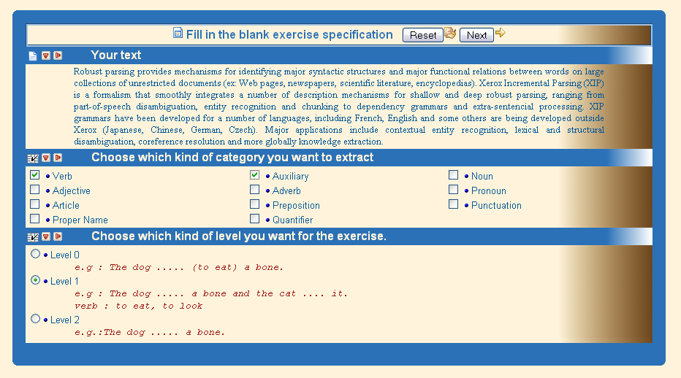
1
2

Figure 4 : Choice of catégories

Finalization of the exercise: choice of surfaces form.

Last step for the creation of an exercise. After it, theformulary corresponding with the exercise will be created and store on disk.
This screen show to the teacher his text with the words extracted. He just needs to click on a « checkbox » button type to announce to the application that the word must become a blank. More over, in order to help the teacher to check the words, a list of lemma and a list of tenses are available to check automatically. Press the « shift » or on « ctrl » key to choose severel lemma or tenses use this button to check your selection. Click on button and the formulary will be create.
1
2
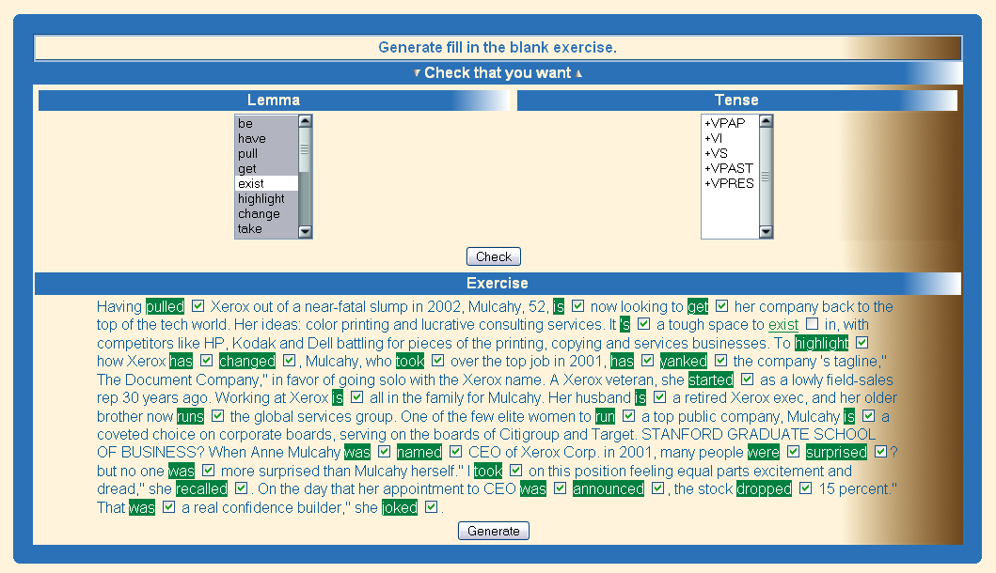
3
Figure 5 : choice of words.

View an exercise.

A list of all exercises is available from the menu and after the creation of an exercise. Click on a link to view the formulary. You can use the sort button in order to sort the list of exercises.

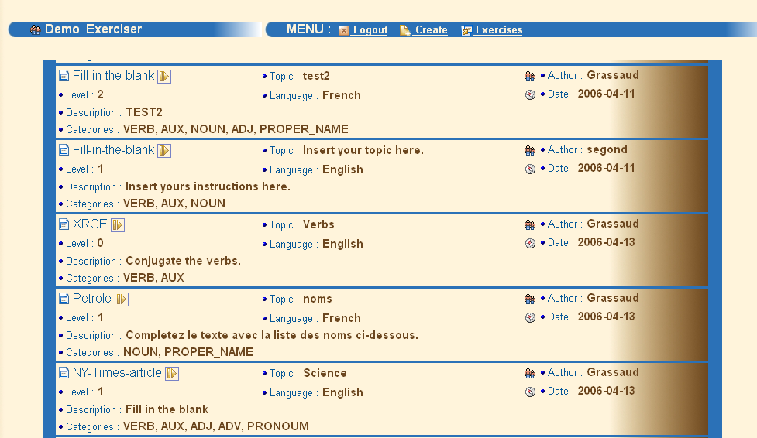
Figure 6 : List of exercises

Student profile: Do an exercise.

Choose an exercise.

The student clicks on the exercise that he wants to do . In this list, he can know the title, the language and the author about the exercise.

Figure 7 : List of exercises

Do the exercise, fill in the blank.

To do an exercise, your must just fill in the blank. A field can be empty, and there is no process to validate a field, so “ eat” is different than “eat”.

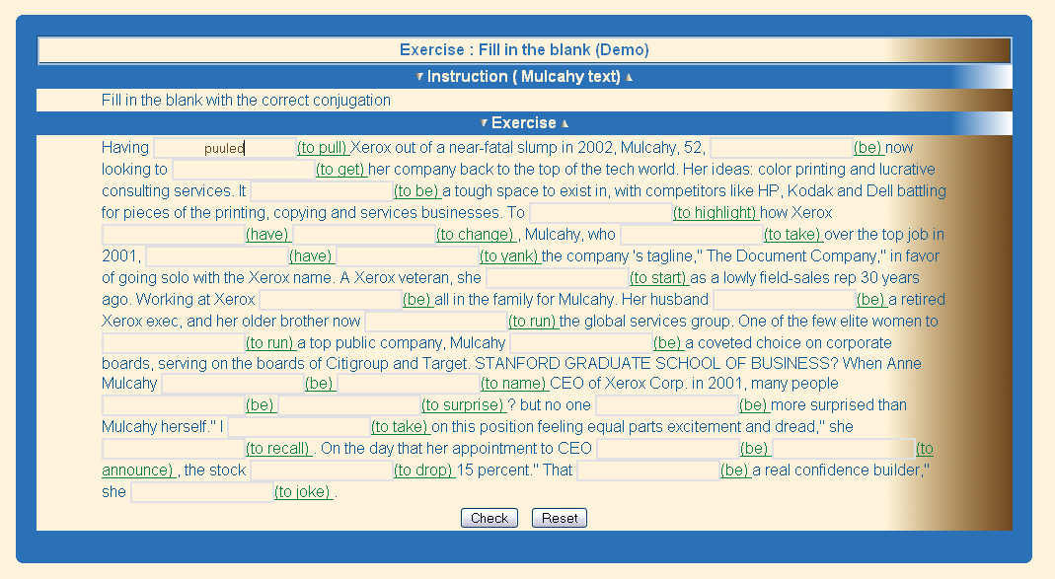
Figure 8 : Exercise formulary.

Use automatic correction.

The correction is automatic, use the button , the application use the morphological analysis for that. If a student writes “ he eat” instead of “he eats”, the corrector will indicate that there is an error on the verb person. And the corrector can also indicate that there is an error on tense verb. Bad answers are displayed in red, good answers are displayed in green.
The application indicates to the student his percentage of error. You can view the full correction (use the button ) and retry the exercise.
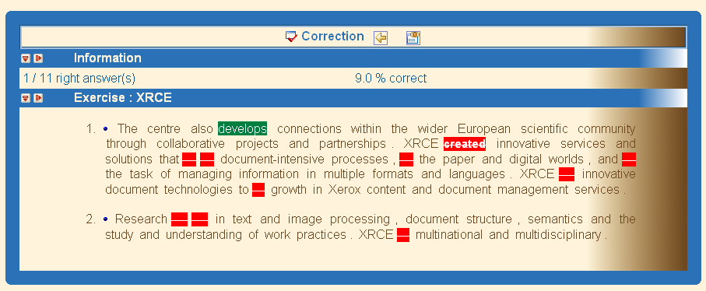
Figure 9 : Automatic correction.

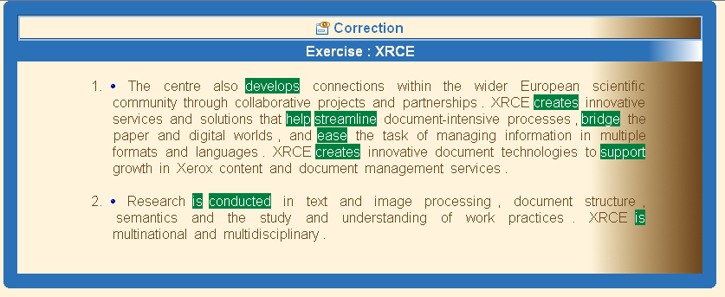
Figure 10 : Correction

The data base.

The application Web is connected to a MYSQL data base. There are two data base used: elearning for the XRCE project and the data base vowel for the VOWEL project.

The « Exerciser » uses 3 tables for read or write some information :

A users table for identification.

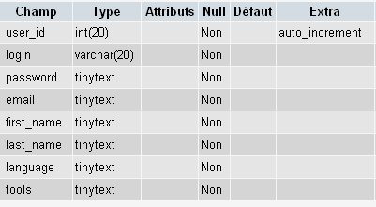

A exerciser_list table in order to keep the list of exercises.

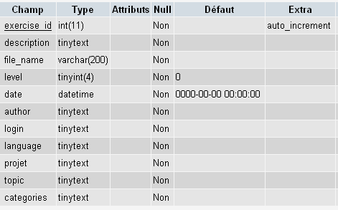

A exercises_results table in order to store the scores of the students.

