**GRAPHIX MP DOCUMENTATION**

SEDILLO, CLAUDE KRISTOFFER APRIL 20, 2018

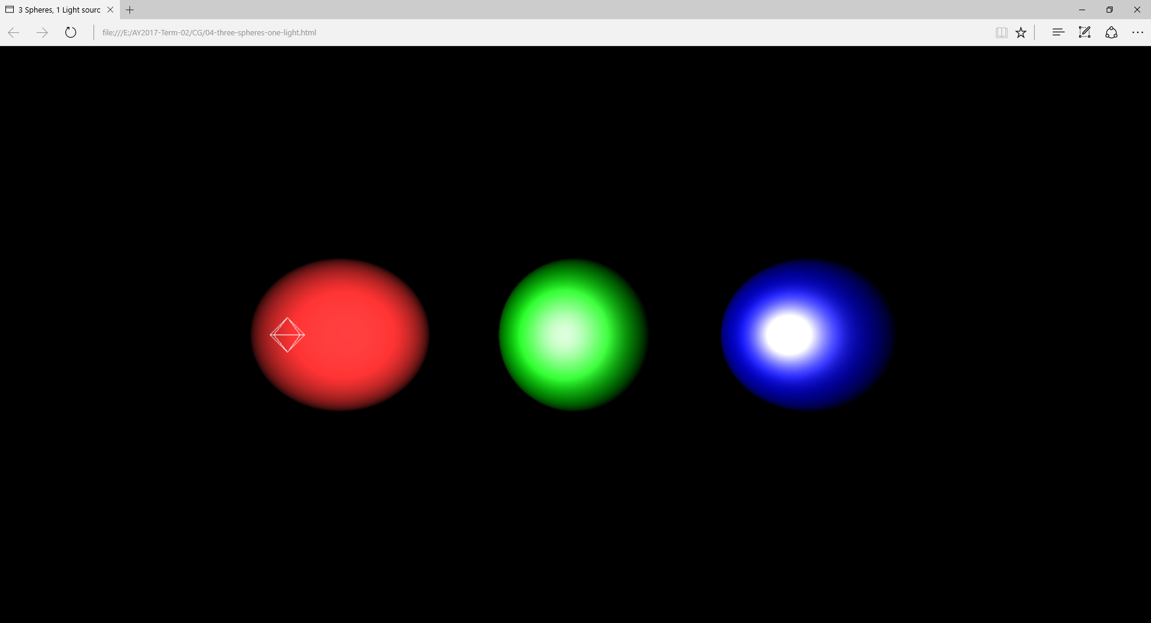

*Paste screenshot(s) of your project in the space above*

**I. PROJECT DESCRIPTION**

*My project is a simple simulator of the solar system. It involves 8 planetary models rotating on their own axis, while revolving around a sphere modelled after the sun.*

*This project is inspired by my interest in astronomy. I got the idea of doing a space simulator from my interest in playing space simulation games such as Kerbal Space Program and Space engine.*

**II. CONCEPTS YOU APPLIED**

*The main concepts applied in the project mainly revolve around modeling transformation. Planets rotate on their axis and revolve around their parent star. Therefore, portraying their natural actions with high accuracy is a must for a simulator of this nature. Another major concept in this simulator is the proper implementation of lighting. For my project, I applied a faint ambient light so that the user can still see a part of the unilluminated side of a planet, or else one side would be illuminated, and the other side would be pitch black. The last concept applied is proper camera positioning. When playing a space simulator game, the user expects to not only see the planets revolve around the sun, but to also see the planets in detail. Which is why having the ability to focus on a planet is a must.*

*Describe how you applied what you learned (from our class and from what you learned on your own) in your project. Provide a description also of 3D models that you created on your own (the model can be built from scratch, or as combination of the 3D primitives such as sphere, cones etc.).*

**III. RESOURCES THAT YOU BORROWED FROM THE PUBLIC DOMAIN**

[**https://github.com/jeromeetienne/threex.planets**](https://github.com/jeromeetienne/threex.planets)

**https://jsfiddle.net/prisoner849/a2ogz9vx/**

*Describe and acknowledge resources (such as 3D models, or code snippets) that you borrowed from the public domain via citation. For example:*

*The bunny model used in the project is from the Stanford 3D Scanning Repository (2018) and made available from the paper of Turk & Levoy in (1994).*

**IV. REFERENCE**

*List your references Describe and acknowledge resources (such as 3D models, or code snippets) that you borrowed from the public domain. For example:*

Turk, G. & Levoy, M. (1994). Zippered polygon meshes from range images. Proc. SIGGRAPH '94 (Orlando, Florida, July 24-29, 1994). In Computer Graphics Proceedings, Annual Conference Series, 1994, ACM SIGGRAPH, pp. 311-318.

Stanford 3D Scanning Repository (2018). Stanford Bunny. Retrieved from <http://graphics.stanford.edu/data/3Dscanrep/>.