Clone team-trello-project repository to your computer if you haven’t done so.

The following branches were created to review any changes to the code before merging to the master branch:

tanner

mathias

team1(Claudia will be using this branch)

The following are instructions to access your branch through your command window:

1) How to create a new branch (2 ways to create):

1. in Github:
   1. on repository code page locate the following dropdown



* 1. click it to open dropdown and select the branch you want to create a new branch from (ie. master)

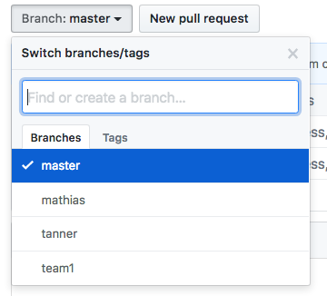

* 1. Enter new branch name in the field provided and enter to create the new branch.

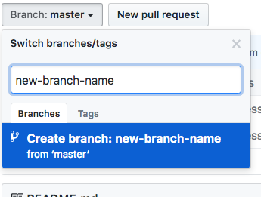

* 1. Click on the branches link

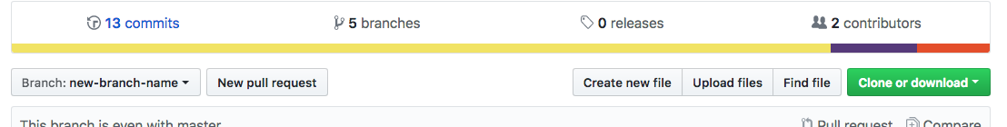

* 1. You should be redirected to the branches screen where you will find your new branch 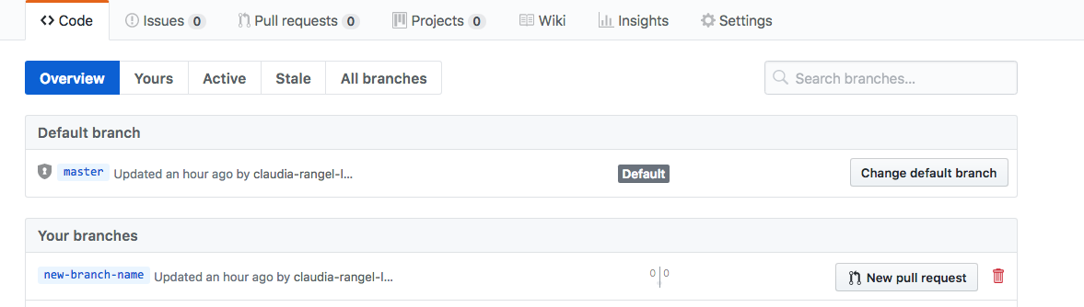
  2. Next time you pull from github you will get the new branch to your machine locally and will be able to check it out

1. Local on your machine:
   1. On the command window make sure you are at the root of your repository
   2. Run the following command to create a new branch

git checkout –b <new-branch-name>

* 1. that will create the new branch locally
  2. In order for it to be available in github for others to use, you will need to push the branch to github. Before you are able to github you need to configure which branch in github your new branch is associated with. To do this, run the following command:

*git push –set-upstream origin <new-branch-name>*

* 1. This will both configure the github branch associated with your new branch and push your new branch to github so others can see it and use it.

2) To change to your branch:

a) git checkout <your branch name>

Ex: git checkout tanner

3) Daily Development Process:

1. Merge latest changes from master into your branch
   1. git checkout master
   2. git pull
   3. git checkout <your-branch-name>
   4. git merge master
   5. If previous command results in conflicts then do the following:
      1. Resolve the conflicts by editing the files that were in conflict
      2. git add .
      3. git commit –m “merge master into <your-branch-name>”
2. Make your changes
3. Merge latest changes into your branch (see a above)
4. Push your changes to github
   1. git push

4) Code Review Process:

1. On the repository code page click on the branches link



1. This should take you the branches page where you will find the branch you want reviewed



1. Click the **new pull request** button to the far right of the branch you want reviewed.

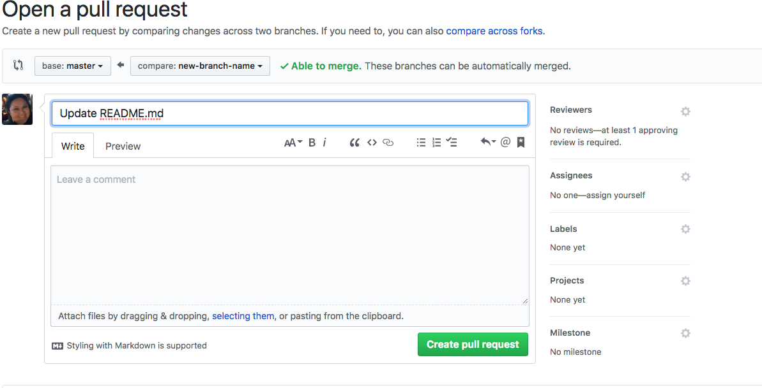

1. Fill in the name, description and select a reviewer (should include at least your team lead) then click the **Create pull request** button.

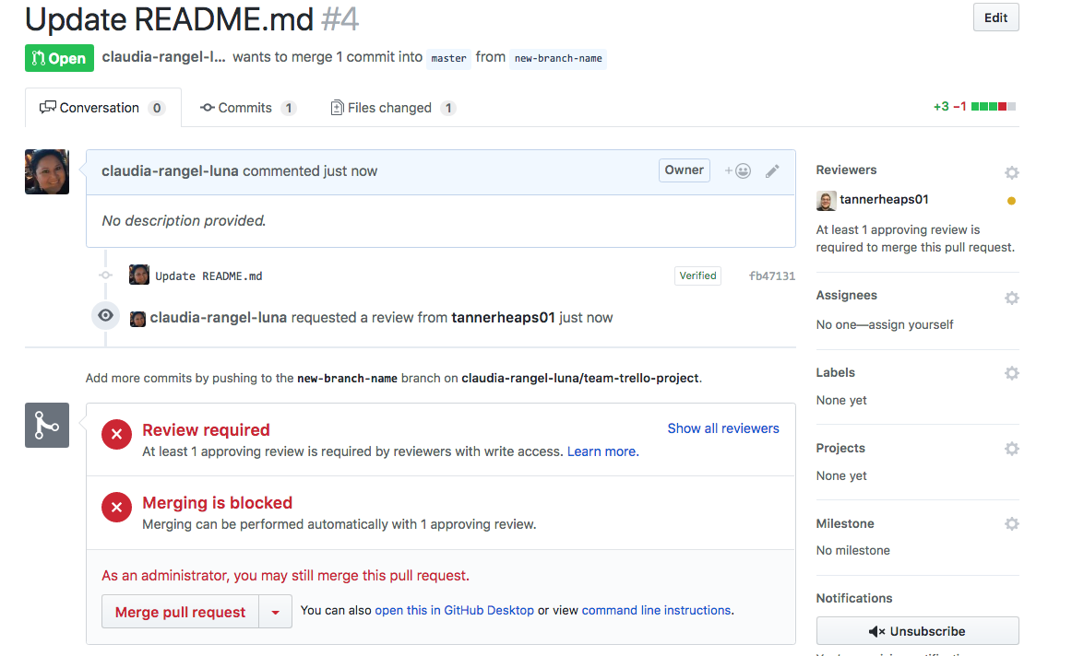

1. Once the reviewer has reviewed your code, he/she will:
   1. Approve your code to be merged to the master branch providing a comment, or
   2. Reject your code giving you additional feedback to do changes in your code before merging to master. If your code is denied you must revise your code and repeat steps in #4 and on.