H2H SALES & MARKETING
Sales Performance Report
May 2011 – May 2014 | Prepared for Executive Review | August 2026
$34.15M  Total Sales | $30.31M  Net Sales | 1,465  Orders | 85,866  Units Sold | 294  Customers | $23.3K  Avg Order Value
What's Working
● Strong, sustained growth. Comparing the two full calendar years on record, sales grew 86% from 2012 ($8.7M) to 2013 ($16.2M) - a very healthy trajectory.
● A genuinely international footprint. Sales span 8 markets across North America, Europe, and the Pacific - Canada (35%), Northwest (20%), France (15%), and the UK (14%) are the four strongest.
● A capable core sales team. The top 3 reps (Noah Bennett, Ethan Parker, Lucas Morgan) are strong, consistent performers driving nearly two-thirds of all revenue.
What Needs Attention
● Extreme category concentration. Bikes account for 80.6% of all sales. Components, Clothing, and Accessories combined make up just 19% - a single-category shock would hit hard.
● 1 in 5 orders doesn't complete cleanly. 303 of 1,465 orders (20.7%) end up Cancelled, Rejected, or Backordered - a meaningful, recoverable revenue leak worth root-causing.
● Two months of 2014 show almost no recorded sales. February and April 2014 each show under $4K in sales, sandwiched between months over $1.7M - this looks like a data or system gap, not a real slowdown, but it needs to be confirmed.
Recommendations
1. Diversify beyond Bikes. Set targets to grow Components, Clothing, and Accessories attach-rates - reducing reliance on a single category is the highest-leverage risk fix available.
2. Root-cause the order failure rate. Audit why 1 in 5 orders is Cancelled, Rejected, or Backordered - likely candidates are inventory availability or the approval workflow. Even halving this rate recovers substantial revenue.
3. Investigate the Feb/Apr 2014 data gap immediately before drawing any conclusions about slowing momentum - confirm whether this is a reporting issue or a real operational disruption.
4. Scale what the top reps do well. Formalize the practices of Noah Bennett, Ethan Parker, and Lucas Morgan into coaching for the rest of the team to close the wide performance gap.
At a Glance
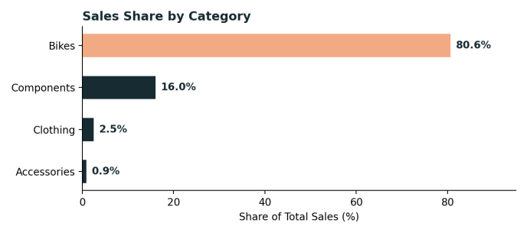 | 