**Analysis**

The following section illustrates the different steps undertaken to obtain a prediction model for pro-environmental action. In particular, the first step consists of Exploratory Data Analysis, to investigate climate change attitudes. Then, the best fitting models tested to predict the final price are presented.

**Exploratory Data Analysis: Macro-level**

Climate change attitudes do not vary only between countries but also between citizens in the same country (Xie et al., 2019). As you can see in figure 1, the percentage of those who believe that climate change is the single most serious problem varies significantly according to country. For example, Bulgaria and Croatia obtain a smaller percentage, that is 11% of citizens who think climate change is the single most serious problem. On the contrary, about 1 out 2 of Sweden’s citizens indicated climate change.

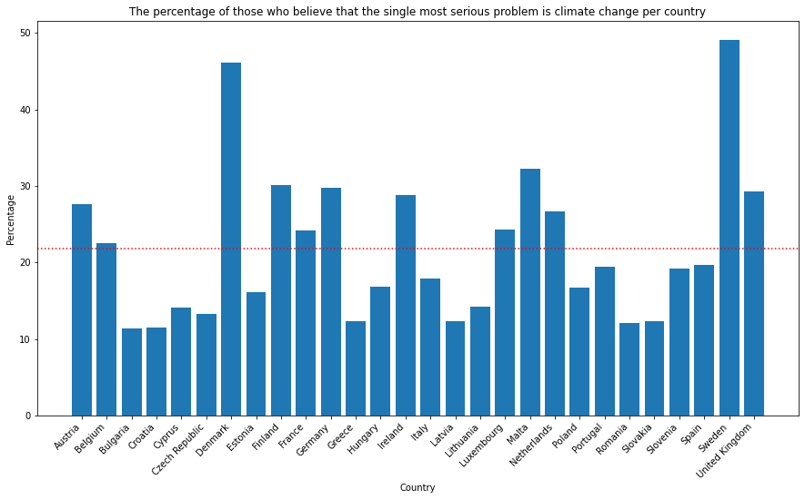

Figure 1: Single Most Serious Problem per Country

Another interesting example is the difference in the climate change risk perception. As you can see in figure 2, about half of the citizens of Malta and Luxemburg declared that they are extremely worried about the phenomenon studied.

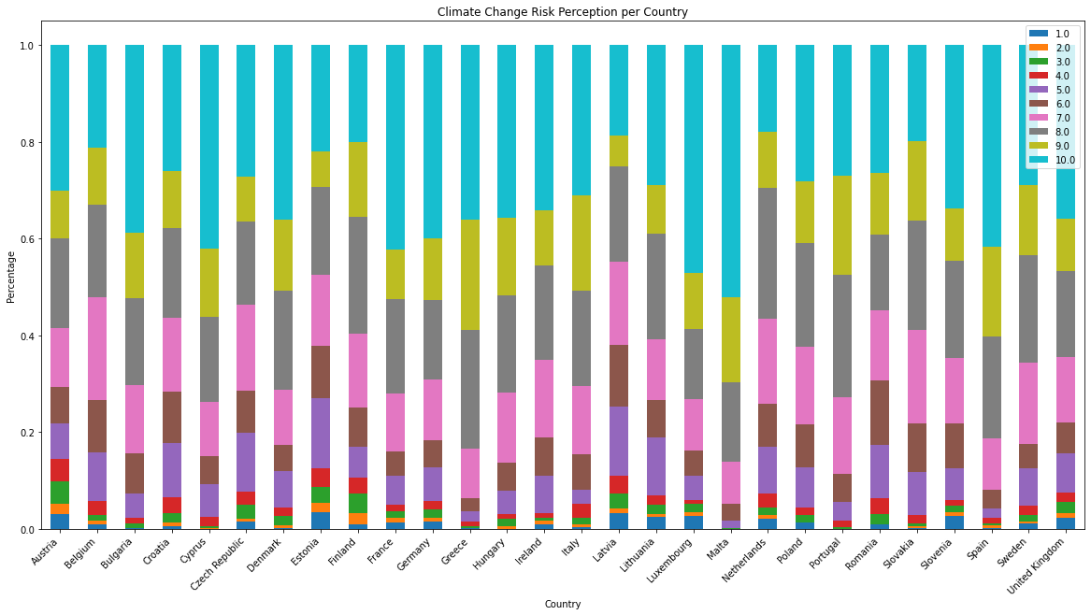

Figure 2: Climate Change Risk Perception per Country

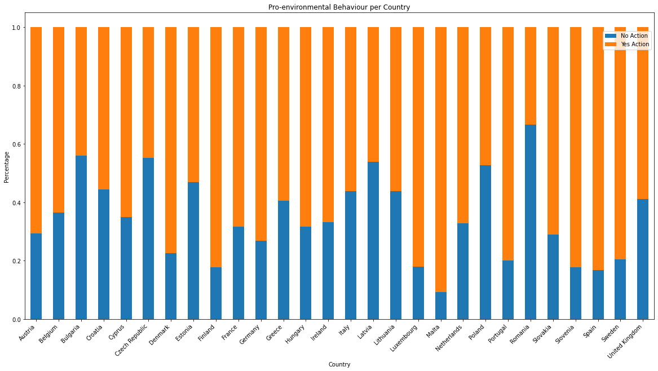

Figure 3: Pro-environemntal Behaviour per Country

Attitudes among countries could so vary since they are influenced by different contextual factors (Echavarren et al., 2019; Krajhanzl, 2010). According to Echavarren and colleagues (2019), opinion, perception, and behavior could change due to different natural hazards and political contexts. For example water deficit or temperature growth regarding natural hazards and the “level of environmentalism in the political arena of a given country” (Echavarren et al., 2019, p. 815) for political variables. These macro-variables should be significant mediators in explaining risk perception or pro-environmental behavior. Some indexes are considered with the sole purpose of remembering that they could affect and moderate the phenomenon studied. Then, they are not inserted in the final models since only the multilevel method could be adopted. Besides, the aim of the research is not to evidence national or cultural differences, but on the contrary, it is to find patterns at individual levels, regardless of the place of origin. However, these differences at the macro levels are presented.

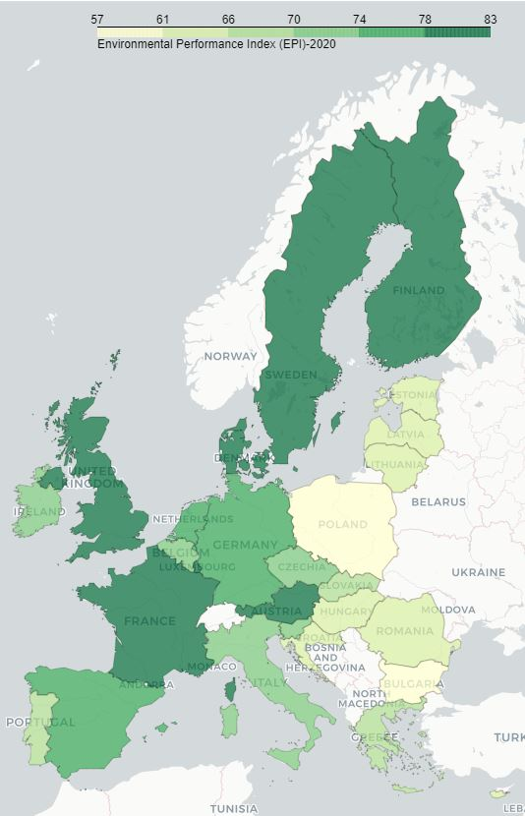For the natural hazards the 2020 Environmental Performance Index (EPI) is used (the 2019 EPI is not available to use the same data of year of the survey) (Yale Center for Environmental Law & Policy, 2020). EPI quantifies numerically environmental health and ecosystem vitality around the world. Some indicators that composed the index are air pollution, drinking water quality, species protection. These phenomena could positively affect climate change concerns and opinions (Echavarren et al., 2019). Citizens should perceive biodiversity loss or temperature increases, leading to greater apprehension. Figure 3 shows the score across European Union (EU). The best score is obtained from Denmark, while the worst from Bulgaria.

Figure 4: The 2020 EPI

For the political context, the 2019 Climate Change Policy Performance is selected, which is a measurement of national and international climate policies (Burck, 2018) developed by organization Germanwatch. It is one of the indicators that belong to the Climate Change Performance Index (CCPI). The indicator constitutes the measurements taken by governments to reduce the current level of GHG emissions per capita or the use of renewable energy. Briefly, it is defined as a measure of countries’ progress and their capacity for climate protection (Burck, 2018). In the Climate Change Policy, the record goes to Portugal and Bulgaria gets the lowest score in all European Union, as figure 4 shows.

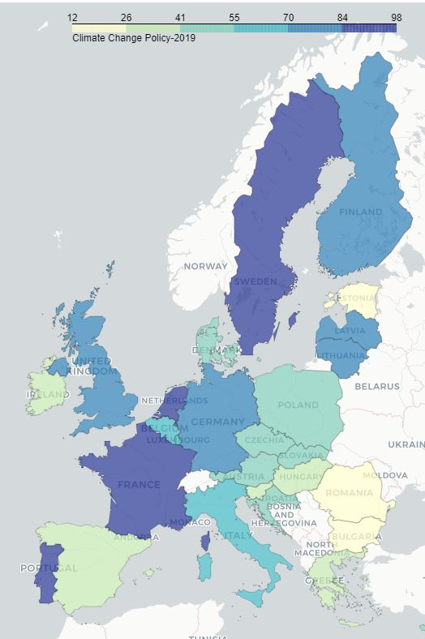According to scholars (Echavarren et al., 2019; van der Linden, 2015) socio-cultural context influces individual attitudes towards climate change concerns. Therefore, the notable diferencess in attitudes across coutries should be also due to these indicators. In fact, “sociological research suggests that contextual factors and processes can be powerful forces shaping how individuals and communities engage with the issue” (Lee et al., 2015, p. 1014). There are different ecological tax reforms or cultural habits that affect and shape individual climate change attitudes and behavior.

Figure 5:The 2019 Climate Change Policy

In this way, It is important to remember that these macro-factors should affect also individual preferences.

**Analysis: Data Exploratory**

**3.1 Correlation Class Analysis**

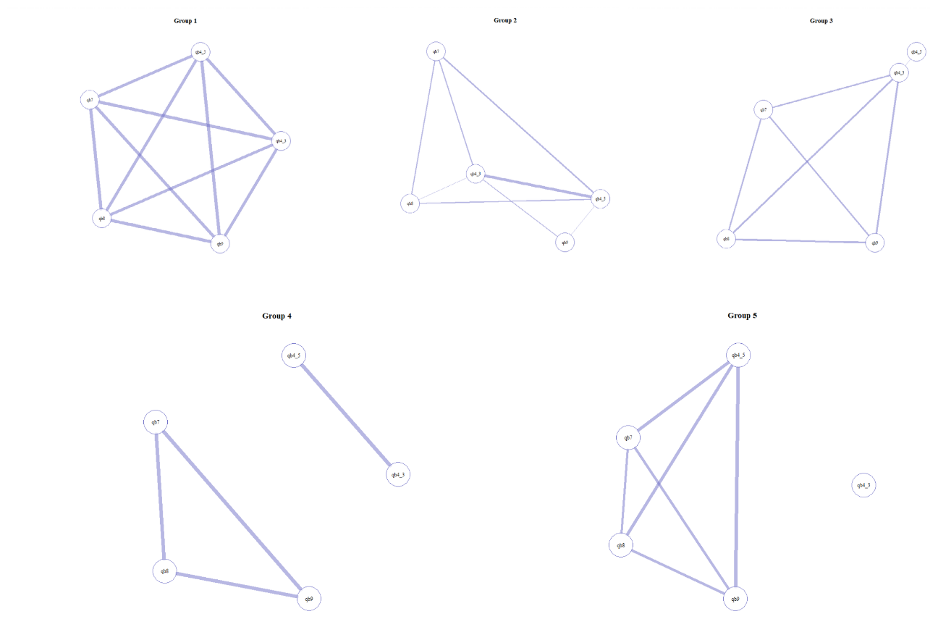

Figure 6: CCA

CCA partitions the dataset into classes based on the similarity of correlation patterns to apprehend unobserved heterogeneity (Rossoni et al., 2021). The algorithm is performed through the *corclass* package in the R software. For our dataset, the CCA algorithm produces five groups. Figure 5 illustrates the individual modules or classes created as a network. Each node corresponds to one item, while the edges show the statistically significant correlation between variables (Rossoni et al., 2021). The more line is thicker, the more significant is the correlation. [1] In group 1 the correlations between all pairs of variables are set to 1. Group 2 obtains a high positive correlation (0.8) mainly between qb4_3 and qb4_5. Group 3 has a slight correlation among all variables, except for qb4_5. In group 4 we find a strong positive correlation among qb7, qb8, and qb9 and separately between qb4_3 and qb4_5. Lastly, group 5 has a strong correlation between the following pair of variables: qb4_5 and qb7; qb4_5 and qb8; qb4_5 and qb9. In this case, qb4_3 is completely isolated.

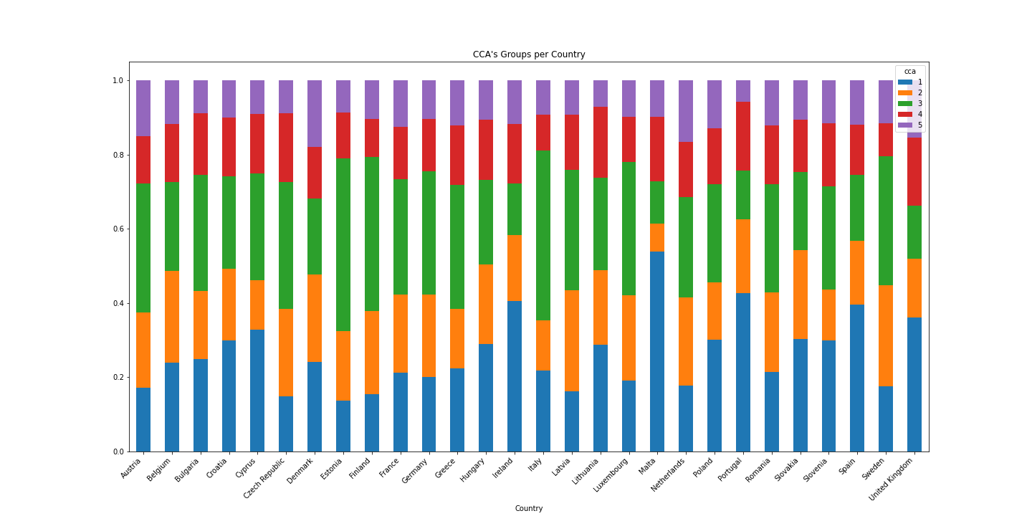Figure 7: CCA and Country

In the second place, it is interesting to analyse how CCA’s groups are distributed according to country, as shown in figure 6. The aim is to understand whether there are some shared meanings among citizens of the same country. We analyse the percentage of individuals belonging to the CCA’s groups for each country. Group 2, 4, and 5 are composed of a similar proportion of citizens from each country. Instead, if we look at the composition for each country, we find that over 30% of citizens from Cyprus, Ireland, Malta, Portugal, Slovakia, Spain, and United Kingdom belong to group 1. Additionally, over 30% of citizens from Austria, Bulgaria, Czech Republic, Estonia, Finland, France, Germany, Greece Italy, Latvia, Luxemburg, and Sweden belong to group 3. In both cases, we can not find some specific patterns, such as belonging to the same part of Europe. It is interesting to find similar shared meanings schemas among subjects in nations extremely different and opposite such as Italy and Estonia.

**3.2 Partitioning Around Medoids Clustering**

PAM clustering is an unsupervised method that looks for patterns without any knowledge of the classification purpose. The aim is to partition citizens into classes (clusters) according to similar *green-identity*. Clustering groups the similar observations within each group, while the observations in different groups are different from other clusters. Grouping the attitudes of citizens in clusters means dividing them according to similar opinions about the governance of climate change. We remember that also in this case the questions about climate change (qb4_3, qb4_5, qb7, qb8, qb9) are fitted in that algorithm. also for this PAM algorithm we use the *cluster* package in the R the software.

PAM requires, as a parameter, the number of clusters. “One of the most commonly applied methods for assessing cluster validity is silhouette width which encompasses two clustering criteria: separation (i.e., the average distance to the closest other clusters) and compactness (i.e., average within‐cluster distance)” (Lengyel & Botta‐Dukát, 2019, pag. 13232). Silhouette width indicates how well each cluster divides observations, as shown in figure 7. The best choice is 2.

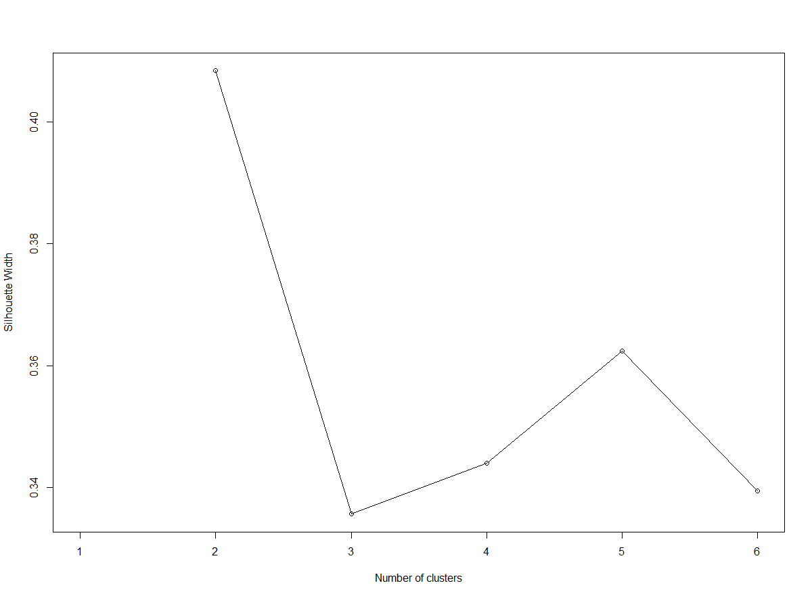Figure 8: Clustering silhouette

Observations are then divided into two clusters with PAM. The summary results of PAM clustering are shown in figure 8. The distribution is balanced: 11171 individuals belong to cluster 1, and 10807 belong to cluster 2. Although overall the level of agreement or importance of these questions is elevated (the mode of qb4_3, qb4_5 is 2, while the mode of qb7, qb8, qb9 is 1), we can see that 2 clusters resemble two different types of green-identity, which we call “moderate green identity”, “extreme green-identity”.

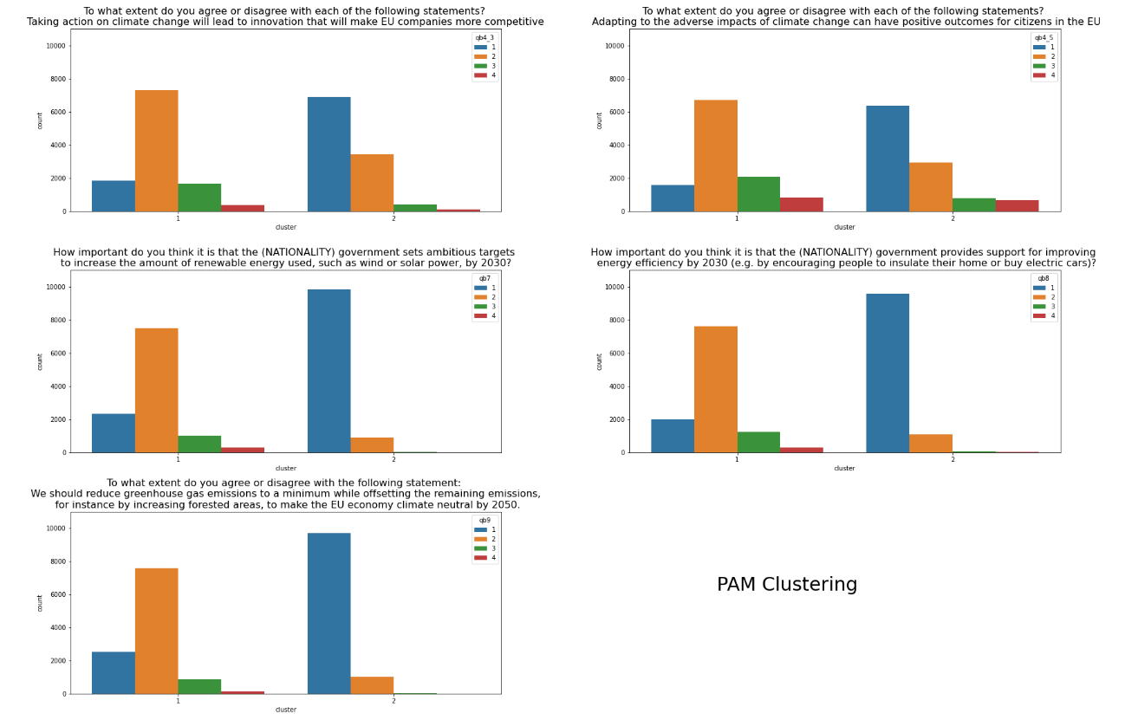

Figure 9: Summary of PAM Clustering

**Cluster 1: Moderate green identity**

* More than 75% answered questions (qb3_4,qb4_5, qb7, qb8, qb9 ) with moderate answers (option 2 or 3);
* There is no difference among genders;
* 70% of citizens belong to centre, centre-left or centre-right;
* 57% stopped studying at the latest at 19, 35% stopped studying after 20, 6% are still studying;
* More than 65% of the citizens of Czech Republic, Estonia, Finland, Latvia, Poland belong to this cluster;
* the average age is 51 years old;
* the average climate change risk perception is 7.2;
* 56% take place a pro-environmental behaviour.

**Cluster 2: Extreme green-identity**

* More than 60% answered qb3_4 and qb4_5 questions with the maximum answer (1), and about 90% answered qb7, qb8, qb9 questions with the maximum answer (1).
* There is no relevant difference among genders;
* 66% of citizens belong to centre, centre-left or centre-right
* 49% stopped studying at the latest at 19, 41% stopped studying after 20, 7% are still studying;
* More than 65% of the citizens of Cyprus, Denmark, Spain, United Kingdom belong to this cluster;
* The average age is 50 years old:
* The average climate change risk perception is8.6;
* 75% take place a pro-environmental behaviour.

To sum up, cluster 1 is composed of citizens that are more moderate in the answers to climate change items than the citizens of the opposite cluster. Additionally, cluster 2 is composed of slightly younger, more educated, more worried, and more active citizens.

**EDA of two subsets**

**Mode**

|  |  |  |
| --- | --- | --- |
| **Variable** | **High-risk perception subset (N= 19072)** | **Low-risk perception subset (N= 2906)** |
| **Qb5** | Yes (12988) | No (1567) |
| **D1** | Centre-letf (5210) | Centre (899) |
| **D7** | Partner (6704) | Partner (1087) |
| **D8** | 16-19 years old (7988) | 16-19 years old (1370) |
| **D10** | Woman (10104) | Man (1559) |
| **D11** | 50.3 | 51.75 |
| **D25** | Small or middle sized town (7422) | Small or middle sized town (1088) |
| **D63** | The middle class of society  (9520) | The middle class of society (1422) |
| **CCA** | 3 (5296) | 3 (810) |
| **CLUSTER** | 2 (10090) | 1 (2189) |

**Mean**

|  |  |  |
| --- | --- | --- |
| **Variable** | **High-risk perception subset (N= 19072)** | **Low-risk perception subset (N= 2906)** |
| **Qb2** | 8.53 | 4.06 |
| **D11** | 50.32 | 51.75 |

**Prediction**

As mentioned in the literature review, the main predictor of pro-environmental behaviour is climate change risk perception. However, other factors can shape the outcomes. The main focus is now on predicting behaviour of citizens in a dummy outcome.

**Evaluating Classification Models**

Before proceeding with the analysis, it is important to first explain the ways the errors will be measured, since one of the main factors according to which we will choose the best model is the minimization of the error. We consider two measurements of error:

* **Accuracy**: the proportion of correct predictions to the total number of predictions (true positives and true negatives) given by the classifier (Battiti & Brunato, 2014). Accuracy is the most used metric that generally describes the goodness of a model. The formula is:

The range is 0-1, where 0 is the worst score and 1 the best score, all the inputs are predicted in the right way.

* **Macro F1-score average**: combine precision and recall, where the precision is the number of true positives divided by the total number of element labeled as positive, and the recall is the number of true positives divided by the total number of elements that belong to the positive class (Shmueli, 2019). Macro F1-score is computed harmonic mean, as shown in the formula:

The range of the score is 0-1, where 0 is the worst score and 1 is the best score. It is used especially when for the class imbalance problem due to it is more sensitive to data distribution, as in this case.

To select the best model for each classifier, we decide to use a first compromise: the balance between accuracy and f1-score macro average. The aim is to classify and predict as well both classes. On one side, this compromise can sometimes lead to losing a few percentage points of accuracy but, on the other side, it improves accuracy within the classes.

In closing, we explain how to understand what variables have a fundamental role in our models. We compute feature importance by the different algorithms in *scikit-learn*. Logistic regression finds a set of coefficients to use in the weighted sum to make a prediction. These coefficients can be used directly as a crude type of feature importance score. Instead, tree-based models can measure feature importance in two ways: Gini importance or Mean Decrease Accuracy. Gini importance counts the times a feature is used to split a node. Mean Decrease Accuracy measures how much accuracy the model losses by excluding each variable. However, *scikit-learn* implemented Gini importance, also in our analysis, it is adopted.

**Prediction**

In this part, the research study aims to identify and discover the most significant variables and offer a good prediction of pro-environmental behaviour. As presented in the Methodology (Chapter 2), different classifiers are trained and implemented to predict behaviour. The analysis starts with Logistic Regression and continues with tree-based methods: Decision Tree, Random Forest, and Gradient Boosting. These algorithms are implemented in scikit-learn. For each classifier best tuning parameters, called hyperparameters, are fitted. The technique adopted for knowing the optimal hyperparameter is called random search (RandomizedSearchCV() in scikit-learn) (Benner, 2020).[2] We adopt, in turn, for random search 3 fold cross-validation, a resampling procedure to evaluate model performance. in practice, each possible random combination will train and evaluate for three different folds.

We remember that the independent variables, at an individual level, of this part are:

* Climate change risk perception (qb2)
* CCA’s class (cca)
* Cluster’s class (cluster)
* Political orientation (d1)
* Marital status (d7)
* Stopped full-time education (d8)
* Gender (d10)
* Age (d11)
* Residence (d25)
* Class identity (d63)
* Country

Each independent categorical variable is converted into a dummy, to fit the supervised algorithms. All explanatory variables are categorical, except for risk perception, which is kept as a metric, and age. After the conversion, the dataset has 65 independent variables.

**Prediction of complete models**

It can be convenient, to sum up, the predictive accuracy and f1-score of the models trained in table 1.

Table 1: Metrics comparison

|  |  |  |
| --- | --- | --- |
| **Models** | **Accuracy** | **Macro-f1 score** |
| **Logistic Regression** | 0.67 | 0.65 |
| **Decision Tree** | 0.64 | 0.62 |
| **Random Forest** | 0.70 | 0.67 |
| **Gradient Boosting** | 0.69 | 0.65 |

**Logistic regression**

The first method explored is Logistic regression. We use *LogisticRegression()* function in *scikit-learn* library for the Python programming language. This algorithm supposes that all the assumptions (~~independence of errors~~, linearity in the logit for continuous independent variables, the absence of multicollinearity, the absence of multicollinearity, lack of outliers) are satisfied. However, there are some violations of different assumptions.

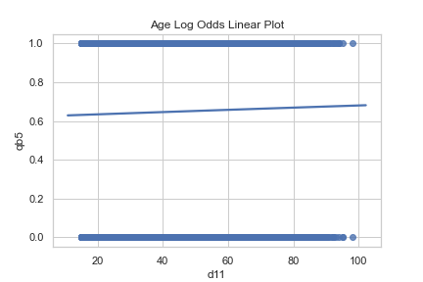

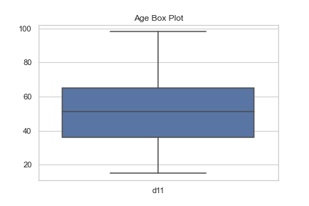First, we check the assumption of linearity in the logit for continuous independent variables, also in this case only for the continuous variables. In this case, only age is continuous, and it does not verify this assumption, as figure 10 displays (there should be an “s” curve line). Second, we can not check the absence of multicollinearity (independent variables), due to it is not possible to compute correlation with one variable alone. Lastly, lack of outliers, always for continuous variables. Figure 11 shows that there are not outliers in the age variable.

Figure 10: Lack of outliers for Age

Figure 11: Linearity in the Logit for Age

We try a simple model with all the variables and the model with the adding of interactions (gender and education, social class and education, risk perception and education). The interactions do not present statistically significant, therefore the simple model is chosen.

The fitted model, with the best tuning parameters, has 0.67 of accuracy and 0.66 of macro f1-score. The figure displays all feature importance. Different countries are the most important variables in this model, as shown in figure 13. The coefficient table shows that Romania, Bulgaria, Czech Republic, and Poland have a negative influence on predicting pro-environmental behaviour. it very interesting due to all these first countries are situated in Eastern Europe. Instead, Malta, Finland, Portugal have a positive influence on predicting pro-environmental behaviour. We remember that these coefficients are in log-odds terms.[3] It is not easy to compare these results with the feature importance of the other algorithms. These last describe Gini importance.

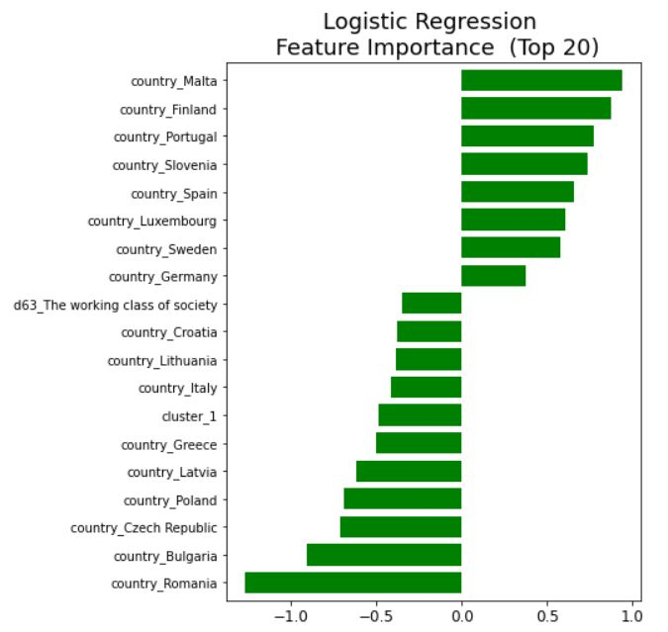

**Decision Tree**

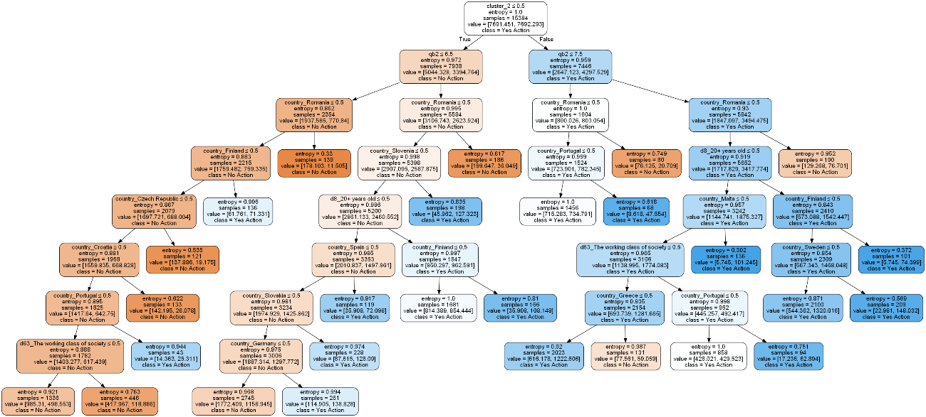

Figure 12: Decision Tree

First of all, the decision tree is implemented with *DecisionTreeClassifier()* function using the *scikit-learn*. Figure 14 displays the tree, the color of the dots represents behaviour: orange for no-action, blue for yes-action. The main advantage is the immediate interpretation analysing the figure. However, this model gets the worst performance if compared with the other ones. Accuracy is 66% and f1 score is 53. Cluster 2, or called extreme green-identity, is the predictor variable used for the primary split, it is the root node. Risk perception is the predictor variable used for the second and the third split. Whether the individual belongs to cluster 2 and he/she has a level of risk perception greater or equal than 7,5 the outcome is yes-action. if the individual does not belong to cluster 2 and he/she has a level of risk perception (less or equal to 6.5), he/she classify in the no-action class.

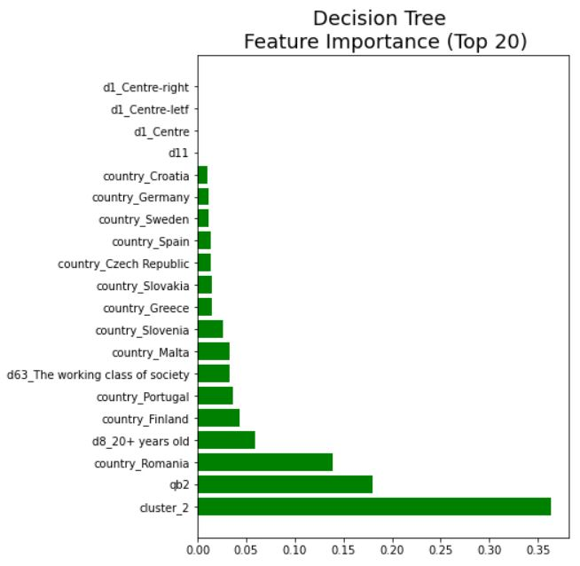

Figure 13: Decision Tree - Feature Importance

Figure 16 shows feature importance. As we have already discussed, the principal variable is cluster 2, the second one is climate change risk perception.

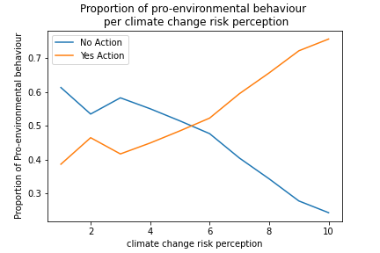The result is quite different from logistic regression. Extreme green-identity (cluster 2) and risk perception for the first time are the main predictors, as the literature review affirmed. 75% of individuals belonging to cluster 2 have done some eco-friendly actions. For this reason, that cluster is particularly influencing on predicting behaviour. Climate change risk perception is even more interesting to analyse, as figure 14 shows. As referred to in the literature review (chapter 1), the more an individual worries, the more he tends to take place environmental action. This hypothesis is confirmed. If we analyse the percentage of those who take place action within the level of perceived risk, we find that for the classes with a low level there are more than 50% of individuals that declare to not take place action. The more the risk increases, the more the percentage of taking place action increase in turn.

Figure 14: Crosstab between Risk Perception and Behaviour

**Random Forest**

Random Forest is implemented with *RandomForestClassifier()* function using the *scikit-learn*. Compared to the previous models, the accuracy and f1-score greatly improve, there are respectively 70% and 66%. It is the best model.

Once the model is proved to fit the data, the variable importance is explored. Plot 15 describes the 20 most important variables. We can identify, another time, climate change risk perception. It is the second influential variable for predicting behaviour. Instead, the first one is age. Also, cluster 2 and 1 are relatively important, even if definitely less than the first two.

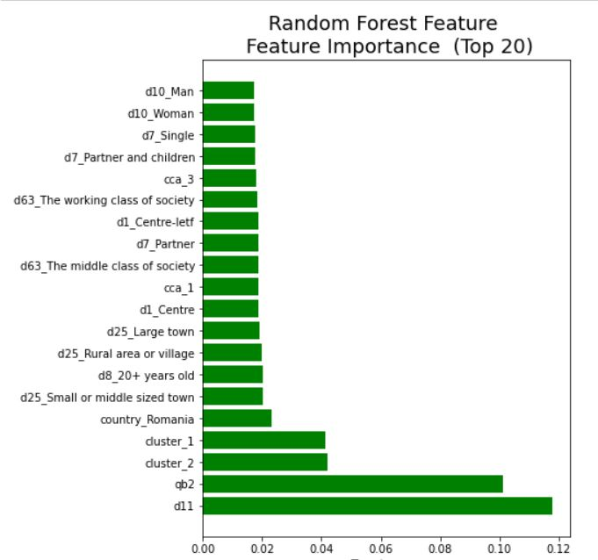

Figure 15: Random Forest - feature importance

As shown in figure 15, analysing the feature importances of the model, we see that age and, again, climate risk perception are the most important variable to classify and predict pro-environmental behaviour. We expect that most young people take place pro-environmental action. However, this relationship is not so clear. If we analyse the percentage of those who take place action within the age group, we find that on average 60% do something. This percentage drops for classes over 80. The relationship between behaviour and risk perception has already been explained in the decision tree model. Other important features are both created clusters, which correspond to the different green-identity. As we have already seen, cluster 1, moderate green-identity, is more likely to do not behave in favor of the environment than cluster 2.

**Gradient Boosting**

Gradient Boosting concludes the first part of the analysis. *XGBClassifier()* function is implemented in using the *scikit-learn*. Gradient Boosting gets slightly worse results than the Random Forest classifier. Accuracy is 69% and f1-score 65%. Again, the variable importance is checked and compared to the previous list. Cluster 1, moderate green identity, is the best predictor. It is followed by Romania and climate change risk perception. However, a new important variable presents in the top 5: high-level if education (d8_20+years old). 72% of those who have declared to stop study after 20 years take place pro-environmental behaviour. The percentage is considerably higher than the other categories that have studied less or the students.

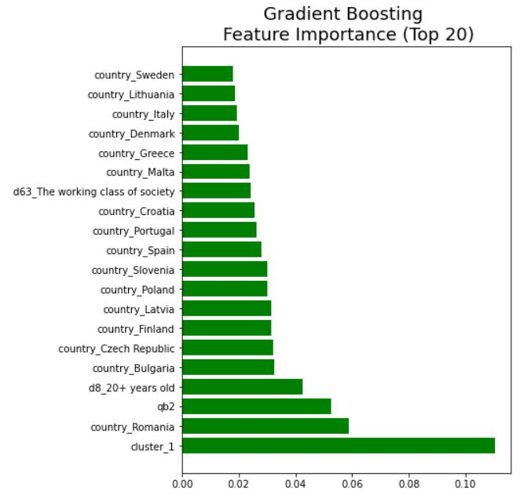

Figure 16: Gradient Boosting- Feature Importance

In conclusion, we see that the main pattern is to identify as important features climate change risk perception and green-identity. Another recurve important variable is country_Romania. As we have seen Romania has a high percentage of citizens who do not behave eco-friendly. However, our aim is not to identify what is the country more ecological but is to understand what are the individual characteristics that shape the behaviour. We can confirm the hypothesis that climate change risk perception is the most important variable. It is appeared in all models, except for logistic regression. Therefore, we can continue with the next analysis.

**Prediction according to the level of risk perception**

In the second part of the analysis, we divide the subset into two: one with the only observations of those who have a high-risk perception (level greater than or equal to 6) and those who have a low-risk perception (level less than or equal to 5). For convenience, we call the first subset “with high-risk Perception observations” and the second one “with low-risk perception observations”. At this point of the analysis, we can confirm the hypothesis suggest from the literature: climate risk perception is one of the main factors for predicting pro-environmental behaviour. Now, we want to understand what are the most important predictors if we change the level of risk perception. Also in this part, we implemented the same algorithms for both subsets: Logistic Regression, Decision Tree, Random Forest, and Gradient Boosting. Hyperparameters using random search are found.

We remember that the independent variables, at an individual level, of this part are:

* CCA’s class (cca)
* Cluster’s class (cluster)
* Political orientation (d1)
* Marital status (d7)
* Stopped full-time education (d8)
* Gender (d10)
* Age (d11)
* Residence (d25)
* Class identity (d63)
* Country

Tables 2 and 3 summarize the performance of all models.

Table 2: Metrics comparison-Subsert with High-Risk Perception observations

|  |  |  |
| --- | --- | --- |
| **Models** | **Accuracy** | **Macro-f1 score** |
| **Logistic Regression** | 0.65 | 0.63 |
| **Decision Tree** | 0.63 | 0.60 |
| **Random Forest** | 0.70 | 0.60 |
| **Gradient Boosting** | 0.67 | 0.64 |

Table 3: Metrics comparison-Subset with low-risk perception observations

|  |  |  |
| --- | --- | --- |
| **Models** | **Accuracy** | **Macro-f1 score** |
| **Logistic Regression** | 0.63 | 0.63 |
| **Decision Tree** | 0.60 | 0.58 |
| **Random Forest** | 0.65 | 0.65 |
| **Gradient Boosting** | 0.65 | 0.64 |

In both cases, Random Forest has yielded the best performance when compared to other classifiers, as shown in tables 2 and 3. Now, we compare for each algorithm both models according to the subset.

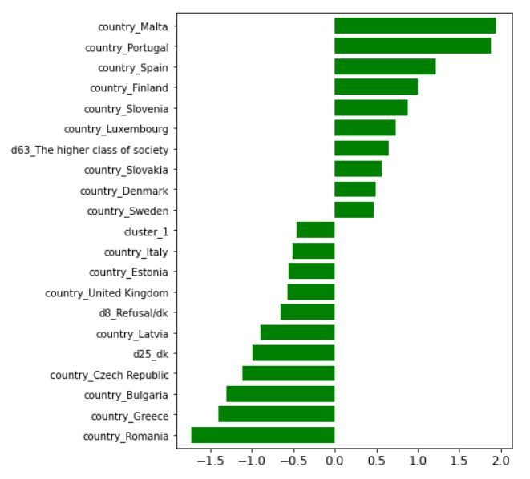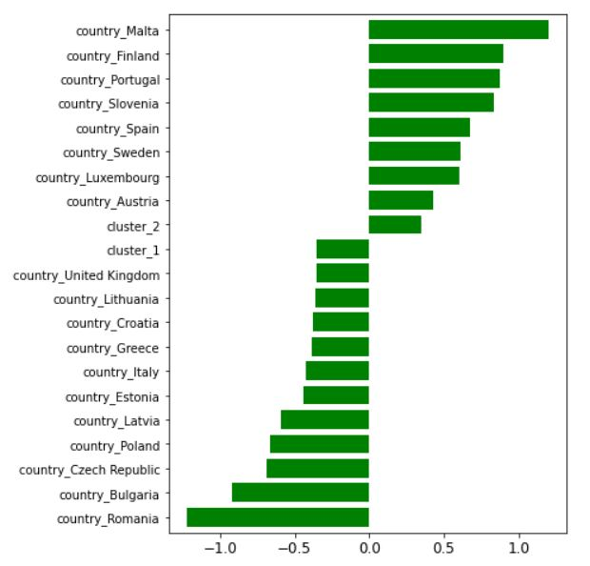**Logistic Regression**

|  |  |
| --- | --- |
| 1. Subset with High-risk Perception observations | 1. Subset with Low-risk Perception observations |

Figure 17: Comparison of variable importance (top 20) - Logistic Regression

Figure 17 displays the first 20 feature importance for predicting pro-environmental behaviour according to the different levels of climate change risk perception. The important variables in the two different subsets are similar. We found always Romania with a negative influence on predicting pro-environmental behaviour. instead, in both case,s Filnlad is the first varibale with a postive influece.

**Decision Tree**

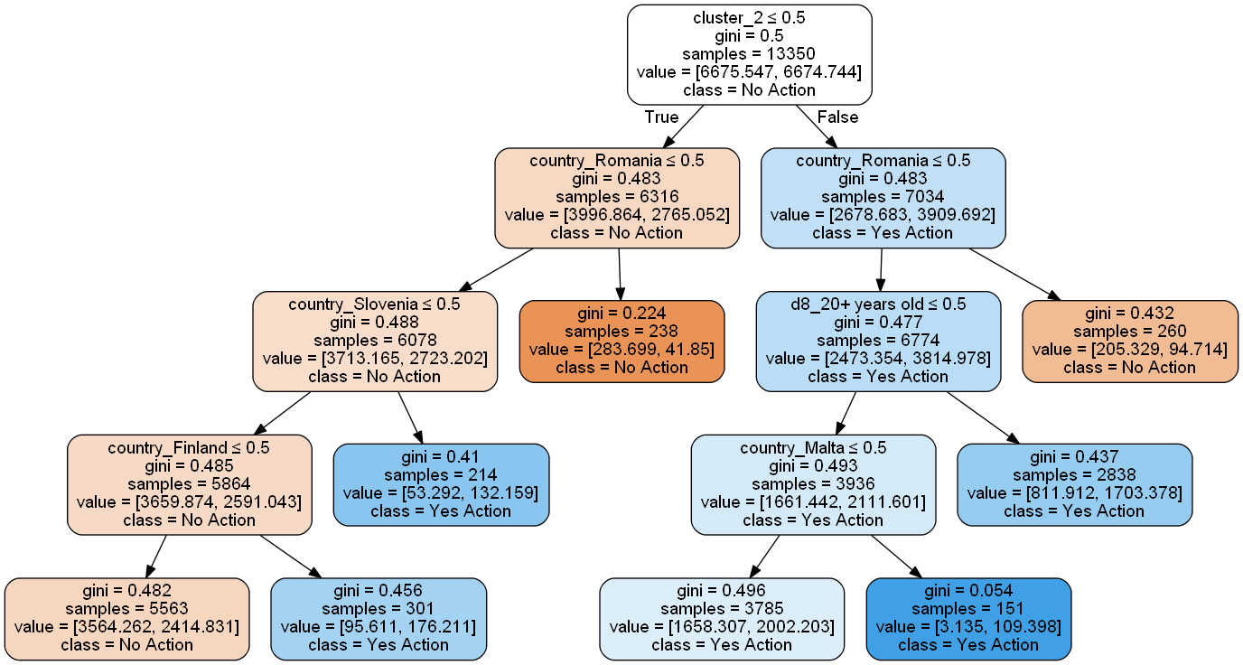

1. **Subset with High-risk Perception observations**

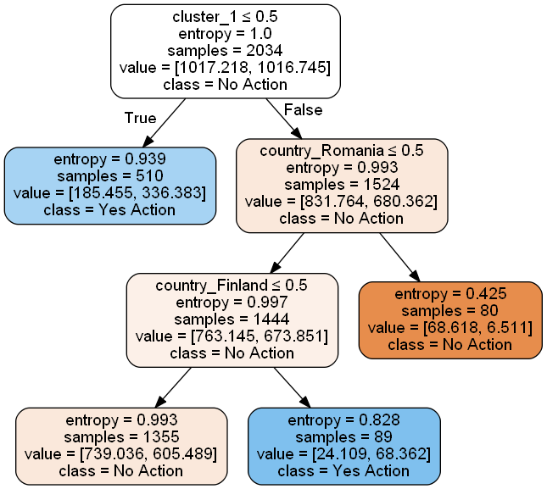

1. **Subset with High-risk Perception observations**

Figure 18 shows the two different decision trees. The first one, with the observations of those who have a high-risk perception, is more branched. For both trees, the root is the green-identity. On one side in the first tree we have cluster 2, the extreme green-identity, on the other side we have cluster 1, the moderate green-identity. We have another confirmation of the hypothesis formulated. A strong green-identity, mixed with a high-risk perception, influences positively pro-environmental behaviour. the opposite happens in the second tree: and moderate green-identity mixed with a low-risk perception influences anti-environmental behaviour.

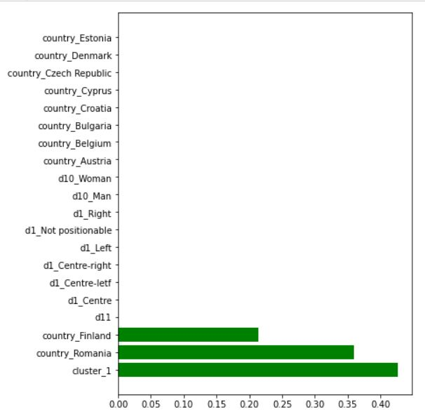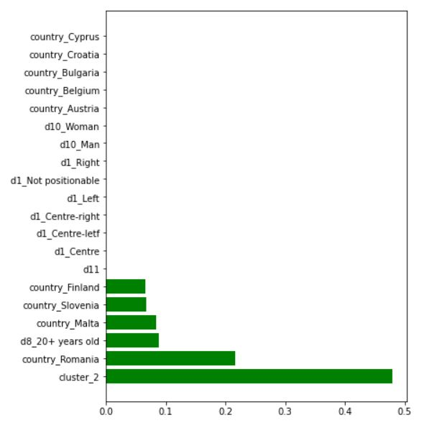

|  |  |
| --- | --- |
| 1. Subset with High-risk Perception observations | 1. Subset with Low-risk Perception observations |

Figure 19: Comparison of feature importance- Decision Tree

The comparison of feature importance in figure 19, is extremely different from the previous model. As we have just explained, the important variables for the respective subsets are cluster 2 for high risk perception observations and cluster 1 for low risk perception. Country Romania is the second important variable for both models. In the first one Romania has the 63% of citizens who do not take place pro-environemntal behaviour. In the second one, the percentage goes to 85%. Third variable important for the first subset is high level of education. In this subset there are 75% of high-educated individuals that do something. In the second subset, in third place we have Finland. In this case Finland has a positive influence in predicting pro-environmental behaviour, due to 70% of citiziens who do not care, at the same time, they behave in favor of nature.

**Random Forest**

Both Random forest’s model classify and predict well the outputs. 0.70 accuracy and 0.65 f1-score for the first subset with high-risk perception, 0.65 and again 0.65 for the second one with low-risk perception.

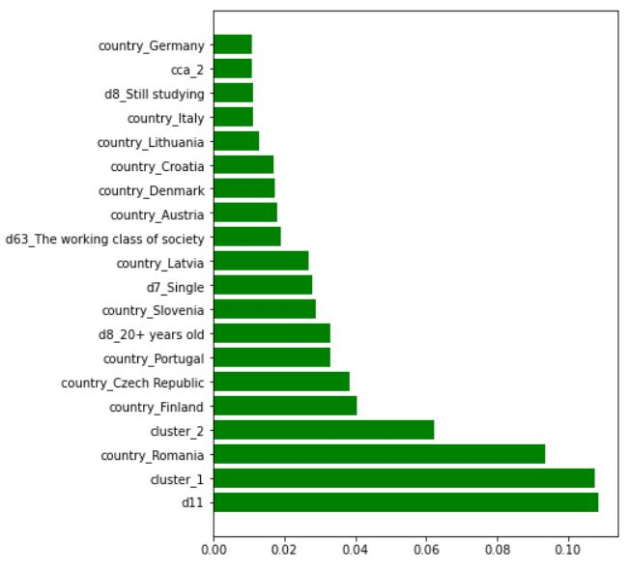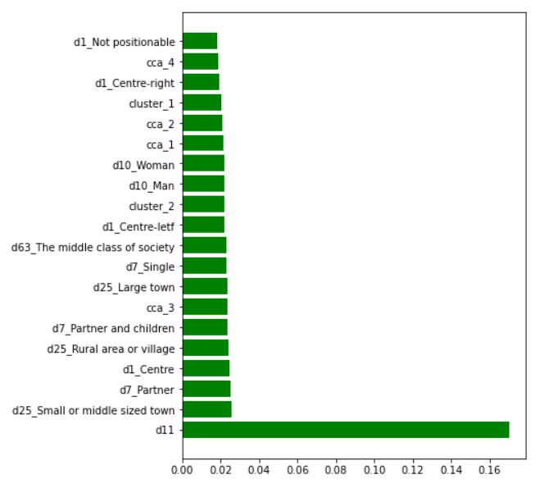

|  |  |
| --- | --- |
| 1. Subset with High-risk Perception observations | 1. Subset with Low-risk Perception observations |

Figure 20: Comparison of variables importance- Random Forest

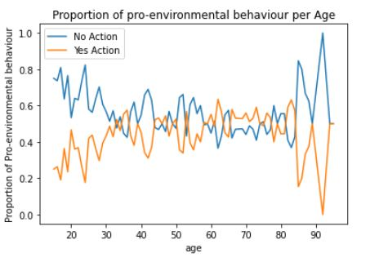

Figure 21: trend of age in the Subset with low-risk perception

Figure 20 shows the importance of variables in both subsets. In both cases, age is the most important variable for predicting behaviour. The variation of age in the subset with high-risk perception is similar to the complete model. On average 60% of each age group does eco-friendly something. Another time, this percentage drops from 80 years old. More interesting is the trend in the second subset, as figure 21 shows. On average 70% of younger have a negative behaviour in favor of the environment. This percentage drops with the increase of years, and the trend is reversed.

Then, in the first subset has many importance variables but in a much lesser way, such as small or middle sized town, 68% of this class in this subset do something, live with partner, centre in political orientation. In the second subset we have more relevant variable, or rather with with a higher gini imporntance score. For example, cluster 1 is the second variable, where 40% do not nothing. Romania is again in the to three. Then, there are cluster 2, where 62% do something even if they are not worried.

**Gradient Boositng**

The first model of Grandient Boosting gets 0.67 of accuracy and 0.64 of f1-score, and the second one gets respectively 0.64 and 0.63. the model with high-risk perception observations gets better results when compared with others. The accuracy is slightly less than a few percentage points than Random forest’ accuracy but in turn f1-score is higher. Since the first subset is particularly unbalanced, it is better considered f1-score as evaluating parameter.

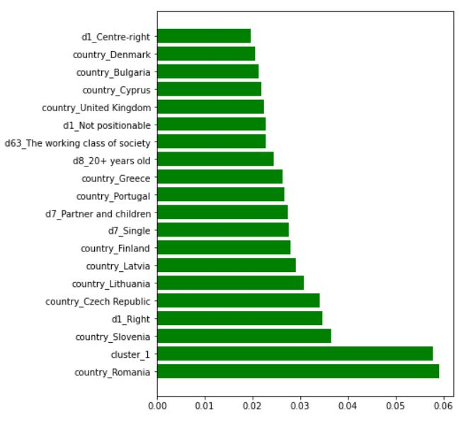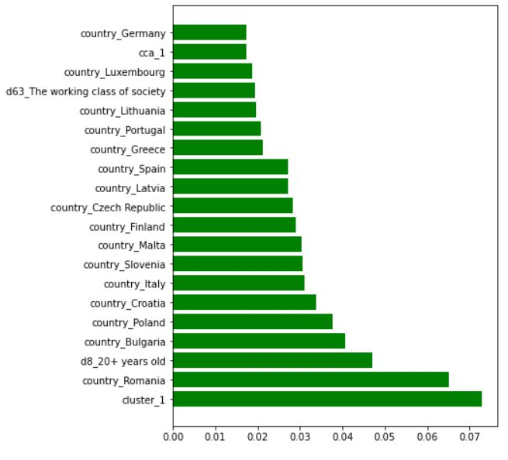

|  |  |
| --- | --- |
| 1. Subset with High-risk Perception observations | 1. Subset with Low-risk Perception observations |

Figure 22: Comparison of varibale importance- Gradient Boosting

Figure 22 shows the comparison of feature importance of our last models, using Gradient Boosting classifier. In both models we find cluster 1, moderate green-identity and Romania. In the first subset there alre also high-education level. In the second one, we find two new variables: Slovenia and right (political orientation). Slovenia has a positive influence in pro-environmentla behavioru, due to 70% of Slovaks in this subset do something. For first time, political orientation compare. If we compute the propotion in thi subset 50% of radicals take place pro-environemntal behaviour, while the other orientations gets a smaller percentage.

REFERENCES

Battiti, R., & Brunato, M. (2014). *The LION way: Machine learning plus intelligent optimization* (1. ed). CreateSpace.

Benner, J. (2020, agosto 6). Cross-Validation and Hyperparameter Tuning: How to Optimise your Machine Learning Model. *Towards Data Science*. https://towardsdatascience.com/cross-validation-and-hyperparameter-tuning-how-to-optimise-your-machine-learning-model-13f005af9d7d

Burck, J. (2018). *CCPI, climate change performance index background and methodology*.

Echavarren, J. M., Balžekienė, A., & Telešienė, A. (2019). Multilevel analysis of climate change risk perception in Europe: Natural hazards, political contexts and mediating individual effects. *Safety Science*, *120*, 813–823. https://doi.org/10.1016/j.ssci.2019.08.024

Krajhanzl, J. (2010). *Environmental and Pro-environmental Behavior*. *School and Health*, 251–274.

Lee, T. M., Markowitz, E. M., Howe, P. D., Ko, C.-Y., & Leiserowitz, A. A. (2015). Predictors of public climate change awareness and risk perception around the world. *Nature Climate Change*, *5*(11), 1014–1020. https://doi.org/10.1038/nclimate2728

Lengyel, A., & Botta‐Dukát, Z. (2019). Silhouette width using generalized mean—A flexible method for assessing clustering efficiency. *Ecology and Evolution*, *9*(23), 13231–13243. https://doi.org/10.1002/ece3.5774

Rossoni, L., Gonçalves, C. P., Silva, M. P. da, & Gonçalves, A. F. (2021). Mapping Organizational Culture Schemas Based on Correlational Class Analysis: A Tutorial. *Revista de Administração Contemporânea*, *25*(1), e200096. https://doi.org/10.1590/1982-7849rac2021200096

Shmueli, B. (2019, luglio 3). Multi-Class Metrics Made Simple, Part II: the F1-score. *Towards Data Science*. https://towardsdatascience.com/multi-class-metrics-made-simple-part-ii-the-f1-score-ebe8b2c2ca1

van der Linden, S. (2015). The social-psychological determinants of climate change risk perceptions: Towards a comprehensive model. *Journal of Environmental Psychology*, *41*, 112–124. https://doi.org/10.1016/j.jenvp.2014.11.012

Xie, B., Brewer, M. B., Hayes, B. K., McDonald, R. I., & Newell, B. R. (2019). Predicting climate change risk perception and willingness to act. *Journal of Environmental Psychology*, *65*, 101331. https://doi.org/10.1016/j.jenvp.2019.101331

Yale Center for Environmental Law & Policy. (2020). *Environmental Performance Index 2020*. https://epi.yale.edu/

**APPENDIX D. Correlation matrix for each CCA’s group.**

Group 1

|  |  |  |  |  |  |
| --- | --- | --- | --- | --- | --- |
|  | **qb4_3** | **qb4_5** | **qb7** | **qb8** | **qb9** |
| **qb4_3** | 1 | 1 | 1 | 1 | 1 |
| **qb4_5** | 1 | 1 | 1 | 1 | 1 |
| **qb7** | 1 | 1 | 1 | 1 | 1 |
| **qb8** | 1 | 1 | 1 | 1 | 1 |
| **qb9** | 1 | 1 | 1 | 1 | 1 |

Group2

|  | **qb4_3** | **qb4_5** | **qb7** | **qb8** | **qb9** |
| --- | --- | --- | --- | --- | --- |
| **qb4_3** | 1 | 0.8209258 | 0.34825902 | 0.1660830 | 0.22869773 |
| **qb4_5** | 0.8209258 | 1 | 0.48758501 | 0.3021902 | 0.13889897 |
| **qb7** | 0.34825902 | 0.48758501 | 1 | 0.3923910 | -0.01232148 |
| **qb8** | 0.1660830 | 0.3021902 | 0.3923910 | 1 | -0.14657797 |
| **qb9** | 0.22869773 | 0.13889897 | -0.01232148 | -0.14657797 | 1 |

Group 3

|  |  |  |  |  |  |
| --- | --- | --- | --- | --- | --- |
|  | **qb4_3** | **qb4_5** | **qb7** | **qb8** | **qb9** |
| **qb4_3** | 1 | 0.07469395 | 0.4400537 | 0.5437509 | 0.5195602 |
| **qb4_5** | 0.07469395 | 1 | -0.1859863 | -0.1112473 | -0.1150310 |
| **qb7** | 0.44005368 | -0.18598635 | 1 | 0.4965637 | 0.4023176 |
| **qb8** | 0.54375089 | -0.11124727 | 0.4965637 | 1 | 0.5111735 |
| **qb9** | 0.51956019 | -0.11503102 | 0.4023176 | 0.5111735 | 1 |

Group 4

|  |  |  |  |  |  |
| --- | --- | --- | --- | --- | --- |
|  | **qb4_3** | **qb4_5** | **qb7** | **qb8** | **qb9** |
| **qb4_3** | 1 | 0.9001736 | -0.2393692 | -0.2281035 | -0.2411191 |
| **qb4_5** | 0.9001736 | 1 | -0.1607610 | -0.1477551 | -0.1715444 |
| **qb7** | -0.2393692 | -0.1607610 | 1 | 0.8869407 | 0.8548438 |
| **qb8** | -0.2281035 | -0.1477551 | 0.8869407 | 1 | 0.8476377 |
| **qb9** | -0.2411191 | -0.1715444 | 0.8548438 | 0.8476377 | 1 |

Group 5

|  |  |  |  |  |  |
| --- | --- | --- | --- | --- | --- |
|  | **qb4_3** | **qb4_5** | **qb7** | **qb8** | **qb9** |
| **qb4_3** | 1 | -0.1514635 | -0.05905457 | -0.03462609 | -0.1298436 |
| **qb4_5** | -0.15146353 | 1 | 0.75879238 | 0.73159084 | 0.8669082 |
| **qb7** | -0.05905457 | 0.7587924 | 1 | 0.54913637 | 0.6663558 |
| **qb8** | -0.03462609 | 0.7315908 | 0.54913637 | 1 | 0.6540521 |
| **qb9** | -0.12984356 | 0.8669082 | 0.66635581 | 0.65405206 | 1 |

APPENDIX E. Grid of parameters and Hyperparameters for complete model

***Logistic Regression***

{'solver': ['newton-cg', 'lbfgs', 'liblinear'],

'penalty': ['l2'],

'C': [100, 10, 1.0, 0.1, 0.01]}

Complete model

LogisticRegression(C=0.1, class_weight={0: 1.43631197, 1: 0.76700502}, 'solver': 'lbfgs', 'penalty': 'l2')

Model with High Risk Perception Observations

LogisticRegression(C=0.1, class_weight={0: 1.56837406, 1: 0.73400044}, 'solver': 'lbfgs', 'penalty': 'l2')

Model with Low Risk Perception Observations

LogisticRegression(C=10, class_weight={0: 0.92119565, 1: 1.09354839},solver='newton-cg', 'penalty': 'l2')

***Decision Tree***

{'criterion': ['gini', 'entropy'],

'max_depth': range(1, 10),

'min_samples_split': range(0, 10),

'min_samples_leaf': range(1, 5)}

DecisionTreeClassifier(ccp_alpha=0.000993163342228487,class_weight={0: 1.43631197, 1: 0.76700502},criterion='entropy', max_depth=8, min_samples_split=4,random_state=123)

DecisionTreeClassifier(class_weight={0: 1.56739773, 1: 0.73421448}, max_depth=7,min_samples_leaf=3, min_samples_split=6, ccp_alpha=0.0022213271836104)

DecisionTreeClassifier(ccp_alpha=0.009396010830688362,class_weight={0: 0.92727273, 1: 1.08510638},criterion='entropy', max_depth=5, min_samples_leaf=2,min_samples_split=8, random_state=50)

***Random Forest***

{'n_estimators': [50, 120, 190, 260, 330, 400],

'max_depth': [5, 8, 15, 25, 30, None],

'min_samples_split': [2, 5, 10, 15, 100],

'min_samples_leaf': [1, 2, 5, 10],

'max_features': ['auto', 'sqrt', 'log2'],

'bootstrap': [True, False]}

RandomForestClassifier(bootstrap=False,class_weight={0: 1.43631197, 1: 0.76700502}, max_depth=30, max_features='log2', max_leaf_nodes=49,min_samples_leaf=10, min_samples_split=10, n_estimators=136)

RandomForestClassifier(class_weight={0: 1.56739773, 1: 0.73421448},max_depth=25, min_samples_split=5, n_estimators=150)

RandomForestClassifier(class_weight={0: 0.9272727, 1: 1.08510638}, max_depth=25,min_samples_leaf=5, n_estimators=500)

***Gradient Boosting***

{'max_depth': [3, 4, 5],

'learning_rate': [0.1, 0.25, 0.5, 0.75, 1],

'n_estimators': [50, 100, 150],

'gamma': [0.5, 1, 1.5, 2],

'min_child_weight': [1, 5, 10]}

XGBClassifier(n_estimators= 100, class_weight={0: 1.43631197, 1: 0.76700502}, gamma=0.5, max_depth=4, min_child_weight=10, scale_pos_weight=0.75, learning_rate=0.1)

XGBClassifier(n_estimators= 50, class_weight={ 1.56726931, 0.73424266}, gamma=1, max_depth=5, min_child_weight=5, scale_pos_weight=0.5, learning_rate=0.25)

XGBClassifier(n_estimators= 50, class_weight={ 0: 0.92727273 , 1:1.08510638}, gamma=0.5, max_depth=5, min_child_weight=1, scale_pos_weight=0.75, learning_rate=0.1)

***Appendix F. Comparison of Feature importance***

|  |  |  |  |  |  |
| --- | --- | --- | --- | --- | --- |
| **Variables** | **Logistic Regressio (log-odds)** | **Logistic Regression (log-ratio)** | **Decision Tree** | **Random Forest** | **Gradient Boosting** |
| cca_1 | -0,209858 | 1.094700 | 0,000000 | 0,019062 | 0,012829 |
| cca_2 | 0,738323 | 0,874998 | 0,000000 | 0,016596 | 0,007485 |
| cca_3 | 0,090480 | 0,985721 | 0,000000 | 0,018206 | 0,008831 |
| cca_4 | -0,693412 | 0,817540 | 0,000000 | 0,015214 | 0,006943 |
| cca_5 | -0,317492 | 0,882812 | 0,000000 | 0,012256 | 0,004835 |
| cluster_1 | -0,379284 | 0,613437 | 0,000000 | 0,041727 | 0,110380 |
| cluster_2 | -0,207715 | 1.110870 | 0,363349 | 0,039542 | 0,000000 |
| country_Austria | 0,376858 | 1.385805 | 0,000000 | 0,007761 | 0,015435 |
| country_Belgium | -0,084771 | 0,946520 | 0,000000 | 0,008014 | 0,006064 |
| country_Bulgaria | -0,110913 | 0,402731 | 0,000000 | 0,011924 | 0,032368 |
| country_Croatia | 0,233174 | 0,684351 | 0,010332 | 0,007805 | 0,025696 |
| country_Cyprus | 0,012143 | 0,720662 | 0,000000 | 0,004430 | 0,008818 |
| country_Czech Republic | -0,063769 | 0,490561 | 0,013328 | 0,009673 | 0,032311 |
| country_Denmark | -0,385178 | 1.262602 | 0,000000 | 0,006220 | 0,020020 |
| country_Estonia | -0,417317 | 0,770702 | 0,000000 | 0,005026 | 0,012538 |
| country_Finland | 0,033848 | 2.399747 | 0,043743 | 0,013164 | 0,031635 |
| country_France | -0,133533 | 1.012217 | 0,000000 | 0,007010 | 0,000000 |
| country_Germany | -0,260454 | 1.457698 | 0,011016 | 0,008913 | 0,012628 |
| country_Greece | -0,909487 | 0,604072 | 0,014445 | 0,010817 | 0,023253 |
| country_Hungary | -0,353149 | 1.066808 | 0,000000 | 0,006774 | 0,006763 |
| country_Ireland | 0,105144 | 1.017430 | 0,000000 | 0,007397 | 0,008521 |
| country_Italy | -0,327586 | 0,658812 | 0,000000 | 0,008272 | 0,019470 |
| country_Latvia | -0,078007 | 0,537925 | 0,000000 | 0,008844 | 0,031471 |
| country_Lithuania | -0,712205 | 0,680330 | 0,000000 | 0,007319 | 0,018772 |
| country_Luxembourg | 0,326281 | 1.837222 | 0,000000 | 0,004957 | 0,011951 |
| country_Malta | 0,001655 | 2.552832 | 0,032584 | 0,011038 | 0,023969 |
| country_Netherlands | -0,087574 | 0,956347 | 0,000000 | 0,005708 | 0,000000 |
| country_Poland | -0,129992 | 0,499868 | 0,000000 | 0,009214 | 0,030119 |
| country_Portugal | -0,119521 | 2.172106 | 0,035880 | 0,011508 | 0,026177 |
| country_Romania | 0,172588 | 0,281159 | 0,138376 | 0,022591 | 0,058919 |
| country_Slovakia | 0,064671 | 1.368817 | 0,014299 | 0,008303 | 0,010795 |
| country_Slovenia | 0,006813 | 2.092424 | 0,025906 | 0,016035 | 0,029955 |
| country_Spain | -0,305527 | 1.929948 | 0,013195 | 0,011806 | 0,028085 |
| country_Sweden | -0,054963 | 1.776633 | 0,011141 | 0,007111 | 0,017834 |
| country_United Kingdom | -0,504062 | 0,727973 | 0,000000 | 0,007358 | 0,014201 |
| d10_Man | 0,017280 | 0,736735 | 0,000000 | 0,017423 | 0,012519 |
| d10_Woman | -0,098238 | 0,924958 | 0,000000 | 0,017610 | 0,000000 |
| d11 | -0,124643 | 1.001656 | 0,000000 | 0,117401 | 0,008397 |
| d1_Centre | -0,052656 | 0,895017 | 0,000000 | 0,019336 | 0,006432 |
| d1_Centre-letf | -0,488677 | 1.034428 | 0,000000 | 0,018209 | 0,012128 |
| d1_Centre-right | 0,189972 | 0,887345 | 0,000000 | 0,014253 | 0,006708 |
| d1_Left | -0,201456 | 1.006836 | 0,000000 | 0,010170 | 0,009450 |
| d1_Not positionable | -0,080494 | 0,938221 | 0,000000 | 0,014547 | 0,005224 |
| d1_Right | 0,657493 | 0,878102 | 0,000000 | 0,009807 | 0,006163 |
| d25_Large town | -0,090355 | 0,911024 | 0,000000 | 0,018818 | 0,008761 |
| d25_Rural area or village | 0,009865 | 0,913607 | 0,000000 | 0,019882 | 0,007375 |
| d25_Small or middle sized town | 0,608254 | 0,810700 | 0,000000 | 0,020090 | 0,008478 |
| d25_dk | -0,014382 | 1.009914 | 0,000000 | 0,000000 | 0,000000 |
| d63_Refusal/Other | -0,256266 | 0,887628 | 0,000000 | 0,004359 | 0,000000 |
| d63_The higher class of society | -0,056869 | 1.127653 | 0,000000 | 0,001199 | 0,000000 |
| d63_The lower middle class of society | 0,574720 | 0,880021 | 0,000000 | 0,014478 | 0,004229 |
| d63_The middle class of society | -0,093186 | 0,906433 | 0,000000 | 0,019116 | 0,007185 |
| d63_The upper middle class of society | 0,775697 | 1.214980 | 0,000000 | 0,009316 | 0,010250 |
| d63_The working class of society | 0,875363 | 0,702473 | 0,033201 | 0,018282 | 0,024077 |
| d7_Partner | -0,127810 | 0,922660 | 0,000000 | 0,019254 | 0,010784 |
| d7_Partner and children | 0,194728 | 1.074891 | 0,000000 | 0,017980 | 0,006382 |
| d7_Refusal/Other | 0,120138 | 0,918723 | 0,000000 | 0,000656 | 0,005651 |
| d7_Single | -0,044634 | 0,816348 | 0,000000 | 0,018027 | 0,014263 |
| d7_Single with children | -0,119203 | 0,916151 | 0,000000 | 0,006349 | 0,000000 |
| d8_16-19 years old | 0,072220 | 0,944718 | 0,000000 | 0,016040 | 0,004562 |
| d8_20+ years old | -1.268834 | 1.209216 | 0,059630 | 0,020213 | 0,042662 |
| d8_Refusal/dk | -0,620036 | 0,773936 | 0,000000 | 0,002582 | 0,009517 |
| d8_Still studying | -0,202914 | 0,948706 | 0,000000 | 0,005767 | 0,000000 |
| d8_Up to 15 years old | 0,937203 | 0,812438 | 0,000000 | 0,009676 | 0,007241 |
| qb2 | 0,313947 | 1.188376 | 0,179575 | 0,101564 | 0,052489 |

***HIGH RISK PERCEPTION***

|  |  |  |  |  |  |
| --- | --- | --- | --- | --- | --- |
| **Variables** | **Logistic Regressio (log-odds)** | **Logistic Regression (log-ratio)** | **Decision Tree** | **Random Forest** | **Gradient Boosting** |
| cca_1 | 0,871945 | 1.160816 | 0,000000 | 0,021365 | 0,017443 |
| cca_2 | 0,674228 | 0,877755849 | 0,000000 | 0,020861 | 0,008659 |
| cca_3 | 0,052552 | 1.101637 | 0,000000 | 0,023717 | 0,008094 |
| cca_4 | -0,011284 | 0,894653232 | 0,000000 | 0,018692 | 0,008399 |
| cca_5 | -0,111319 | 0,992147437 | 0,000000 | 0,016508 | 0,006375 |
| cluster_1 | 0,302820 | 0,70380212 | 0,000000 | 0,020606 | 0,072865 |
| cluster_2 | -0,385593 | 1.415650 | 0,479606 | 0,022067 | 0,000000 |
| country_Austria | -0,687568 | 1.527121 | 0,000000 | 0,007862 | 0,012066 |
| country_Belgium | -0,191327 | 0,895993039 | 0,000000 | 0,010056 | 0,010948 |
| country_Bulgaria | 0,131567 | 0,398998689 | 0,000000 | 0,010004 | 0,040672 |
| country_Croatia | -0,444270 | 0,686748555 | 0,000000 | 0,009013 | 0,033704 |
| country_Cyprus | -0,081006 | 0,722403396 | 0,000000 | 0,005639 | 0,006562 |
| country_Czech Republic | -0,133467 | 0,502797324 | 0,000000 | 0,007923 | 0,028346 |
| country_Denmark | 0,608179 | 1.138685 | 0,000000 | 0,006895 | 0,013247 |
| country_Estonia | -0,375787 | 0,641291948 | 0,000000 | 0,005906 | 0,007428 |
| country_Finland | -0,141899 | 2.449681 | 0,065555 | 0,009097 | 0,029050 |
| country_France | -0,075103 | 1.094098 | 0,000000 | 0,009301 | 0,012242 |
| country_Germany | -0,424495 | 1.353670 | 0,000000 | 0,009952 | 0,017283 |
| country_Greece | 0,129874 | 0,680047108 | 0,000000 | 0,010254 | 0,021152 |
| country_Hungary | -0,008101 | 1.096890 | 0,000000 | 0,009453 | 0,009158 |
| country_Ireland | 0,187259 | 0,922188179 | 0,000000 | 0,009359 | 0,008543 |
| country_Italy | -0,325172 | 0,654100034 | 0,000000 | 0,008348 | 0,031129 |
| country_Latvia | -0,918797 | 0,552486363 | 0,000000 | 0,007263 | 0,027204 |
| country_Lithuania | 0,895958 | 0,697040363 | 0,000000 | 0,008151 | 0,019618 |
| country_Luxembourg | -0,109823 | 1.828238 | 0,000000 | 0,005526 | 0,018782 |
| country_Malta | -0,010549 | 3.321828 | 0,083321 | 0,007927 | 0,030413 |
| country_Netherlands | 0,049980 | 0,891017971 | 0,000000 | 0,007820 | 0,007267 |
| country_Poland | 0,115581 | 0,514181038 | 0,000000 | 0,009137 | 0,037728 |
| country_Portugal | 0,199826 | 2.391557 | 0,000000 | 0,009300 | 0,020809 |
| country_Romania | 0,002008 | 0,294012064 | 0,215886 | 0,016822 | 0,065110 |
| country_Slovakia | 0,092479 | 1.405489 | 0,000000 | 0,008383 | 0,011394 |
| country_Slovenia | -0,049147 | 2.298981 | 0,067584 | 0,010354 | 0,030685 |
| country_Spain | -0,119250 | 1.962518 | 0,000000 | 0,009518 | 0,027077 |
| country_Sweden | 0,423384 | 1.837082 | 0,000000 | 0,007497 | 0,015841 |
| country_United Kingdom | 0,089930 | 0,699261643 | 0,000000 | 0,008697 | 0,015792 |
| d10_Man | -0,069786 | 0,887585663 | 0,000000 | 0,021851 | 0,011721 |
| d10_Woman | 0,218749 | 1.122525 | 0,000000 | 0,021773 | 0,000000 |
| d11 | -0,007884 | 1.002010 | 0,000000 | 0,169988 | 0,009328 |
| d1_Centre | -0,130387 | 0,989506082 | 0,000000 | 0,024838 | 0,007971 |
| d1_Centre-letf | 0,832466 | 1.140614 | 0,000000 | 0,022215 | 0,013901 |
| d1_Centre-right | -1.224134 | 0,867709065 | 0,000000 | 0,019467 | 0,010425 |
| d1_Left | 1.200515 | 1.221190 | 0,000000 | 0,013801 | 0,008603 |
| d1_Not positionable | -0,081722 | 0,95204112 | 0,000000 | 0,018297 | 0,009256 |
| d1_Right | 0,340386 | 0,875056135 | 0,000000 | 0,012818 | 0,007727 |
| d25_Large town | -0,016638 | 1.053957 | 0,000000 | 0,023648 | 0,007752 |
| d25_Rural area or village | 0,096797 | 0,991932114 | 0,000000 | 0,024329 | 0,008468 |
| d25_Small or middle sized town | -0,056988 | 0,927648257 | 0,000000 | 0,025911 | 0,006678 |
| d25_dk | -0,351258 | 1.027350 | 0,000000 | 0,000109 | 0,000000 |
| d63_Refusal/Other | 0,026982 | 0,919288034 | 0,000000 | 0,005680 | 0,007998 |
| d63_The higher class of society | -0,665180 | 1.205939 | 0,000000 | 0,002002 | 0,000000 |
| d63_The lower middle class of society | -0,279845 | 0,944605474 | 0,000000 | 0,017826 | 0,009212 |
| d63_The middle class of society | 0,125863 | 0,950759703 | 0,000000 | 0,022926 | 0,007731 |
| d63_The upper middle class of society | -0,593327 | 1.323864 | 0,000000 | 0,009712 | 0,014237 |
| d63_The working class of society | -0,360912 | 0,755900959 | 0,000000 | 0,018019 | 0,019305 |
| d7_Partner | 0,347589 | 0,983499725 | 0,000000 | 0,024984 | 0,005069 |
| d7_Partner and children | -0,357730 | 1.134127 | 0,000000 | 0,023721 | 0,008515 |
| d7_Refusal/Other | 0,280555 | 0,93326374 | 0,000000 | 0,001092 | 0,000000 |
| d7_Single | -0,084156 | 0,921527674 | 0,000000 | 0,022939 | 0,010200 |
| d7_Single with children | 0,037895 | 1.038623 | 0,000000 | 0,009661 | 0,009651 |
| d8_16-19 years old | -0,050494 | 0,932592956 | 0,000000 | 0,016212 | 0,008454 |
| d8_20+ years old | 0,603353 | 1.244519 | 0,088049 | 0,015743 | 0,047157 |
| d8_Refusal/dk | -0,069067 | 1.051250 | 0,000000 | 0,003583 | 0,006065 |
| d8_Still studying | 0,149123 | 0,988778962 | 0,000000 | 0,006516 | 0,006548 |
| d8_Up to 15 years old | -0,115391 | 0,825862643 | 0,000000 | 0,011068 | 0,006944 |

***Low risk perception***

|  |  |  |  |  |  |
| --- | --- | --- | --- | --- | --- |
| **Variables** | **Logistic Regressio (log-odds)** | **Logistic Regression (log-ratio)** | **Decision Tree** | **Random Forest** | **Gradient Boosting** |
| cca_1 | 0,017753 | 1.006476 | 0,000000 | 0,006200 | 0,007691 |
| cca_2 | 0,167401 | 1.129289 | 0,000000 | 0,011028 | 0,015933 |
| cca_3 | 0,398833 | 1.017911 | 0,000000 | 0,006102 | 0,006277 |
| cca_4 | -0,405617 | 1.027453 | 0,000000 | 0,005584 | 0,012052 |
| cca_5 | -0,561250 | 0,841240 | 0,000000 | 0,007494 | 0,014207 |
| cluster_1 | -0,256186 | 0,671103 | 0,426276 | 0,107565 | 0,057859 |
| cluster_2 | 0,735099 | 1.490084 | 0,000000 | 0,062236 | 0,000000 |
| country_Austria | -0,398833 | 0,979002 | 0,000000 | 0,017888 | 0,000000 |
| country_Belgium | 0,080522 | 1.023511 | 0,000000 | 0,007876 | 0,000000 |
| country_Bulgaria | 0,052831 | 0,272859 | 0,000000 | 0,009870 | 0,021334 |
| country_Croatia | 1.883838 | 0,731877 | 0,000000 | 0,017007 | 0,017186 |
| country_Cyprus | 0,387567 | 1.162884 | 0,000000 | 0,004371 | 0,021824 |
| country_Czech Republic | -0,164886 | 0,329505 | 0,000000 | 0,038408 | 0,034103 |
| country_Denmark | -0,452506 | 1.650174 | 0,000000 | 0,017159 | 0,020530 |
| country_Estonia | -0,552504 | 0,575507 | 0,000000 | 0,004880 | 0,013605 |
| country_Finland | 0,096397 | 2.732727 | 0,213650 | 0,040581 | 0,027986 |
| country_France | -0,210631 | 0,636032 | 0,000000 | 0,007886 | 0,012712 |
| country_Germany | -0,389685 | 1.455285 | 0,000000 | 0,010843 | 0,019017 |
| country_Greece | -0,108819 | 0,248032 | 0,000000 | 0,004275 | 0,026235 |
| country_Hungary | 0,469477 | 0,810073 | 0,000000 | 0,008655 | 0,000000 |
| country_Ireland | 0,408612 | 0.810073 | 0,000000 | 0,003904 | 0,010234 |
| country_Italy | 1.005300 | 0,603315 | 0,000000 | 0,011286 | 0,016200 |
| country_Latvia | -0,021222 | 0,409695 | 0,000000 | 0,027013 | 0,029190 |
| country_Lithuania | -1.727335 | 0,773998 | 0,000000 | 0,012872 | 0,030785 |
| country_Luxembourg | -1.298802 | 2.085688 | 0,000000 | 0,007529 | 0,014170 |
| country_Malta | 0,010044 | 7.249611 | 0,000000 | 0,000000 | 0,000000 |
| country_Netherlands | 0,883120 | 0,791134 | 0,000000 | 0,008268 | 0,012930 |
| country_Poland | 1.980948 | 0,677270 | 0,000000 | 0,003947 | 0,000000 |
| country_Portugal | 0,120858 | 6.578703 | 0,000000 | 0,032986 | 0,026622 |
| country_Romania | -0,004143 | 0,177757 | 0,360074 | 0,093431 | 0,059134 |
| country_Slovakia | -1.110164 | 1.771408 | 0,000000 | 0,009930 | 0,014453 |
| country_Slovenia | 0,023239 | 2.418433 | 0,000000 | 0,028926 | 0,036506 |
| country_Spain | 0,104157 | 3.374126 | 0,000000 | 0,005975 | 0,010503 |
| country_Sweden | -1.394199 | 1.599158 | 0,000000 | 0,007808 | 0,010157 |
| country_United Kingdom | 0,500881 | 0,570496 | 0,000000 | 0,006896 | 0,022480 |
| d10_Man | -0,015008 | 0,908103 | 0,000000 | 0,006237 | 0,015099 |
| d10_Woman | -0,033445 | 1.101196 | 0,000000 | 0,005818 | 0,000000 |
| d11 | 0,121588 | 1.010094 | 0,000000 | 0,108500 | 0,018443 |
| d1_Centre | -1.058548 | 1.128465 | 0,000000 | 0,007556 | 0,012482 |
| d1_Centre-letf | 0,027082 | 0,995865 | 0,000000 | 0,004108 | 0,011041 |
| d1_Centre-right | -0,049085 | 0,896893 | 0,000000 | 0,006651 | 0,019590 |
| d1_Left | -0,002212 | 1.054252 | 0,000000 | 0,007751 | 0,000000 |
| d1_Not positionable | 0,670363 | 1.109775 | 0,000000 | 0,004947 | 0,022822 |
| d1_Right | 0,219321 | 0,847991 | 0,000000 | 0,005855 | 0,034645 |
| d25_Large town | 0,375201 | 1.620177 | 0,000000 | 0,009755 | 0,010110 |
| d25_Rural area or village | -0,505315 | 1.504727 | 0,000000 | 0,004085 | 0,011965 |
| d25_Small or middle sized town | 0,162582 | 1.182228 | 0,000000 | 0,010400 | 0,011851 |
| d25_dk | -0,096398 | 0,346959 | 0,000000 | 0,000000 | 0,000000 |
| d63_Refusal/Other | 0,077097 | 0,952101 | 0,000000 | 0,004815 | 0,016932 |
| d63_The higher class of society | -0,312142 | 1.954947 | 0,000000 | 0,004068 | 0,005841 |
| d63_The lower middle class of society | 0,006455 | 0,985104 | 0,000000 | 0,008583 | 0,009595 |
| d63_The middle class of society | 0,250209 | 0,967108 | 0,000000 | 0,006989 | 0,012307 |
| d63_The upper middle class of society | 0,482535 | 0,866171 | 0,000000 | 0,005473 | 0,014925 |
| d63_The working class of society | 0,122655 | 0,651060 | 0,000000 | 0,019158 | 0,022833 |
| d7_Partner | -0,172879 | 0,997790 | 0,000000 | 0,007793 | 0,011527 |
| d7_Partner and children | -0,429153 | 1.080147 | 0,000000 | 0,007664 | 0,027435 |
| d7_Refusal/Other | 0,571775 | 1.284294 | 0,000000 | 0,000113 | 0,000000 |
| d7_Single | -0,892342 | 0,666566 | 0,000000 | 0,027964 | 0,027686 |
| d7_Single with children | -0,143673 | 1.083853 | 0,000000 | 0,004817 | 0,011125 |
| d8_16-19 years old | -0,625210 | 1.176544 | 0,000000 | 0,006233 | 0,009601 |
| d8_20+ years old | 1.216136 | 1.245231 | 0,000000 | 0,032899 | 0,024464 |
| d8_Refusal/dk | 0,150903 | 0,535149 | 0,000000 | 0,008131 | 0,009971 |
| d8_Still studying | -0,234288 | 1.473391 | 0,000000 | 0,011274 | 0,005794 |
| d8_Up to 15 years old | -0,144260 | 0,865663 | 0,000000 | 0,005683 | 0,000000 |

***Summary composition dataset 1***

|  |  |  |  |  |  |
| --- | --- | --- | --- | --- | --- |
| **Variables** | **Obs.** | **Mean** | **Std. Dev.** | **Min** | **Max** |
| **Qb5** | 19072 |  |  |  |  |
| *Yes* | *12988* |  |  |  |  |
| *No* | *6084* |  |  |  |  |
| **Qb2** | 19072 | 8.53 | 1.35 | 6 | 10 |
| **Qb4_3** | 19072 | 1.69 | 0.68 | 1 | 4 |
| **Qb4_5** | 19072 | 1.87 | 0.87 | 1 | 4 |
| **Qb7** | 19072 | 1.46 | 0.60 | 1 | 4 |
| **Qb8** | 19072 | 1.50 | 0.63 | 1 | 4 |
| **Qb9** | 19072 | 1.45 | 0.58 | 1 | 4 |
| **D1** | 19072 |  |  |  |  |
| *Left* | *1617* |  |  |  |  |
| *Centre-left* | *5210* |  |  |  |  |
| *Centre* | *7968* |  |  |  |  |
| *Centre-right* | *2972* |  |  |  |  |
| *Right* | *1383* |  |  |  |  |
| *Not positionable* | *2867* |  |  |  |  |
| **D7** | 19072 |  |  |  |  |
| *Partner* | *6704* |  |  |  |  |
| *Partner and children* | *6204* |  |  |  |  |
| *Single* | *5116* |  |  |  |  |
| *Single with children* | *967* |  |  |  |  |
| *Refusal/Other* | *81* |  |  |  |  |
| **D8** | 19072 |  |  |  |  |
| *Still studying* | *1242* |  |  |  |  |
| *Up to 15 years old* | *2268* |  |  |  |  |
| *16-19 years old* | *7988* |  |  |  |  |
| *20+ years old* | *7323* |  |  |  |  |
| *Refusal/dk* | *251* |  |  |  |  |
| **D10** | 19072 |  |  |  |  |
| *Man* | *8968* |  |  |  |  |
| *Woman* | *10104* |  |  |  |  |
| **D11** | 19072 | 50.32 | 17.80 | 15 | 98 |
| **D25** | 19072 |  |  |  |  |
| *Rural area or village* | *6075* |  |  |  |  |
| *Small or middle sized town* | *7422* |  |  |  |  |
| *Large town* | *5572* |  |  |  |  |
| *Dk* | *3* |  |  |  |  |
| **D63** | 19072 |  |  |  |  |
| *The higher class of society* | *134* |  |  |  |  |
| *The lower middle class of society* | *3007* |  |  |  |  |
| *The middle class of society* | *9520* |  |  |  |  |
| *The upper middle class of society* | *1400* |  |  |  |  |
| *The working class of society* | *4561* |  |  |  |  |
| *Refusal/Other* | *450* |  |  |  |  |
| **CCA** | *19072* |  |  |  |  |
| *1* | *5144* |  |  |  |  |
| *2* | *3697* |  |  |  |  |
| *3* | *5296* |  |  |  |  |
| *4* | *2823* |  |  |  |  |
| *5* | *2112* |  |  |  |  |
| **CLUSTER** | 19072 |  |  |  |  |
| *1* | *8982* |  |  |  |  |
| *2* | *10090* |  |  |  |  |

***Summary composition dataset 2***

|  |  |  |  |  |  |
| --- | --- | --- | --- | --- | --- |
| **Variables** | **Obs.** | **Mean** | **Std. Dev.** | **Min** | **Max** |
| **Qb5** | 2906 |  |  |  |  |
| *Yes* | *1339* |  |  |  |  |
| *No* | *1567* |  |  |  |  |
| **Qb2** | 2906 | 4.06 | 1.31 | 1 | 5 |
| **Qb4_3** | 2906 | 2.08 | 0.82 | 1 | 4 |
| **Qb4_5** | 2906 | 2.15 | 0.88 | 1 | 4 |
| **Qb7** | 2906 | 1.94 | 0.83 | 1 | 4 |
| **Qb8** | 2906 | 1.95 | 0.83 | 1 | 4 |
| **Qb9** | 2906 | 1.84 | 0.78 | 1 | 4 |
| **D1** | 2906 |  |  |  |  |
| *Left* | *236* |  |  |  |  |
| *Centre-left* | *692* |  |  |  |  |
| *Centre* | *899* |  |  |  |  |
| *Centre-right* | *498* |  |  |  |  |
| *Right* | *220* |  |  |  |  |
| *Not positionable* | *361* |  |  |  |  |
| **D7** | 2906 |  |  |  |  |
| *Partner* | *1087* |  |  |  |  |
| *Partner and children* | *796* |  |  |  |  |
| *Single* | *859* |  |  |  |  |
| *Single with children* | *153* |  |  |  |  |
| *Refusal/Other* | *11* |  |  |  |  |
| **D8** | 2906 |  |  |  |  |
| *Still studying* | *163* |  |  |  |  |
| *Up to 15 years old* | *330* |  |  |  |  |
| *16-19 years old* | *1370* |  |  |  |  |
| *20+ years old* | *975* |  |  |  |  |
| *Refusal/dk* | *68* |  |  |  |  |
| **D10** | 2906 |  |  |  |  |
| *Man* | *1559* |  |  |  |  |
| *Woman* | *1347* |  |  |  |  |
| **D11** | 2906 | 51.75 | 18.32 | 15 | 95 |
| **D25** | 2906 |  |  |  |  |
| *Rural area or village* | *993* |  |  |  |  |
| *Small or middle sized town* | *1088* |  |  |  |  |
| *Large town* | *824* |  |  |  |  |
| *Dk* | *1* |  |  |  |  |
| **D63** | 2906 |  |  |  |  |
| *The higher class of society* | *20* |  |  |  |  |
| *The lower middle class of society* | *449* |  |  |  |  |
| *The middle class of society* | *1422* |  |  |  |  |
| *The upper middle class of society* | *230* |  |  |  |  |
| *The working class of society* | *715* |  |  |  |  |
| *Refusal/Other* | *70* |  |  |  |  |
| **CCA** | 2906 |  |  |  |  |
| *1* | *560* |  |  |  |  |
| *2* | *718* |  |  |  |  |
| *3* | *810* |  |  |  |  |
| *4* | *448* |  |  |  |  |
| *5* | *370* |  |  |  |  |
| **CLUSTER** | 2906 |  |  |  |  |
| *1* | *2189* |  |  |  |  |
| *2* | *717* |  |  |  |  |

1. See appendix D for the correlation of each class separately.
2. See appendix for the grids of parameters and the hyperparamenters for each algorithm
3. The interpretation of log-odds terms is not so easy. For this reason, we convert the log-odds term into odds ratio, which means the probability of an event occurring. When the odds ratio is greater than 1, it describes a positive relationship (to do action). If an odds ratio less than 1 implies a negative relationship (to do no action). See appendix for more details about log-odd table.