Objectives: Are We Optimizing the Right Thing?
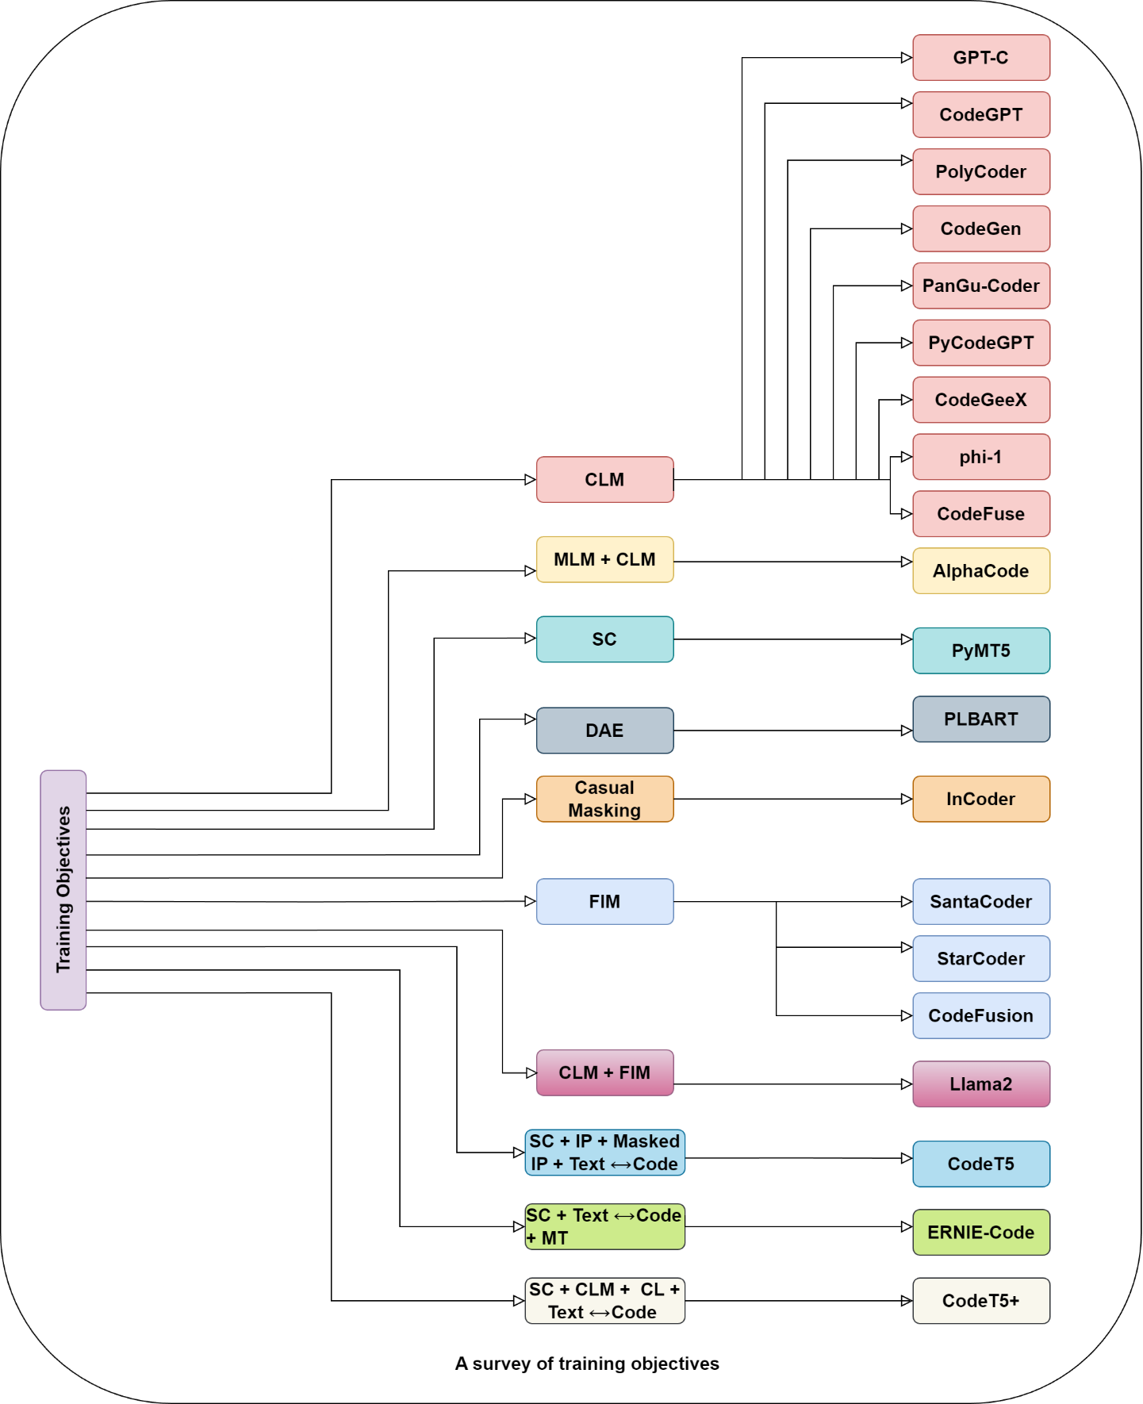
While a wide range of objectives have been explored, it is important to separate pretraining from fine-tuning.
During pretraining, models are trained on large datasets using objectives such as:
- CLM (Causal Language Modeling): predicting the next token in a sequence
- MLM (Masked Language Modeling): predicting randomly masked tokens
- SC (Span Corruption): masking spans of text instead of individual tokens
- DAE (Denoising Autoencoding): reconstructing clean input from noisy input
- FIM (Fill-in-the-Middle): generating missing code segments within context
- CL (Contrastive Learning): distinguishing correct vs incorrect representations
These objectives help the model learn general patterns in language and code.
Fine-tuning, however, is much more uniform than it appears.
Most instruction tuning and supervised fine-tuning pipelines still rely on next-token prediction. The model is trained to generate the output sequence given an instruction and input. The objective does not change significantly, the data format does.
This introduces two closely related ideas:
- Instruction Tuning: training the model on instruction–output pairs so it learns to follow tasks
- Instruction Modelling (IM): extending this by explicitly modeling the instruction itself, applying loss to both instruction and output

Beyond Text: Can Models Understand Code Structure?
One limitation of traditional objectives is that they treat code as plain text. But code has structure - variables interact, values flow, and logic follows strict rules.
To address this, several approaches introduce structure-aware objectives.
- AST (Abstract Syntax Tree) represents code as a hierarchical structure of operations
- DFG (Data Flow Graph) captures how values move between variables
- Graph-based models like GraphCodeBERT incorporate data flow into training
- CodeT5 introduces identifier-aware objectives to help models understand variable roles
These methods aim to move beyond surface-level patterns and capture the underlying semantics of code.
Some approaches modify the architecture itself to support these representations, while others integrate structure into the training objective without changing the model design.
The idea is simple:
If code is structured, why should training ignore that structure?

The variety of objectives explored in code models is broader than it initially appears.
While many variations exist, most models still rely heavily on CLM during pretraining. Structure-aware objectives are introduced selectively, and often inconsistently across models.
Which makes the following question difficult to ignore:
If better objectives exist, why do most models still default to next-token prediction?

So Where Are These Gains Coming From?
Across different approaches, three factors consistently influence performance:
- Data quality and complexity - more realistic datasets improve reasoning ability
- Instruction design - clearer and more diverse instructions improve generalization
- Training objectives - structure-aware objectives improve understanding
But these factors are often explored independently.
Which leads to an open question:
Are we optimizing each component separately, while missing how they interact?

Final Thought
Instruction tuning has clearly improved code-generating models. Performance increases, benchmarks improve, and models become more capable.
But the process still feels fragmented. Different datasets, different objectives, different tuning strategies- all contributing in ways that are not fully understood.

