CSUSB International Studies

Mobile Application

V.1.2

Software Project Management Plan

February 5, 2015

Prepared By: Advisor:

Claudia Tristan Arturo I. Concepcion

Craig Mulari

**Table of contents**

**1. Overview**……………………………………………………………………………… 4

1.1 Project Summary……………………………………………………………. 4

1.1.1 Purpose, scope, and objectives…………………………………. 4

1.1.2 Assumptions and constraints……………………………………. 4

1.1.3 Project deliverables………………………………………………. 5

1.1.4 Schedule and budget summary…………………………………. 5

1.2 Evolution of the plan……………………………………………………….. 5

**2.References**…………………………………………………………………………… 5

**3.Definitions**……………………………………………………………………………. 5

**4. Project Organization**……………………………………………………………….. 6

4.1 External Interfaces…………………………………………………………. 6

4.2 Internal Interfaces………………………………………………………….. 7

4.3. Roles and Responsibilities……………………………………………….. 7

**5. Managerial process plans**…………………………………………………………. 8

5.1 Start-up plan…………………………………………………………………. 8

5.1.1 Staffing Plan……………………………………………………….. 9 5.1.2 Resource acquisition……………………………………………… 9

5.1.3 Project staff training plan…………………………………………. 9

5.2 Work Plan…………………………………………………………………….. 9

5.2.1 Work activities………………………………………………………9

5.2.2 Schedule allocation……………………………………………….. 9

5.2.3 Resource allocation……………………………………………….. 9

5.2.4 Budget allocation………………………………………………….. 10

5.3 Control Plan…………………………………………………………………. 10

5.3.1 Requirement control plan………………………………………… 10

5.3.2 Schedule control plan…………………………………………….. 10

5.3.3 Budget control plan………………………………………………. 10

5.3.4 Quality control plan……………………………………………….. 10

5.3.5 Reporting plan…………………………………………………….. 11

5.3.6 Metrics collection plan……………………………………………. 11

5.4 Risk Management Plan……………………………………………………. 11

5.5 Closeout plan……………………………………………………………….. 11

**6. Technical process plans**…………………………………………………………. 11

6.1 Process Model……………………………………………………………… 11

6.2 Methods, tools, and techniques………………………………………….. 12

6.3 Infrastructure plan…………………………………………………………. 12

6.4 Product acceptance plan…………………………………………………. 12

**7. Supporting process plan**………………………………………………………… 13

7.1 Configuration management plan………………………………………… 13

7.2 Verification and validation plan…………………………………………... 13

7.3 Documentation Plan………………………………………………………. 13

7.4 Quality assurance plan……………………………………………………. 13

7.5 Reviews and audits……………………………………………………….. 14

7.6 Problem resolution plan………………………………………………….. 14

7.8 Process improvement plan………………………………………………. 14

**1. Overview**

**1.1 Project Summary**

**1.1.1 Purpose, scope and objectives**

The purpose of this Software Project Management Plan document is to outline the management of the International Studies mobile application. It contains the references, definitions, organization, requirements, and process that will be implemented in the application. The intended audience for this document is Dr. Arturo I. Concepcion.

The objective of this document is to provide a detailed schedule of development, roles and responsibilities assigned to each individual of the development team responsible in creating the application. This will provide Dr.Concepcion with a very clear schedule of what to expect from the development team at the appropriate given deadlines as described later on in this document.

**1.1.2 Assumptions and Constraints**

The following assumptions will be made:

* An initial prototype will be demonstrated on the 7th week of the Winter 2015 Semester.
* A final prototype demonstration will be made on the last week of the Winter 2015 Semester.
* An APK will be provided to the QA team for review.
* The team members will attend the demonstrations.
* The team members will be following the approved SRS.
* The client will be an extremely integral part of the design process and will provide constant feedback.
* The project manager will meet with the client every week to update and receive feedback from the client.
* Team members will dedicate time outside of the allotted class and lab times towards the development of the project.

The following constraints for this project will be:

* The application must be designed to work for mobile phones and tablets.
* There will be a short time frame for development.
* Ability to test and debug during the Android development.
* Prior knowledge of the development tools and technologies.

**1.1.3 Project Deliverables**

The following documentation will be delivered:

* SRS
* SPMP
* SQAP
* Detailed design
* Documented Source Code

The International Studies Mobile application containing:

* CISP info
* Admission info
* Advising info
* Study Abroad Info
* Housing
* News & Weather
* Registration
* Android Compatibility

**1.1.4 Schedule and Budget Summary**

Prototype #1 will be delivered on 25th of Feb 2015 and prototype #2 will be delivered on 25 Mar 2015. Although there will be no budget provided for this project there will be equipment made available such as:

* Computers suitable for the appropriate development environments needed.
* Mobile devices for demonstrating prototypes on if none are personally owned by any team member
* A server to maintain a database and server-side code on

**1.2 Evolution of the plan**

This is the first revision of this document that includes our initial plans and ideas for scheduling time and resources into the project. We started with interviewing Dr.Chuang and writing the SRS. Once the SRS is completed the plan will evolve.

**2. References**

Software Project Management Plan IEEE Std, 1058-1998.

Student Advising SPMP, Winter 2014

CSUSB International Studies SRS V.1.1 Winter 2015

**3. Definitions**

**APK**

**-(**Android application package) a package file format use to install and distribute

software and middleware onto Google Android Operating Systems

**CISP**

**-**Center for International Studies and Programs

**Client**

**-**Dr. Rueyling Chuang

**IDE**

**-**(integrated development environment) a software application that provides

comprehensive facilities to computer programmers for software development.

**IEEE**

**-**Institute of Electrical and Electronic Engineers

**Java**

**-**a general purpose computer programming language that is concurrent, class based,

and object oriented.

**Mobile Application**

**-**A computer program designed to run on smartphones, tablet computers and other

mobile devices

**QA**

**-**Quality Assurance

**SRS**

**-**Software Requirements Specifications

**4. Project Organizations**

**4.1 External Interfaces**

The project manager will work with the server team to request certain resources they will provide to the team as well as serve the needs of the client. The QA team will asses and give feedback regarding the work created by the team according to the SRS Document. The project manager and assistant project manager will supervise and manage the team in progressing in the project as well as adhering to the SRS guidelines.

**4.2 Internal Interfaces**

**4.3 Roles and Responsibilities**

|  |  |  |
| --- | --- | --- |
| **Name** | **Role** | **Responsibility** |
| Claudia Tristan | Project Manager | * Conducts meetings with client * A median for info between team members and client * Assigns work to each team member * Oversees all issues team has with project |
| Craig Mulari | Assistant Project Manager | * Assists project manager * Reviews team members contribution to project * Oversees design of project |
| Richard Arevalo | Programmer | * Develops in Java * Implements the Specifications of the SRS * Adheres to standards set |
| Shea Grotke |
| Thomas Clyde |
| Dj Balane | Graphic Designer | * Develops in Photoshop and other Adobe Services * Adheres to standards set * Creates and develops the User Interface |

**5. Managerial Process Plans**

**5.1 Start-up plan**

Our start-up plan consisted of two branches that worked simultaneously depending on what obstacles and client specifications we came across. These two branches consisted of:

* Client specifications
* technology research and familiarity
* Set up of the environment and technology
* Design planning and overview

5.1.1 Staffing Plan

The team was formed using a survey of skills questionnaire.

5.1.2 Resource Acquisition

Resources acquisitions will need to be obtained from the server team. Smartphones are mainly owned by most team members but in the case if one is needed testing smartphones will be made available.

5.1.3 Project Staff Training Plan

All staff is expected to learn the specific technologies that will be used for the project independently. Since most team members are not familiar with creating Android apps or working with Java this will be a learning experience for all. Tutorials will be given on the basic aspects and functions of Android Studio downloaded from:developer.**android**.com/sdk/ as well as a tutorial on how to use our GitHub repository: https://github.com/claudiat1213/international-studies

If team members are having difficulty with certain technologies or aspects of the project everyone will take time to work out the issues and difficulties based on what has been learned thus far to help others struggling.

**5.2 Work Plan**

5.2.1 Work Activities

**Prototype-** early working build of project

**Graphic Design-** images, icons, styles, layout, graphics

**Programming-** Source code

**Testing-** Verify the durability and reliability of project app

**Documentation-** Keep application maintainable for future developers

5.2.2 Schedule Allocation

Each team member will devote several hours each week to revise and edit the necessary documentation sections they were assigned as well as familiarize themselves more with PhoneGap and Android Studio. Each team member will also devote time to working on their section of the application as set by the client’s powerpoint outline.

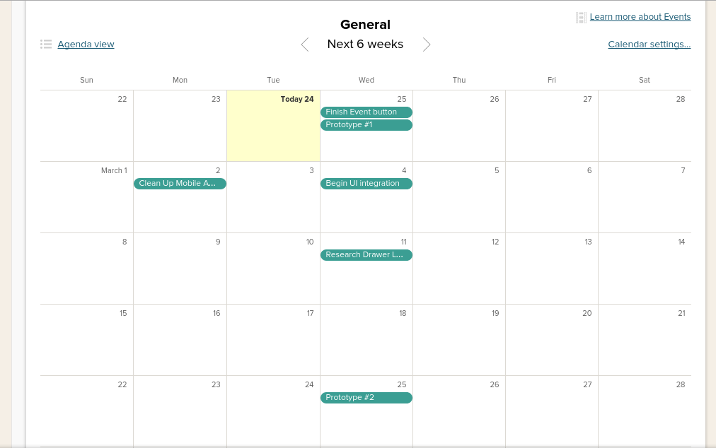

5.2.3 Resource Allocation

Resources needed by the team from the server team, Dr.Rueyling Chuang, or Wen-Yang Cheng will be allocated and discussed to the Project Manager Claudia Tristan or Assistant Project Manager Craig Mulari who will appropriately share the resources according to each individual team member’s responsibility on the project and what they need to appropriately develop their section.

5.2.4 Budget Allocation

There is no budget for this project but certain resources are made available. See section 1.1.4 *Schedule and Budget Summary.*

**5.3 Control Plan**

5.3.1 Requirement Control Plan

The team will meet twice a week to discuss the progress of the application and what issues or suggestions each team member may have. The client will be continually updated on the progress of the prototypes whenever new content is updated for constant feedback and approval. When requirements are changes the SRS will be revised and the whatever needs to be altered will be changed accordingly.

5.3.2 Schedule Control Plan

Dr.Concepcion will meet with Claudia Tristan and Craig Mulari once a week to discuss all progress made on the application and to also evaluate all aspects of the team and application. If there is a change in the schedule then schedules will be altered accordingly to ensure progress can be tracked and managed.

5.3.3 Budget Control Plan

There is no budget for this project but certain resources are made available. See section 1.1.4 *Schedule and Budget Summary.*

5.3.4 Quality Control Plan

All team members will evaluate the quality of the graphical designs and provide any feedback and suggestions as to what they believe would be appropriate for our application. Claudia Tristan will overview all aspects of the project for quality and the overall final approval, evaluation and feedback will come from Dr.Concepcion and Dr.Rueyling Chuang. Every team member will be expected to have no less than 30 LOC/hr to report every week when meetings takes place.

5.3.5 Reporting Plan

Claudia Tristan will report the progress of the project to the client every week whenever they are available for approval and feedback. Dr. Concepcion will hold weekly meeting with all Project managers and Assistant Project managers to be updated on the progress of each project. Each team member will have an opportunity to discuss their progress on the project every Monday and Wednesday during meeting hours.

5.3.6 Metrics Collection Plan

A metric of 30 LOC/hr will be set to measure productivity.

**5.4 Risk Management Plan**

For a potential human resource loss project management will pick up what other team members were not able to finish or other team members will help accordingly. In the case of equipment loss the individual alone will be held accountable as policy of CSUSB. In the case of server unavailability an email will be sent to the server team and the necessary steps will be taken to ensure there is a backup in case server issues do arise.

**5.5 Closeout Plan**

1. Presentation of prototype to the client
2. Store all deliverables to repository
3. Submit Maintenance manual

**6. Technical Process Plan**

**6.1 Process Model**

The Agile software development model will be utilized for the development of this application. There will two main iterations throughout the development of our project. The project will be reviewed on a weekly basis on the Monday of every week while everyone on the team is together. Code will be reviewed and tested for any bugs that might have made their way through. Once the code is verified the master branch will be updated. Mondays will also serve as a checkpoint and a marker for our progress. As a team we will analyze whether or not the group is on track to make the deadlines. Work that was deadlined on Monday but was not completed will be carried over to the the next week and special emphasis will be made to keep on pace. The first iteration will take place when the product is demonstrated to Dr. Concepcion and the Client. The second and final iteration will take place on the final week, and will be a demonstration of the final product to the Client and Dr. Concepcion.

**Process Model Diagram**

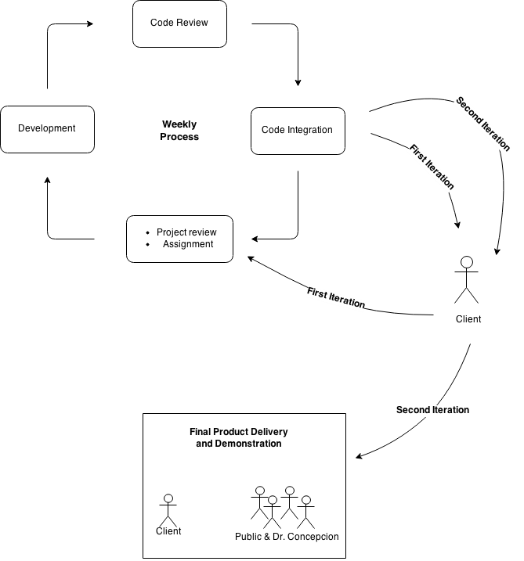

**6.2 Methods, Tools, and Techniques**

Methods:

* Agile Development
* Object-Oriented Design

Tools:

* Android SDK
* GitHub

Techniques:

We will be storing projects in GitHub and creating branches from a master file. Using Agile programming methodology we will be programming mostly over the course of the weekend. The lab times will be spent presenting what we have worked on and how to improve on it. To test the program we will adopt a black-box testing style in which we test every facet of the app for complete functionality.

**6.3 Infrastructure Plan**

The App will be developed using technology that the students own and maintain. Personal computers along with the computers at CSUSB will be the main means of developing this App. Continued work and maintenance of this App will be assessed at the end of the quarter. If future work is to be done on this project it will be at the hands of future CSE 455 students and interns.

**6.4 Product Acceptance Plan**

The acceptance of the final product will be determined by the client and Dr. Concepcion. They will be looking for:

* Functionality and completeness
* Any bugs within the App
* Memory leaks
* Design and aesthetics
* Speed

**7 Supporting Process Plans**

**7.1 Configuration Management Plan**

The configuration of the project will be handled by the server team. As our project is not in need of server team resources, they’re configuration and collaboration in our project will not be necessary.

**7.2 Verification and Validation Plan**

The Quality Assurance Team is the designated group for testing the app and comparing it to standards set up by the SRS. They will run diagnostics on the app and thoroughly test it for completeness and functionality.

**7.3 Documentation Plan**

Any documentation of the project needed will be in the form of text documents included in the folders of the Android studio project. Considering we will soon pass on this project to another group of students, documentation will need to include: the basic layout and idea of the project, any intermediary steps including how we used PhoneGap, and any other steps that need verbose documentation. Further documents will include the SRS, SPMP documents. The SRS is a collaborative effort from the entire development team. The SPMP is a document written only by the Project Manager and their Assistant Project Manager. An SQAP document will be written by the server team but will not directly involve our team, as we do not need any resources from them.

**7.4 Quality Assurance Plan**

The entire development team will be in charge or ensuring the code is of a high-quality. This will include uniformity, efficiency and commonplace methods of coding. Proper training and uniform development has been put in place to ensure that this higher quality of code is met.

**7.5 Reviews and Audits**

Reviewing the software will make sure that the quality of code produced is efficient, uniform, and functional. The reviewing and auditing of the software will take place during the allotted lab times on Monday and Wednesday. This will include full reviews of the overall design and layout of the app, and also audits of code that is not functional. Any further reviews will be handled by Project Manager Claudia Tristan and Assistant Project Manager Craig Mulari.

**7.6 Problem Resolution Plan**

Problems will be resolved within the team itself and the final decision will come from Project Manager Claudia Tristan. If the problem cannot be resolved within the team, then and only then will Dr. Concepcion be consulted for assistance and ultimate ruling.

**7.8 Process Improvement Plan**

Improvement upon the software process will be made after the first prototype demonstration. The development team will discuss how to improve productivity and, if needed, Claudia Tristan and Craig Mulari will reassign development positions if necessary.