# Pixel Group Processing Assessment

|  |  |  |  |
| --- | --- | --- | --- |
| Name |  | Course |  |
| Date |  |  |  |

[Type the test instructions here. For example, instruct the student to write a short paragraph in response to each of the following questions.]

### What colour would this produce, white or black and why

255,0,0

Answer:

### What is the spatial frequency of this image and state your reasoning below

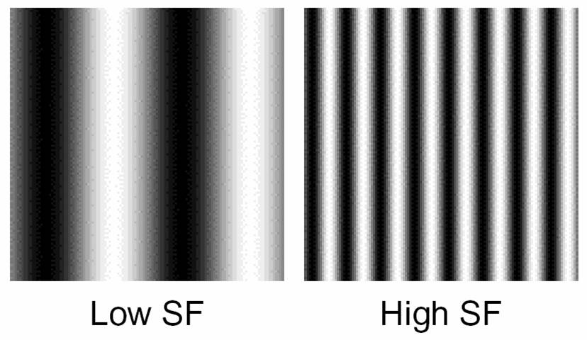



Reason:

### Workout out the output the center pixel weighed by the kernel

Heres a simple edge detection kernel normalized by 1 tenth workout the the pixel

X

$$\frac{1}{10}$$

|  |  |  |  |  |
| --- | --- | --- | --- | --- |
| 55 | 255 | 158 | 100 | 12 |
| 30 | 244 | 55 | 90 | 200 |
| 60 | 200 | 50 | 26 | 154 |
| 89 | 100 | 35 | 25 | 100 |
| 55 | 24 | 40 | 40 | 32 |

|  |  |  |
| --- | --- | --- |
| 1 | 0 | -1 |
| 0 | 0 | 0 |
| -1 | 0 | 1 |

Answer:

### Explain why we need edge handling

Answer

### List one way we can handle the edges

Answer

### What feature would this kernel detect

|  |  |  |
| --- | --- | --- |
| 0 | 1 | 0 |
| 1 | 0 | -1 |
| 0 | =1 | 0 |

Answer: