TASKS

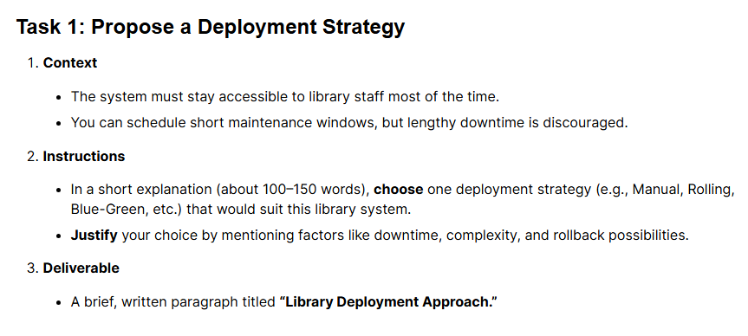

Library Deployment Approach
I propose using the Rolling Deployment strategy. This approach involves gradually replacing the older version of the application with the new version on a set of servers (or containers) one by one. This minimizes downtime, as the old version remains operational until the new one is confirmed to be running correctly. The library system requires high availability with minimal tolerance for downtime, making the zero-downtime nature of rolling deployment ideal. While slightly more complex than a manual update, it is less complex than Blue-Green. A key advantage is the possibility of an easy rollback: if the new version encounters issues, the process can be halted, and traffic can be immediately rerouted back to the untouched, running older instances, ensuring library staff can continue their work quickly.

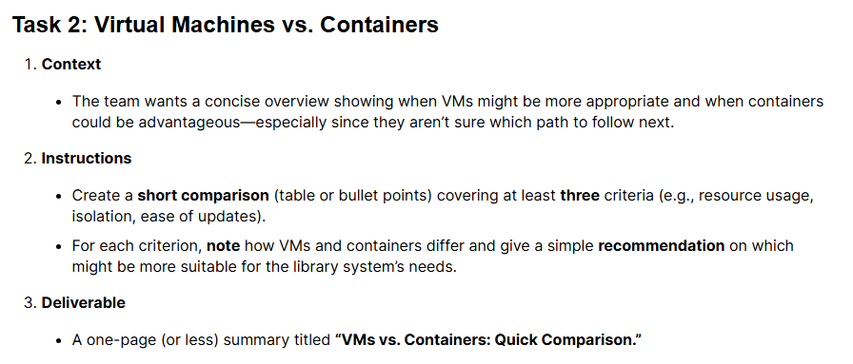
VMs vs. Containers: Quick Comparison
Criterion | Virtual Machines (VMs) | Containers (e.g., Docker) | Suitability for Library System
Resource Usage | High. Each VM requires its own full OS, leading to significant overhead in CPU, RAM, and disk space. | Low. Share the host OS kernel, only packaging the application and its dependencies. Extremely lightweight and fast to start. | Containers. Lower resource consumption means lower hosting costs and better performance for a small application.
Isolation | Strong (OS-level). Completely isolated from the host OS and other VMs, providing maximum security and independence. | Moderate (Process-level). Isolated from other containers, but they all share the host OS kernel. Isolation is less robust than VMs. | Containers. Strong isolation isn't strictly necessary for a non-security-critical internal application, and the resource benefits outweigh the slight isolation difference.
Ease of Updates | Low/Slow. Requires updating the application, libraries, and potentially the entire Guest OS on each VM. Image creation is slow. | High/Fast. Updates only the application code/dependencies within the container image. New containers can be built and deployed in seconds. | Containers. Given frequent updates (every few weeks), the speed and consistency of container updates are a major operational advantage.
Recommendation: Containerization is the superior choice for the Library Management System. Its low resource usage, rapid deployment cycle, and ease of updates align perfectly with a small, frequently-updated application requiring high availability.

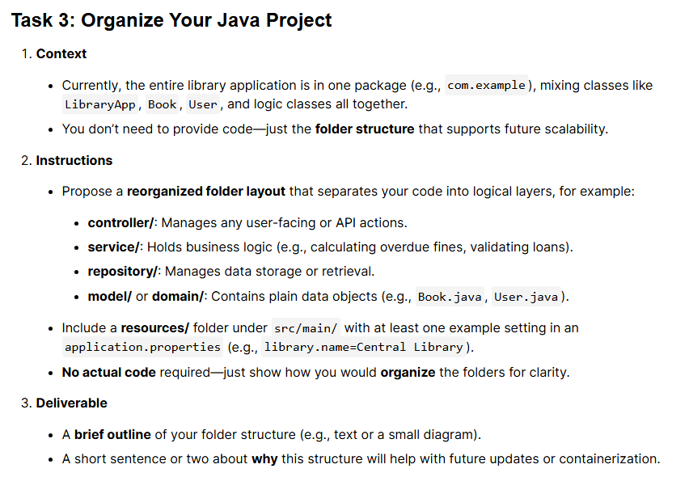

📁 Java Folder Structure Outline
This structure follows a typical layered (or MVC/Microservice) architecture, promoting the Separation of Concerns

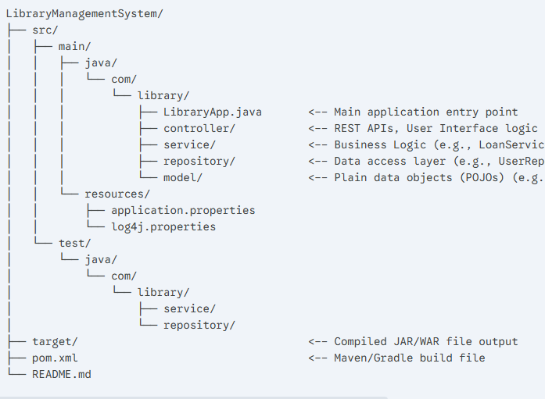
Example application.properties content:
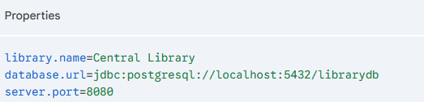

Justification:
This layered structure ensures that business logic (service) is fully isolated from the data access (repository) and user-facing (controller) concerns. This separation makes the system significantly easier to maintain, as changes in one layer (e.g., switching databases only impacts the repository) won't break others. Furthermore, this clean organization is crucial for containerization, as it simplifies dependencies and clearly delineates the application components needed inside the final container image, promoting clean and efficient JAR/WAR file creation.

