

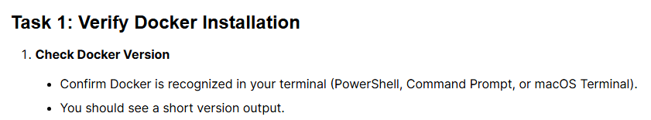
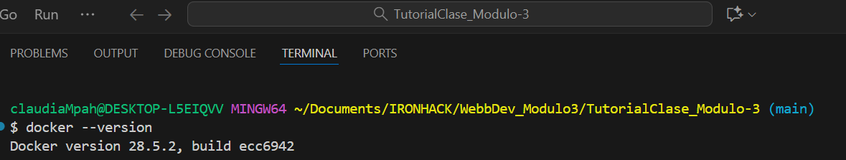



I decided to pull mysql image
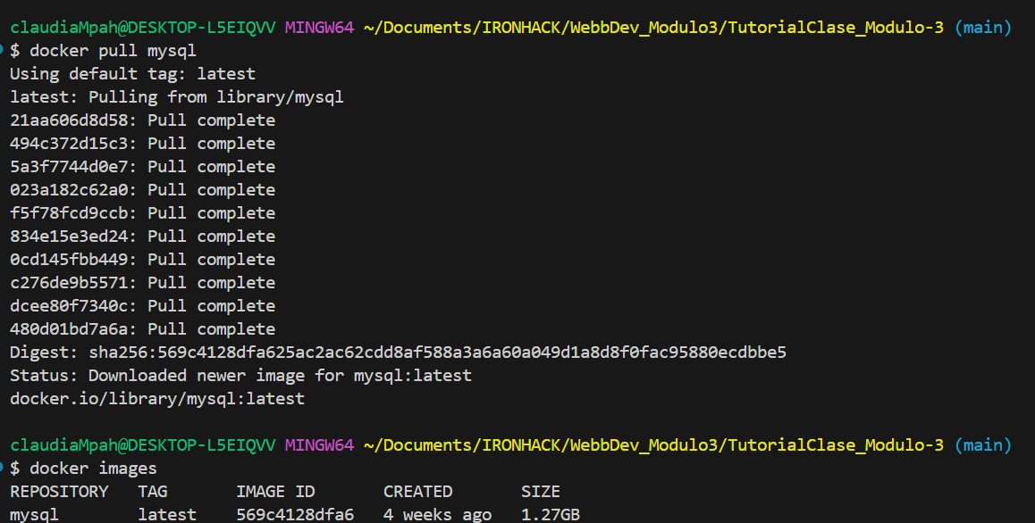
Docker mysql image created:



I confirmed Docker was installed by version check:

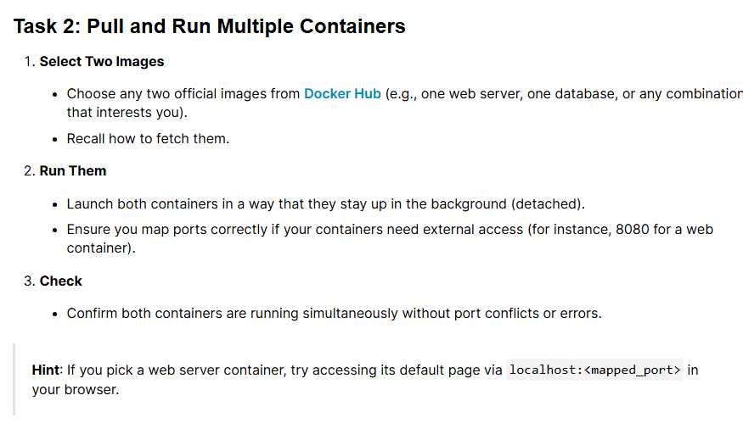
We will follow the teacher's instructions received during the class and only launch one container, in this case the mysql one with the instruction: docker run --name my-mysql -e MYSQL_ROOT_PASSWORD=secret123 -e MYSQL_DATABASE=appdb -p 3308:3306 mysql
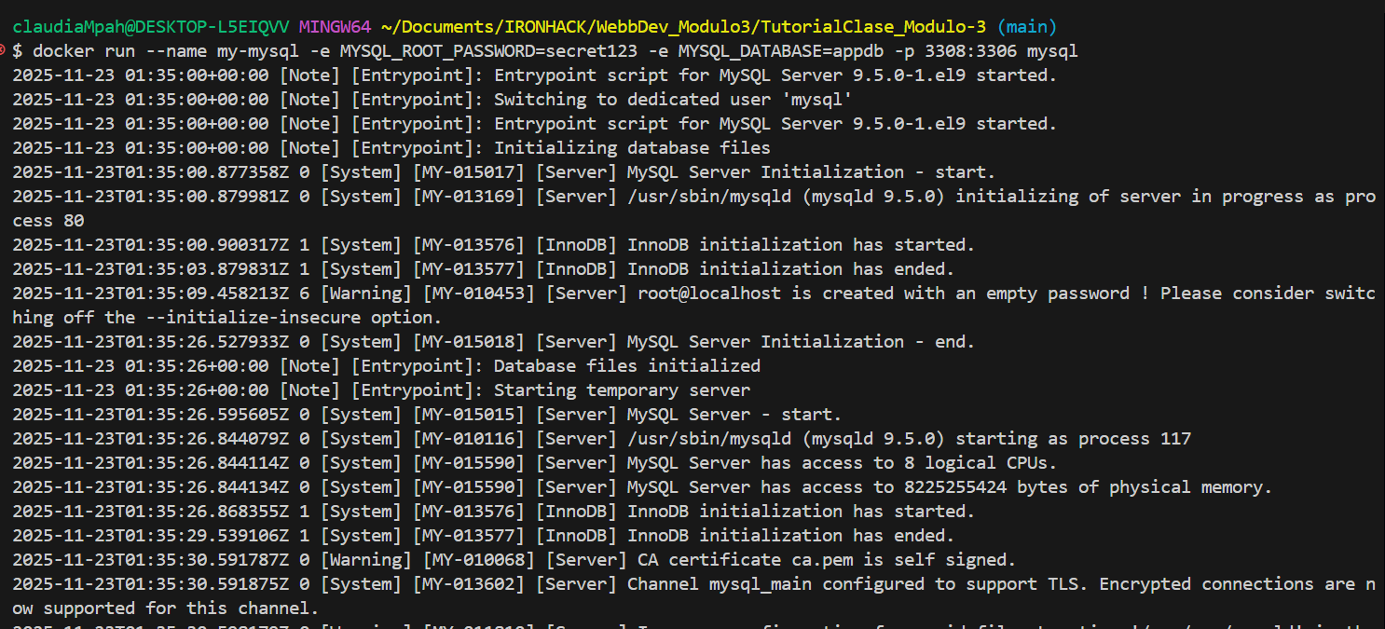

Container my-mysql created:
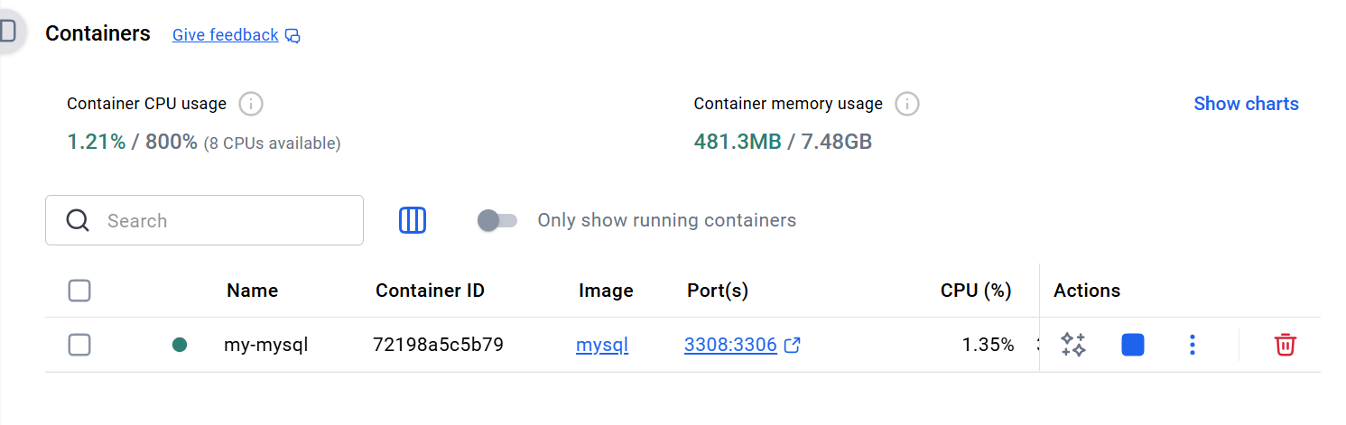

Checking the connection to the MySQL database:
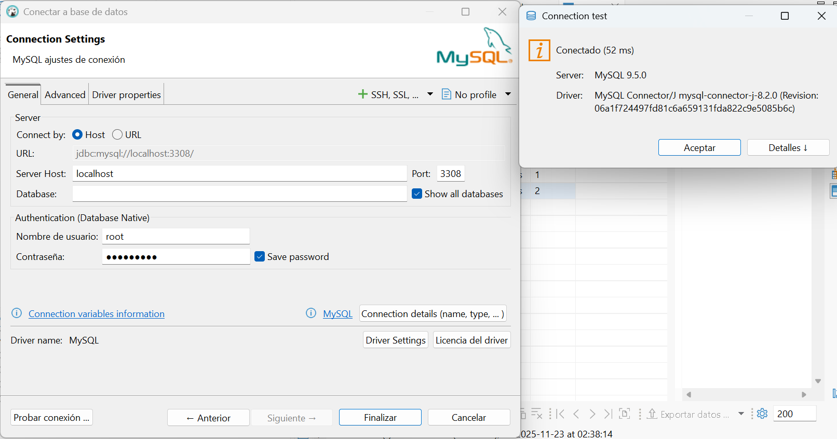
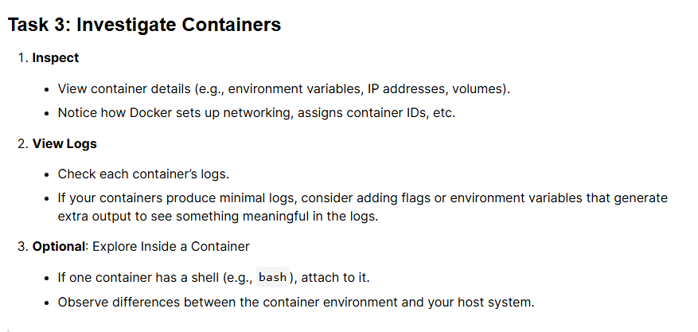

Containers inspect:
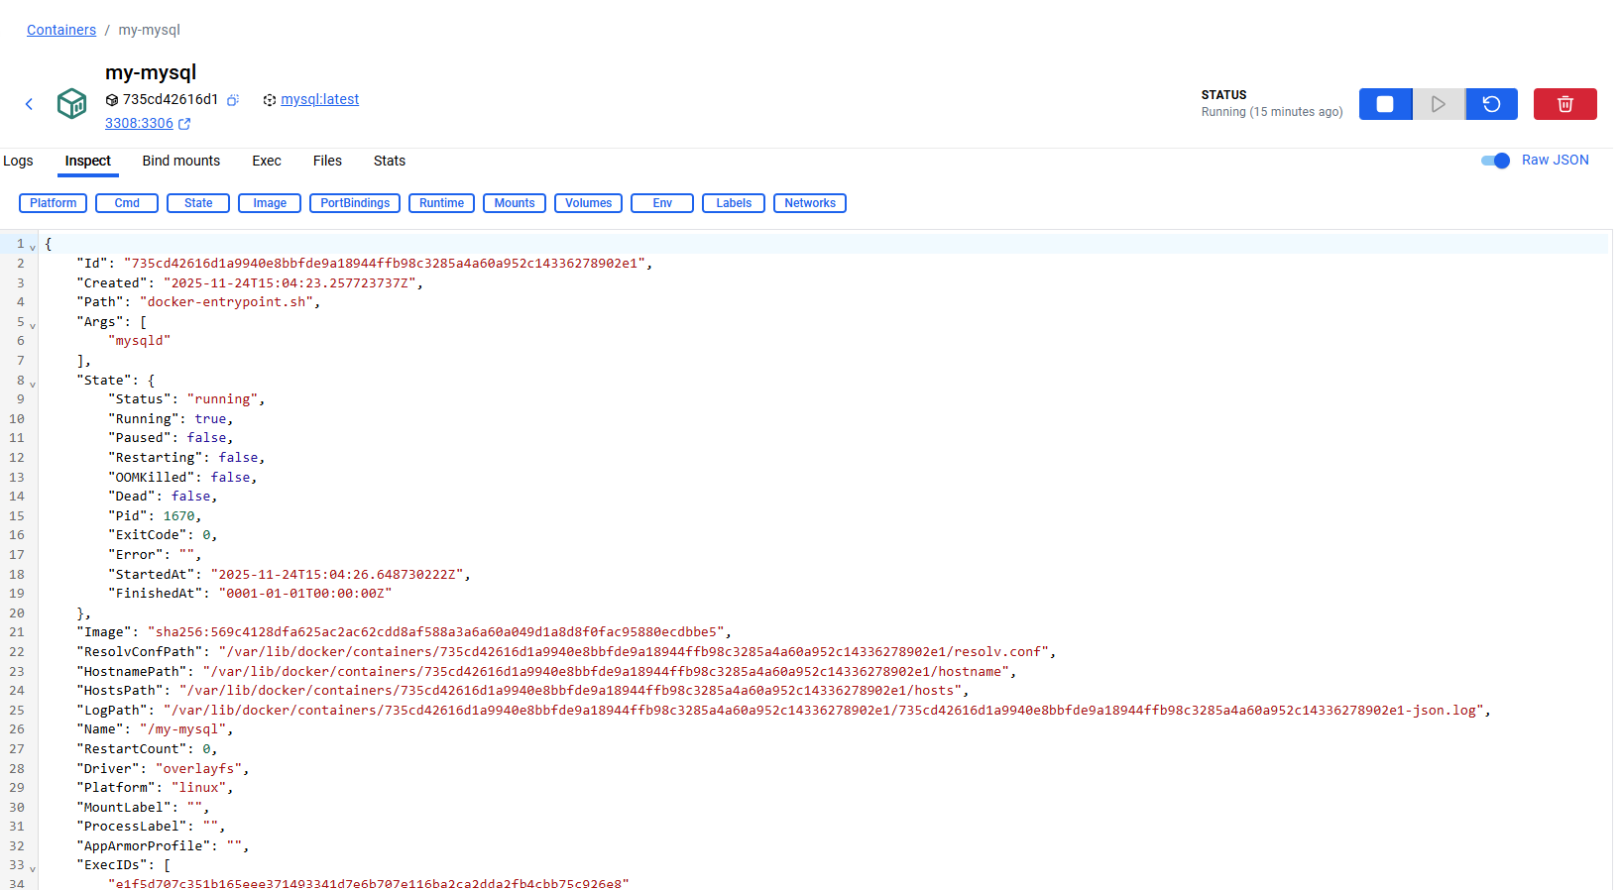

Containers Logs:
:
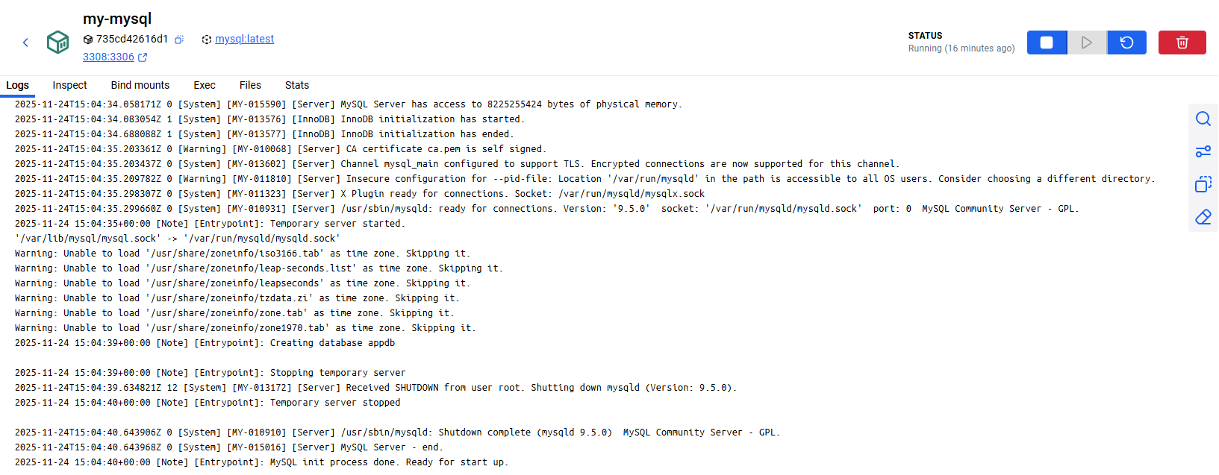

Containers Stats:
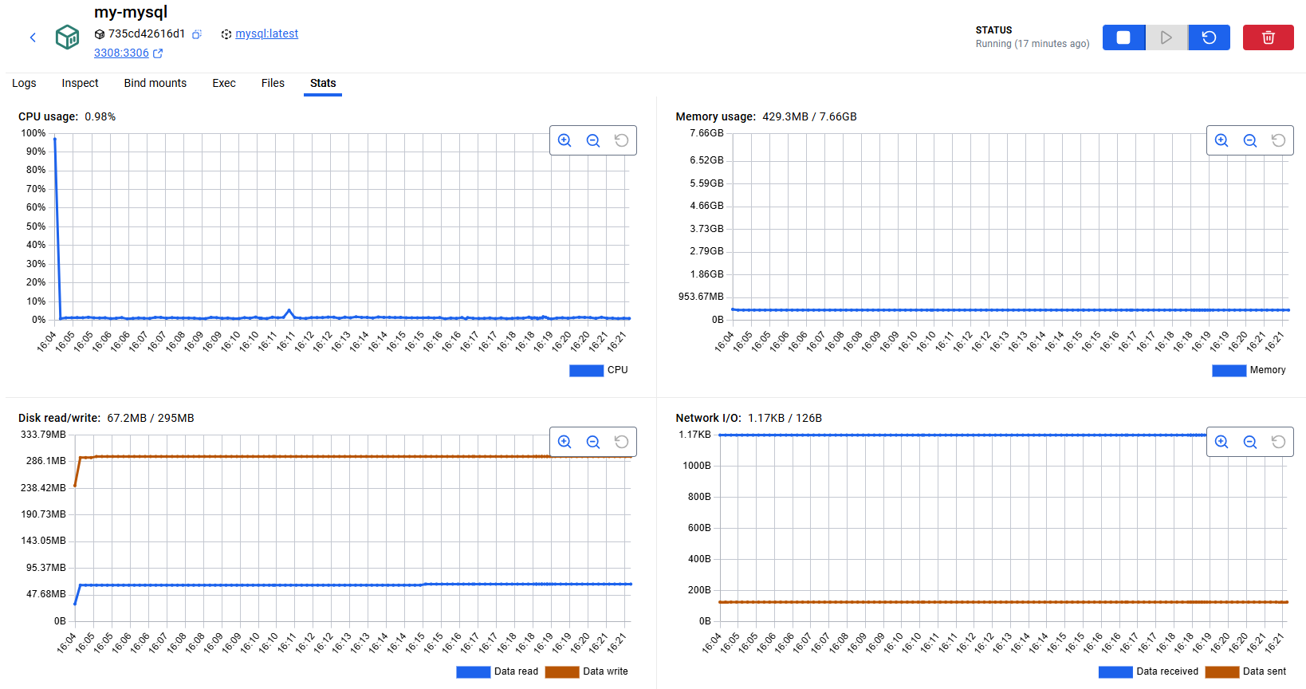

Containers Exec:

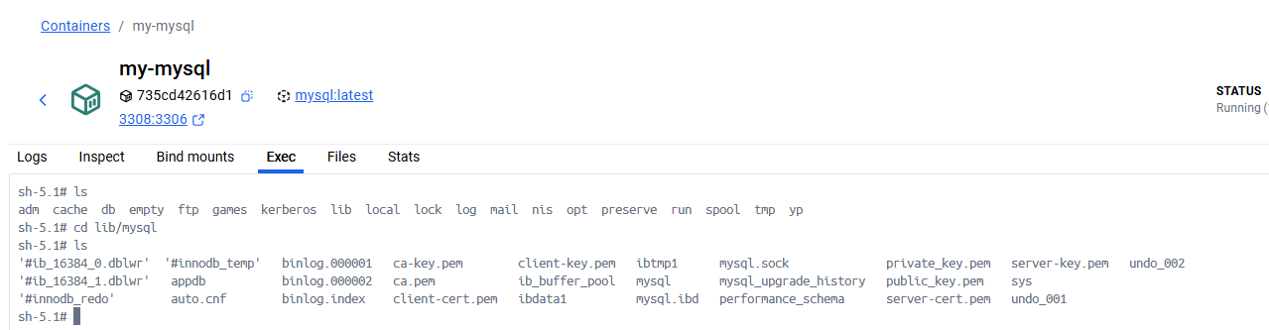
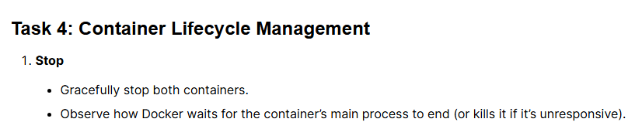
When we stop the container from the console, we see that it also stops from the Docker application.
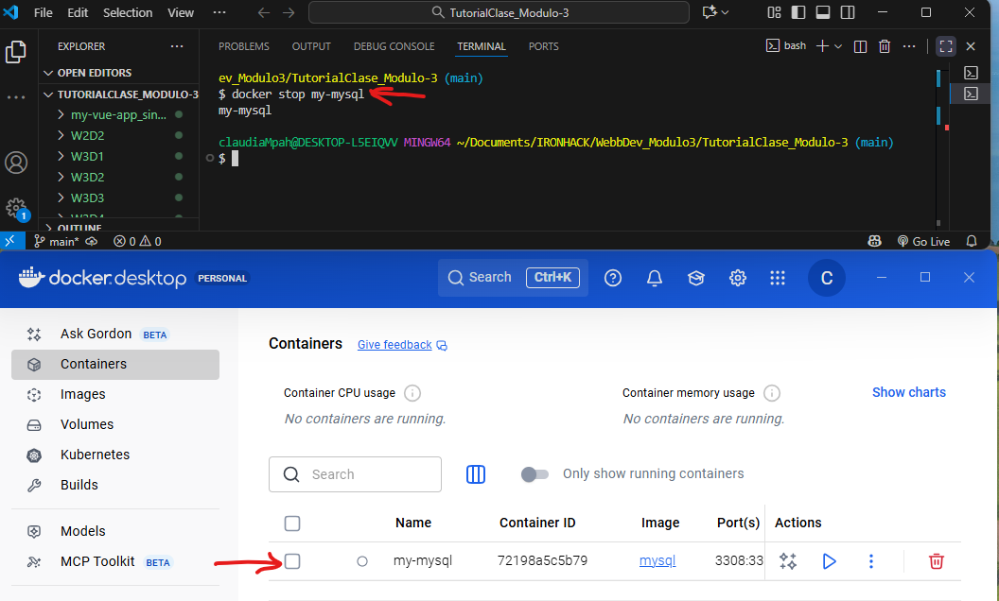

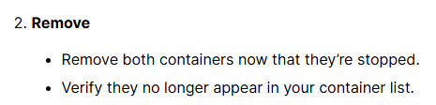

When we delete the container from the console, we see how it is deleted from the Docker application.

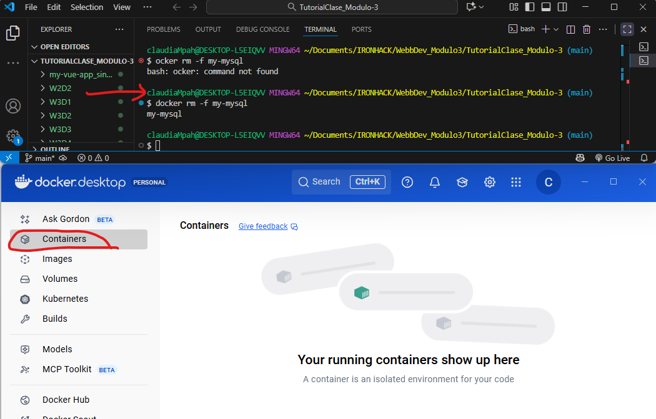



We've noticed that removing the container doesn't remove the image. Using the command "docker rmi mysql" from the console successfully removed the image from Docker.

