BELLEROFONTE

COMMAND LINE MANUAL - 27/07/2003 - ver. 0.86

In this brief manual on expect that the installation have had a good conclusion. If so, the Bellerofonte’s root dir is as in figure:

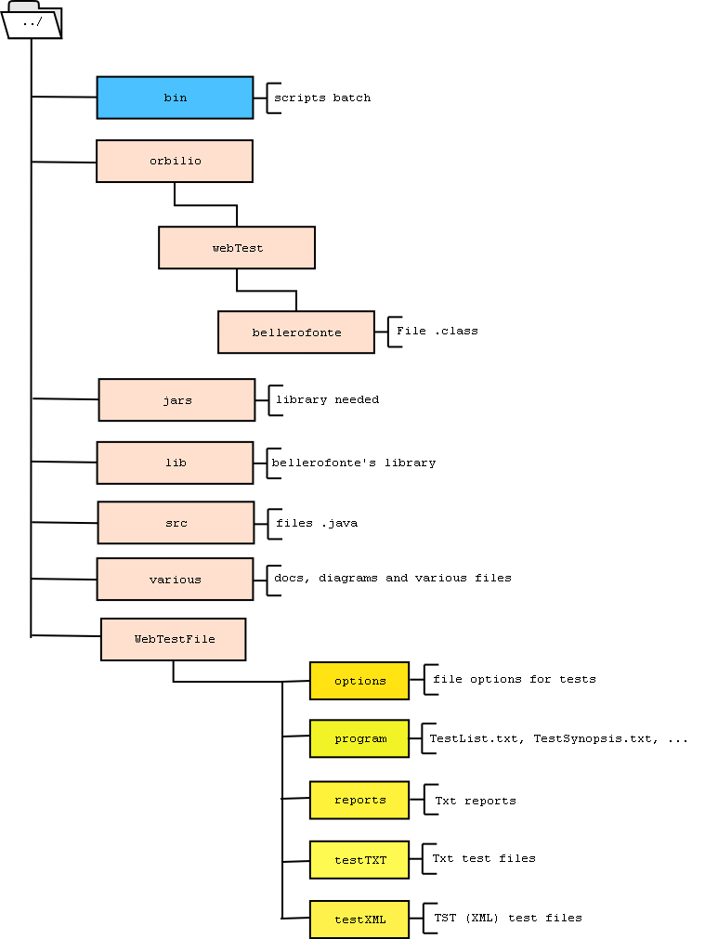

The Bellerofonte’s directories

The first step is to edit the program files needed by Bellerofonte that are holds in WebTestFiles directories:

- in \options there are files that define the environment options and the target of the test. They are file Properties in which are some record in “key = value” form. All tests must have one file options in input and one file options can be associated with many tests. Normally it’s a safe manner to proceed to open “options.txt” and save it with other name. Then it’s possible to modify the new file options how is requested. For all options there is a brief comment of explication;
- in \testTXT there are test files in textual form. At the first execution, a test must be in this form. Then, after the execution, if it is expressly saved (in XML form), it’s possible to load a test also as TST object. For the first execution you must create a new file txt with the list of Single test (- the steps of the new test -), using the syntax described in the TestSynopsis. Remember that Bellerofonte override some eventual existent files with the new ones! So, if exist a myTest.tst created from an execution of myTest.txt and then you reload myTest.txt and resave it, all informations hold in myTest.tst will be lost. To avoid this delete you must reload (and resave) always myTest.tst.

Bellerofonte don’t support basic file’s operations how delete, rename and move. It is possible to do these operations with text editors or file managers available on the market.

The next step is the execution of Bellerofonte. In the \bin directory there are some batch scripts: “belJAR.bat” is dedicated to launch Bellerofonte. In linux/unix system it’s possible to execute this script changing its permissions and writing “./belJAR.bat”. Remember that for its execution Bellerofonte need a Java Virtual Machine already installed on the system.
Bellerofonte can be executed from command line in two manner: the first is passing expressly to it the file options’s name and the file test’s name (with the extension too), the second is launching “belJAR.bat” and select from the interactive console the parameters listed. The interactive console is called when Bellerofonte don’t find the parameters in input from the command line. It search in \webtestfiles the existing data that the user can select.
In general Bellerofonte need of three parameters in input:

- name of file options: it’s the full name of a file txt in the \options directory. With the interactive console you can select one of these writing its number or writing its name (always with extension);
- name of file test: as the previous point it’s a full name of a test that is in \testTXT or \testXML. The interactive console permit to select a test from its number in the list;
- other execution directives: these are some keyword to manage the report of test’s execution and the save of test. Only one of these can be used in a execution:
  - “saveToMacroTest” = save the test and its report in a tst object in \testXML directory. If the tst test file already exists, the only the new report is stored and the oldest one is deleted. It’s possible to select this parameter with txt and tst input test names;
  - “compareToOld” = compare actual report with the last ones stored in a tst object (max two ones). The comparation is displayed only on screen and not saved to report. It’s possible to select this keyword only with tst file test in input;
  - “compareToOldAndSave” = it make the two operations listed before in the same order;
  - NameFileReport = it’s the name of textual report that is generated by Bellerofonte at the end of execution and stored in \reports directory. If one test with the same name already exists it will be overwrited;
  - Null = if the third parameter is empty Bellerofonte execute the test and report only to video the results.
The interactive console permit to select these keyword writing their numbers or names.

Finally, if the execution is done without errors, Bellerofonte reports its results.
Good luck !!!

